Appendix A. Supporting information

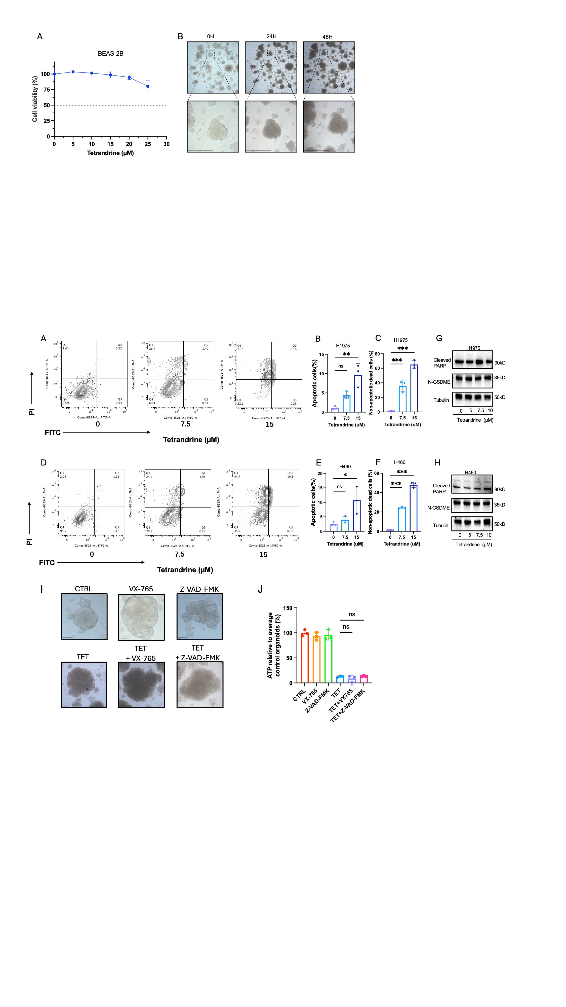
Supplementary Fig. 1. Effects of tetrandrine on BEAS-2B cell viability and NSCLC organoid morphology (related to Fig. 1). A BEAS-2B cells were treated with the indicated concentrations of tetrandrine for 48 h, and cell viability was measured using CCK-8. Data are presented as mean ± SD from three independent experiments. B Representative bright-field images of NSCLC organoids at 0, 24, and 48 h after treatment with 10 μM tetrandrine. Enlarged views of the boxed regions are shown below. Scale bars, 100 μm. Images are representative of three independent experiments.

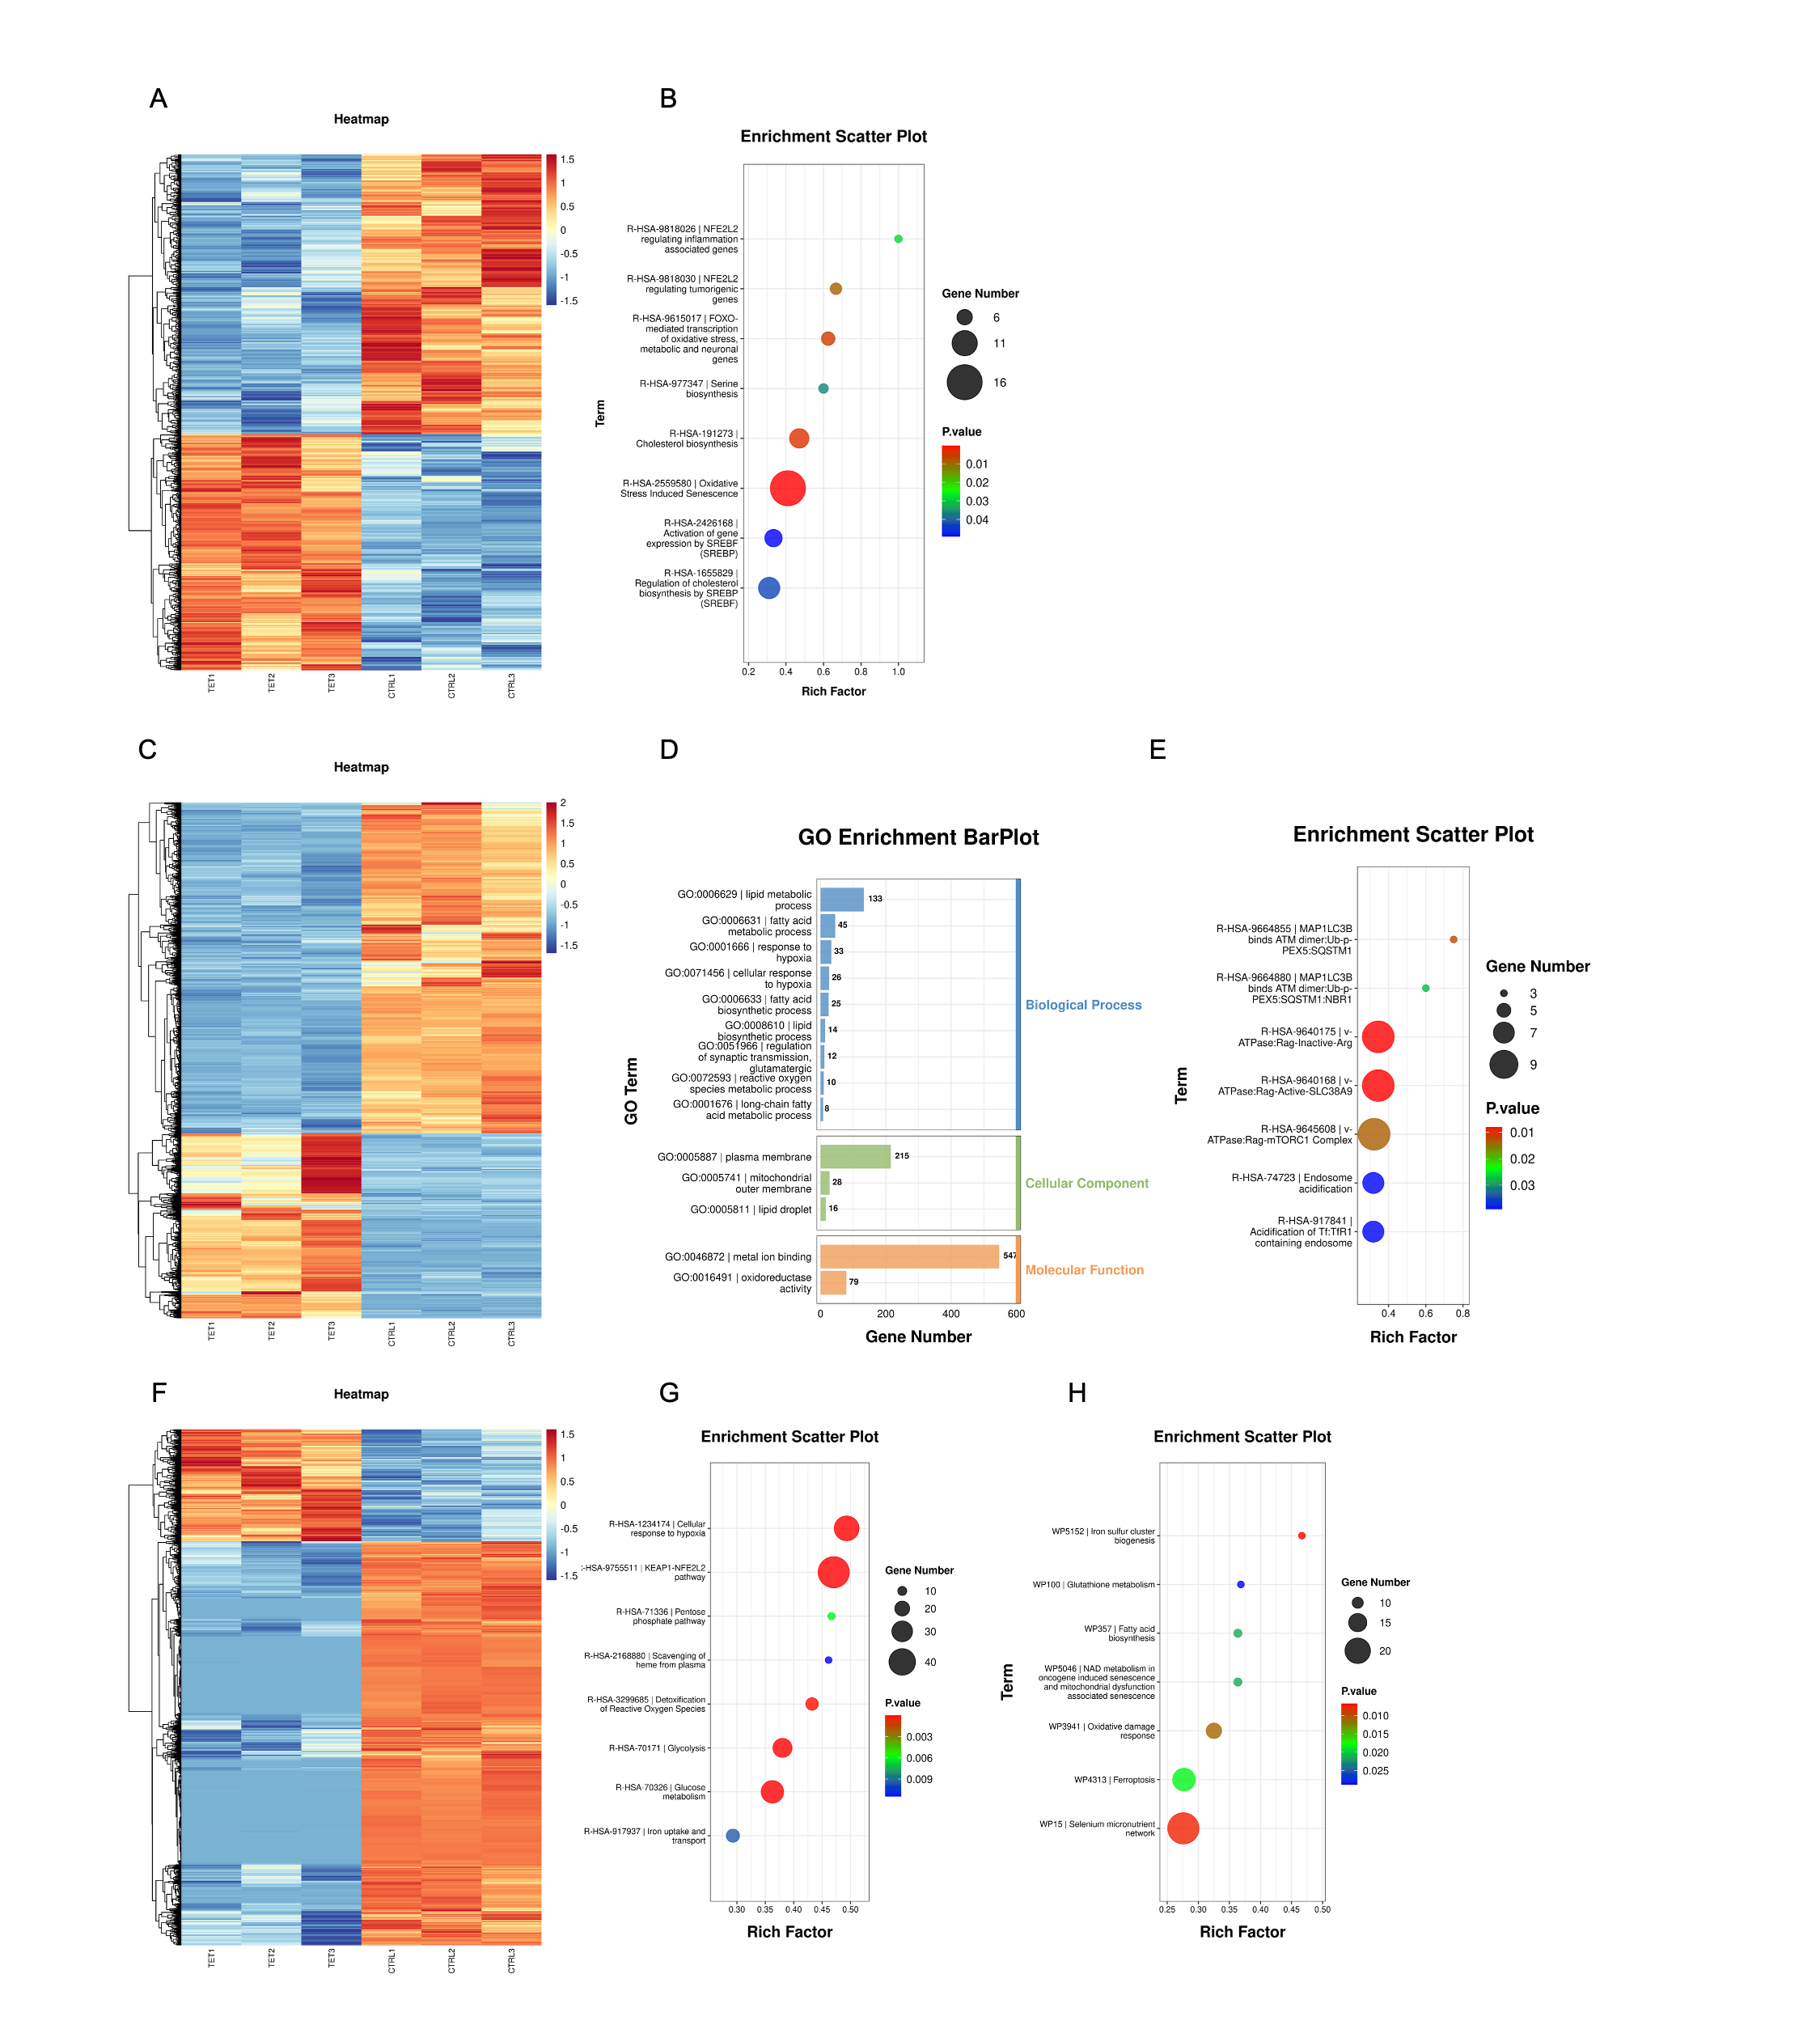

Supplementary Fig. 2. Proteomic and transcriptomic analyses of tetrandrine-treated NSCLC cells and organoids (related to Fig. 2). A–B Heatmap of differentially expressed proteins (A) and Reactome enrichment analysis (B) in H460 cells treated with tetrandrine (10 μM) for 24 h compared with controls. C–E Heatmap of differentially expressed genes (C), GO enrichment analysis (D), and Reactome enrichment analysis (E) in H460 cells treated with tetrandrine (10 μM) for 24 h compared with controls. F–H Heatmap of differentially expressed proteins (F), Reactome enrichment analysis (G), and WikiPathways enrichment analysis (H) in patient-derived NSCLC organoids treated with tetrandrine (10 μM) for 24 h compared with controls. In the bubble plots, bubble size represents the number of mapped genes or proteins, and color indicates the P value.

Supplementary Fig. 3. Effects of tetrandrine on apoptosis and pyroptosis in NSCLC cells and organoids (related to Fig. 2). A–F H1975 and H460 cells were treated with the indicated concentrations of tetrandrine for 48 h and analyzed by Annexin V-FITC/PI staining. Representative flow cytometry plots are shown in A (H1975) and D (H460), with quantification of Annexin V-positive cells (B, E) and Annexin V-negative/PI-positive cells (C, F). G–H Western blot analysis of cleaved PARP and N-terminal GSDME (N-GSDME) in H1975 (G) and H460 (H) cells treated with the indicated concentrations of tetrandrine for 48 h. Tubulin served as the loading control. I–J NSCLC organoids were treated with tetrandrine (10 μM) for 48 h, with or without pretreatment with VX-765 (10 μM) or Z-VAD-FMK (20 μM) for 2 h. Representative bright-field images are shown in I. Scale bars, 50 μm. Organoid viability was measured using an ATP-based luminescence assay and normalized to the untreated control (J). Quantitative data are presented as mean ± SD from three independent experiments. Statistical significance was assessed using ANOVA with multiple comparisons. ns, not significant; *P < 0.05; **P < 0.01; ***P < 0.001.
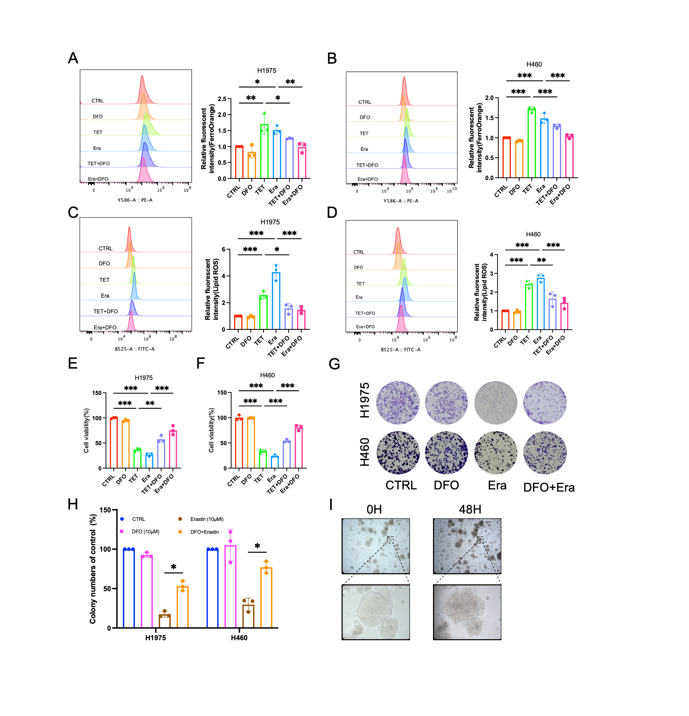
Supplementary Fig. 4. Tetrandrine and erastin induce ferroptosis in NSCLC cells (related to Fig. 2). A–F H1975 and H460 cells were treated with tetrandrine (TET, 10 μM) or erastin (Era, 10 μM) for 48 h, with or without DFO (10 μM) pretreatment for 2 h. Erastin served as a positive control for ferroptosis. Intracellular Fe²⁺ levels were assessed by FerroOrange staining (A–B), and lipid peroxidation was measured by flow cytometry (C–D). Representative flow cytometry plots and quantification are shown for H1975 (A, C) and H460 (B, D) cells. Cell viability was measured using CCK-8 (E–F). G–H Representative crystal violet staining images (G) and quantification of colony numbers (H) in H1975 and H460 cells treated with erastin (10 μM) for 48 h, with or without DFO (10 μM) pretreatment for 2 h. I Representative bright-field images of NSCLC organoids before and after 48 h of erastin treatment. Enlarged views of the boxed regions are shown below. Scale bars, 100 μm. Quantitative data are presented as mean ± SD from three independent experiments. Statistical significance was assessed using ANOVA with multiple comparisons. *P < 0.05; **P < 0.01; ***P < 0.001.

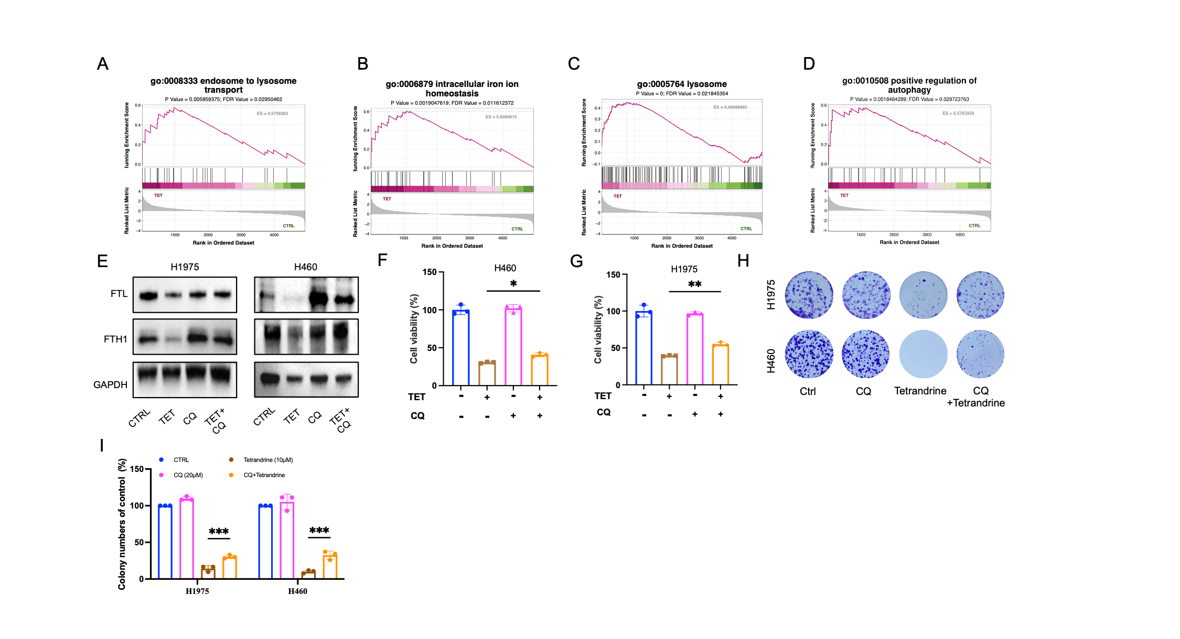

Supplementary Fig. 5. Chloroquine attenuates tetrandrine-induced ferritin loss and growth inhibition in NSCLC cells (related to Fig. 3). A–D GSEA plots of H460 proteomic data following tetrandrine treatment (10 μM, 24 h), showing positive enrichment of the GO terms endosome-to-lysosome transport (A), intracellular iron ion homeostasis (B), lysosome (C), and positive regulation of autophagy (D). E–I Cells were treated with tetrandrine (10 μM) for 48 h, with or without chloroquine (CQ, 20 μM) pretreatment for 2 h. FTL and FTH1 protein levels were examined by western blotting in H1975 and H460 cells, with GAPDH as the loading control (E). Cell viability was measured using CCK-8 in H460 (F) and H1975 (G) cells. Representative crystal violet staining images (H) and quantification of colony numbers relative to untreated controls (I) are shown for both cell lines. Quantitative data are presented as mean ± SD from three independent experiments. Statistical significance was assessed using ANOVA with multiple comparisons. *P < 0.05; **P < 0.01; ***P < 0.001.

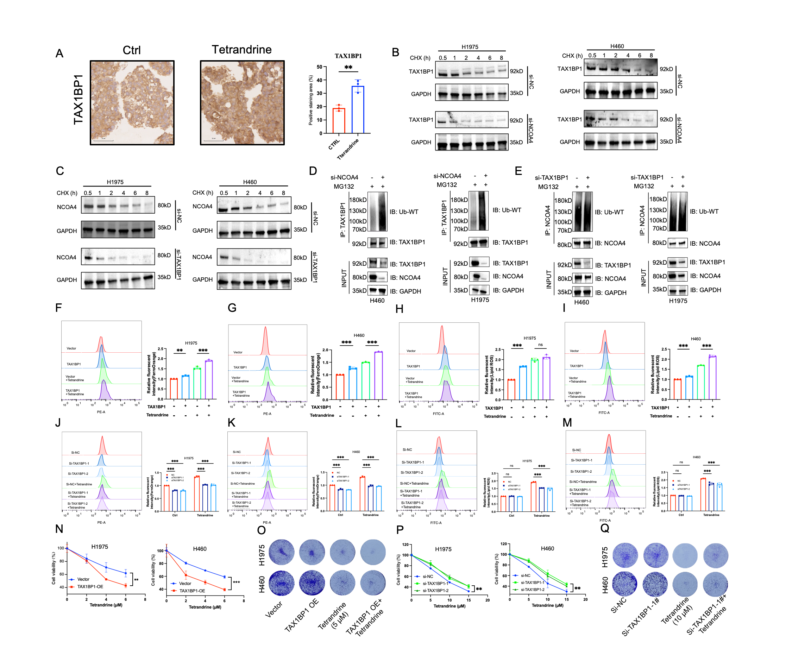
Supplementary Fig.6. NCOA4 and TAX1BP1 regulate each other’s protein stability, and TAX1BP1 modulates tetrandrine-induced ferroptosis (related to Fig. 5). A Representative TAX1BP1 immunohistochemical staining and quantification of positive staining area in NSCLC organoids treated with or without tetrandrine (10 μM) for 24 h. Scale bars, 50 μm. B–C Cycloheximide (CHX) chase assays of TAX1BP1 following NCOA4 knockdown (B) and NCOA4 following TAX1BP1 knockdown (C) in H1975 and H460 cells. Cells were treated with CHX (100 μg/mL) and collected at the indicated times. D–E Immunoprecipitation analysis of TAX1BP1 ubiquitination following NCOA4 knockdown (D) and NCOA4 ubiquitination following TAX1BP1 knockdown (E) in H460 and H1975 cells transfected with a wild-type ubiquitin plasmid and treated with MG132 (10 μM) for 6 h. F–I Flow cytometric analysis and quantification of intracellular Fe²⁺ levels (F–G) and lipid peroxidation (H–I) in control and TAX1BP1-overexpressing H1975 and H460 cells treated with or without tetrandrine (10 μM) for 48 h. J–M Flow cytometric analysis and quantification of intracellular Fe²⁺ levels (J–K) and lipid peroxidation (L–M) in H1975 and H460 cells transfected with control siRNA or two independent TAX1BP1-targeting siRNAs and treated with or without tetrandrine (10 μM) for 48 h. N–O CCK-8 cell viability assays at the indicated tetrandrine concentrations (N) and crystal violet staining following tetrandrine treatment in control and TAX1BP1-overexpressing H1975 and H460 cells. P–Q CCK-8 cell viability assays at the indicated tetrandrine concentrations (P) and crystal violet staining following tetrandrine treatment in control and TAX1BP1-knockdown H1975 and H460 cells. Cells in N–Q were treated for 48 h. Quantitative data are presented as mean ± SD from three independent experiments. Statistical significance was assessed using ANOVA with multiple comparisons. ns, not significant; **P < 0.01; ***P < 0.001.
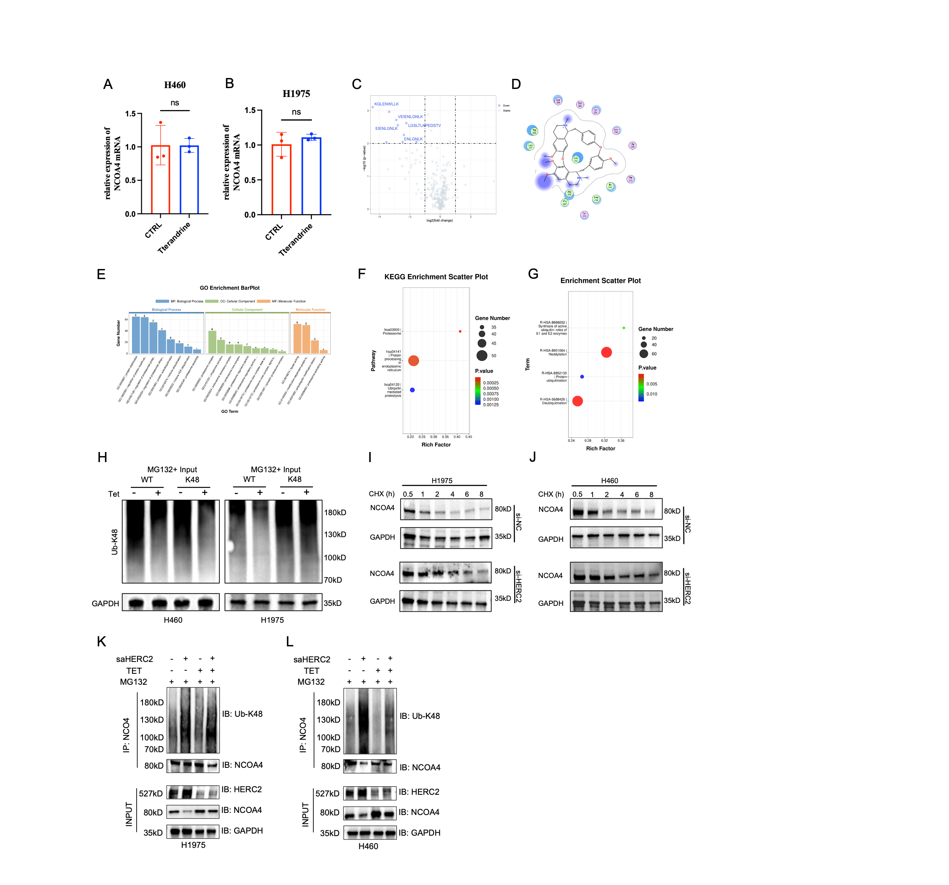
Supplementary Fig. 7. Tetrandrine binding and regulation of NCOA4 stability (related to Fig. 6). A–B qRT-PCR analysis of NCOA4 mRNA levels in H460 (A) and H1975 (B) cells treated with or without tetrandrine (10 μM) for 48 h. C Volcano plot of peptide abundance changes in the LiP–MS analysis following tetrandrine treatment, with differentially cleaved NCOA4 peptides highlighted. D Two-dimensional diagram of the predicted interactions between tetrandrine and NCOA4. E–G GO (E), KEGG (F), and Reactome (G) enrichment analyses of proteomic data from tetrandrine-treated NSCLC organoids, showing terms related to ubiquitination and protein degradation. H Immunoblot analysis of K48-linked ubiquitin chains in input lysates from H460 and H1975 cells transfected with wild-type or K48-only ubiquitin plasmids and treated with or without tetrandrine (10 μM) for 48 h. GAPDH served as the loading control. I–J CHX chase assays of NCOA4 in H1975 (I) and H460 (J) cells transfected with control or HERC2-targeting siRNA. Cells were treated with CHX (100 μg/mL) and collected at the indicated times. K–L Immunoprecipitation analysis of K48-linked NCOA4 ubiquitination in H1975 (K) and H460 (L) cells transfected with control or HERC2-targeting small activating RNA (saRNA) and treated with or without tetrandrine (10 μM) for 48 h. Cells in H, K, and L were treated with MG132 (10 μM) for 6 h before collection. Experiments were performed independently three times. Data in A–B are presented as mean ± SD and were analyzed using an unpaired two-tailed Student’s t test. ns, not significant.

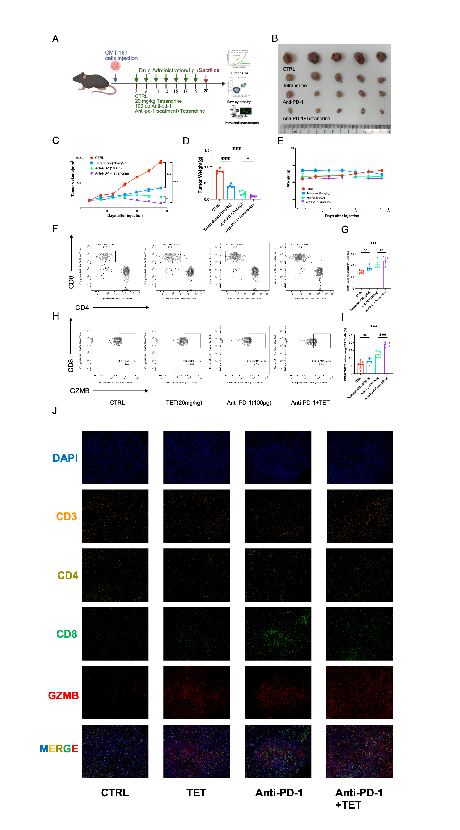
Supplementary Fig. 8. Tetrandrine enhances the antitumor effects of anti-PD-1 in CMT167 tumors (related to Fig. 8). A Experimental schedule for subcutaneous CMT167 syngeneic tumors in C57BL/6 mice. Mice received vehicle, tetrandrine (20 mg/kg), anti-PD-1 antibody (100 μg per mouse), or their combination by intraperitoneal injection on days 7, 9, 11, 13, 15, 17, and 19 after inoculation. Tumors were collected on day 20 (n = 5 mice per group). B–E Representative images of excised tumors (B), tumor growth curves (C), endpoint tumor weights (D), and mouse body weights (E). F–G Representative flow cytometry plots (F) and quantification (G) of CD8⁺ T cells in mouse peripheral blood. H–I Representative flow cytometry plots (H) and quantification (I) of CD8⁺GZMB⁺ T cells in mouse peripheral blood. Quantified populations in G and I are expressed as percentages of CD3⁺ T cells. J Representative multiplex immunofluorescence images of CD3 (orange), CD4 (yellow), CD8 (green), and granzyme B (GZMB, red) in tumor tissues. Nuclei were stained with DAPI (blue). Scale bars, 50 μm. Data are presented as mean ± SD. Statistical significance was assessed using ANOVA with multiple comparisons. ns, not significant; *P < 0.05; ***P < 0.001.

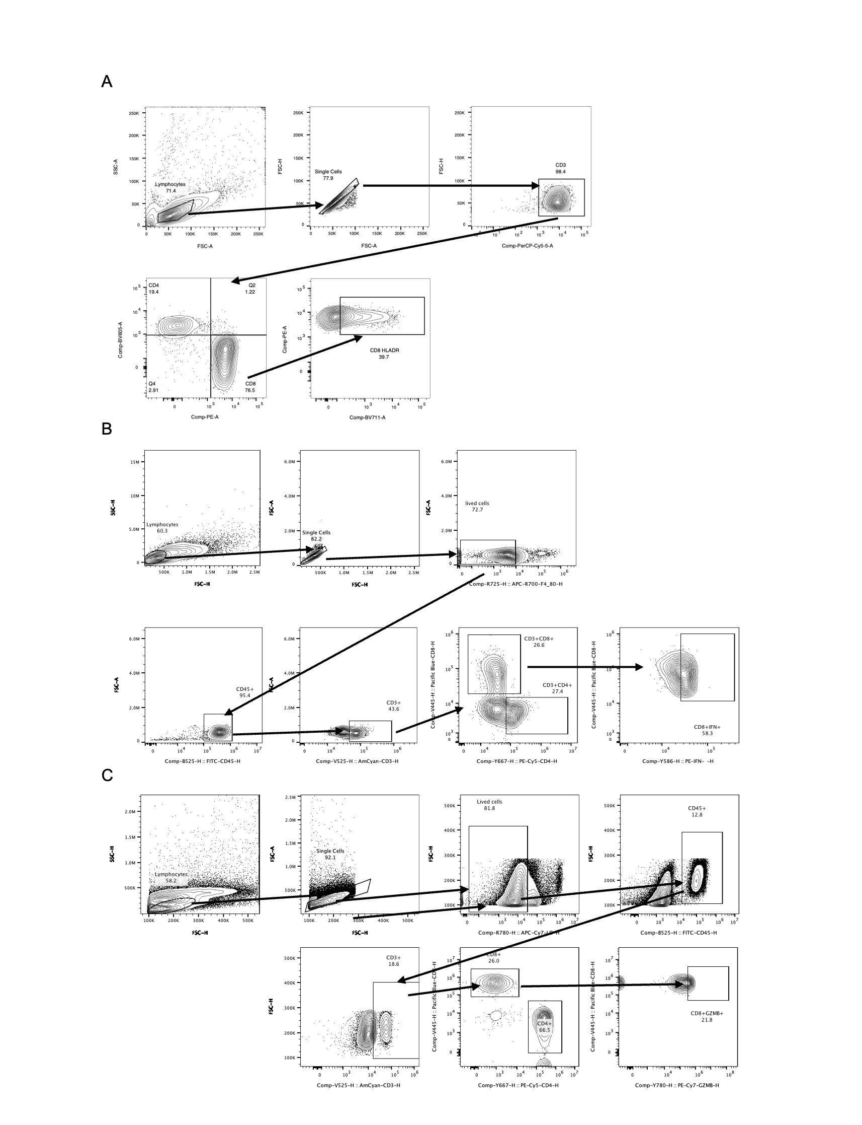
Supplementary Fig. 9. Flow cytometry gating strategies for T-cell analysis. A Gating strategy for H460–PBMC co-cultures. Lymphocytes were selected by forward and side scatter, followed by singlet selection and identification of CD3⁺ T cells. CD4⁺ and CD8⁺ subsets were then identified, and HLA-DR expression was assessed within CD8⁺ T cells. B Gating strategy for mouse tumor tissues. Following lymphocyte, singlet, and live-cell selection, CD45⁺ leukocytes and CD3⁺ T cells were identified. CD4⁺ and CD8⁺ subsets were subsequently gated, followed by analysis of IFN-γ expression within CD8⁺ T cells. C Gating strategy for mouse peripheral blood. Following lymphocyte, singlet, and live-cell selection, CD45⁺ leukocytes and CD3⁺ T cells were identified. CD4⁺ and CD8⁺ subsets were subsequently gated, followed by analysis of GZMB expression within CD8⁺ T cells. Arrows indicate the sequence of gating.
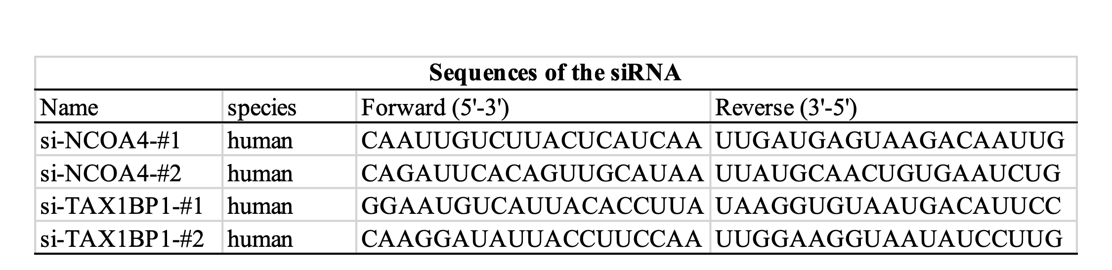
Supplementary Table 1 The sequences of the relevant siRNAs used in this study

