Additional file 2. Framework for diagnosis with an overview of the role of the involved healthcare professions in the Netherlands.
part 1

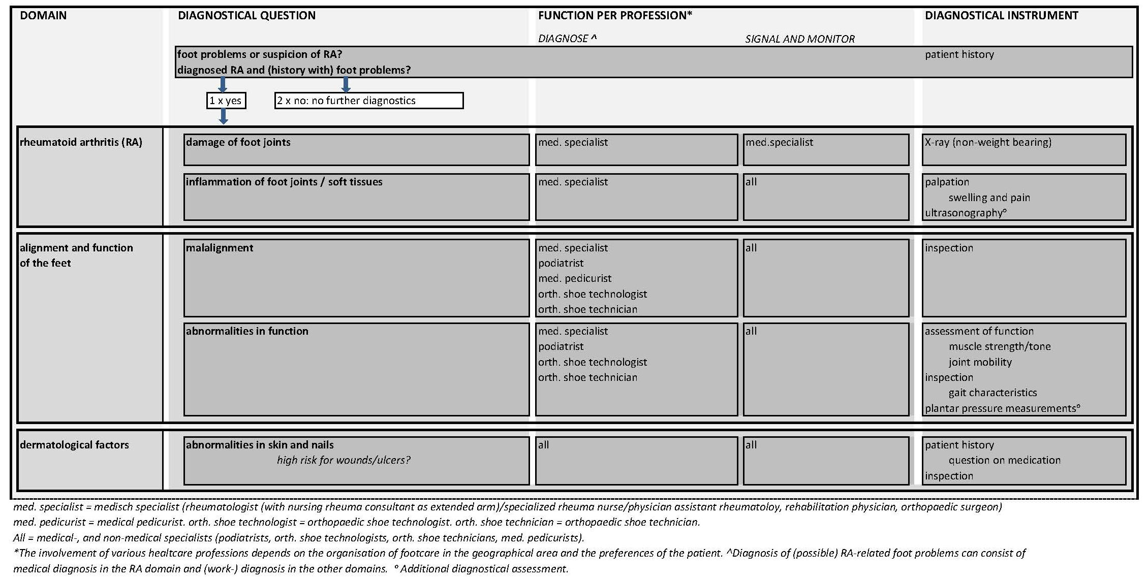

part 2
