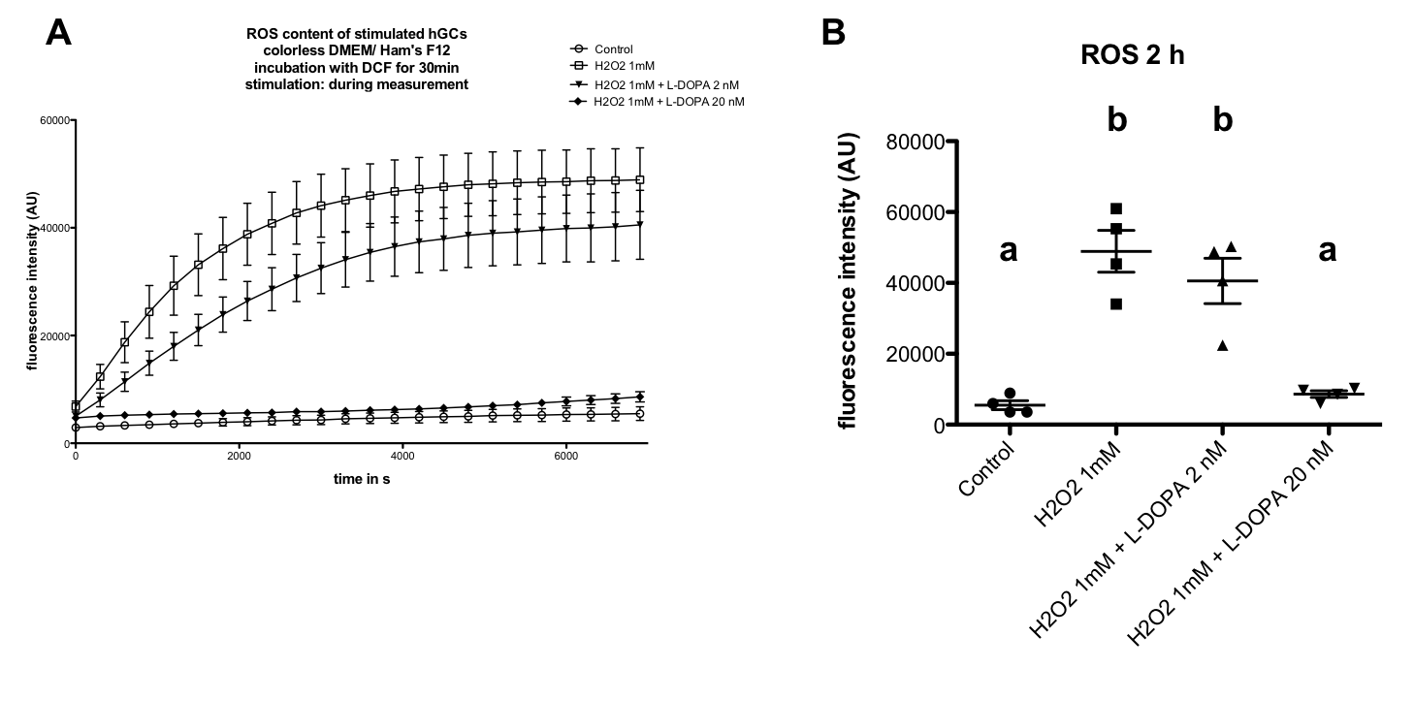

Additional file 1. ROS generation in cultured human GCs. A L-DOPA (2 nM, 20 nM) reduces H₂O₂-dependent (1mM) ROS production during 2 h of stimulation shown by DCF fluorescence intensity. B Endpoint measurements of cells treated witch L-DOPA (2 nM) after 2 h show a slightly reduced H₂O₂-dependent ROS signal. A L-DOPA concentration of 20 nM leads to a significantly decreased ROS generation (P < 0.05, ANOVA, Newman-Keuls). All values are shown as mean ± S.E.M. of n = 4 independent preparations of cells from two to five patients each. Different letters indicate statistically significant differences between the treatment groups.

