Table 1S. Association between MMPs proteins expression and steroid hormone receptors in stromaof the tumors
by histological subtype.
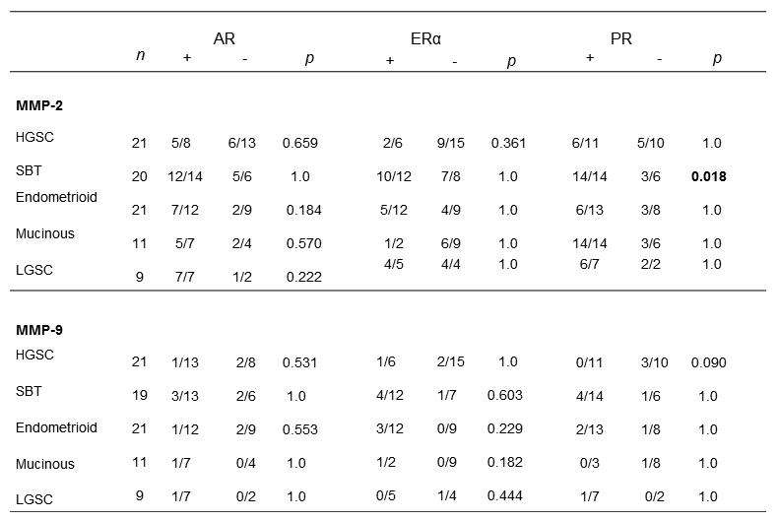
SBT: serous borderline tumor, HGSC: high grade serous carcinoma , LGSC: low grade serous carcinoma
P values obtained by Fisher’s exact test

