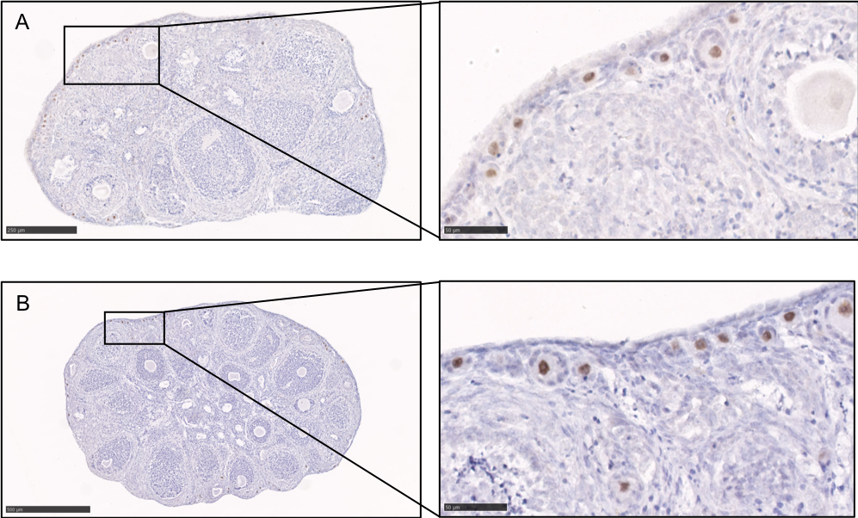

Additional file 1: Representative images of LIM-homeobox protein 8 (Lhx8) immunostaining. Ovaries from Nu/Nu mice, 4 weeks old, (A) cultured for 24 h in control medium or (B) cultured for 24h in the presence of rapamycin.

