Figure S1 Distribution of bacterial taxa at the phylum level (a) and genus level (b). The 20 genera of top relative abundance were chose.

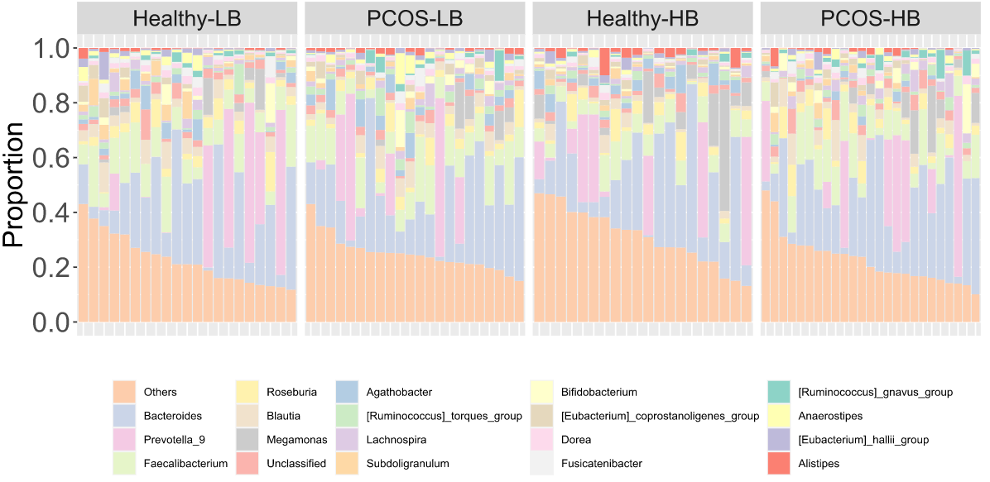
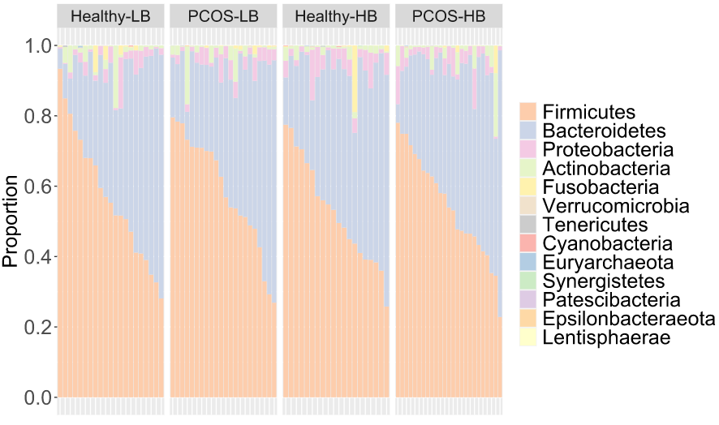
a
b

Figure S2 Reveal of characteristic bacterial taxa based on LDA Effect Size (LEfSe) analysis.(a) Comparison between Healthy-LB and PCOS-LB. (b) Comparison between Healthy-HB and PCOS-HB.
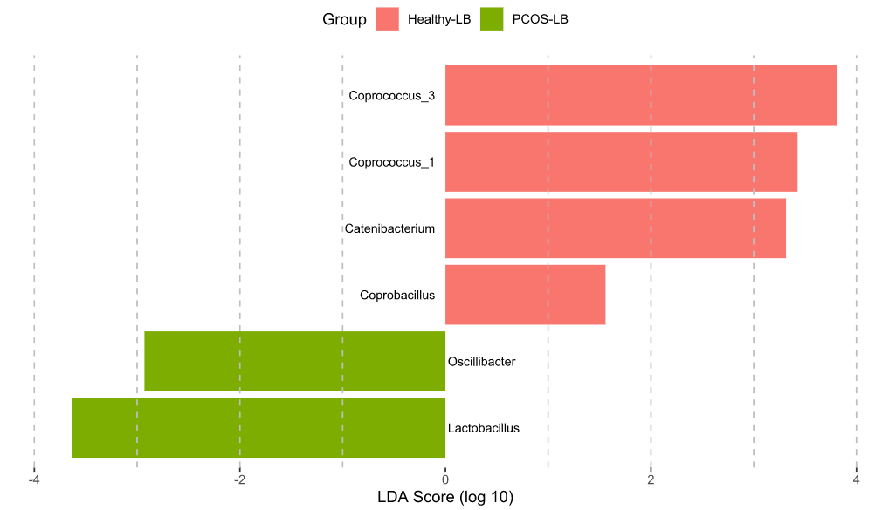
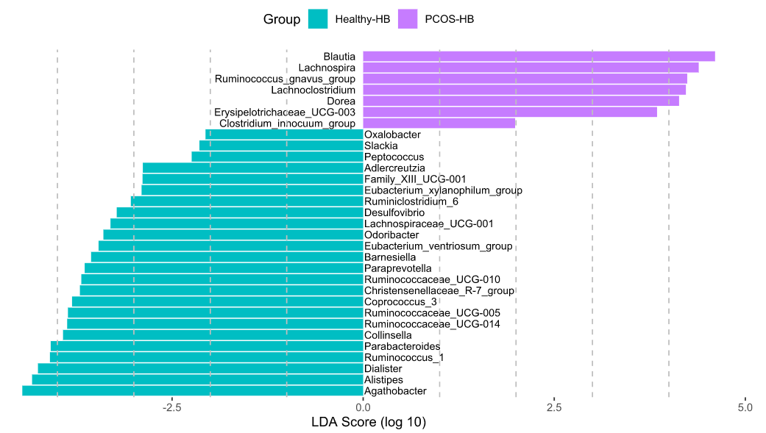
a
b

Figure S3 Distribution of fungal taxa at the phylum level (a) and genus level (b). The 20 genera of top relative abundance were chose.
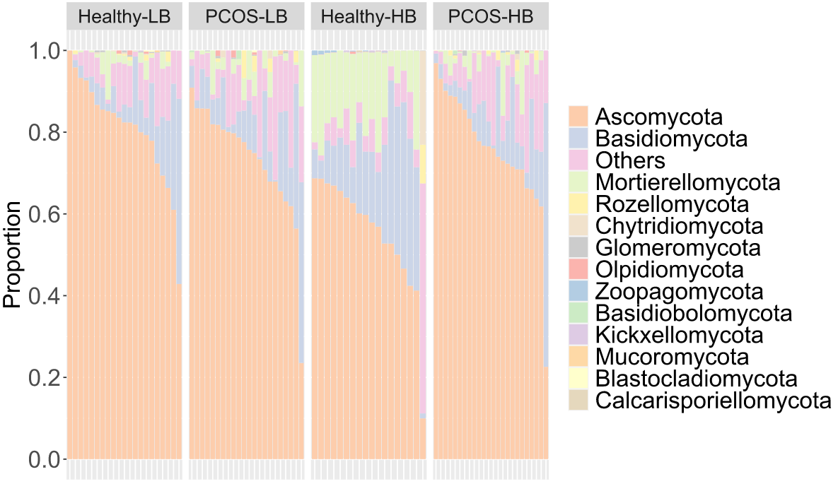
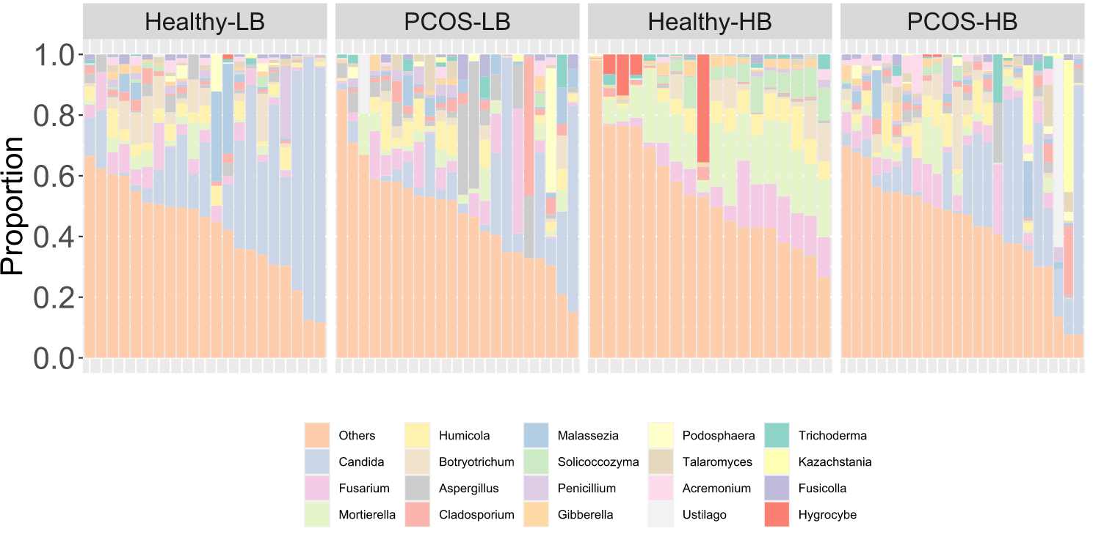
a
b

Figure S4 Reveal of characteristic fungal taxa based on LDA Effect Size (LEfSe) analysis. Comparison between Healthy-LB and PCOS-LB.

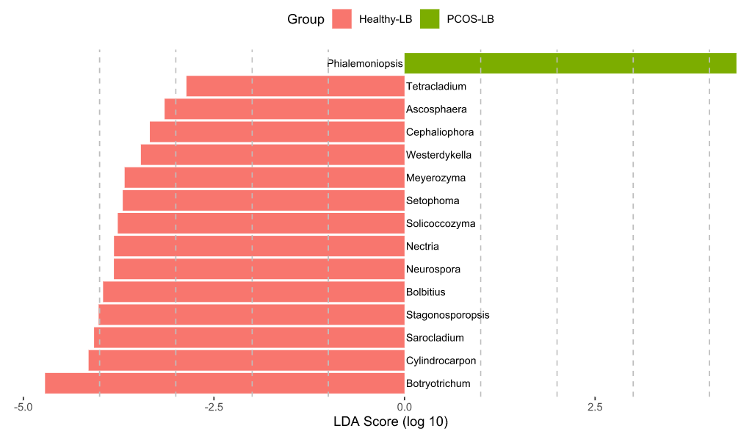

Figure S5 Reveal of characteristic fungal taxa based on LDA Effect Size (LEfSe) analysis. Comparison between Healthy-HB and PCOS-HB.

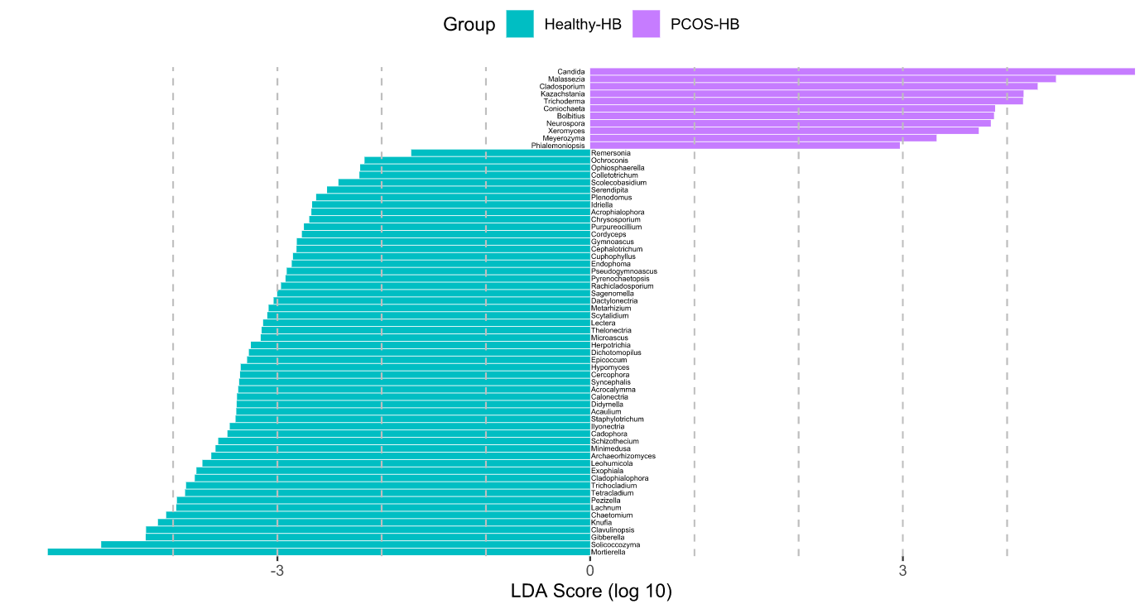
Figure S6 Serum metabolome changes in disease and healthy subjects. (a) RDA analyses reflecting differences in gut metabolites structures fitted with significantly correlated clinical properties. (b) Volcano plot demonstrated metabolites change in PCOS-LB, compared with Healthy-LB. (c) Volcano plot demonstrated metabolites change in PCOS-HB, compared with Healthy-HB. The X axis indicates log2-transformed FC of serum metabolites abundance and Y axis denotes FDR adjusted p value analysed using Wilcox test. (d) The correlation heatmap showing the interaction between key clinical parameters and characterized top 40 metabolites.

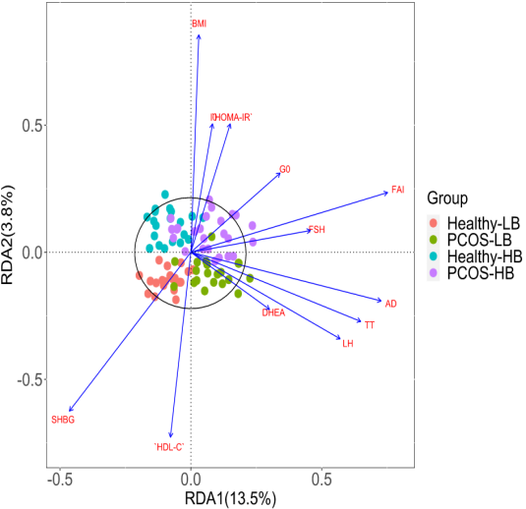
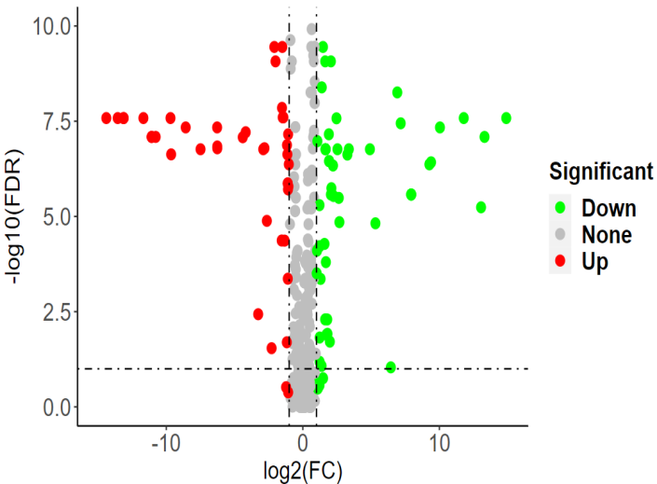
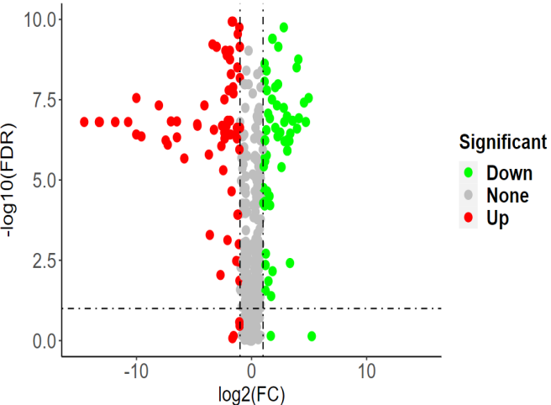
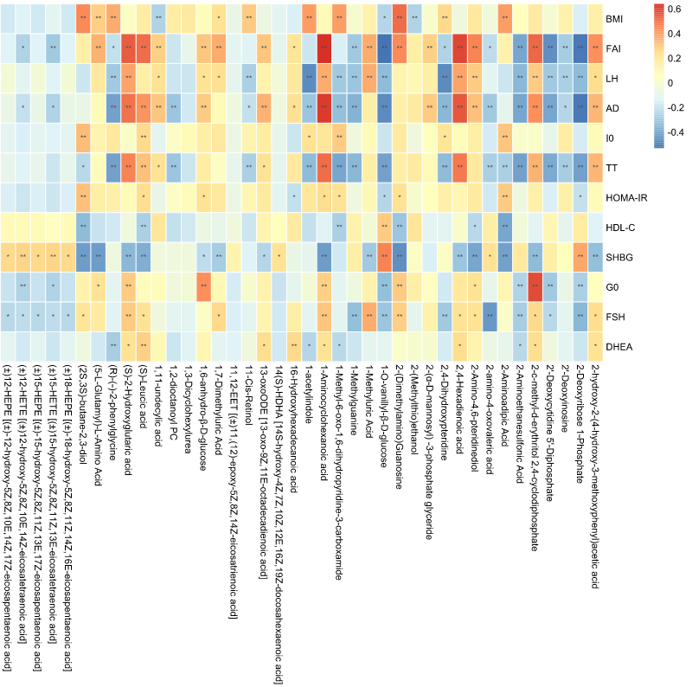
a
b
c
d

Figure S7 Reveal of characteristic metabolites based on LDA Effect Size (LEfSe) analysis. Comparison between Healthy-LB and PCOS-LB.

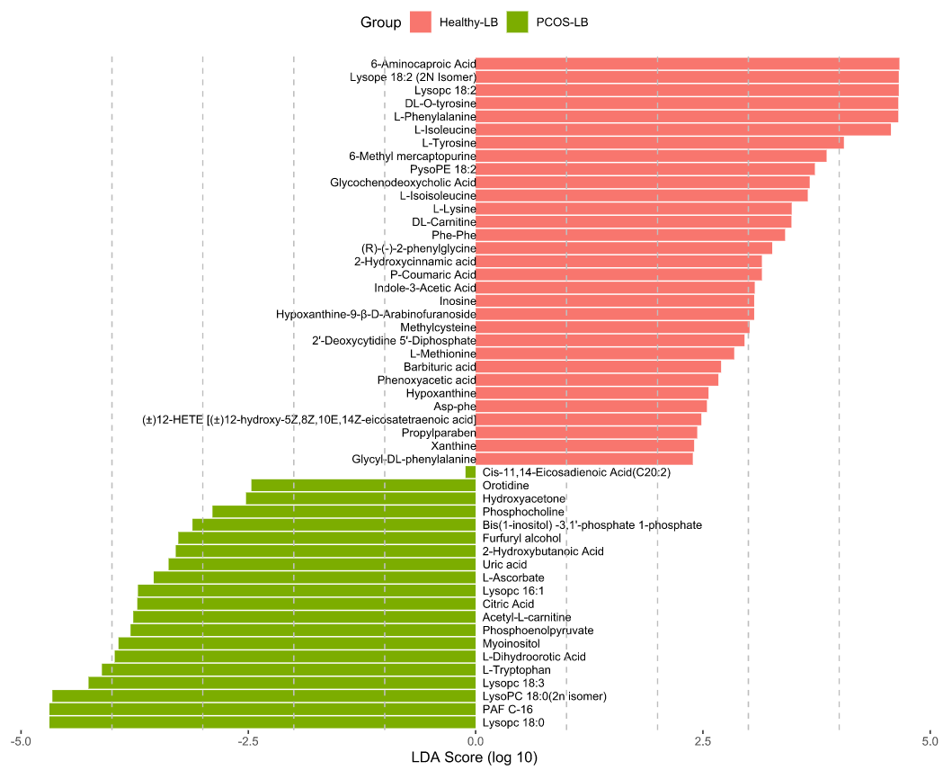

Figure S8 Reveal of characteristic metabolites based on LDA Effect Size (LEfSe) analysis. Comparison between Healthy-HB and PCOS-HB.

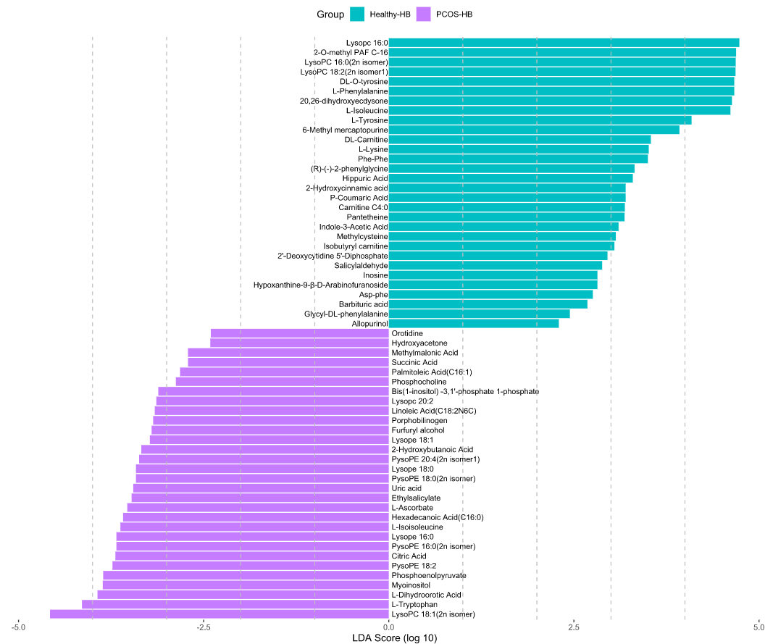

Figure S9 The bacterial genera and predicted pathway features were excavated on the base of Wilcox test comparison and Mean Decrease Gini by random forest importance parameter. (a,b,c) Bacterial genera used for disease diagnose with comparison between the pairs of PCOS vs Healthy, PCOS-LB vs Healthy-LB, PCOS-HB vs Healthy-HB. (d,e,f) Pathway used for disease diagnose with comparison between the pairs of PCOS vs Healthy, PCOS-LB vs Healthy-LB, PCOS-HB vs Healthy-HB.

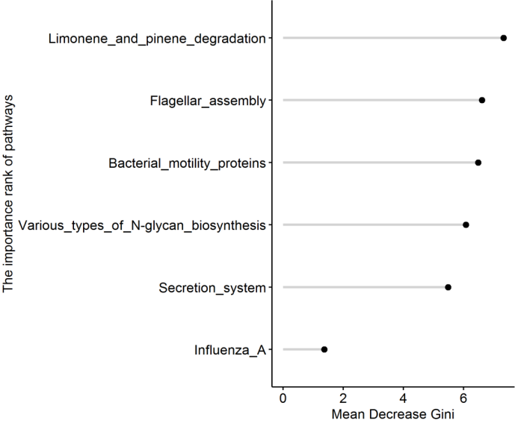
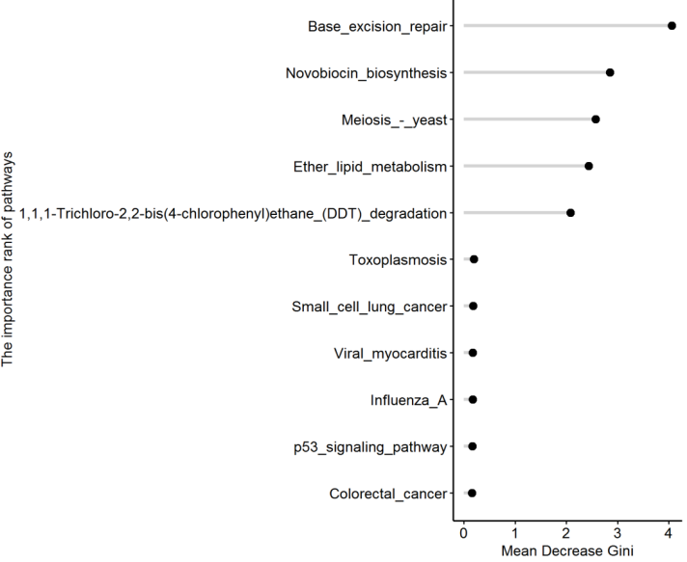
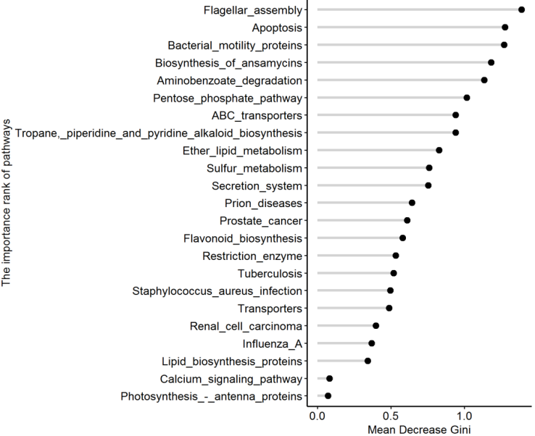
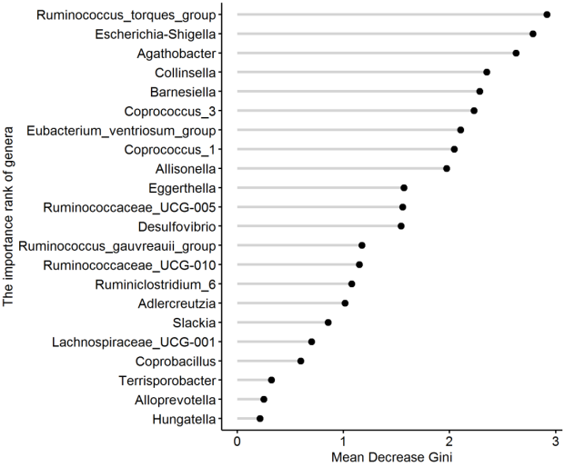
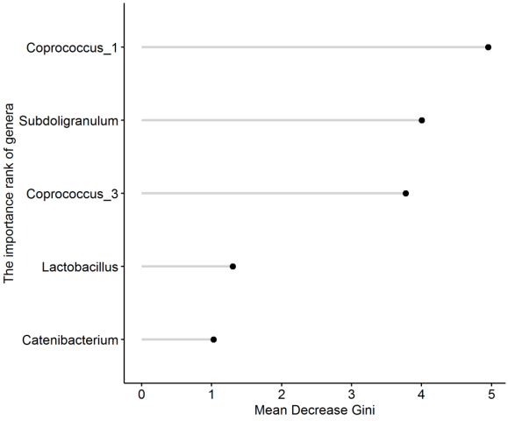
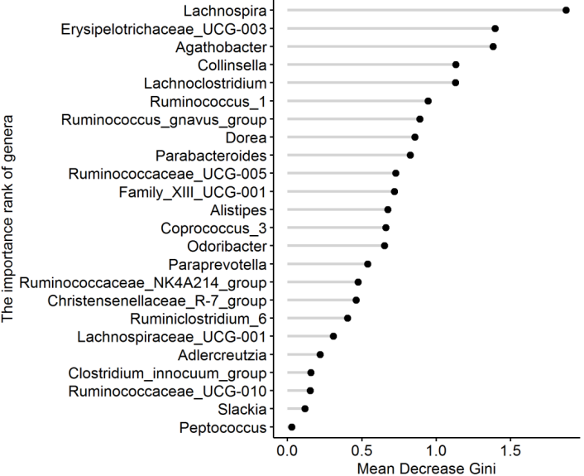
d
e
f
a
b
c

Figure S10 The fungal genera and metabolites were excavated on the base of Wilcox test comparison and Mean Decrease Gini by random forest importance parameter. (a,b,c) Fungal genera used for disease diagnose with comparison between the pairs of PCOS vs Healthy, PCOS-LB vs Healthy-LB, PCOS-HB vs Healthy-HB. (d,e,f) Metabolites used for disease diagnose with comparison between the pairs of PCOS vs Healthy, PCOS-LB vs Healthy-LB, PCOS-HB vs Healthy-HB.

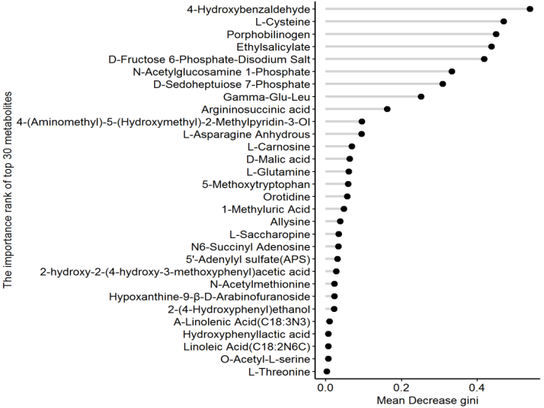
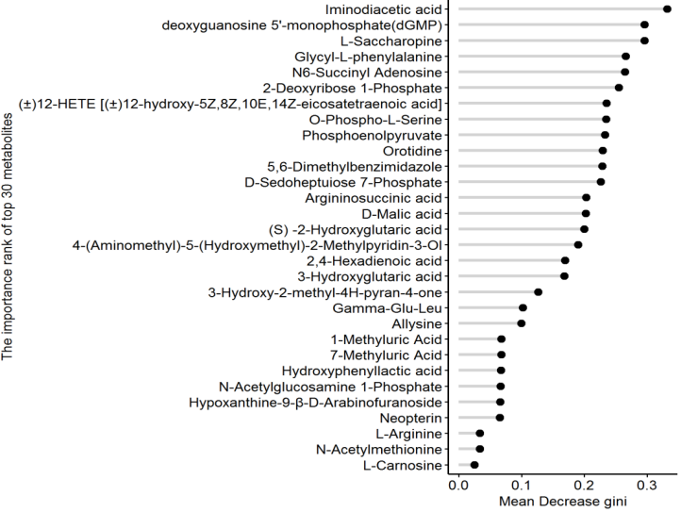
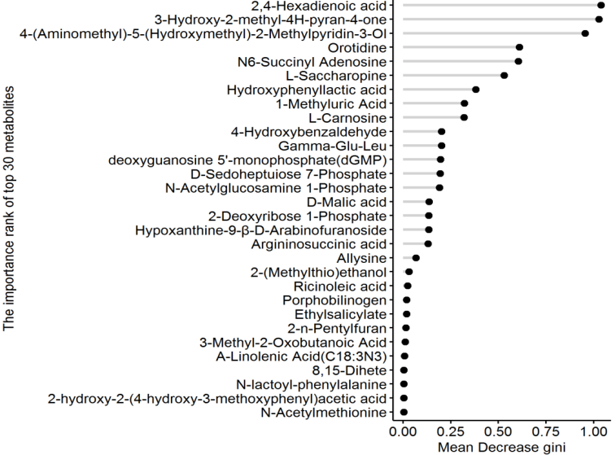
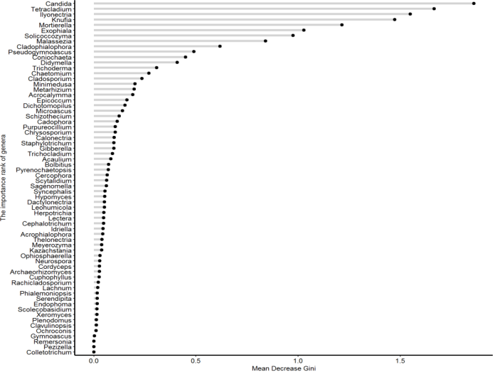
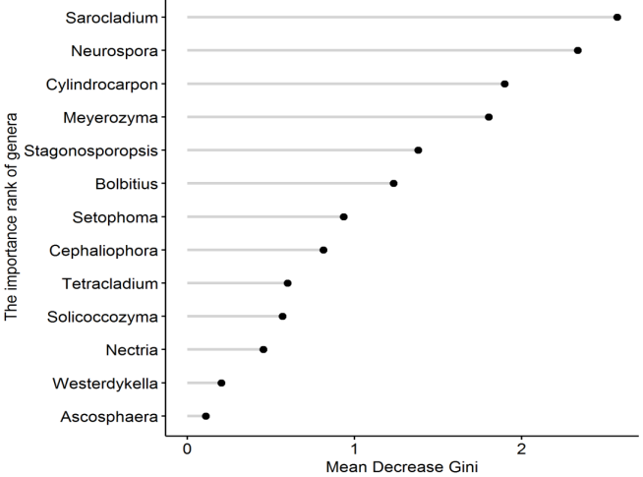
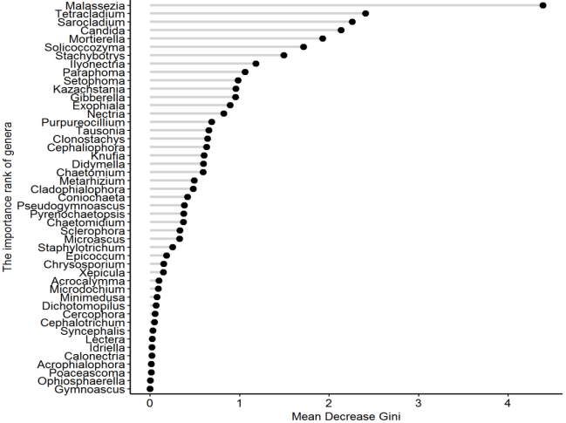
a
b
c
d
e
f

Figure S11 Correlation between bacterial diversity and fungal diversity. (a) The linear relationship between bacterial Chao1 and fungal Chao1 index. (b) The linear relationship between bacterial Shannon and fungal Shannon index.

