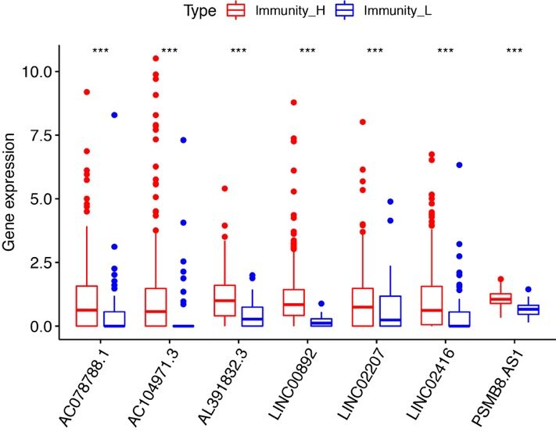
Fig. S1: Expression levels of 7 selected lncRNAs in different immunity clusters.

