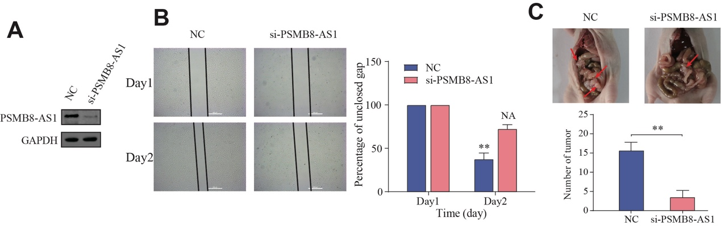
Fig. S2: Functional analysis of PSMB8-AS1 in SKOV3 cell line in vitro and in vivo. A Knockdown efficiency of PSMB8-AS1 in SKOV3 cells in protein level. B Gap closure for PSMB8-AS1 in SKOV3 cell line. C In vivo experiments used to verify the function of PSMB8-AS1. NC, Negative Control.

