a.
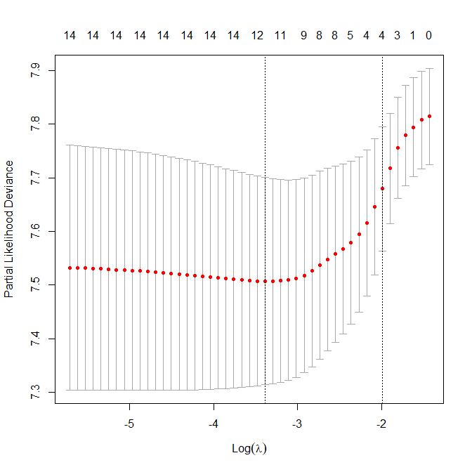
b
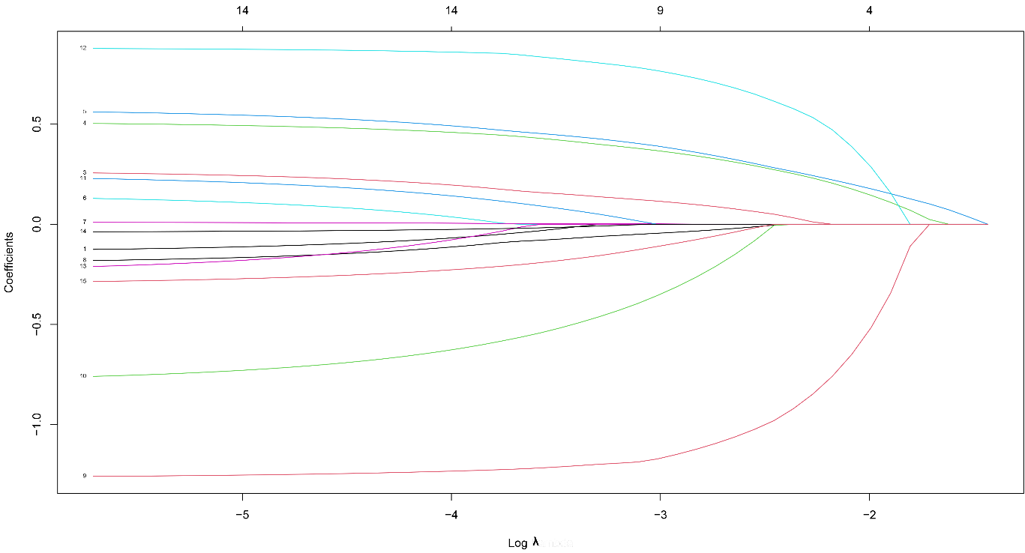
Figure legends
a. Selection of largest λ with an average error within one standard deviation. The partial likelihood binomial deviance is plotted vs log (λ). b. LASSO coefficient profiles for clinical features, each coefficient profile plot is produced vs log (λ) sequence.

