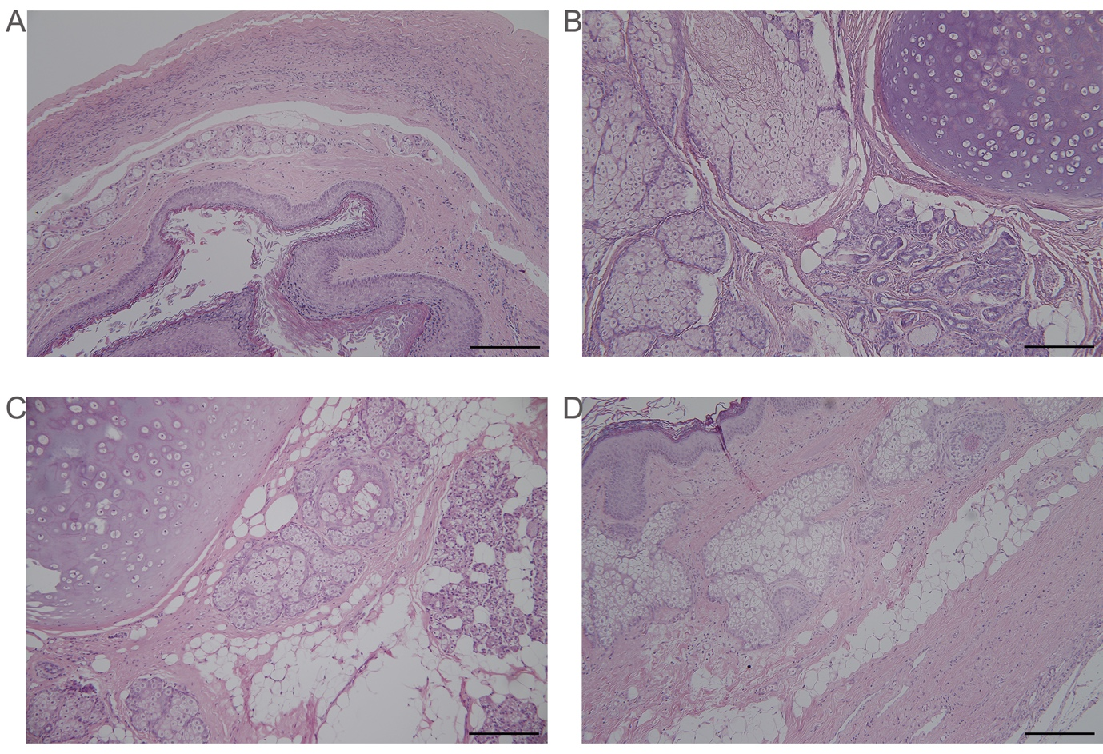

Additional file 1. Histological characteristics of mature cystic teratomas of the ovary (hematoxylin and eosin, H&E) with a ruler. Tera-6 (A), Tera-7 (B), Tera-8 (C), and Right Tera-9 (D) are present in 100X. Scale bar: 200 μm.

