supplementary materials

Supplementary Table 1. Primers for hmgb1, fgf2 and gapdh
Gene | Forward sequence (5'-3') | Reverse sequence (5'-3')
gapdh | AAGAAGGTGGTGAAGCAGG | GAAGGTGGAAGAGTGGGAGT
hmgb1 | CCCAGCGAAGGCTATCACA | TTCATAAAGGGACAAACCACAG
fgf2 | TTGCTATGAAGGAAGATGGACG | CCCAGTTCGTTTCAGTGCC
pcdhb21 | GCTAGTCAAGGACAATGGCG | ACAGACAAGAGGAAGAGCGAAG

Supplementary Table 2. hmgb1, pcdhb21 and fgf2 expression

Gene ID | gene_name | Description | FC
 |  |  | RNAseq | realtime
ENSMUSG00000066551 | hmgb1 | high mobility group box 1 | 2.5 | 2.02
ENSMUSG00000037225 | fgf2* | fibroblast growth factor 2 | -4.47 | -9.29
ENSMUSG00000044022 | pcdhb21* | protocadherin beta 21 | 12.18 | 2.05

Supplementary Table 3. List of top 10 differentially expressed genes between control and cKO(HE) mice, ranked according to p-values

Gene Name | Annotation | Fold Change (cKO/Control) | P value
rpl37rt | ribosomal protein L37, retrotransposed | 203.04 | 3.67454E-37
gm4350 | predicted gene 4350 | 13.28 | 7.38054E-14
pcna-ps2 | proliferating cell nuclear antigen pseudogene 2 | 19.62 | 6.44209E-12
pakap | paralemmin A kinase anchor protein | 100.25 | 1.05204E-08
gm17535 | predicted gene, 17535 | 7278.59 | 4.86076E-07
pla2g4e | phospholipase A2, group IVE | 9.50 | 1.47861E-06
gm10800 | predicted gene 10800 | 516.01 | 9.32042E-06
duox2 | dual oxidase 2 | 46.78 | 1.19778E-05
gm10722 | predicted gene 10722 | 302.84 | 1.18436E-05
lrrc14 | leucine rich repeat containing 14 | 5.538 | 2.11363E-05
ugcg | UDP-glucose ceramide glucosyltransferase | -8.73 | 1.23E-21
gm37915 | predicted gene, 37915 | -154.89 | 2.48E-17
uqcr11 | ubiquinol-cytochrome c reductase, complex III subunit XI | -12.43 | 6.32E-17
uba52 | ubiquitin A-52 residue ribosomal protein fusion product 1 | -13.16 | 2.02E-15
rpl41 | ribosomal protein L41 | -9.30 | 1.64E-10
ndufa11 | NADH:ubiquinone oxidoreductase subunit A11 | -5.42 | 4.36E-08
gm1673 | predicted gene 1673 | -4.81 | 5.98E-08
gm10076 | predicted gene 10076 | -12.34 | 9.64E-08
samhd1 | SAM domain and HD domain, 1 | -3.80 | 1.06E-07
gm6166 | predicted gene 6166 | -53.57 | 7.84E-06

Supplementary Table 4. List of top 5 genes of arginine and proline metabolism and top 5 genes of oxidative phosphorylation

Top 5 genes of arginine and proline metabolism
Gene Name | Annotation | Fold Change (cKO/Control) | P value
azin2 | antizyme inhibitor 2 | 30.94983 | 0.011739
arg1 | arginase, liver | 24.98003 | 0.029765
aoc1 | amine oxidase, copper-containing 1 | 17.32677 | 0.017056
prodh | proline dehydrogenase | 5.370391 | 0.0309
smox | spermine oxidase | 2.340781 | 0.023342
List of top 5 genes of oxidative phosphorylation
uqcr11 | ubiquinol-cytochrome c reductase, complex III subunit XI | -12.43042 | 6.32E-17
ndufs8 | NADH:ubiquinone oxidoreductase core subunit S8 | -10.01772 | 0.044662
cox11 | cytochrome c oxidase assembly protein 11, copper chaperone | -8.014056 | 0.045314
ndufa7 | NADH:ubiquinone oxidoreductase subunit A7 | -5.472158 | 0.04254
ndufa11 | NADH:ubiquinone oxidoreductase subunit A11 | -5.423126 | 4.36E-08

Supplementary Figure 1. The breeding strategy to generate placenta BDNF knockout mice (A) and genotyping (B).
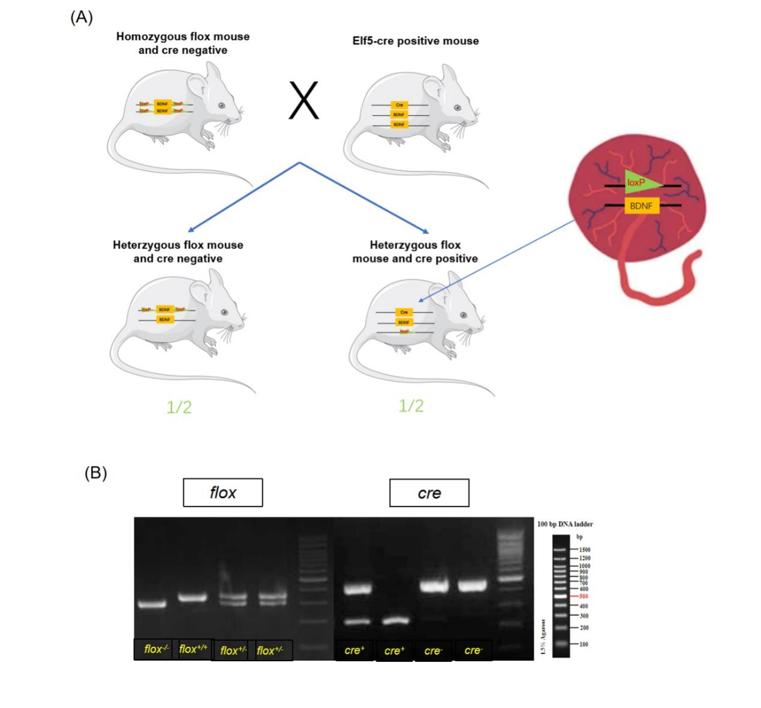
Supplementary Figure 2. Full Western blots of BDNF.
