Figure S1 The study flowchart.
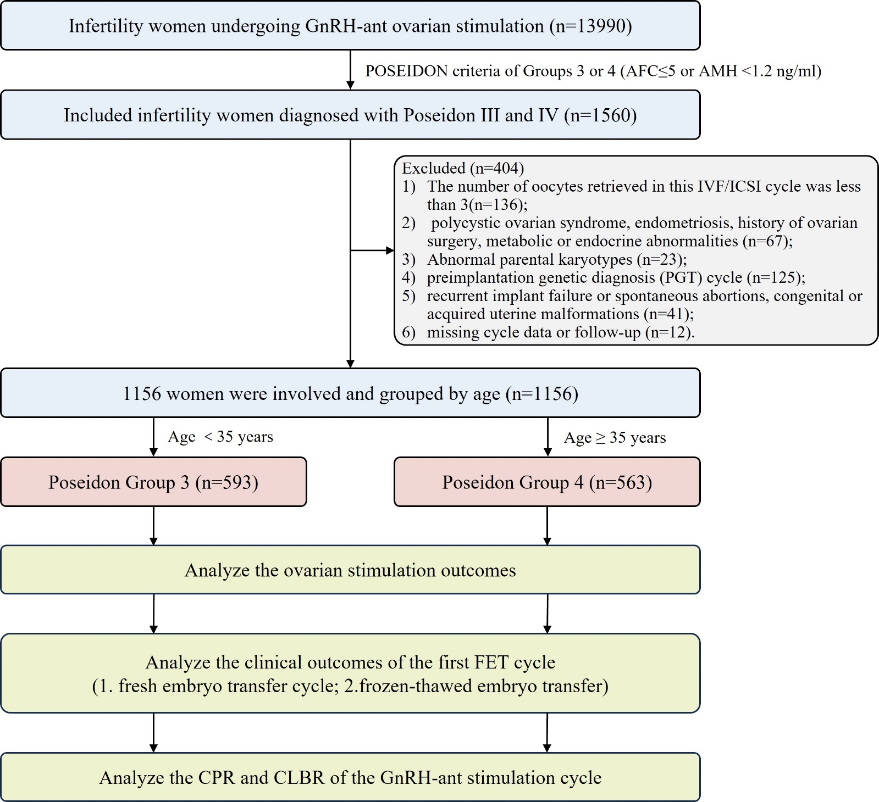
Figure S2 Association between the DFP on trigger day and laboratory outcomes among POSEIDON Group 3 and 4 population. Relationship with the ratio of available embryos (A) number (No.) of blastocysts (A), and ratio of blastocysts (C) among POSEIDON Group 3 population. Relationship with the ratio of available embryos (D) number (No.) of blastocysts (E), and ratio of blastocysts (F) among POSEIDON Group 4 population. β value are indicated by solid lines and 95% confidence intervals (CIs) are indicated by shaded areas.

Table S1 Outcomes of first frozen-thawed embryo transfer cycle among Poseidon Group 3 and Group 4 patients grouped by DFP.
First FET cycle | POSEIDON Group 3 |  |  | POSEIDON Group 4
 | DFP≤40 | DFP＞40 | P | DFP≤40 | DFP＞40 | P
N | 226 | 129 |  | 202 | 97
Female age (years) | 30.33±2.82 | 29.53±3.04 | 0.013 | 38.98±3.16 | 38.75±3.44 | 0.580
BMI (kg/m²) | 22.74±3.44 | 22.44±3.43 | 0.423 | 23.06±2.77 | 22.96±3.39 | 0.767
Basal FSH (IU/L) | 9.15±2.92 | 8.97±2.36 | 0.549 | 9.45±2.58 | 9.38±2.56 | 0.835
AMH (ng/mL) | 1.01±0.94 | 1.16±1.37 | 0.226 | 1.00±0.85 | 0.94±0.85 | 0.542
Endometrial preparation protocols (%) |  |  | 0.996 |  |  | 0.706
Natural cycle | 49/226 (21.7) | 28/129 (21.7) |  | 46/202 (22.8) | 24/97 (24.7)
Artificial cycle | 177/266 (78.3) | 101/129 (78.3) |  | 156/202 (77.2) | 73/97 (75.3）
Embryos transferred type (%) |  |  | 0.316 |  |  | 0.139
Cleavage stage | 135/226 (59.7) | 84/129 (65.1) |  | 148/202 (73.3) | 63/97 (64.9)
Blastocyst | 91/226 (40.3) | 45/129 (34.9) |  | 54/202 (26.7) | 34/97 (35.1)
No. embryos transferred | 1.77±0.45 | 1.75±0.49 | 0.661 | 1.95±0.52 | 1.87±0.55 | 0.196
No. of good-quality embryos | 1.19±0.76 | 1.29±0.74 | 0.230 | 1.39±0.78 | 1.27±0.78 | 0.222
Endometrium thickness (mm) | 9.62±1.93 | 9.55±1.95 | 0.727 | 9.26±2.00 | 9.19±1.81 | 0.756
Implantation rate (%) | 147/401 (36.7) | 76/226 (33.6) | 0.447 | 110/202 (54.5) | 59/97 (60.8) | 0.298
Chemical pregnancy rate (%) | 166/226 (73.5) | 89/129 (69.0) | 0.369 | 83/394 (21.1) | 38/181 (21.0) | 0.984
Clinical pregnancy rate (%) | 123/226 (54.4) | 61/129 (47.3) | 0.195 | 71/202 (35.1) | 34/97 (35.1) | 0.987
Miscarriage rate (%) | 20/123 (16.3) | 11/61 (18.0) | 0.762 | 16/71 (22.5) | 11/34 (32.4) | 0.281
Early miscarriage rate (%) | 17/123 (13.8) | 9/61 (14.8) | 0.864 | 14/71 (19.7) | 10/34 (29.4) | 0.268
Late miscarriage rate (%) | 3/123 (2.4) | 2/61 (3.3) | 1.000 | 2/71 (2.8) | 1/34 (2.9) | 1.000
Live birth rate (%) | 100/226 (44.2) | 50/129 (38.8) | 0.314 | 54/202 (26.7) | 23/97 (23.7) | 0.576
Continuous variables presented as mean±SD. Categorical variables presented as n/N (%).
Abbreviations: DFP, dominant follicular percentage; BMI, body mass index; FSH, follicle-stimulating hormone; AMH, anti-Mullerian hormone; No., number.

