Supplementary Figures

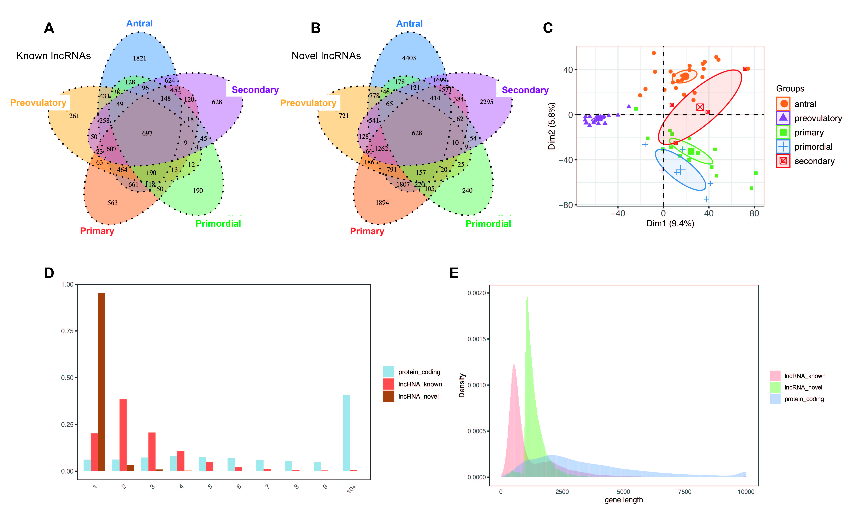
Fig. S1. Characteristics of lncRNAs detected in human granulosa cells.
A-B. Venn diagram of detected known lncRNA (A) and novel lncRNA (B) in human granulosa cells. At least two samples with RPKM ≥ 0.5 was is considered to be detected in the group.
C. Principal component analysis (PCA) of 67 samples of human granulosa cells based on mRNAs. The samples were grouped by stages and the ellipse for each group by the confidence ellipse.
D. Distribution of exon count of known lncRNA, novel lncRNA, and protein-coding RNA.
E. Density of the length distribution of known lncRNA, novel lncRNA, and protein-coding RNA.

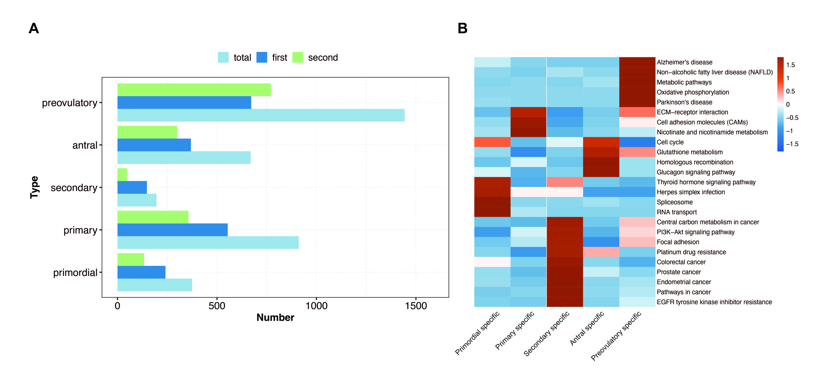
Fig. S2. Co-expression analysis of stage-specific lncRNAs and mRNAs.
A. Bar plot shows the number of co-expressed DE mRNAs of stage-specific lncRNAs. “first” denote directly correlated mRNAs with lncRNAs and “second” denote mRNAs correlated with “first” mRNAs. Cutoffs of P-value ≤ 0.01 and Pearson coefficient ≥ 0.9 were applied to identify the co-expression pairs.
B. The top 5 enriched KEGG pathways were illustrated for the mRNAs co-expressed with stage-specific lncRNAs among different stages. The color scale shows the row-scaled significance (-log 10 corrected P-value) of the terms.

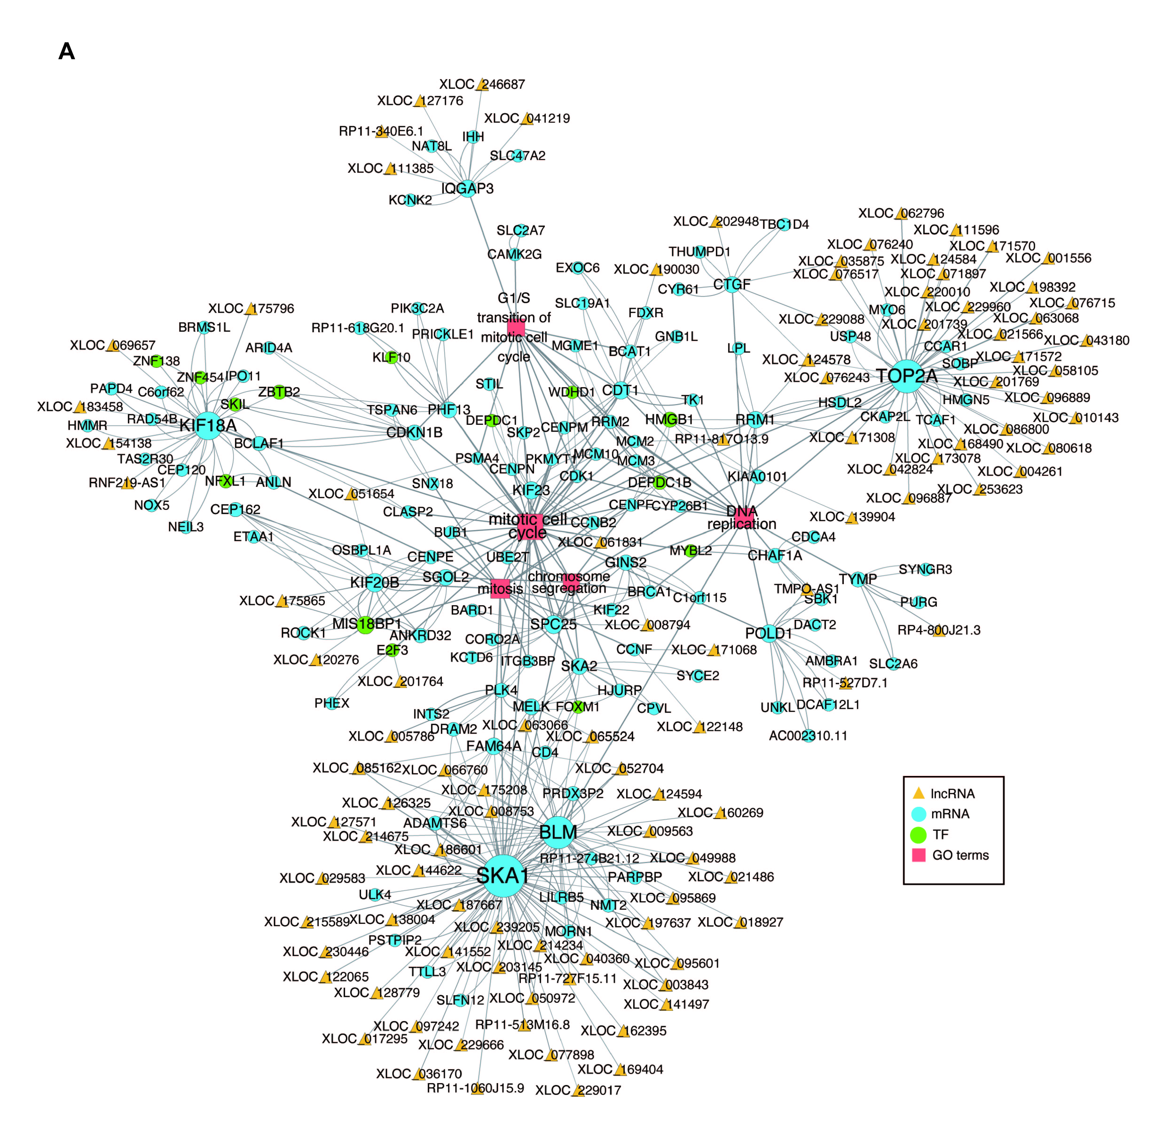
Fig. S3 Co-expression network plots of lncRNAs, mRNAs, TFs, and cell cycle-related terms in antral follicle stage.
The co-expression network of lncRNAs, co-expressed mRNAs and transcription factors (TFs), which are specifically involved in four cell cycle-related terms of the antral follicle stage. LncRNAs are plotted with the yellow triangle, co-expressed mRNAs are plotted with the blue circle, TFs are plotted with the green circle and the mRNA-enriched GO terms are plotted with the red box.

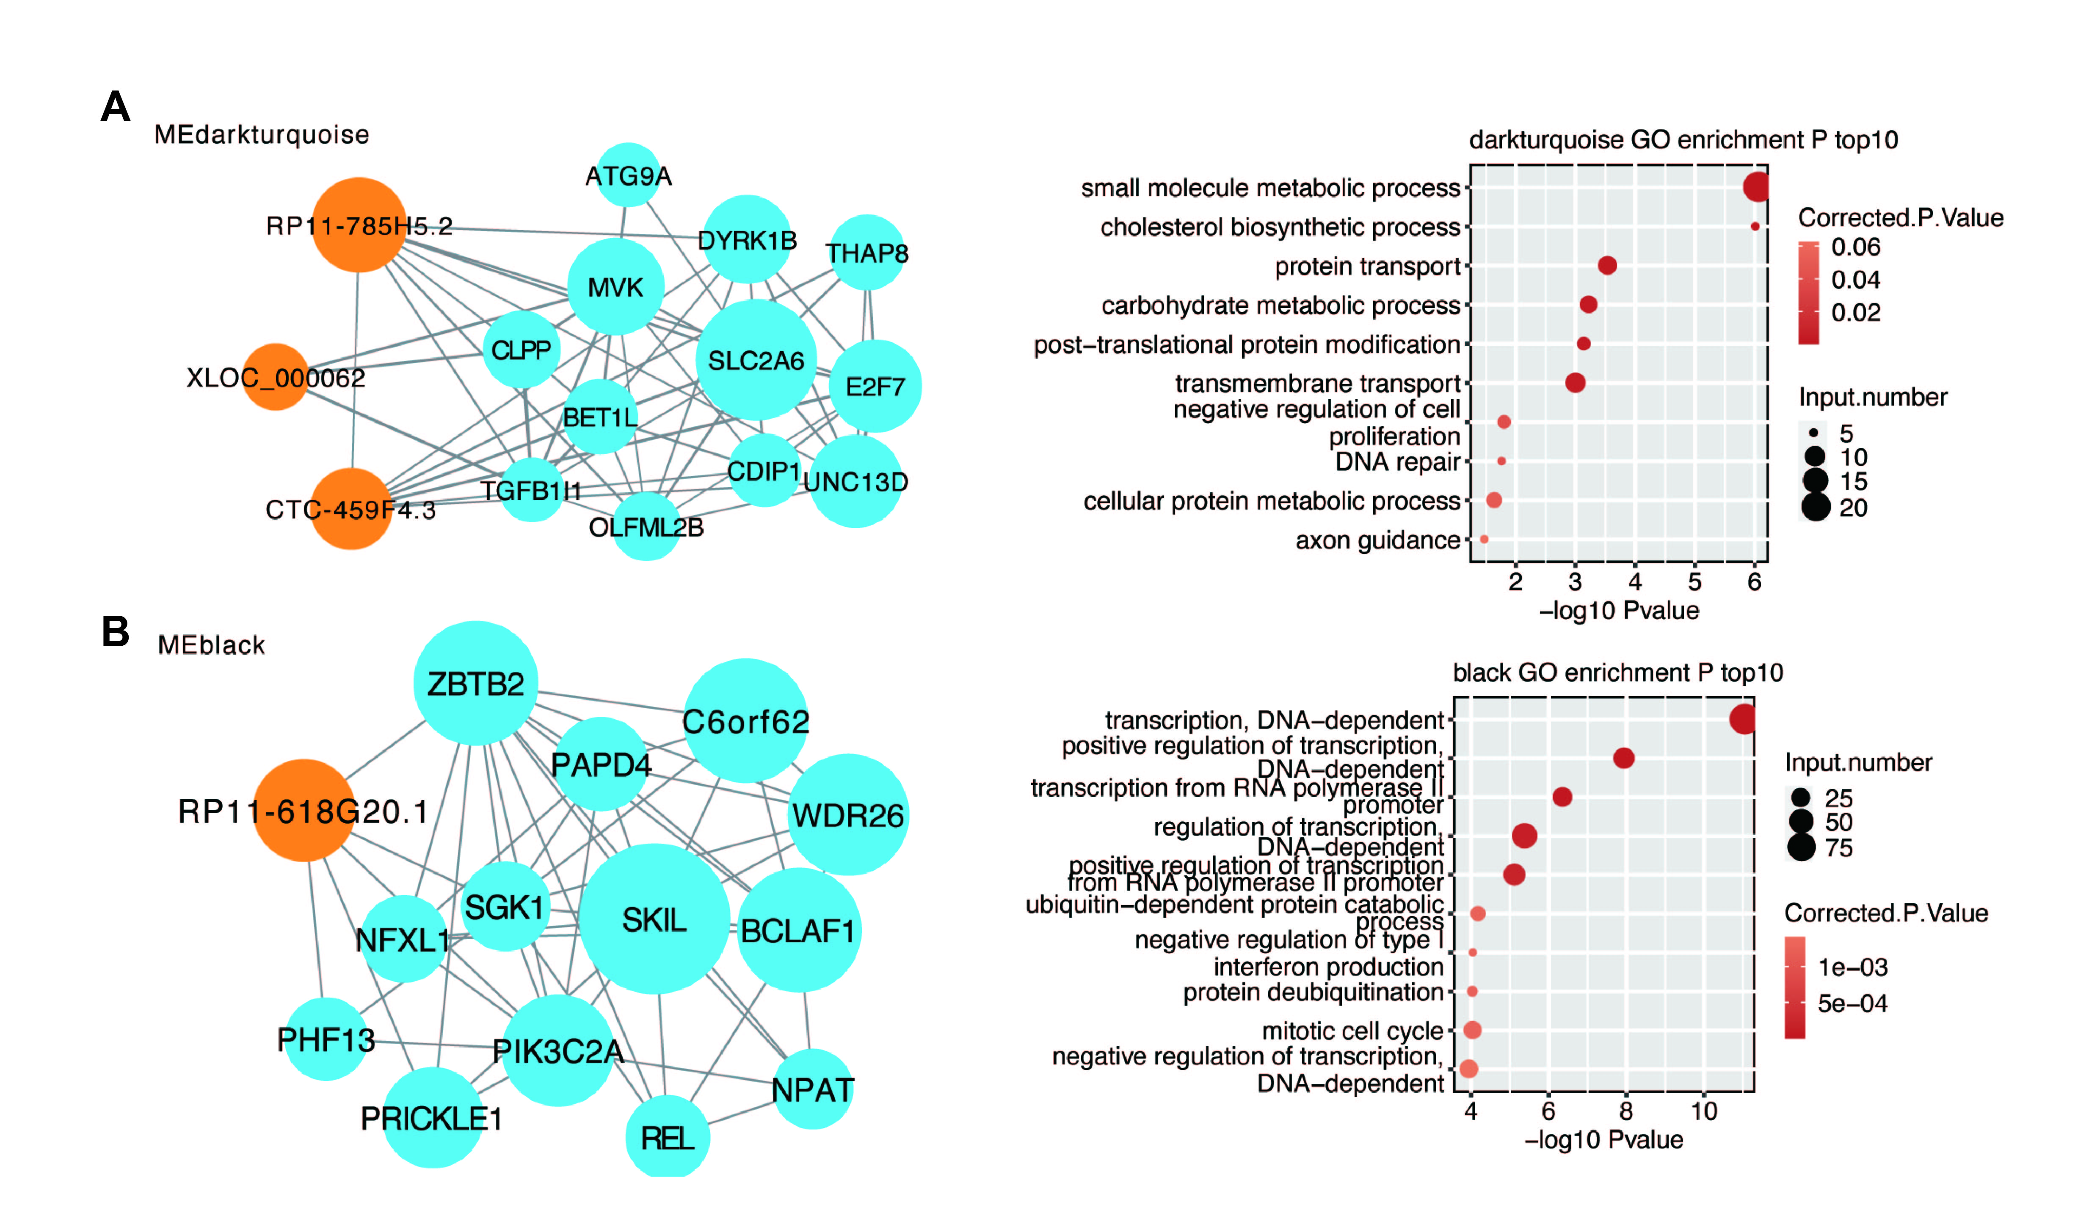
Fig. S4. WGCNA analysis of all lncRNAs and mRNAs.
A-B. Module plots displaying the top 15 hub genes, as well as the enriched GO terms in each of the MEdarkturquoise (A), MEblack (B) modules in Fig. 3A.

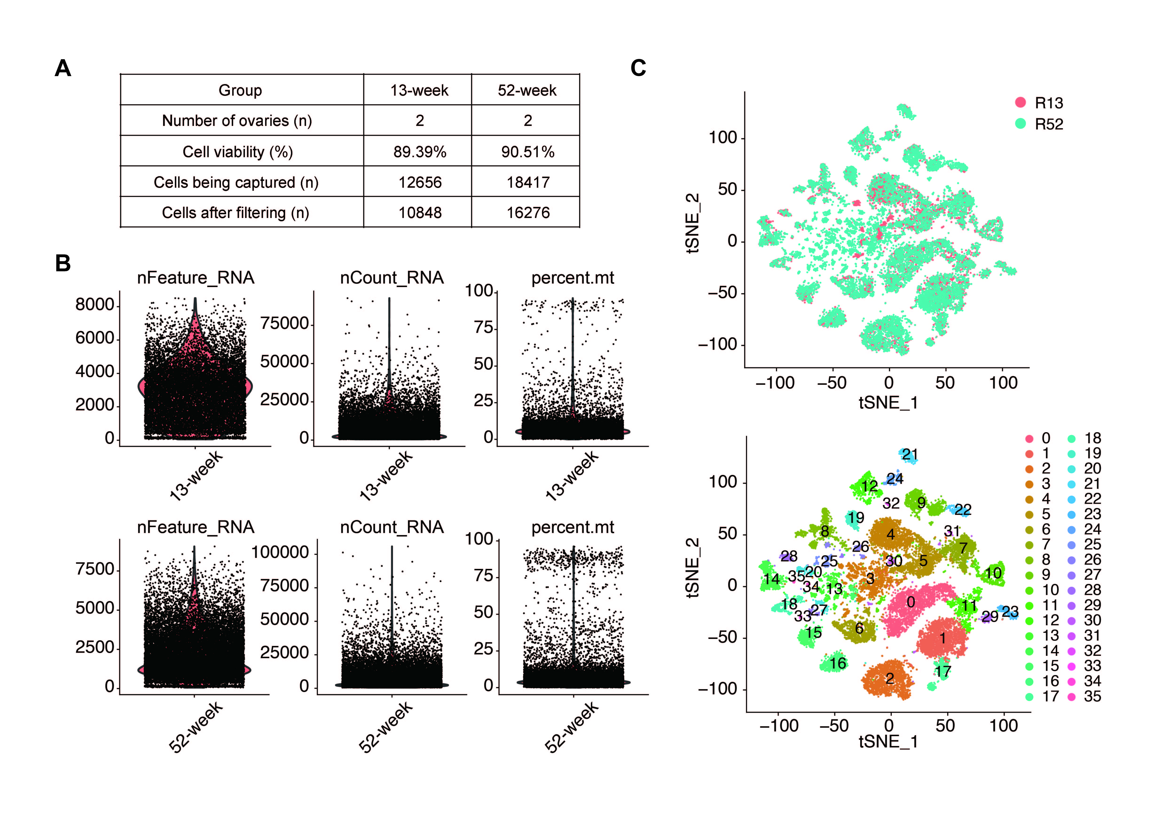
Fig. S5. Quality control and cell clustering of the mouse ovary scRNA-seq.
a. Summary of the mouse ovary information for scRNA-seq.
b. Violin plots showing the number of the captured counts, genes and mitochondrial ratio in 13-week and 52-week ovarian cells.
c. t-SNE plots showing 36 major clusters of somatic cells obtained in the control and GnRH-a group mouse ovaries.

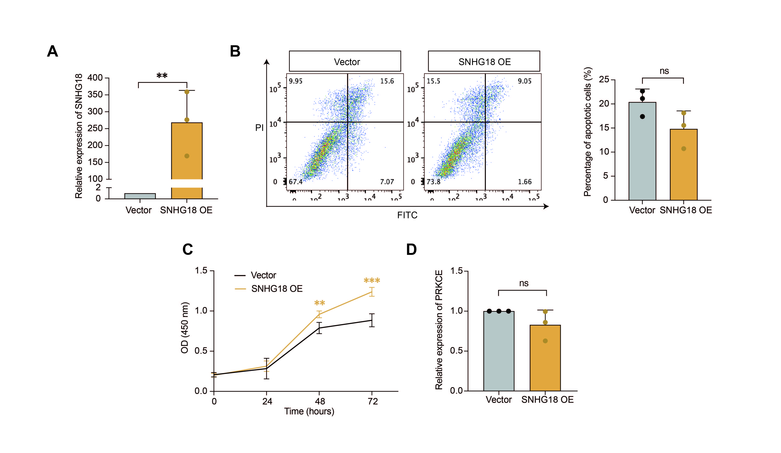
Fig. S6. Upregulated SNHG18 increased cell viability of granulosa cells.
A. The expression level of SNHG18 in SNHG18-overexpression SVOG cells detected by RT-qPCR.
B. Annexin V-FITC/PI staining and flow-cytometry analysis of the proportion of apoptotic SVOG cells.
C. CCK8 assay of the SNHG18-overexpression SVOG cells.
D. The expression level of PRKCE mRNA in SNHG18-overexpression SVOG cells.
All of the experiments were performed in triplicate at least and the data were expressed as the mean ± SD. **, P < 0.01; ***, P<0.001.

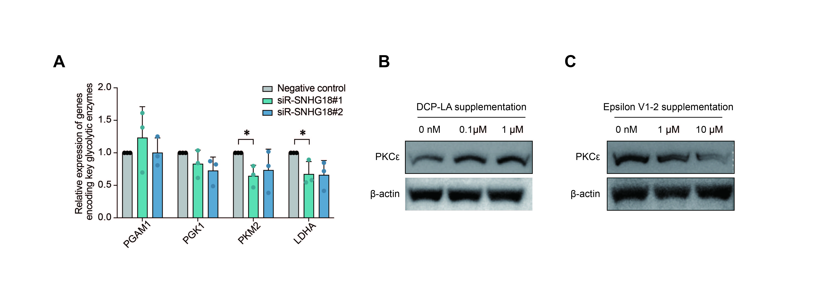
Fig. S7. Dysregulated SNHG18 interrupted the glycolysisof SVOG cells.
A. The expression of multiple genes encoding key glycolytic enzyme in SNHG18-knockdown SVOG cells.
B. Western blotting detection of the ENO1 level after supplementation with DCP-LA.
C. Western blotting detection of the ENO1 level after supplementation with Epsilon V1-2.

