Appendix

Table of content:
Appendix 1: Search strategies 3
1.1 Database Pubmed 3
1.2 Database Web of Science 3
1.3 Database Embase 4
1.4 Database Cochrane Library 4
1.5 Database CNKI： 5
1.6 Database WANFANG： 5
Appendix 2: Effects of Non-Pharmacological Interventions (NPIs) on Various Androgen Biomarkers and Hirsutism, and Subgroup Analysis Results of NPIs on the Primary Outcome Testosterone. 6
2.1 Forest plots of the effects of NPIs on testosterone of PCOS 6
2.1.1 Subgroup Analysis Results of NPIs on the Primary Outcome Testosterone by Age. 7
2.1.2 Subgroup Analysis Results of NPIs on the Primary Outcome Testosterone by BMI. 8
2.1.3 Subgroup Analysis Results of NPIs on the Primary Outcome Testosterone by Duration. 9
2.2 Forest plots of the effects of NPIs on FAI of PCOS 10
2.3 Forest plots of the effects of NPIs on SHGB of PCOS 11
2.4 Forest plots of the effects of NPIs on DHEAS of PCOS 12
2.5 Forest plots of the effects of NPIs on DHEA of PCOS 13
2.6 Forest plots of the effects of NPIs on A4 of PCOS 14
2.7 Forest plots of the effects of NPIs on FT of PCOS 15
2.9 Forest plots of the effects of NPIs on mFG score of PCOS. 17
Appendix 3: Minimal clinically important difference (MCID) 18
3.1 NPIs for testosterone (measurement units to ng/dL) in PCOS participants. 18
Appendix 4: Grading the evidence for primary outcome (serum testosterone level) of the network meta-analysis using CINeMA 19
4.1 Summary of study limitations of the included studies 19
4.2 Contribution percentage of low, moderate, and high RoB comparisons to each network estimate 20
Reasons for Downgrading 21
4.3.1 Within-study Bias 21
4.3.2 Across-study Bias (Publication Bias) 21
4.3.3 Indirectness 21
4.3.4 Imprecision 22
4.3.5 Heterogeneity 22
4.3.6 Inconsistency 22
4.3.7 Summarizing Judgments Across the Six Domains 23
Appendix: 5 Classification of 6 interventions, based on network meta-analysis of interventions for testosterone in women with PCOS 24
5.1 Establish Clear Reference and Thresholds. 24
5.2 Preliminary classification based on the reference group. 24
5.3 Second classification based on comparisons between pairs of interventions. 25
5.4 Certainty of evidence 26
5.5 SUCRA score and final classification. 27
Appendix 6：Heterogeneity, inconsistency and sensitivity analysis 29
6.1 Changes in heterogeneity 29
6.2 The results of global inconsistency detection and node fission detection 30
6.3 Primary outcome measure sensitivity analysis results. 32
Appendix 7：Publication bias 33
7.1 Funnel plot 33
7.2 Egger's publication bias plot. 34
Appendix 8: The impact of NPIs on the quality of life of women with PCOS 35
Appendix 9: Effective Strategies for PCOS Management: Acupuncture, Diet and Exercise. 36

Appendix 1: Search strategies

1.1 Database Pubmed
((("Polycystic Ovary Syndrome"[Mesh]) OR (Stein Leventhal Syndrome[Title/Abstract] OR PCOS[Title/Abstract])) AND ((((((("Hyperandrogenism"[Mesh]) OR ("Androgens"[Mesh])) OR ("Testosterone"[Mesh])) OR ("Androstenedione"[Mesh])) OR (free androgen index[Title/Abstract] OR FAI[Title/Abstract])) OR (sex hormone building globulin[Title/Abstract] OR SHBG[Title/Abstract])) OR (("Dehydroepiandrosterone"[Mesh]) OR (DHEA[Title/Abstract])))) AND (((((((((((("Acupuncture"[Mesh]) OR ("Electroacupuncture"[Mesh])) OR (("Acupuncture, Ear"[Mesh]) OR (auricular acupuncture[Title/Abstract]))) OR (acupoint catgut embedding[Title/Abstract])) OR (("Massage"[Mesh]) OR (tuina[Title/Abstract]))) OR ("Mindfulness"[Mesh])) OR ("Meditation"[Mesh])) OR ("Mind-Body Therapies"[Mesh])) OR ("Yoga"[Mesh])) OR (("Tai Ji"[Mesh]) OR (Tai Chi[Title/Abstract]))) OR ("Qigong"[Mesh])) OR (("Exercise"[Mesh]) OR (physical exercise[Title/Abstract])))

1.2 Database Web of Science
Table 1 | Search strategy for the Web of Science
Number | Search items
1 | TS=(Polycystic Ovary Syndrome) OR TS=(Stein Leventhal Syndrome) OR TS=(PCOS)
2 | TS=(Hyperandrogenism) OR TS=(Androgens) OR TS=(Testosterone) OR TS=(Androstenedione) OR TS=(free androgen index) OR TS=(FAI) OR TS=(sex hormone building globulin) OR TS=(SHBG) OR TS=(Dehydroepiandrosterone) OR TS=(DHEA)
3 | TS=(Acupuncture) OR TS=(Electroacupuncture) OR TS=(Acupuncture, Ear) OR TS=(auricular acupuncture) OR TS=(acupoint catgut embedding) OR TS=(Massage) OR TS=(tuina) OR TS=(Mindfulness) OR TS=(Meditation) OR TS=(Mind-Body Therapies) OR TS=(Yoga) OR TS=(Tai Ji) OR TS=(Tai Chi) OR TS=(Qigong) OR TS=(Exercise) OR TS=(physical exercise)
4 | #1 AND #2 AND #3

1.3 Database Embase
('ovary polycystic disease'/exp OR 'stein leventhal syndrome':ab,ti OR pcos:ab,ti) AND ('hyperandrogenism'/exp OR 'androgen'/exp OR 'testosterone'/exp OR 'androstenedione'/exp OR 'free androgen index':ab,ti OR fai:ab,ti OR 'sex hormone building globulin':ab,ti OR shbg:ab,ti OR 'prasterone'/exp OR dehydroepiandrosterone:ab,ti OR dhea:ab,ti) AND ('acupuncture'/exp OR 'electroacupuncture'/exp OR 'auricular acupuncture'/exp OR 'acupoint catgut embedding':ab,ti OR 'massage'/exp OR tuina:ab,ti OR 'mindfulness'/exp OR 'meditation'/exp OR 'yoga'/exp OR 'tai chi'/exp OR 'tai ji':ab,ti OR 'qigong'/exp OR 'exercise'/exp OR 'physical exercise':ab,ti)

1.4 Database Cochrane Library
#1 MeSH descriptor: [Polycystic Ovary Syndrome] explode all trees
#2 (stein leventhal syndrome or PCOS):ti,ab,kw (Word variations have been searched)
#3 #1 or #2
#4 MeSH descriptor: [Hyperandrogenism] explode all trees
#5 MeSH descriptor: [Androgens] explode all trees
#6 MeSH descriptor: [Testosterone] explode all trees
#7 MeSH descriptor: [Androstenedione] explode all trees
#8 (free androgen index or FAI):ti,ab,kw (Word variations have been searched)
#9 (sex hormone building globulin or SHBG):ti,ab,kw (Word variations have been searched)
#10 MeSH descriptor: [Dehydroepiandrosterone] explode all trees
#11 (DHEA):ti,ab,kw (Word variations have been searched)
#12 #10 or #11
#13 #4 or #5 or #6 or #7 or #8 or #9 or #12
#14 MeSH descriptor: [Acupuncture] explode all trees
#15 MeSH descriptor: [Electroacupuncture] explode all trees
#16 MeSH descriptor: [Acupuncture, Ear] explode all trees
#17 (auricular acupuncture):ti,ab,kw (Word variations have been searched)
#18 #16 or #17
#19 (acupoint catgut embedding):ti,ab,kw (Word variations have been searched)
#20 (tuina):ti,ab,kw (Word variations have been searched)
#21 MeSH descriptor: [Massage] explode all trees
#22 #20 or #21
#23 MeSH descriptor: [Mindfulness] explode all trees
#24 MeSH descriptor: [Meditation] explode all trees
#25 MeSH descriptor: [Mind-Body Therapies] explode all trees
#26 MeSH descriptor: [Yoga] explode all trees
#27 (Tai Chi):ti,ab,kw (Word variations have been searched)
#28 MeSH descriptor: [Tai Ji] explode all trees
#29 MeSH descriptor: [Qigong] explode all trees
#30 MeSH descriptor: [Exercise] explode all trees
#31 (physical exercise):ti,ab,kw (Word variations have been searched)
#32 #27 or #28
#33 #30 or #31
#34 #14 or #15 or #18 or #19 or #22 or #23 or #24 or #25 or #26 or #29 or #32 or #33#35 #3 and #13 and #34

1.5 Database CNKI：
(TKA = '多囊卵巢综合征') AND (TKA = '高雄激素血症' OR TKA = '雄激素' OR TKA = '睾酮' OR TKA = '雄烯二酮' OR TKA = '脱氢表雄酮' OR TKA = '游离雄激素指数' OR TKA = '性激素结合球蛋白') AND (TKA = '针刺' OR TKA = '针灸' OR TKA = '电针' OR TKA = '耳针' OR TKA = '穴位埋线' OR TKA = '推拿' OR TKA = '按摩' OR TKA = '正念' OR TKA = '冥想' OR TKA = '瑜伽' OR TKA = '太极' OR TKA = '气功' OR TKA = '运动' OR TKA = '体育锻炼' OR TKA = '身心')

1.6 Database WANFANG：
题名或关键词:(("多囊卵巢综合征") and ("高雄激素血症" or "雄激" or"睾酮" or "雄烯二酮" or "脱氢表雄酮" or "游离雄激素指数"or "性激素结合球蛋白") and ("针刺" or "针灸" or "电针" or "耳针" or "穴位埋线" or "推拿" or "按摩" or "正念" or "冥想" or "瑜伽" or "太极" or "气功" or "运动" or "体育锻炼" or "身心"))

Appendix 2: Effects of Non-Pharmacological Interventions (NPIs) on Various Androgen Biomarkers and Hirsutism, and Subgroup Analysis Results of NPIs on the Primary Outcome Testosterone.

2.1 Forest plots of the effects of NPIs on testosterone of PCOS
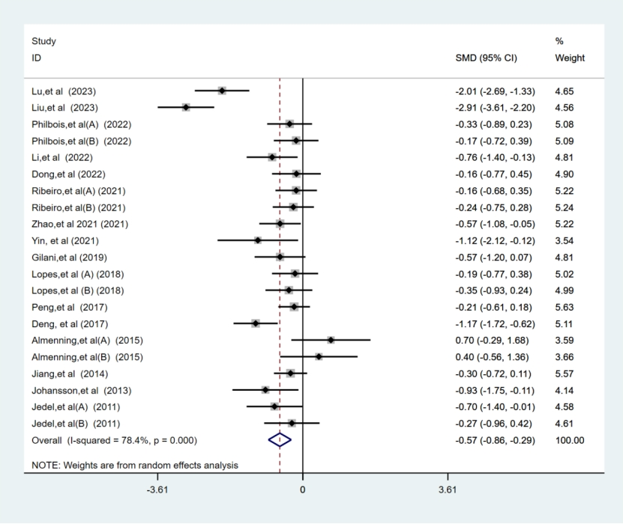

2.1.1 Subgroup Analysis Results of NPIs on the Primary Outcome Testosterone by Age.
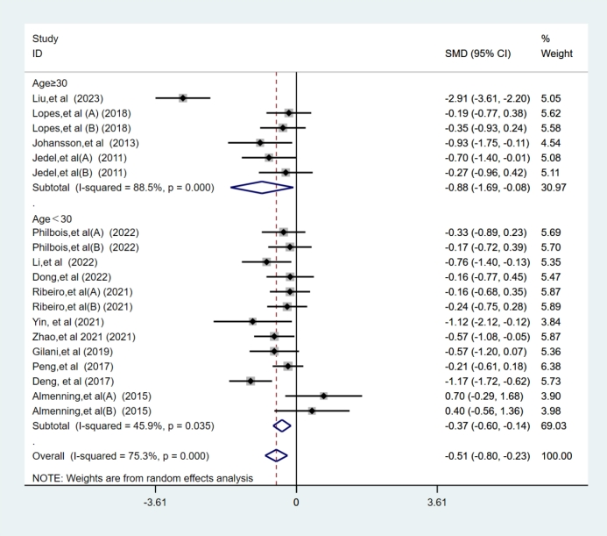

2.1.2 Subgroup Analysis Results of NPIs on the Primary Outcome Testosterone by BMI.
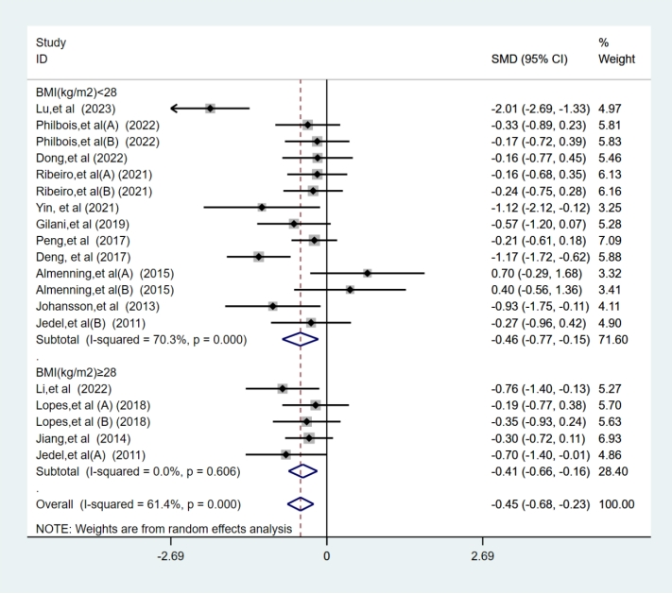

2.1.3 Subgroup Analysis Results of NPIs on the Primary Outcome Testosterone by Duration.
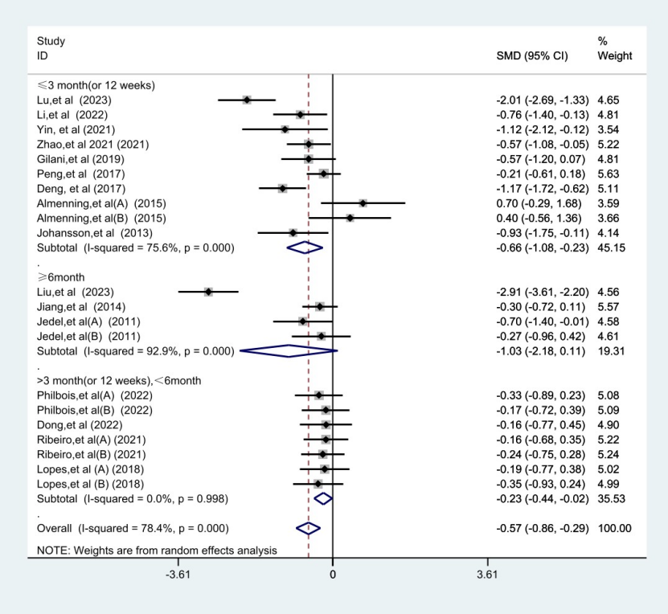

2.2 Forest plots of the effects of NPIs on FAI of PCOS
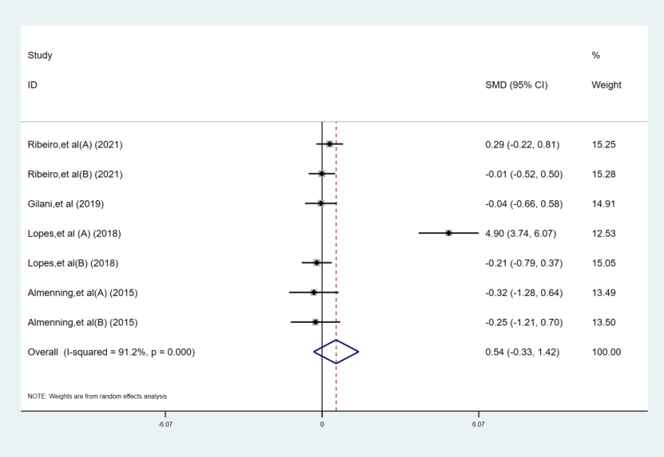

2.3 Forest plots of the effects of NPIs on SHGB of PCOS
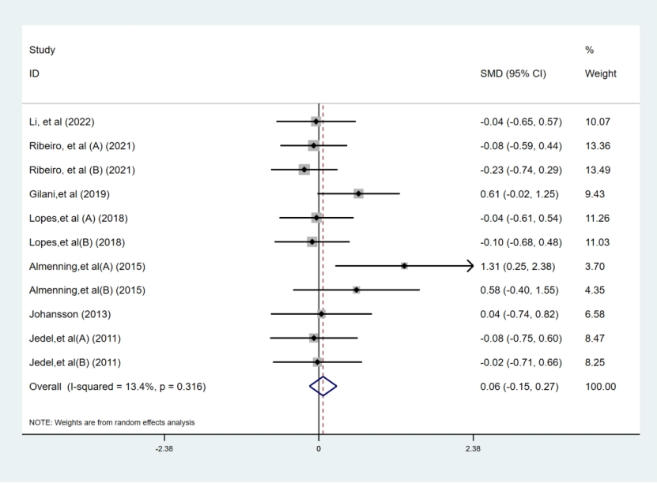

2.4 Forest plots of the effects of NPIs on DHEAS of PCOS
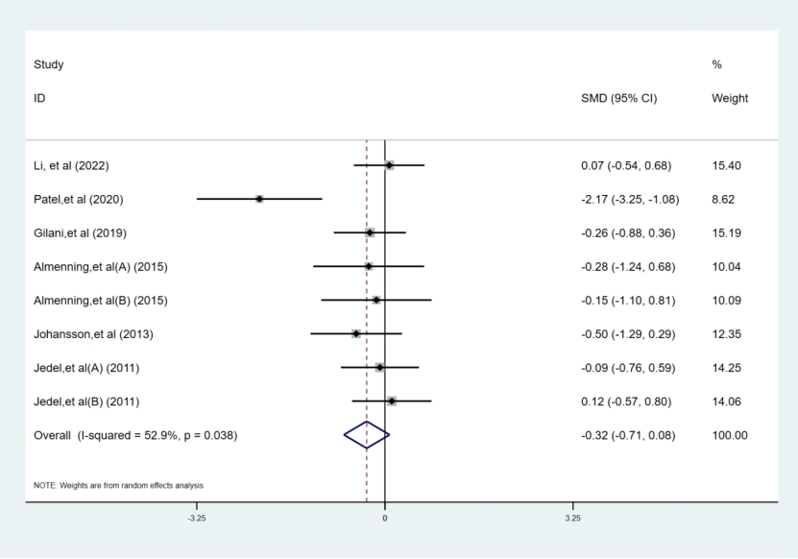

2.5 Forest plots of the effects of NPIs on DHEA of PCOS

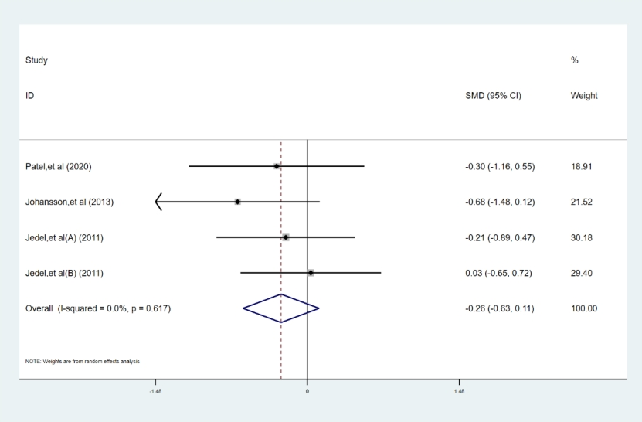

2.6 Forest plots of the effects of NPIs on A4 of PCOS
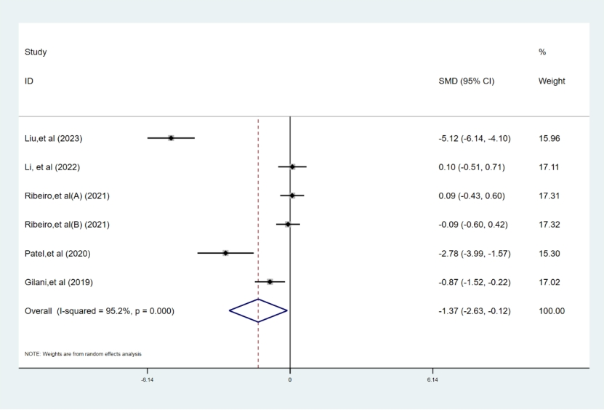

2.7 Forest plots of the effects of NPIs on FT of PCOS
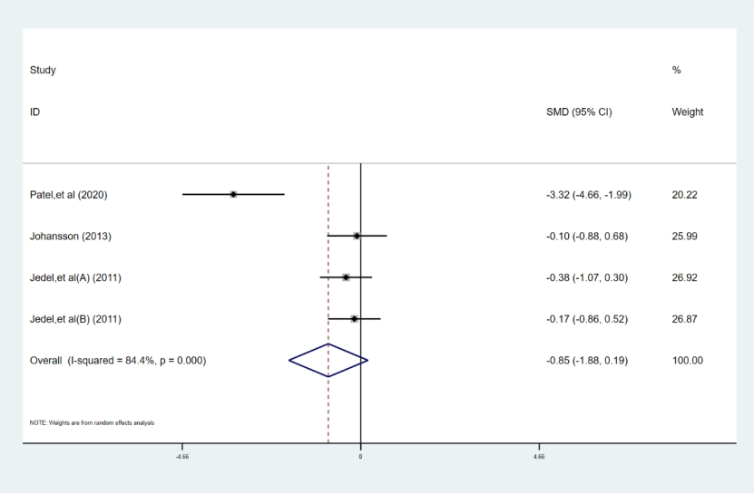

2.8 Forest plots of the effects of NPIs on DHT of PCOS
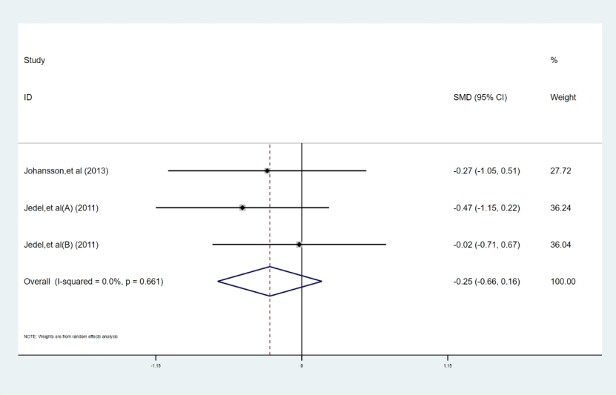

2.9 Forest plots of the effects of NPIs on mFG score of PCOS.
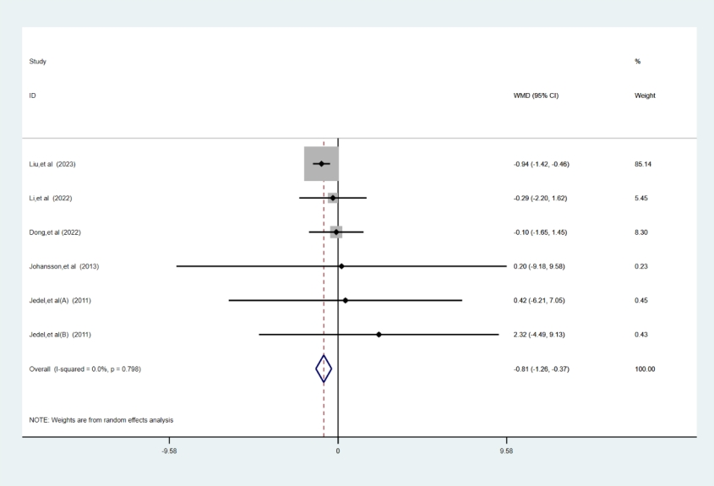

Appendix 3: Minimal clinically important difference (MCID)

3.1 NPIs for testosterone (measurement units to ng/dL) in PCOS participants.
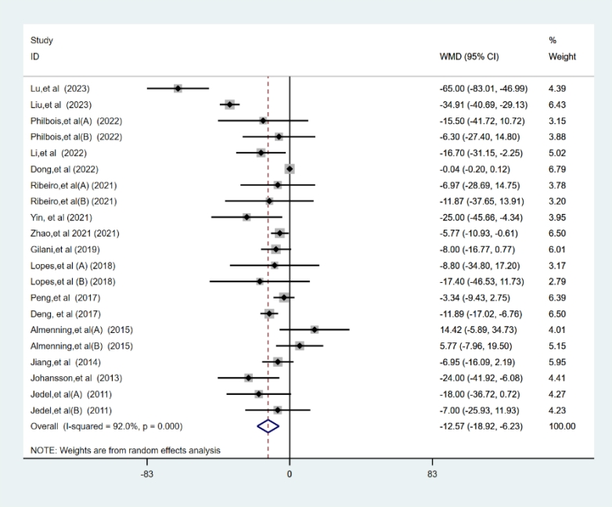

Appendix 4: Grading the evidence for primary outcome (serum testosterone level) of the network meta-analysis using CINeMA

4.1 Summary of study limitations of the included studies
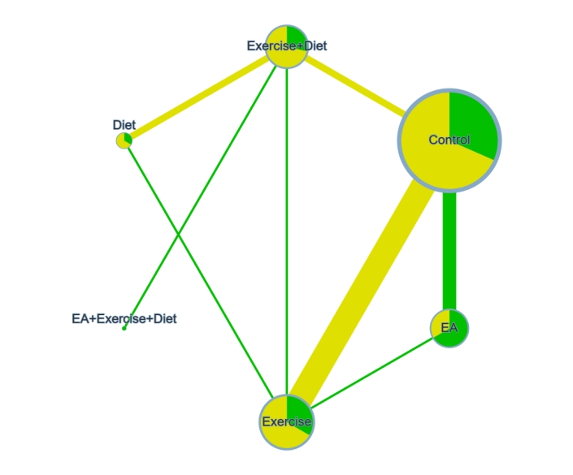
Fig 1 Network plot of study limitations of the included studies. Node size by equal size, node color by RoB. The colors in the circles indicate the percentage of low RoB studies (green), moderate RoB studies (yellow), high RoB studies (red) about each physical activity type. Edge width by sample size. Edge color by average RoB. The colors of the lines indicate the summative RoB assessment of each comparison. Low RoB is green, moderate RoB is yellow, high RoB is red. EA: Electroacupuncture.

4.2 Contribution percentage of low, moderate, and high RoB comparisons to each network estimate
Low RoB is green, moderate RoB is yellow, high RoB is red.
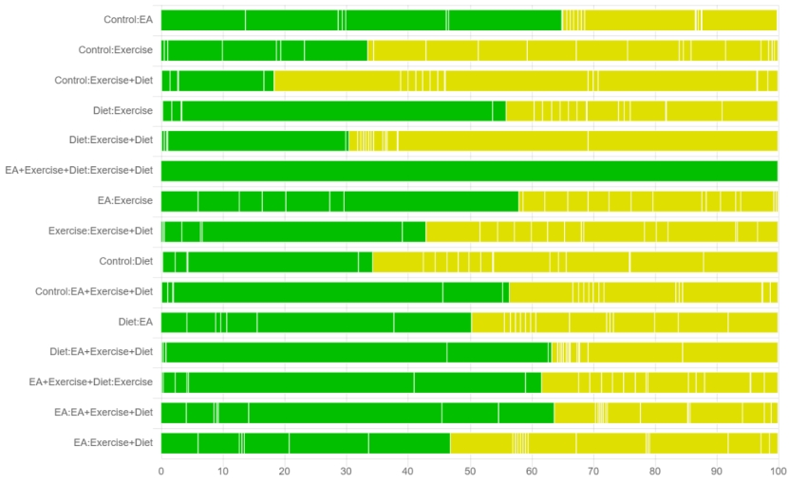

Reasons for Downgrading
According to the recommendations of the CINeMA online document (https://cinema.ispm.unibe.ch/), we rated only the primary outcome of serum testosterone and evaluated the need for downgrading each module based on the following criteria.

4.3.1 Within-study Bias
Based on the assessment results of RoB2 (Fig. 6), the quality of each included study was categorized as low risk, some concerns, or high risk. We adopted the rule of average risk of bias (RoB). No downgrade was applied if the result showed "no concerns," while a downgrade of one level was applied for "some concerns" and two levels for "major concerns."

4.3.2 Across-study Bias (Publication Bias)
Our search was comprehensive, including both published and unpublished studies. With no language restrictions, Chinese studies were also included in our screening scope. Even though it is possible that some small unpublished studies were missed, this does not appear to affect our results. In Fig. 5 and Supplementary Files 1（Fig S5）, we evaluated publication bias for the primary outcome, and adjusted funnel plots for comparisons of physical activity types with control showed no evidence of asymmetry. Therefore, the primary outcome was considered to have no publication bias.

4.3.3 Indirectness
We performed subgroup analysis on baseline information of the included studies (average age, BMI, regions, intervention period, control group with placebo or no treatment) as covariates for the primary outcome, and the results showed that baseline information had no significant impact on the outcomes. Therefore, we assumed no indirectness and did not downgrade any comparison based on this factor.

4.3.4 Imprecision
The primary outcome of serum testosterone level in this network meta-analysis is a continuous variable, and the effect size for continuous outcomes was measured as the standardized mean difference (SMD) of change scores (end value minus baseline score), as different studies used different rating scales or units. Therefore, for comparisons with the control group, the clinically meaningful threshold was set as an SMD higher or lower than 0. For comparisons between two non-pharmacological interventions, thresholds were set at SMD -0.1 and 0.1. If the confidence interval crossed one threshold, one level was downgraded, and if it crossed two thresholds, two levels were downgraded.

4.3.5 Heterogeneity
For heterogeneity, we used the same clinically significant thresholds as above and followed the recommendations automatically provided by CINeMA (https://cinema.ispm.unibe.ch/). No downgrade was applied when the result was "no concerns," while a downgrade of one level was applied for "some concerns" and two levels for "major concerns."

4.3.6 Inconsistency
For inconsistency, we used global and local methods to test the inconsistency of study results. Inconsistency within loops between direct and indirect evidence was evaluated using STATA software. Consistency was considered non-significant when the 95% confidence interval of inconsistent components encompassed zero. No downgrade was applied when p > 0.1, a one-level downgrade was applied when p was 0.05–0.1, and a two-level downgrade when p < 0.05.

4.3.7 Summarizing Judgments Across the Six Domains
The final output of CINeMA is a table displaying the level of concern for each of the six domains. We chose to summarize judgments across domains using the four confidence levels of the GRADE approach: very low, low, moderate, or high(1). Factors that may reduce confidence in treatment effects could impact multiple domains. Indirectness includes consideration of intransitivity, which is manifested as statistical inconsistency in the data. Heterogeneity increases the imprecision of treatment effect and may be related to variations in within-study bias or the presence of reporting bias. Additionally, the ability to detect critical discontinuities is weakened in the presence of heterogeneity(2). Therefore, the six domains of CINeMA should be considered jointly rather than in isolation to avoid multiple downgrades of the overall confidence level for related concerns.
1. A GRADE Working Group approach for rating the quality of treatment effect estimates from network meta-analysis. Bmj. 2015;350:h3326.
2. Veroniki AA, Mavridis D, Higgins JP, Salanti G. Characteristics of a loop of evidence that affect detection and estimation of inconsistency: a simulation study. BMC Med Res Methodol. 2014;14:106.

Appendix: 5 Classification of 6 interventions, based on network meta-analysis of interventions for testosterone in women with PCOS

5.1 Establish Clear Reference and Thresholds.
We designated the control group as the reference intervention and established a clinically relevant threshold for reducing testosterone. In this study, the minimum clinically important difference (MCID) was set at a reduction of 12.47 ng/dL in testosterone levels, serving as the benchmark for determining the effectiveness of the interventions.

5.2 Preliminary classification based on the reference group.
We standardized the measurement unit for testosterone to ng/dL and compared it with the MCID threshold for testosterone, as shown in the results below (Table 1).
Table 1 First classification of interventions based on comparison with reference, for the outcome of serum testosterone.
Intervention | Comparison with Control Group | category
Exercise | -7.65(-16.51,1.21) | Less Effective
Diet | -17.55(-35.99,0.89) | More Effective
Electroacupuncture | -15.08(-25.76, -4.40) | More Effective
Exercise +Diet | -20.06(-33.50, -6.62) | More Effective
Electroacupuncture +Exercise +Diet | -21.75(-49.58,6.07) | More Effective
Control | - | -

5.3 Second classification based on comparisons between pairs of interventions.
For interventions preliminarily labeled as "more effective," pairwise comparisons can be conducted to further differentiate their effectiveness. Based on the results from Step 2, “Electroacupuncture + Exercise + Diet”, “EA” and “Exercise + Diet” can be categorized into a higher tier. The results of the pairwise comparisons are shown below (Table 2)
Table 2: Second classification based on pairwise comparisons, for the outcome of serum testosterone.
Not convincingly different than control (category 0)
•None
Intermediate—more effective than placebo (category 1)
•Exercise
More effective than at least one category 1 intervention (category 2)
•Electroacupuncture + Exercise + Diet
•Electroacupuncture
•Exercise + Diet

5.4 Certainty of evidence
We applied the CINeMA method to evaluate the certainty of evidence for the effectiveness of each intervention. Interventions with high or moderate certainty of evidence were labeled as more reliable, while those with low or very low certainty were categorized at a lower level. The results are presented in Table 3.
Table 3 CINeMA for the primary outcome “serum testosterone level”
Intervention | Within-study bias | Reporting bias | Indirectness | Imprecision | Heterogeneity | Incoherence | Confidence rating
EA | No concerns | Low risk | No concerns | No concerns | Major concerns | No concerns | Low
Exercise | Some concerns | Low risk | No concerns | Major concerns | No concerns | No concerns | Very low
Exercise+Diet | Some concerns | Low risk | No concerns | No concerns | Major concerns | No concerns | Very low
Diet | Some concerns | Low risk | No concerns | Major concerns | No concerns | No concerns | Very low
EA+Exercise+Diet | No concerns | Low risk | No concerns | Major concerns | No concerns | No concerns | Low

5.5 SUCRA score and final classification.
Using the SUCRA values for each intervention, we ensured that classification aligned with ranking. High-ranking interventions classified as effective should significantly outperform those with lower rankings. Based on the results from Steps 2-4, interventions were given a final rating, revealing that acupuncture combined with exercise and diet stands out as a priority recommendation due to its clear clinical relevance. The results are presented in Table 4.
Table 4 Final classification of 5 interventions, based on network meta-analysis of interventions for testosterone in women with PCOS.
Certainty of the evidence, and classification of intervention | Intervention† | Intervention vs Control (mean difference (95% credible interval) | SUCRA (%)
High certainty (moderate to high certainty evidence)
None
Low certainty (low to very low certainty evidence)
Category 2: might be among the most effective | Electroacupuncture+ Exercise +Diet (L) | -21.75(-49.58,6.07) | 72.3
Category 1: might be inferior to the most effective or superior than the least effective | Electroacupuncture (L) | -15.08(-25.76, -4.40) | 57.6
 | Exercise+Diet (VL) | -20.06(-33.50, -6.62) | 74.7
 | Diet (VL) | -17.55(-35.99,0.89) | 63.3
Category 0: might be among the least effective | Exercise (VL) | -7.65(-16.51,1.21) | 29.2
†Letters in brackets represent the certainty of evidence for each intervention when compared with the reference: H=high certainty evidence; M=moderate; L=low; VL=very low.

Appendix 6：Heterogeneity, inconsistency and sensitivity analysis

6.1 Changes in heterogeneity
Below we present the results from the changes in heterogeneity in each network meta-regression model.
Covariate | Shared beta  (median and 95% CrI)
Publish Year | -0.29 (-0.87; 0.29)
Mean Age | 0.20 (-0.40; 0.81)
Sample Size | 0.04 (-0.09; 0.17)
BMI | 0.74 (-0.45; 1.96)
Duration | -0.44 (-1.15; 0.31) ⋇
Total sessions | -0.28 (-0.86; 0.32)
CrI: Credible Interval; ⋇: Significant influence factors, 95% CrI does not contain zero.

6.2 The results of global inconsistency detection and node fission detection
A. Global inconsistency detection result
Outcome | Coefficient | Std. err. | z | p＞|z| | 95% Conf. Interval (Lower) | 95% Conf. Interval (Upper)
_y_B des_BF | -0.4481412 | 1.15553 | -0.39 | 0.698 | -2.712938 | 1.816656
_y_B _cons | -0.4775669 | 0.9873041 | -0.48 | 0.629 | -2.412647 | 1.457514
_y_C des_ACE | 0.1699346 | 0.758926 | 0.22 | 0.823 | -1.317533 | 1.657402
_y_C _cons | -0.8897215 | 0.3032521 | -2.93 | 0.003 | -1.484085 | -0.2953582
_y_D _cons | -1.389463 | -0.7806898 | -1.78 | 0.075 | -2.918411 | 0.1394852
_y_E des_AE | 0.0780169 | 0.7285181 | 0.11 | 0.915 | -1.349852 | 1.505886
_y_E _cons | -0.2797906 | 0.6953944 | -8.48 | 6.687 | -1.642739 | 1.083157
_y_F des_BEF | 0.8671291 | 1.064392 | 0.81 | 0.415 | -1.219041 | 2.953299
_y_F _cons | -1.097377 | 0.3830737 | -2.86 | 0.604 | -1.848188 | -.3465663

B. Node fission detection results
side | Direct Coef. | Std. Err. | Indirect Coef. | Std. Err. | Difference Coef. | Std. Err. | p＞|z| | tau
A C* | -0.85768 | 0.2627195 | -0.6813301 | 1.178318 | -0.1763499 | 1.21187 | 0.884 | 0.5581954
A E | -0.2121008 | 0.1918082 | -0.8936707 | 0.6011899 | 0.6815698 | 0.6325973 | 0.281 | 0.5419624
A F | -1.089116 | 0.520229. | -0.3263405 | 0.6209756 | -0.762775 | 0.7141602 | 0.285 | 0.5405522
B E | 0.1875291 | 0.6606777 | 0.7133468 | 0.5930824 | -0.5258177 | 0.8875394 | 0.554 | 0.5530027
B F* | -0.0515865 | 0.3580609 | -1.576468 | 1.380271 | 1.524881 | 1.428299 | 0.286 | 0.5405543
C E | 0.4399493 | 0.6332533 | 0.6131548 | 0.3464567 | -0.1732055 | 0.7218217 | 0.810 | 0.5586635
D F* | 0.292373 | 0.624648 | -1.807897 | 63.25555 | 2.10027 | 63.25863 | 0.974 | 0.5375619
E F | 0.503322 | 0.6537444 | -0.8587265 | 0.3814338 | 0.9090586 | 0.7592631 | 0.231 | 0.534302

6.3 Primary outcome measure sensitivity analysis results.
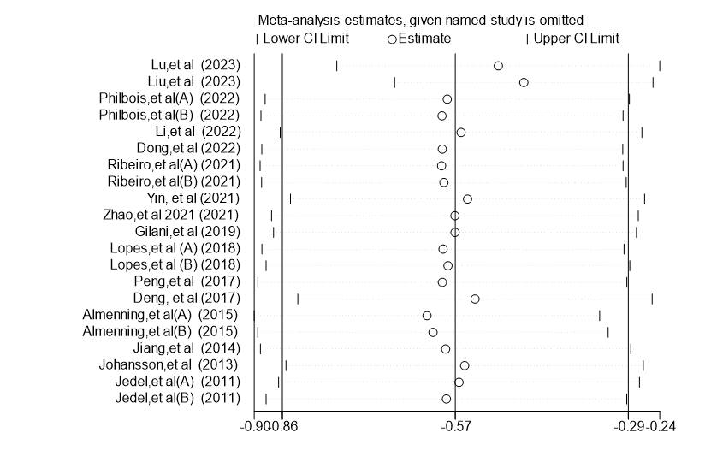

Appendix 7：Publication bias

7.1 Funnel plot
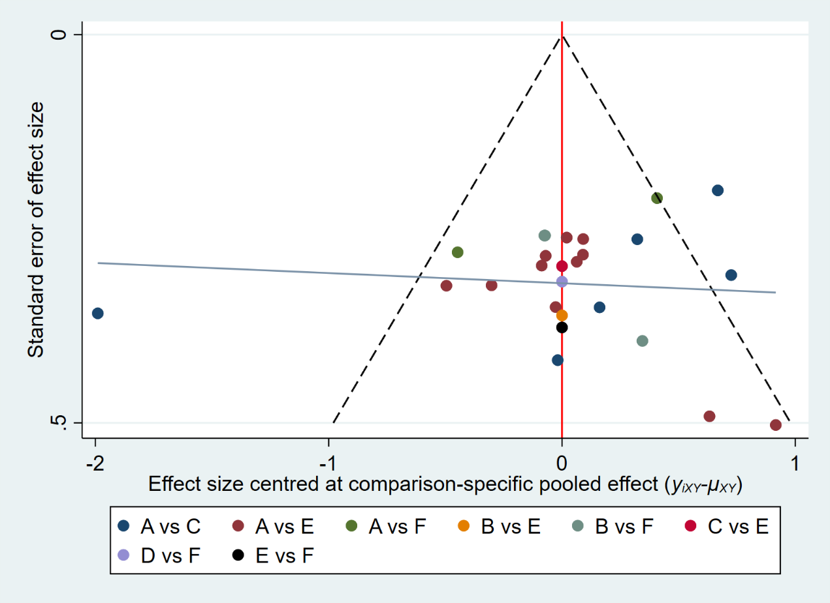

7.2 Egger's publication bias plot.
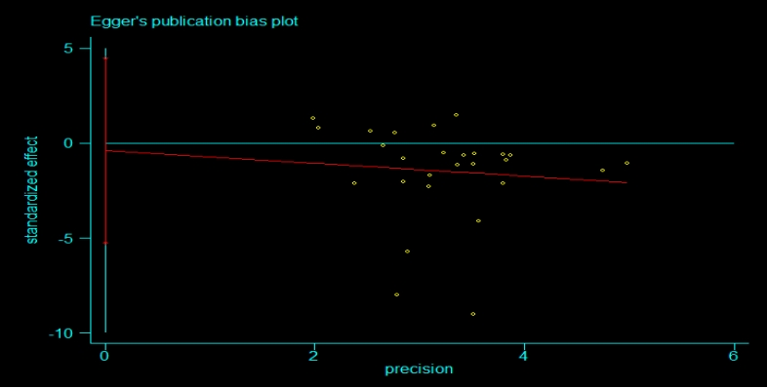

Appendix 8: The impact of NPIs on the quality of life of women with PCOS
Author/Year | Intervention | Samples | Scale | mean±SD | P value
Lu, et al 2023 | Exercise +Diet | 26 | MPCOSQ | 5.12±2.66 | <0.001
Lu, et al 2023 | Usual care | 25 | MPCOSQ | 10.60±2.58 | 0.288
Zhang, et al 2020 | EA +Exercise+ Diet | 20 | PCOSQ | 131.8±26.40 | <0.05
Zhang, et al 2020 | Exercise+ Diet | 20 | PCOSQ | 109.5±31.0 | -
Deng, et al 2017 | Exercise+ Diet | 30 | SF-36 | 68.49±10.37 | <0.01
Deng, et al 2017 | Usual care | 30 | SF-36 | 56.17±10.84 | -

Appendix 9: Effective Strategies for PCOS Management: Acupuncture, Diet and Exercise.
A. Parameters for electroacupuncture
Study |  |  | Acupoints |  |  | Parameters |  |  |  |  | Frequency
Liu,et al 2023 |  |  | CV4, CV3, ST36, ST40, SP10, SP6, KI3 |  |  | Continuous wave,  frequency 2Hz, current intensity 2±1 mA |  |  |  |  | 3 times a week for 3 months
Dong,et al 2022 |  |  | CV3, CV5, GV20, ST29, SP6, SP9, LI4 |  |  | Frequency 2 Hz, intensity tolerated by patient |  |  |  |  | Twice a week, up to 32 treatments
Zhao,et al 2021 |  |  | CV4, CV3, EX-CA1, ST36, ST40, SP10, SP6, KI3 |  |  | Continuous wave, frequency2Hz,  current intensity 2±1 mA |  |  |  |  | 3 times a week for 12 weeks
Zhang,et al 2020 |  |  | GV20, CV12, CV4, ST29, ST32, ST34, SP6, ST36, HT7, LI4 |  |  | Continuous wave, frequency2Hz,  current intensity 2±1 mA |  |  |  |  | 3 times a week for 3 months
Peng,et al 2017 |  |  | SP6, ST36, ST40, ST25 |  |  | Continuous wave, frequency2Hz,  current intensity 2±1 mA |  |  |  |  | 3 times a week for 3 months
Johansson,et al 2013 |  |  | CV3, ST29, SP6, ST25 |  |  | not specified |  |  |  |  | Twice a week for 10-13 weeks
Jedel,et al 2011 |  |  | CV3, CV6, ST29, SP6, SP9 |  |  | Frequency 2 Hz, intensity tolerated by patient |  |  |  |  | Twice a week for 16 weeks
B. Lifestyle Intervention and parameters
Study |  | Intervention method |  |  | Dietary |  | Exercise |  |  | Supervision
Lu,et al 2023 |  | Personalized lifestyle program |  |  | Personalized diet based on evidence |  | Personalized exercise, adjusted based on conditions |  |  | Adjustments based on conditions, follow-up calls, seasonal adjustments
Shi, et al 2021 |  | Personalized nutrition and exercise |  |  | Low-energy diet |  | Aerobic exercise: walking, jogging, 5 times/week, 30-45 minutes each time |  |  | Not specified
Al-Sherbeny,et al 2011 |  | Personalized diet and exercise |  |  | High-protein, energy-restricted diet |  | Walking/jogging, HR-controlled, gradually increasing duration |  |  | Not specified
Nybacka,et al 2013 |  | Personalized diet and exercise |  |  | Low-calorie diet |  | Aerobic exercise: walking, jogging, swimming, 2-3 times/week, 45-60 minutes each time |  |  | Not specified
Jiang,et al 2014 |  | Personalized diet and exercise |  |  | Low-calorie diet, |  | Enhanced aerobic/resistance exercise, adjusted as needed |  |  | Not specified
Deng, et al 2017 |  | Personalized diet and exercise |  |  | Low-energy diet |  | Personalized exercise, adjusted based on physique and experience |  |  | Clinic visit every two weeks, phone follow-up weekly
Zhang,et al 2020 |  | Fixed diet and exercise |  |  | Calorie restriction |  | Daily aerobic exercise, 30-40 min, speed >6 km/h |  |  | Daily exercise log
C. Exercise methods and parameters
Study | Type |  |  | Training Content/Intensity |  |  |  | Duration/Frequency | Supervision and Main Measures
Philbois,et al 2022 | MICT and HIIT |  |  | MICT: 50 mins (70–80% HRmax); HIIT: 35–45 mins (85–90% HRmax) |  |  |  | 16 weeks, 3 times/week | Supervised: Yes; HR monitoring
Li,et al 2022 | Tai Chi and Self-Monitored Exercise |  |  | 60 mins Tai Chi; Self-monitored: 60 mins aerobic exercise (Individualized) |  |  |  | 12 weeks, 3 times/week | Supervised: Yes; HR monitoring, Self-monitoring
Ribeiro,et al 2021 | CAT and IAT |  |  | Progressive increase in exercise duration; Training at different intensities (50–94% HRmax) |  |  |  | 16 weeks, 3 times/week | Supervised: Yes; HR monitoring
Patel,et al 2020 | Mindful Yoga |  |  | Breathing exercises, slow walking meditation, positive self-talk, guided imagery (None) |  |  |  | 3 months, 3 times/week | Supervised: Yes; Meditation training
Gilani,et al 2019 | Endurance Training |  |  | Gradually increased intensity and duration (65–75% Max HR) |  |  |  | 8 weeks, Multiple times/week | Supervised: Yes; HR monitoring
Lopes,et al 2018 | CAT and IAT |  |  | Gradual increase in exercise intensity (65–80% HRmax) |  |  |  | 16 weeks, 3 times/week | Supervised: Yes; HR monitoring
Almenning,et al 2015 | HIT and ST |  |  | HIT: 4x4 mins + 3 mins moderate; ST: 8 dynamic strength drills (HIT: 90–95% HRmax; ST: 75% 1RM) |  |  |  | 10 weeks, 3 times/week | Supervised: Yes; HR monitoring
Note: CV: Conception Vessel Meridian, ST: Stomach Meridian, SP: Spleen Meridian, KI: Kidney Meridian, GV: Governor Vessel Meridian, HT: Heart Meridian, LI: Large Intestine Meridian, EX-CA1: Extra Meridian zi-gong. MICT: Moderate-intensity continuous training; HIIT or HIT: high-intensity interval training; CAT: continuous aerobic training; IAT: intermittent aerobic training; ST: strength training; HR: heart rate.

