Supplementary material
Supplementary Fig. 1 Study design and workflow
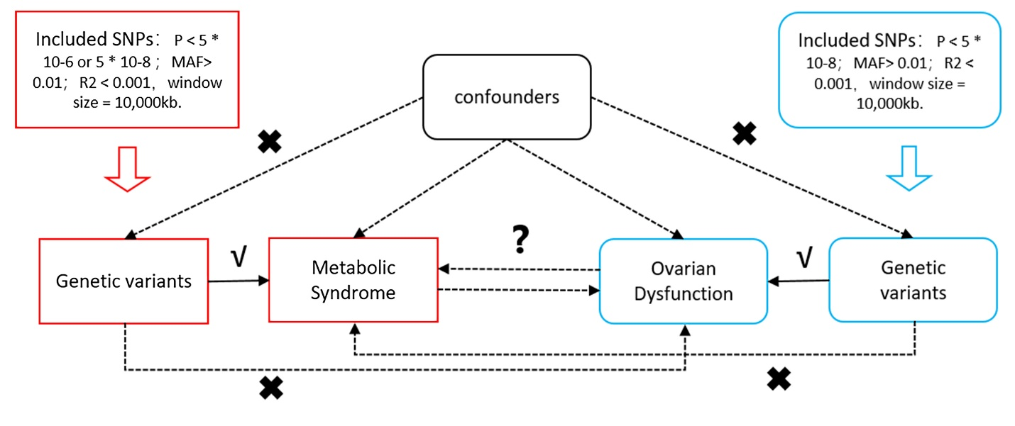

Supplementary Fig. 2 Sensitivity analyses of causal effects of MetS on primary ovarian failure and ovarian dysfunction. Funnel plots of BMI (A) and waist circumference (B) on ovarian dysfunction; and insulin resistance (C) on primary ovarian failure. Leave-one-out plots of BMI (D) and waist circumference (E) on ovarian dysfunction; and insulin resistance (F) on primary ovarian failure.
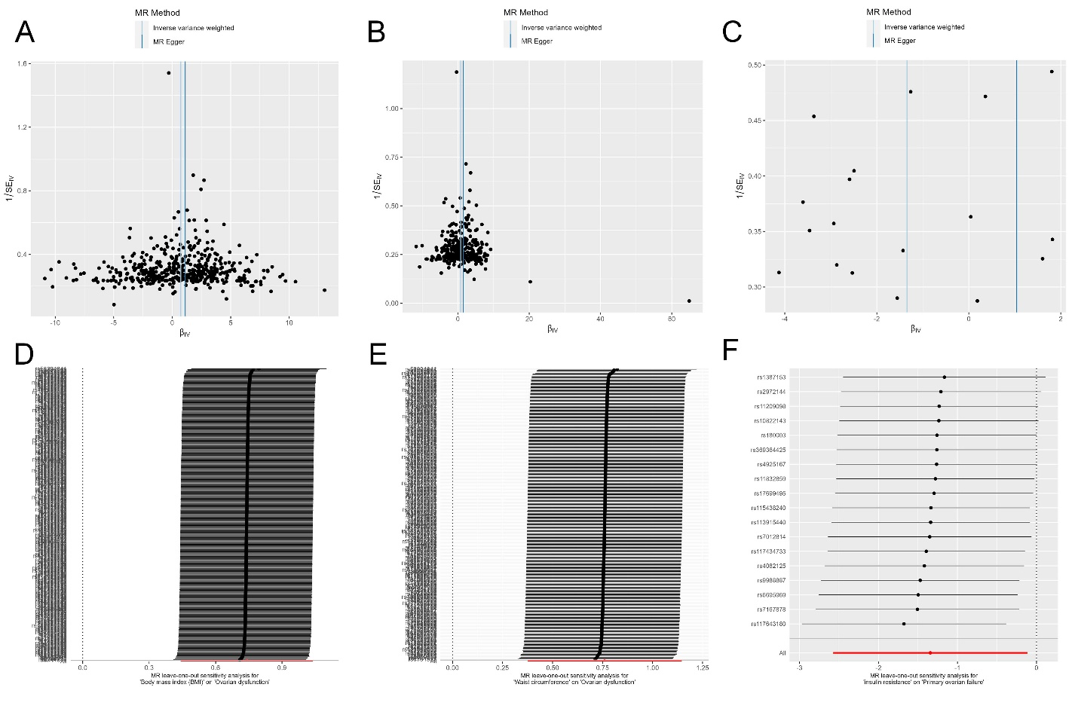

Supplementary Fig. 3 Sensitivity analyses of causal effects of primary ovarian failure and ovarian dysfunction on MetS. Funnel plots of ovarian dysfunction on MetS (A) and waist circumference (B). Leave-one-out plots of ovarian dysfunction on MetS (C) and waist circumference (D).
