Table S1. Search strategies for electronic databases
Query | Results  (Dec 2024)
PubMed
(“Polycystic Ovary Syndrome“[Mesh] OR “polycystic ovar*”[tiab] OR “poly-cystic ovar*”[tiab] OR “PCOS”[tiab] OR “anovulat*”[tiab] OR “Ovary Syndrome, Polycystic“[tiab] OR “Syndrome, Polycystic Ovary“[tiab] OR “Polycystic Ovarian Syndrome“[tiab] OR “Ovarian Syndrome, Polycystic“[tiab] OR “Polycystic Ovary Syndrome 1“[tiab] OR “Sclerocystic Ovarian Degeneration“[tiab] OR “Ovarian Degeneration, Sclerocystic“[tiab] OR “Sclerocystic Ovary Syndrome“[tiab] OR “Stein-Leventhal Syndrome“[tiab] OR “Stein Leventhal Syndrome“[tiab] OR “Syndrome, Stein-Leventhal“[tiab] OR “Sclerocystic Ovaries“[tiab] OR “Ovary, Sclerocystic“[tiab] OR “Sclerocystic Ovary“[tiab] OR “oligo-ovulat*”[tiab] OR “oligoovulat*”[tiab]) AND (“lipid ind*” OR “TyG” OR “triglyceride glucose” OR “triglyceride-glucose” OR “triglyceride-glucose index”) | 44
SCOPUS
( INDEXTERMS ( "Polycystic Ovary Syndrome" ) OR TITLE-ABS ( "polycystic ovar*" ) OR TITLE-ABS ( "poly-cystic ovar*" ) OR TITLE-ABS ( pcos ) OR TITLE-ABS ( anovulat* ) OR TITLE-ABS ( "Ovary Syndrome, Polycystic" ) OR TITLE-ABS ( "Syndrome, Polycystic Ovary" ) OR TITLE-ABS ( "Polycystic Ovarian Syndrome" ) OR TITLE-ABS ( "Ovarian Syndrome, Polycystic" ) OR TITLE-ABS ( "Polycystic Ovary Syndrome 1" ) OR TITLE-ABS ( "Sclerocystic Ovarian Degeneration" ) OR TITLE-ABS ( "Ovarian Degeneration, Sclerocystic" ) OR TITLE-ABS ( "Sclerocystic Ovary Syndrome" ) OR TITLE-ABS ( "Stein-Leventhal Syndrome" ) OR TITLE-ABS ( "Stein Leventhal Syndrome" ) OR TITLE-ABS ( "Syndrome, Stein-Leventhal" ) OR TITLE-ABS ( "Sclerocystic Ovaries" ) OR TITLE-ABS ( "Ovary, Sclerocystic" ) OR TITLE-ABS ( "Sclerocystic Ovary" ) OR TITLE-ABS ( oligo-ovulat* ) OR TITLE-ABS ( oligoovulat* ) ) AND ( "lipid ind*" OR tyg OR "triglyceride glucose" OR triglyceride-glucose OR "triglyceride-glucose index" ) | 219
Embase
('Polycystic Ovary Syndrome'/exp OR 'polycystic ovar*':ti,ab OR 'poly-cystic ovar*':ti,ab OR PCOS:ti,ab OR anovulat*:ti,ab OR 'Ovary Syndrome, Polycystic':ti,ab OR 'Syndrome, Polycystic Ovary':ti,ab OR 'Polycystic Ovarian Syndrome':ti,ab OR 'Ovarian Syndrome, Polycystic':ti,ab OR 'Polycystic Ovary Syndrome 1':ti,ab OR 'Sclerocystic Ovarian Degeneration':ti,ab OR 'Ovarian Degeneration, Sclerocystic':ti,ab OR 'Sclerocystic Ovary Syndrome':ti,ab OR 'Stein-Leventhal Syndrome':ti,ab OR 'Stein Leventhal Syndrome':ti,ab OR 'Syndrome, Stein-Leventhal':ti,ab OR 'Sclerocystic Ovaries':ti,ab OR 'Ovary, Sclerocystic':ti,ab OR 'Sclerocystic Ovary':ti,ab OR oligo-ovulat*:ti,ab OR oligoovulat*:ti,ab) AND ('lipid ind*' OR TyG OR 'triglyceride glucose' OR triglyceride-glucose OR 'triglyceride-glucose index') | 93
Web Of Science
(ALL="Polycystic Ovary Syndrome" OR (TI="polycystic ovar*" OR AB="polycystic ovar*") OR (TI="poly-cystic ovar*" OR AB="poly-cystic ovar*") OR (TI=PCOS OR AB=PCOS) OR (TI=anovulat* OR AB=anovulat*) OR (TI="Ovary Syndrome, Polycystic" OR AB="Ovary Syndrome, Polycystic") OR (TI="Syndrome, Polycystic Ovary" OR AB="Syndrome, Polycystic Ovary") OR (TI="Polycystic Ovarian Syndrome" OR AB="Polycystic Ovarian Syndrome") OR (TI="Ovarian Syndrome, Polycystic" OR AB="Ovarian Syndrome, Polycystic") OR (TI="Polycystic Ovary Syndrome 1" OR AB="Polycystic Ovary Syndrome 1") OR (TI="Sclerocystic Ovarian Degeneration" OR AB="Sclerocystic Ovarian Degeneration") OR (TI="Ovarian Degeneration, Sclerocystic" OR AB="Ovarian Degeneration, Sclerocystic") OR (TI="Sclerocystic Ovary Syndrome" OR AB="Sclerocystic Ovary Syndrome") OR (TI="Stein-Leventhal Syndrome" OR AB="Stein-Leventhal Syndrome") OR (TI="Stein Leventhal Syndrome" OR AB="Stein Leventhal Syndrome") OR (TI="Syndrome, Stein-Leventhal" OR AB="Syndrome, Stein-Leventhal") OR (TI="Sclerocystic Ovaries" OR AB="Sclerocystic Ovaries") OR (TI="Ovary, Sclerocystic" OR AB="Ovary, Sclerocystic") OR (TI="Sclerocystic Ovary" OR AB="Sclerocystic Ovary") OR (TI=oligo-ovulat* OR AB=oligo-ovulat*) OR (TI=oligoovulat* OR AB=oligoovulat*)) AND ((TI="lipid ind*" OR AB="lipid ind*") OR (TI=TyG OR AB=TyG) OR (TI="triglyceride glucose" OR AB="triglyceride glucose") OR (TI=triglyceride-glucose OR AB=triglyceride-glucose) OR (TI="triglyceride-glucose index" OR AB="triglyceride-glucose index")) | 53

Table S2. Clinical Characteristics of the included studies
Study | Groups | FBS (mg/dl) | HDL (mg/dl) | LDL (mg/dl) | TG (mg/dl) | TC (mg/dl) | DBP (mmHg) | SBP (mmHg) | HbA1c  (%) | Insulin (µIU/ml)
Elmugadam 2023 | PCOS | 89.9 ± 12.5 | 39.9 ± 4.7 | 113.9 ± 30.0 | 119.6 ± 53.9 | 190.3 ± 36.8 | N/A | N/A | N/A | 4.48 ± 3.6
Elmugadam 2023 | Non-PCOS | 89.7 ± 12.6 | 47.4 ± 9.1 | 84.7 ± 25.3 | 108.1 ± 38.1 | 148.4 ± 22.0 | N/A | N/A | N/A | 0.71 ± 0.7
Bilginer 2022 | PCOS | 92.75 ± 9.07 | 59.43 ± 13.43 | 120.75 ± 31.19 | 105.15 ± 56.85 | 201.37 ± 34.13 | 75.46 ± 8.83 | 114.53 ± 10.87 | N/A | 14.37 ± 9.56
Bilginer 2022 | Non-PCOS | 90.36 ± 8.77 | 55.13 ± 11.48 | 116.34 ± 31.78 | 79.57 ± 49.32 | 187.47 ± 38.83 | 73.02 ± 8.18 | 113.15 ± 10.16 | N/A | 8.19 ± 3.61
Yang 2023 | PCOS | 95.3±17.8 | 51.39±12.38 | 109.47±28.61 | 119.56±64.64 | 192.81±36.37 | 75.36 ± 9.25 | 113.13 ± 12.67 | N/A | 12.04±6.85
Yang 2023 | Non-PCOS | 93.6±10.3 | 53.74±11.6 | 98.58±24.37 | 92.99±43.44 | 180.44±33.28 | 72.68 ± 8.00 | 109.14 ± 11.35 | N/A | 8.56±4.53
Yavuzcan 2024 | PCOS | 93.79±40.26 | 51.53±13.01 | 91.70±31.83 | 90.16±50.45 | 166.63±32.48 | N/A | N/A | 5.11±0.27 | N/A
Yavuzcan 2024 | Non-PCOS | 102.17±35.97 | 55.93±13.64 | 92.45±24.65 | 80.56±45.14 | 166.88±26.94 | N/A | N/A | 5.27±0.84 | N/A
Zheng 2022 | PCOS | 94.14±8.27 | 49.31±10.74 | 123.04±21.39 | 115.06±69.11 | 191.03±29.55 | N/A | N/A | N/A | 12.09±12.34
Zheng 2022 | Non-PCOS | 89.46±9.09 | 52.98±12.92 | 113.34±22.31 | 95.82±43.02 | 180.20±28.34 | N/A | N/A | N/A | 8.72±5.78
Xu 2016 | PCOS | 84.3±8.4 | 52.2±10.4 | 43.97±4.37 | 103.32±63.68 | 169.38±40.19 | 74.94±5.60 | 114.34±10.15 | N/A | 1.06±0.27
Xu 2016 | PCOS+Mets | 96.7±44.5 | 44.09±16.19 | 57.07±7.34 | 193.46±102.89 | 180.44±34.43 | 80.71±8.35 | 119.84±10.52 | N/A | 1.32±0.25
Xu 2016 | Non-PCOS | 80.4±7.8 | 45.64±13.14 | 52.22±6.73 | 78.77±46.07 | 148.94±38.67 | 74.78±7.75 | 109.06±8.01 | N/A | 0.87±0.15
Forys 2023 | PCOS | 88.9 ±8.4 | 50.3 ±12.4 | 92.3 ±25.7 | 116.3 ±51.9 | 166.7 ±30.8 | N/A | N/A | N/A | 15.5 ±9.8
Forys 2023 | NON-PCOS | 86.8 ±6.6 | 53.5 ±11.0 | 103.8 ±36.7 | 119.9±52.5 | 181.9 ±42.2 | N/A | N/A | N/A | 14.0 ±9.7
Jabczyk 2023 | PCOS | 99.3±51.0 | 68.08±63.05 | 118.45±107.17 | 123.00±156.69 | 195.68±129.52 | N/A | N/A | 3.93±3.63 | 23.18±36.26
Kheirollahi 2020 | PCOS | 89.57 ± 9.48 | 43.86±8.64 | 98.54 ± 29.08 | 119.51±52.14 | 172.46 ± 36.24 | N/A | N/A | N/A | 4.87±3.43
Uysal 2024 | PCOS | 89.35±8.2 | 55.68 ± 14.43 | 95.92 ± 25.95 | 99.23±44.37 | 171.19 ± 30.22 | N/A | N/A | 5.39 ± 0.59 | 11.98±5.66
Hestiantoro 2024 | IR | 90.3±8.1 | 43.61±7.29 | 133.31±30.75 | 141.33±72.44 | 203.98±39.98 | N/A | N/A | N/A | 19.14±5.57
Hestiantoro 2024 | Non-IR | 87.3±6.7 | 43.03±5.87 | 136.23±23.15 | 99.31±48.21 | 206.79±21.20 | N/A | N/A | N/A | 10.26±1.01
Ilhan 2019 | IR | N/A | 51.89 ± 13.91 | 95.66 ± 26.52 | 118.84 ± 59.18 | 180.71 ± 39.09 | 70.38 ± 7.75 | 114.15 ± 12.92 | N/A | N/A
Ilhan 2019 | Non-IR | N/A | 56.14 ± 14.11 | 95.37 ± 25.65 | 97.69 ± 35.53 | 179.71 ± 33.49 | 70.55 ± 8.88 | 116.64 ± 15.85 | N/A | N/A
Yin 2022 | Mets | N/A | N/A | N/A | N/A | N/A | N/A | N/A | N/A | N/A
Yin 2022 | Non-MetS | N/A | N/A | N/A | N/A | N/A | N/A | N/A | N/A | N/A
Zhang 2023 | Mets | 94.3±12.2 | 39.45±9.28 | 119.18±36.75 | 197.29±75.28 | 176.45±42.54 | 85.94±10.11 | 128.61±14.59 | N/A | 27.22±14.41
Zhang 2023 | Non-MetS | 85.7±11.7 | 49.15±10.05 | 100.18±36.37 | 93.84±43.41 | 157.85±38.37 | 73.76±9.44 | 111.85±13.18 | N/A | 11.70±7.01
Kwon 2023 | TYG index<8.126) | 88.39±7.12 | 65.77±15.68 | 93.00±25.68 | 49.94±14.41 | 169.95±27.52 | N/A | N/A | N/A | 5.79±3.22
Kwon 2023 | TYG index>8.126) | 92.19±6.30 | 54.44±13.71 | 109.26±29.12 | 130.39±80.61 | 184.24±33.07 | N/A | N/A | N/A | 14.27±11.18
Abbreviations: FBS, Fasting Blood Sugar; HDL, High-Density Lipoprotein; LDL, Low-Density Lipoprotein; TG, Triglycerides; TC, Total Cholesterol; DBP, Diastolic Blood Pressure; SBP, Systolic Blood Pressure; HbA1c, Hemoglobin A1c; IR, Insulin Resistance; Mets, Metabolic Syndrome; PCOS, Polycystic Ovary Syndrome; TYG index, Triglyceride-Glucose index

Table S3. Qualities of included studies based on NOS
Study | Year | Selection |  |  |  | Comparability | Outcome |  |  | Overall score | Overall quality
Elmugadam | 2023 | * | * | * | * | * | * | * | * | 8 | Good
Jabczyk | 2023 | * | - | * | * | ** | * | - | * | 7 | Good
Bilginer | 2022 | * | * | * | * | ** | * | * | * | 9 | Very Good
Hestiantoro | 2024 | * | * | - | * | ** | - | * | * | 7 | Good
Ilhan | 2019 | * | * | * | * | ** | * | * | * | 9 | Very Good
Foryś | 2023 | * | * | * | * | * | * | * | * | 8 | Good
Kheirollahi | 2020 | * | * | * | * | * | * | * | * | 8 | Good
Yang | 2023 | * | * | * | * | ** | * | * | * | 9 | Very Good
Yavuzcan | 2024 | * | * | * | * | ** | * | * | * | 9 | Very Good
Yin | 2021 | * | * | - | * | * | * | * | * | 6 | Fair
Zhang | 2023 | * | * | * | * | ** | * | * | * | 9 | Very Good
Xu | 2016 | * | - | * | * | * | * | - | * | 6 | Fair
Zheng | 2022 | * | * | * | * | ** | * | * | * | 9 | Very Good
Uysal | 2024 | * | * | * | * | ** | * | * | - | 8 | Good
Kwon | 2023 | * | * | * | * | * | * | * | * | 7 | Good
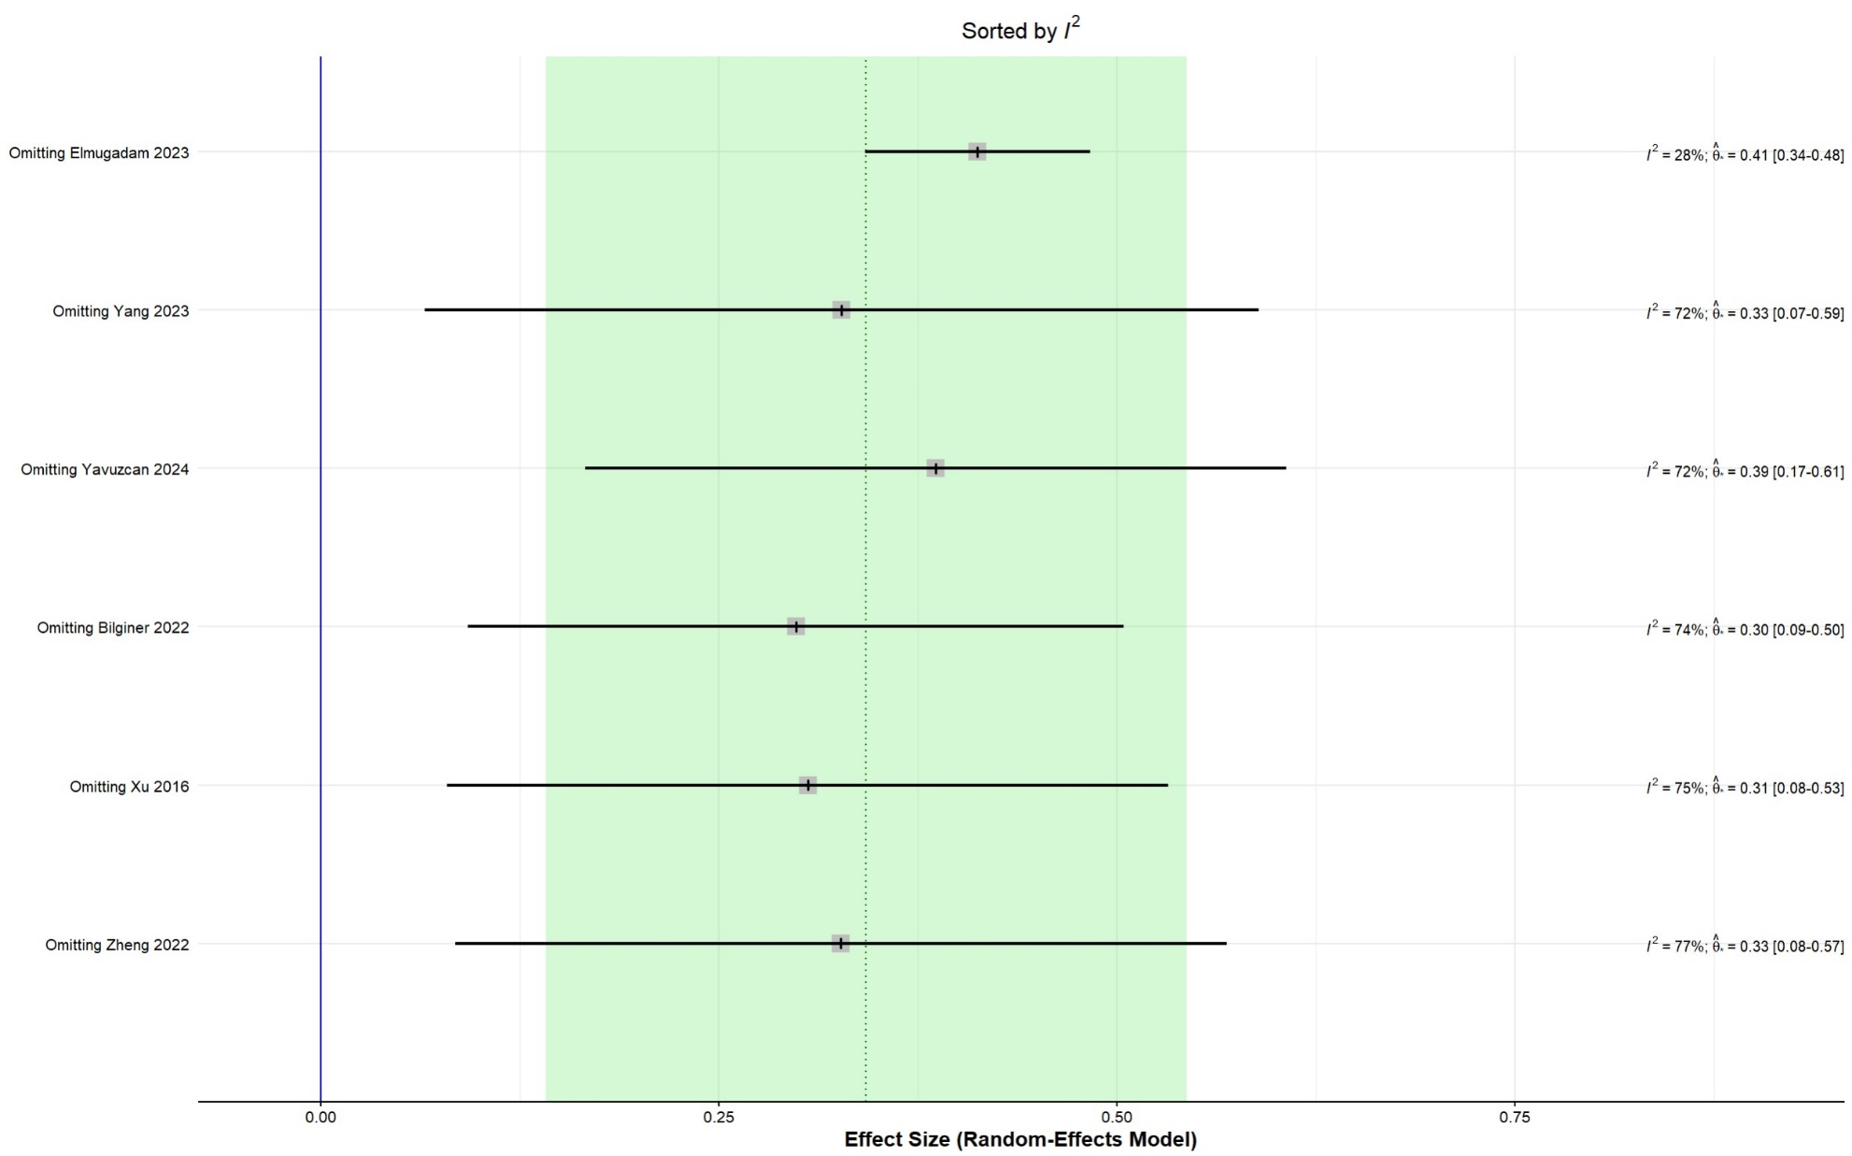
Figure S1. Sensitivity meta-analysis of TyG index in PCOS vs. control

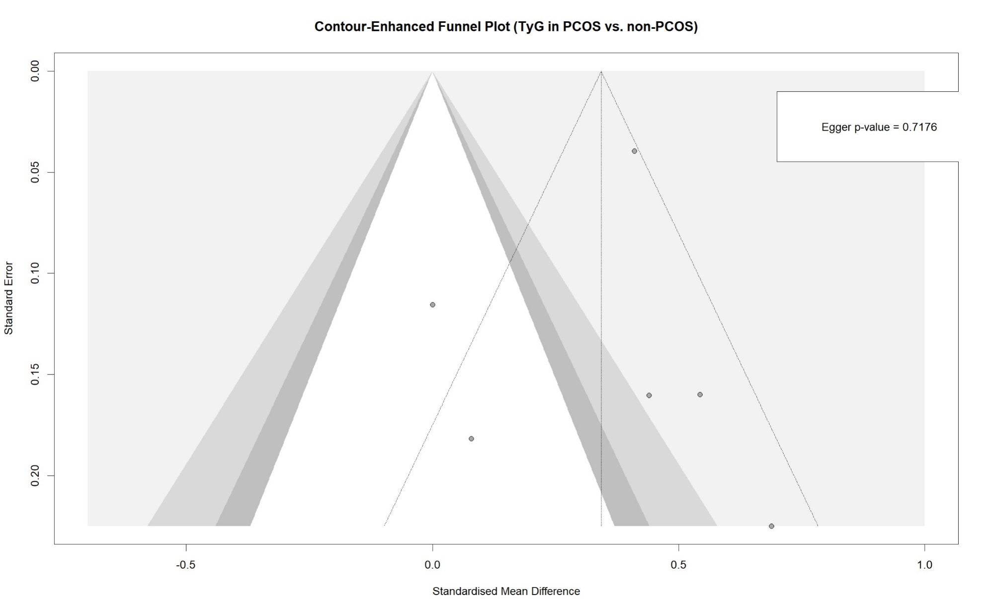Figure S2. Funnel plot for asymmetry assessment of TyG index in PCOS vs. control

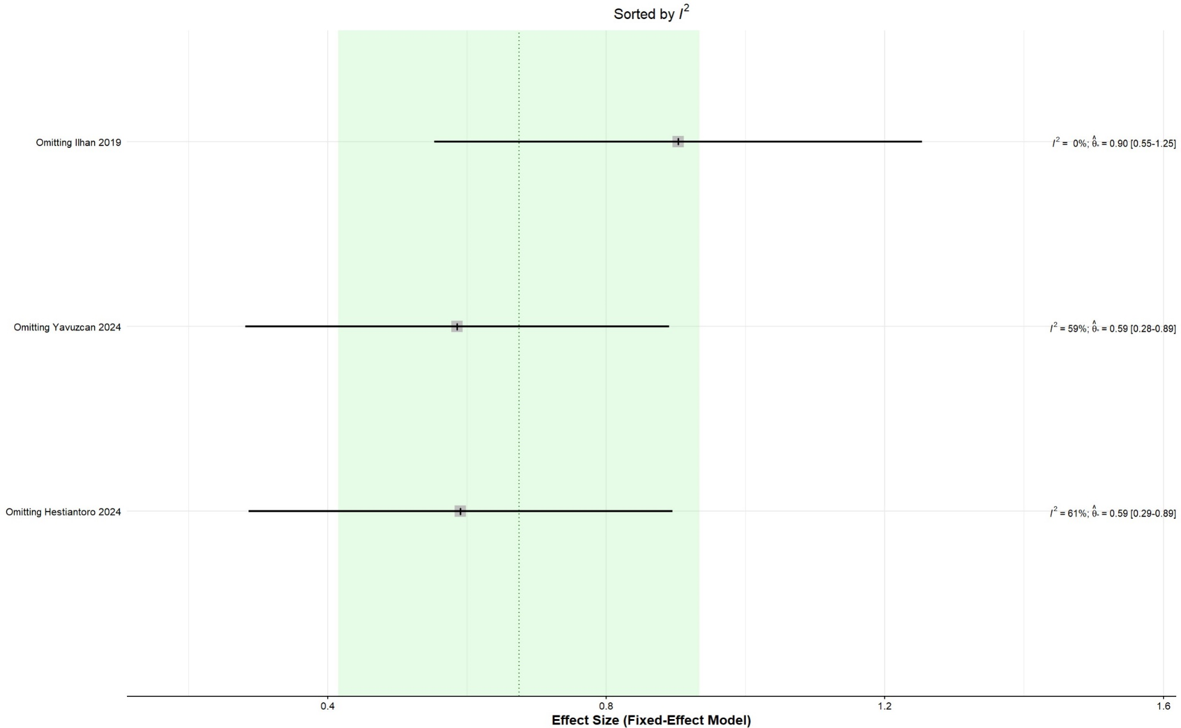
Figure S3. Sensitivity meta-analysis of TyG index in IR vs. control in PCOS population

