Supplemental Figure 1 Grouping Flowchart
Supplemental Table 1 Baseline characteristics of Day5 and Day6 cycles
Supplemental Table 2 Influencing factors associated with biochemical pregnancy rate by logistic regression analysis
Supplemental Table 3 Effect of AH on biochemical pregnancy rate with or without consideration of re-expansion
Supplemental Table 4 Effect of AH on all pregnancy outcomes
Supplemental Figure 2 Biochemical pregnancy rate and re-expansion rate with and without AH in TE=A+B, TE=C and all cycles
Supplemental Figure 3 Pregnancy outcomes with and without AH in TE=A+B and TE=C cycles
Supplemental Figure 4 Pregnancy outcomes with and without AH in re-expansion and no re-expansion cycles
Supplemental Figure 5 Mechanism hypothesis diagram
Supplemental Figure 1 Grouping Flowchart
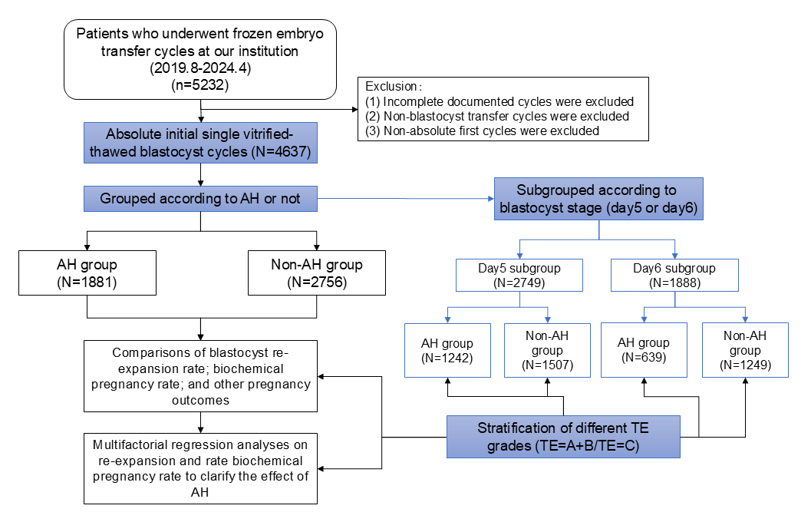
Abbreviations: AH, assisted hatching; TE, trophoblastic ectoderm.

Supplemental Table 1 Baseline characteristics of Day5 and Day6 cycles
Cycles/N
Day 5 | AH group (N=1242) | Non-AH group (N=1507) | P
Maternal age (years) | 31.97±4.21 | 31.79±4.25 | 0.284
Duration of infertility (years) | 2.85±2.56 | 2.92±2.85 | 0.536
Maternal BMI (kg/m²) | 22.83±5.88 | 22.62±3.77 | 0.248
AMH | 6.03±5.02 | 5.98±11.45 | 0.913
Primary infertility (n, %) | 718 (57.8%) | 869 (57.7%) | 0.939
Pluriparous (n, %) | 158 (12.7%) | 196 (13.0%) | 0.825
Infertility cause (n, %) |  |  | 0.878
Tubal factor | 440 (35.4%) | 556 (36.9%)
Male factor | 331 (26.7%) | 400 (26.5%)
Ovulatory dysfunction | 139 (11.2%) | 173 (11.5%)
Uterine factor | 52 (4.2%) | 55 (3.6%)
Mixed factor | 228 (18.4%) | 259 (17.2%)
Other factors | 52 (4.2%) | 64 (4.2%)
Endometrial thickness (mm) | 10.98±2.48 | 11.03±2.46 | 0.629
Day 6 | AH group (N=639) | Non-AH group (N=1249) | P
Maternal age (years) | 33.39±4.47 | 32.80±4.53 | 0.007*
Duration of infertility (years) | 3.09±2.94 | 3.02±2.97 | 0.631
Maternal BMI (kg/m²) | 22.68±3.56 | 22.50±5.86 | 0.477
AMH | 4.42±3.50 | 4.38±3.56 | 0.882
Primary infertility (n, %) | 360 (56.3%) | 702 (56.2%) | 0.956
Pluriparous (n, %) | 98 (15.3%) | 156 (12.5%) | 0.086
Infertility cause (n, %) |  |  | 0.418
Tubal factor | 224 (35.1%) | 501 (40.1%)
Male factor | 175 (27.4%) | 317 (25.4%)
Ovulatory dysfunction | 70 (9.3%) | 98 (7.8%)
Uterine factor | 26 (4.1%) | 54 (4.3%)
Mixed factor | 123 (19.2%) | 224 (17.9%)
Other factors | 31 (4.9%) | 55 (4.4%)
Endometrial thickness (mm) | 11.03±2.57 | 11.02±2.48 | 0.953
Abbreviations: AH, assisted hatching; AMH, anti-Müllerian hormone; BMI, body mass index.
Note: Data are presented as mean ± SD or number of cases (n) with rate (%). *P < 0.05.
Supplemental Table 2 Influencing factors associated with biochemical pregnancy rate by logistic regression analysis
Day5 blastocyst FET cycles/N=2749 | aOR (95% CI) | P
AH or not
AH | 1.013 (0.862,1.191) | 0.874
No AH | Reference
Grade of blastocyst trophoblastic ectoderm
TE grade =A+B | Reference
TE grade =C | 0.735 (0.588,0.918)* | 0.007*
Blastocyst re-expansion or not
Re-expansion | 2.300 (1.761,3.005)* | <0.001*
No re-expansion | Reference
Maternal age (years) | 0.956 (0.937,0.975)* | <0.001*
Endometrial thickness | 1.052 (1.016,1.089)* | 0.004*
Day5 TE = C blastocyst FET cycles/N=396 | aOR (95% CI) | P
AH or not
AH | 1.289 (0.842,1.973) | 0.243
No AH | Reference
Blastocyst re-expansion or not
Re-expansion | 3.676 (1.753,7.708)* | 0.001*
No re-expansion | Reference
Day6 blastocyst FET cycles/N=1888 | aOR (95% CI) | P
AH or not
AH | 1.153 (0.942,1.411) | 0.168
No AH | Reference
Blastocyst re-expansion or not
Re-expansion | 4.411 (3.265,5.957)* | <0.001*
No re-expansion | Reference
Maternal age (years) | 0.965 (0.943,0.987)* | 0.002*
Endometrial thickness | 1.045 (1.005,1.087)* | 0.026*
Day6 TE = C blastocyst FET cycles/N=568 | aOR (95% CI) | P
AH or not
AH | 1.374 (0.944,2.001) | 0.097
No AH | Reference
Blastocyst re-expansion or not
Re-expansion | 6.499 (3.634,11.622)* | <0.001*
No re-expansion | Reference
Maternal age (years) | 0.921 (0.884,0.960)* | 0.001*
Endometrial thickness | 1.092 (1.014,1.176)* | 0.019*
Abbreviations: AH, assisted hatching; BMI, body mass index; aOR, adjusted odds ratio; CI, confidence interval; TE, trophoblastic ectoderm.
Note: Variables introduced into the analysis: maternal age, maternal body mass index, gravidity, parity, duration of infertility, infertility cause, endometrial thickness, stage of embryos transferred, assisted hatching or not, grade of blastocyst trophoblast and blastocyst re-expansion or not. Factors not displayed in the table were not statistically significant.
Data are presented as aOR with 95%CI. * P < 0.05.
Supplemental Table 3 Effect of AH on biochemical pregnancy rate with or without consideration of re-expansion
All first blastocyst FET cycles/N
N=4637 | aOR (95% CI)ª | Pª | aOR (95% CI)^{b} |  |  | P^{b}
AH or not
AH | 1.024 (0.905,1.159) | 0.705 | 1.064 (0.938,1.206) |  |  | 0.337
No AH | Reference |  | Reference
TE = C blastocyst FET cycles/N
N=964 | aOR (95% CI)ª | Pª | aOR (95% CI)^{b} |  |  | P^{b}
AH or not
AH | 1.236 (0.948,1.611) | 0.117 | 1.340 (1.017,1.766)* |  |  | 0.038*
No AH | Reference |  | Reference
Abbreviations: AH, assisted hatching; TE, trophoblastic ectoderm; aOR, adjusted odds ratio; CI, confidence interval.
Note: All the logistic regression analysis of biochemical pregnancy rate including variables: maternal age, maternal body mass index, gravidity, parity, duration of infertility, infertility cause, endometrial thickness, stage of embryos transferred, grade of blastocyst trophoblast and assisted hatching or not.
ª Blastocyst re-expansion or not were not included in the analysis.
^{b} Blastocyst re-expansion or not were included in the analysis.
Data are presented as aOR with 95%CI. * P < 0.05.
Supplemental Table 4 Effect of AH on all pregnancy outcomes
 | All first blastocyst FET cycles (N=4637) |  | TE = C blastocyst FET cycles (N=964)
AH or not | aOR (95% CI) | P | aOR (95% CI) | P
Biochemical pregnancy rate | 1.064 (0.938,1.206) | 0.337 | 1.340 (1.017,1.766)* | 0.038*
Clinical pregnancy rate | 1.028 (0.907,1.165) | 0.662 | 0.914 (0.691,1.210) | 0.531
Ongoing pregnancy rate | 1.025 (0.902,1.165) | 0.707 | 0.819 (0.611,1.099) | 0.183
Live birth rate | 1.006 (0.975,1.157) | 0.931 | 1.270 (0.919,1.756) | 0.148
Miscarriage rate | 1.002 (0.813,1.235) | 0.983 | 1.240 (0.777,1.977) | 0.367
Abbreviations: AH, assisted hatching; TE, trophoblastic ectoderm; aOR, adjusted odds ratio; CI, confidence interval.
Note: All the logistic regression analysis including variables: maternal age, maternal body mass index, gravidity, parity, duration of infertility, infertility cause, endometrial thickness, stage of embryos transferred, grade of blastocyst trophoblast, blastocyst re-expansion or not and assisted hatching or not. Only the results of AH or not were displayed in this table, and No AH was set as the reference of AH in all logistic regression.
Data are presented as aOR with 95%CI. * P < 0.05.
Supplemental Figure 2 Biochemical pregnancy rate and re-expansion rate with and without AH in TE=A+B, TE=C and all cycles
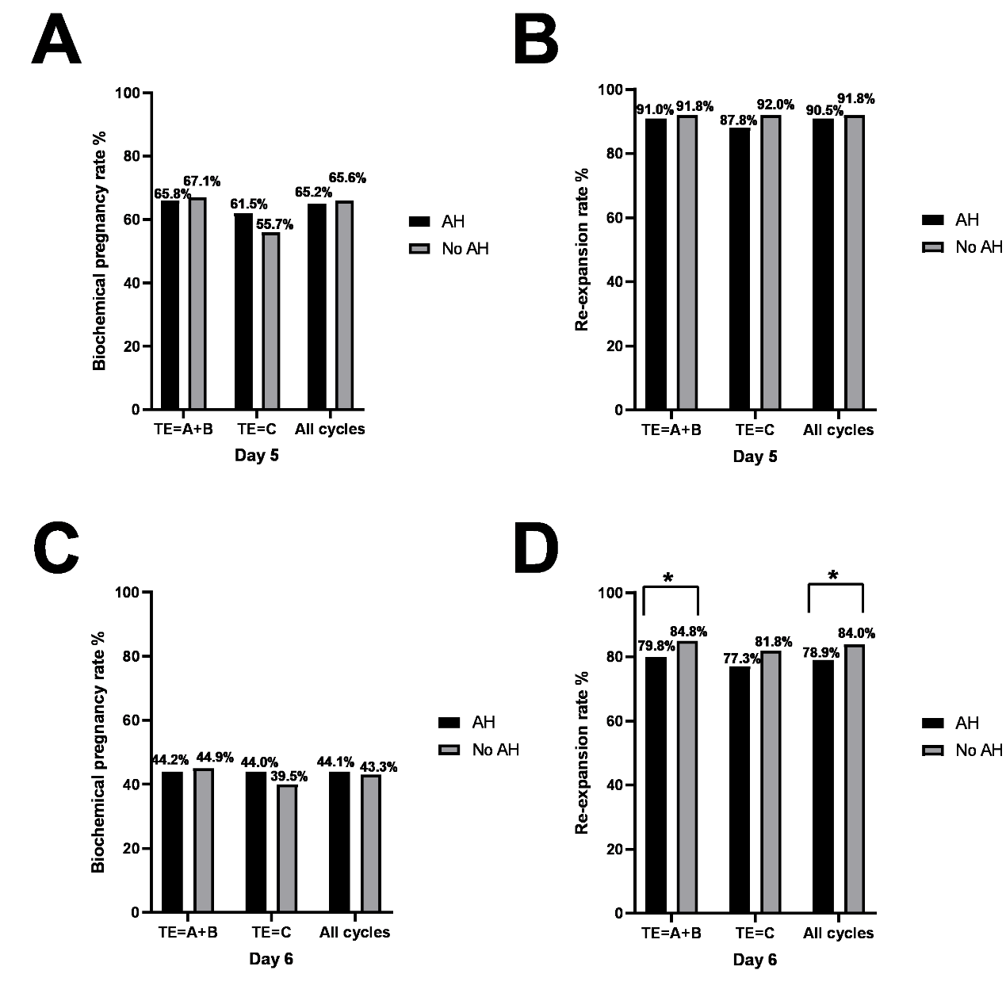
Abbreviations: AH, assisted hatching; TE, trophoblastic ectoderm.
Note: This figure showed the biochemical pregnancy rate and re-expansion rate with and without AH in cycles of TE grade=A+B, TE grade=C and all cycles. (A) and (B) showed the results of the comparison of biochemical pregnancy rate and re-expansion rate in Day5 cycles. (C) and (D) showed the results of the comparison of biochemical pregnancy rate and re-expansion rate in Day6 cycles. * P < 0.05.
Supplemental Figure 3 Pregnancy outcomes with and without AH in TE=A+B and TE=C cycles
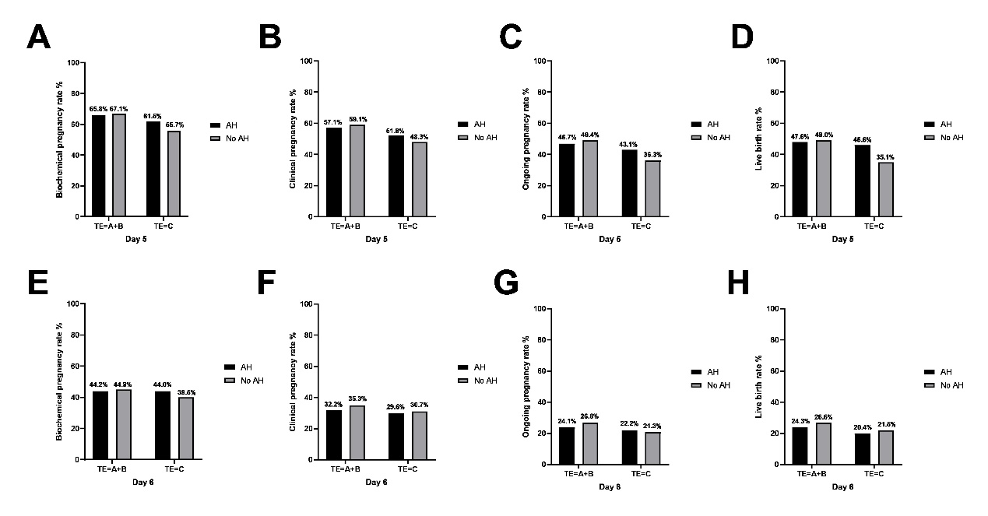
Abbreviations: AH, assisted hatching; TE, trophoblastic ectoderm.
Note: This figure showed the pregnancy outcomes with and without AH in cycles of TE grade=A+B and TE grade=C. (A), (B), (C) and (D) showed the results of the comparison of biochemical pregnancy rate, clinical pregnancy rate, ongoing pregnancy rate and live birth rate in Day5 cycles. (E), (F), (G) and (H) showed the results of the comparison of biochemical pregnancy rate, clinical pregnancy rate, ongoing pregnancy rate and live birth rate in Day6 cycles. There were no statistical differences between the AH and No AH groups in any of the figures.
Supplemental Figure 4 Pregnancy outcomes with and without AH in re-expansion and no re-expansion cycles
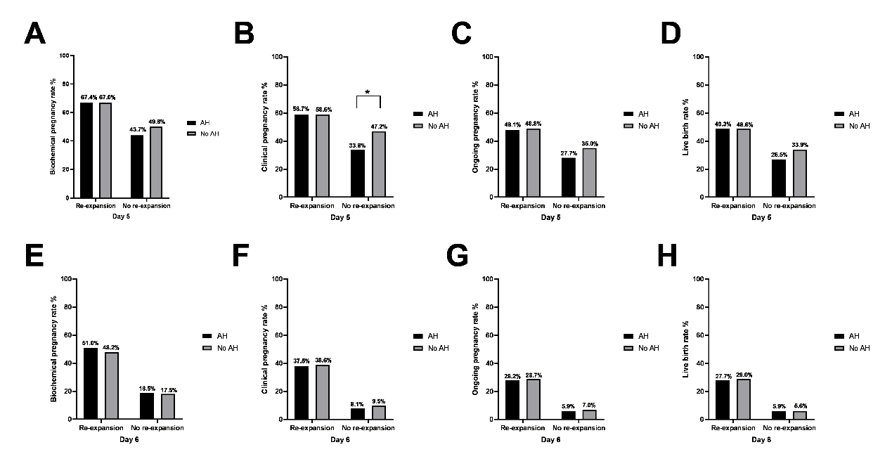
Abbreviations: AH, assisted hatching.
Note: This figure showed the pregnancy outcomes with and without AH in cycles of re-expansion and no re-expansion. (A), (B), (C) and (D) showed the results of the comparison of biochemical pregnancy rate, clinical pregnancy rate, ongoing pregnancy rate and live birth rate in Day5 cycles. (E), (F), (G) and (H) showed the results of the comparison of biochemical pregnancy rate, clinical pregnancy rate, ongoing pregnancy rate and live birth rate in Day6 cycles. * P < 0.05.
Supplemental Figure 5 Mechanism hypothesis diagram
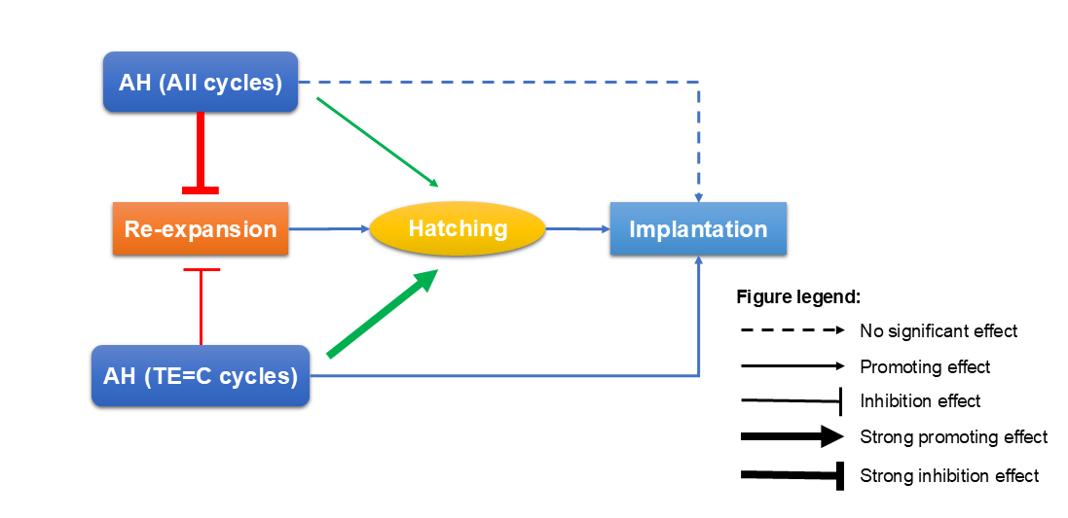
Abbreviations: AH, assisted hatching; TE, trophoblastic ectoderm.

