BAX:21 kDa; Bcl-2: 26 kDa; CYP19A1: 58 kDa; CCND1: 34kDa; GAPDH:36 kDa

β-actin:42 kDa

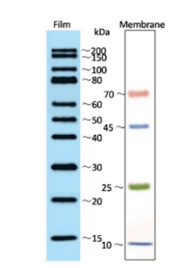
Fig 7-C BCL-2-OE
Fig 7-C BCL-2-SH

Fig 7-C BAX-SH
Fig 7-C BAX-OE
Fig 7-C GAPDH-OE
Fig 7-C GAPDH-SH
Fig 6-D B-ACTIN-SH
Fig 6-D B-ACTIN-OE

Fig 6-D CCND1-SH
Fig 6-D CCND1-OE
Fig 5-C CYP19A1-OE
Fig 5-C CYP19A1-SH
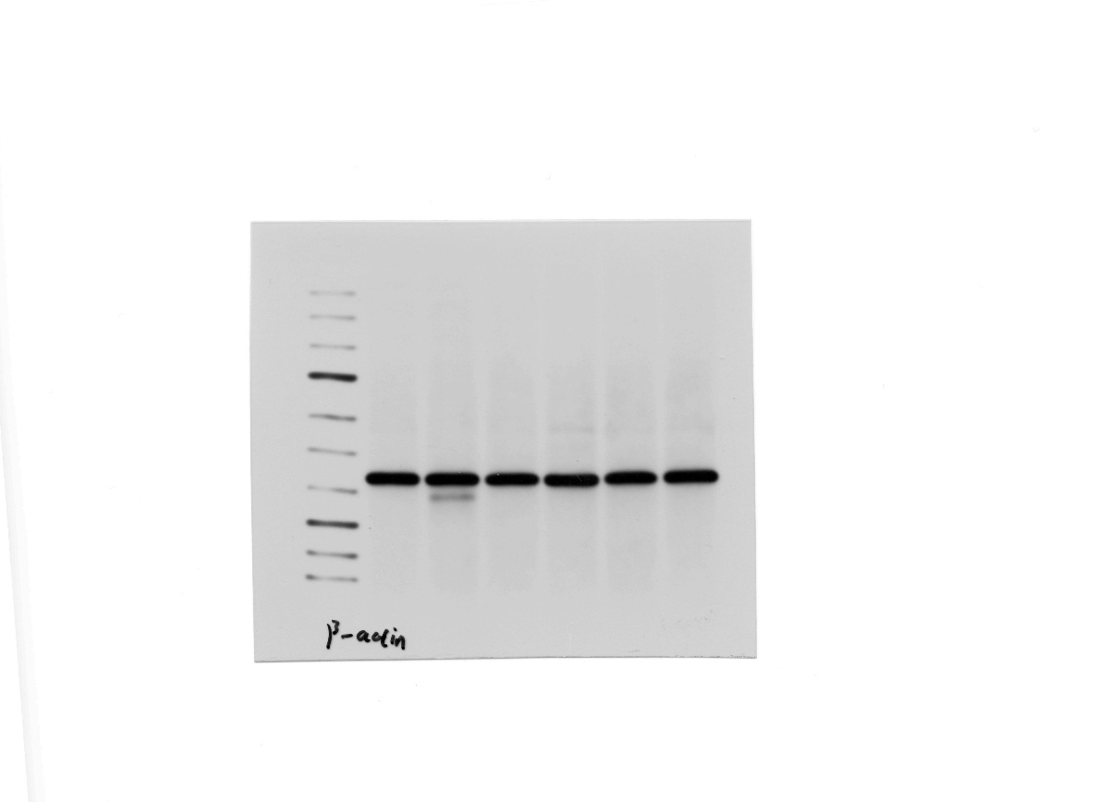
Fig 5-C B-ACTIN-OE
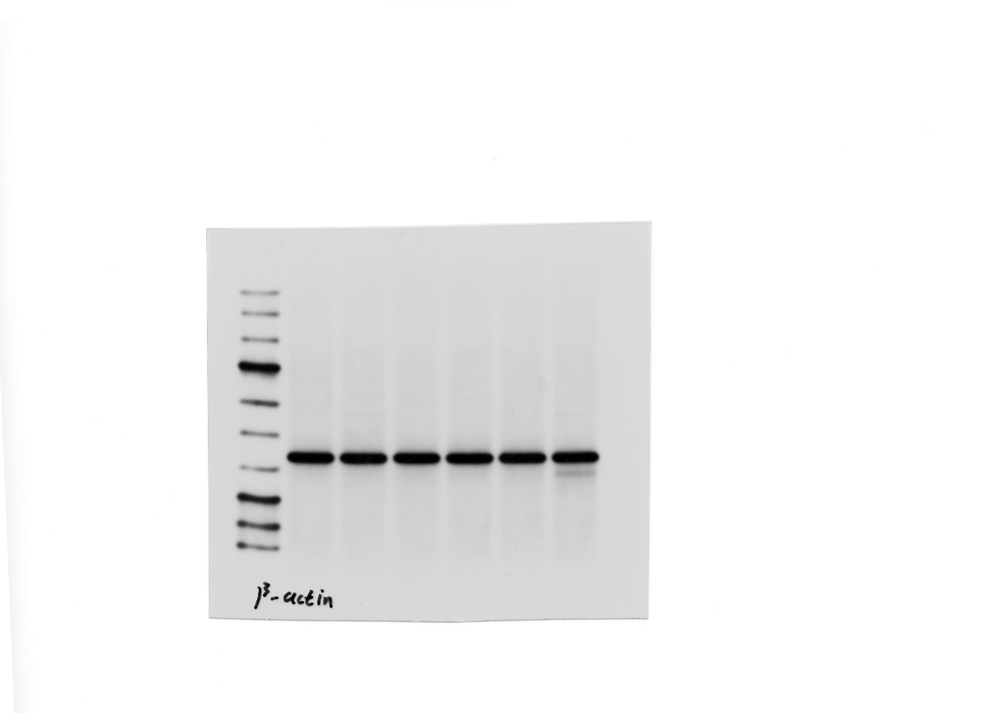
Fig 5-C B-ACTIN-SH

