Supplement Figure 1 Measurement of ovarian volume by 3D ultrasound
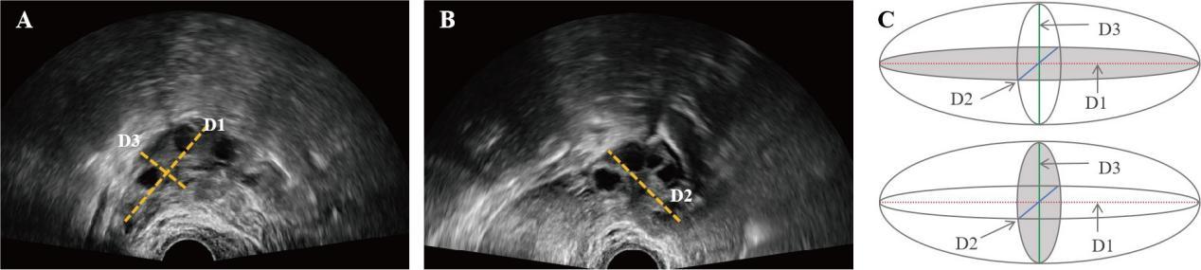
A, measurements of ovarian diameters D1(cm) and D3(cm); B, rotation of the probe by 90° to obtain ovarian diameter D2(cm); three diameters obtained by 3D-US, with shaded areas showing the orientation of the two planes.

Supplement Figure 2 Distribution of follicle sphericity

Supplement Figure 3 The follicular sphericity and AFC in the prediction of MII oocyte by ROC
*The blue curve indicates the ROC curve for AFC, and the red curve indicates the ROC curve for AFC combined with follicular sphericity.
Abbreviations: antral follicle count(AFC), follicular sphericity(FS)

Supplement Table 1 Baseline characteristics of patients with poor ovarian reserve or normal ovarian reserve

 | Patients with low ovarian reserve |  |  | Patients with normal ovarian reserve
 | Low sphericity  (n=28) | High sphericity  (n=19) | P | Low sphericity  (n=143) | High sphericity  (n=58) | P
Age | 32.65±3.51 | 32.67±4.58 | 0.412 | 30.72±3.79 | 31.76±4.17 | 0.089
BMI, kg/m2 | 22.43±2.93 | 21.85±2.6 | 0.561 | 22.34±3.14 | 22.92±3.07 | 0.236
Serum AMH, ng/mL | 1.7±0.85 | 1.16±0.44 | 0.044 | 4.94±2.68 | 4.12±3.13 | 0.064
Base serum P, IU/L | 0.23±0.11 | 0.24±0.14 | 0.863 | 0.25±0.21 | 0.28±0.13 | 0.373
Base serum FSH, IU/L | 7.32±1.77 | 7.31±2.31 | 0.979 | 5.71±1.41 | 6.01±1.37 | 0.178
Base serum LH, IU/L | 2.59±1.22 | 2.91±1.15 | 0.441 | 3.63±1.89 | 3.45±1.57 | 0.528
Base serum E2, pg/ml | 32.56±18.3 | 27.08±9.48 | 0.336 | 28.51±12.98 | 30.14±15.61 | 0.446
Number of AFC | 4.08±1.81 | 4.75±1.42 | 0.264 | 12.15±4.57 | 9.74±4.75 | 0.001
Infertility |  |  | 0.538 |  |  | 0.386
Male factor | 28.58%(8) | 10.53%(2) |  | 15.38%(22) | 13.79%(8)
Ovulatory dysfunction | 3.57%(1) | 5.26%(1) |  | 13.29%(19) | 10.34%(6)
Tubal factor | 50.00%(14) | 57.89%(11) |  | 69.93%(100) | 72.41%(42)
Diminished ovarian reserve | 10.71%(3) | 20.05%(4) |  | (0) | (0)
Unexplained factor | 7.14%(2) | 5.26%(1) |  | 1.40%(2) | 3.46%(2)
Fertilization |  |  | 0.713 |  |  | 0.605
ICSI | 28.57%(8) | 47.37%(9) |  | 26.57%(38) | 20.69%(12)
IVF | 71.43%(20) | 52.63%(10) |  | 73.43%(105) | 79.31%(46)
Starting dose of Gn | 245.67±50.86 | 245.83±33.43 | 0.992 | 176.14±42.35 | 203.88±52.78 | 0.001
Days of Gn administration | 8.31±1.64 | 7.50±0.67 | 0.112 | 8.80±6.19 | 8.10±1.33 | 0.400
Total dose of Gn | 1987.50±686.01 | 1806.25±370.52 | 0.398 | 1505.86±624.58 | 1682.76±549.6 | 0.061
*Abbreviations: BMI, body mass index; AMH,anti-Müllerian hormone; FSH, follicle-stimulating hormone; LH, Luteinizing hormone; E₂, estradiol; AFC, antral follicle count; IVF, in vitro fertilization; ICSI, intracytoplasmic sperm injection.

