Supplementary 1. preliminary optimization work to find the best dose. Here, 100 microliters of PVNLME (0.1, 1, 10, 100, and 1000 mg/ml) were separately injected every week for three consecutive weeks. After the fourth week, blood samples were collected from the heart tissue using an insulin syringe. The serum was then separated from the blood using a centrifuge. Then, the ELISA method was utilized to measure the antibody titer in immunized mice. The procedure involved coating the wells of a 96-well plate with the 1 mg/ml synthesized peptide, followed by the use of a 5% skim milk solution. Subsequently, the serum concentration series with dilutions of 1:10, 1:100, 1:1000, and 1:10000 were prepared and placed adjacent to the coated peptides. Mouse antibody conjugated with HRP enzyme was then added and after incubation and adding the substrate, the OD of each well was assessed at a wavelength of 630 nm. Finally, the OD of each well was compared with the OD of the control and cutoff baseline. Finally, two doses were selected, 10 and 100 mg/ml.

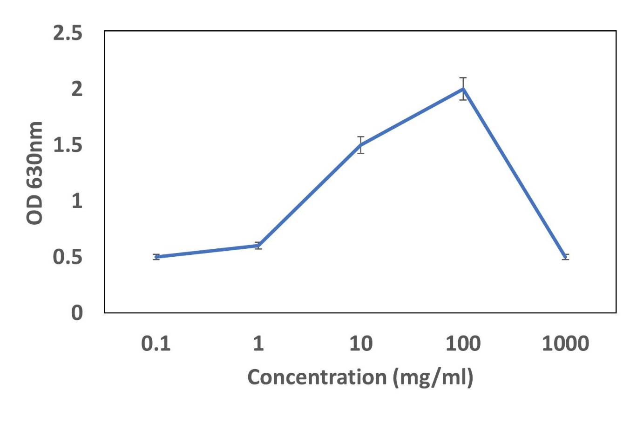

Supplementary 2. The clinical characterization of samples for PDX models

Tumor size (cm) | Histopathology | Age | Primary/  Metastasis | Origin | Tumor differentiation
4±1 | High-grade serous carcinoma 70%  Low-grade serous carcinoma 30% | 55±3 | Primary 45%  Metastasis 55% | Ovarian 90%  Lymph nude 10% | Undiff. 60%  Poor 40%

Supplementary 3. The basic characterization of Ovarian cancer used for PDX models.

ID number | Stroma content(%) | vascularization  (grade) | differentiation  (grade) | Take rate (%) | PDL-1 expression | TIL expression | doubling time (days)
1 | 9 | ++ | Poor. | 70 | 0.11 | 0.21 | 3
2 | 8 | ++ | Undiff. | 72 | 0.12 | 0.22 | 3
3 | 7 | ++ | Poor | 75 | 0.15 | 0.23 | 4
4 | 8 | ++ | Poor. | 74 | 0.22 | 0.17 | 5
5 | 5 | + | Poor. | 78 | 0.18 | 0.18 | 5
6 | 4 | +++ | Undiff. | 80 | 0.16 | 0.15 | 4
7 | 8 | ++ | Undiff. | 75 | 0.21 | 0.16 | 6
8 | 7 | ++ | Undiff. | 76 | 0.22 | 0.18 | 6
9 | 9 | + | Undiff. | 79 | 0.21 | 0.21 | 5
10 | 10 | ++ | Poor | 80 | 0.10 | 0.22 | 5
11 | 9 | ++ | Undiff. | 81 | 0.11 | 0.23 | 4
12 | 8 | +++ | Undiff. | 74 | 0.18 | 0.28 | 5

Supplementary 4. The stability test in physiological buffer (PBS) and 50% FBS
during 1-4 weeks FBS at 37 °C, 25 °C, 4 °C, and -20 °C by measuring their distribution size and Zeta potential

 | Mean size (nm)
 | Week 1 | Week 2 | Week 3 | Week 4
The nanoliposomes containing multi-epitope peptide | 111±1 | 112±1 | 114±1 | 115±2
The nanoliposomes alone | 110±1 | 110±1 | 111±1 | 111±1
 | Zeta potential (+mV)
 | Week 1 | Week 2 | Week 3 | Week 4
The nanoliposomes containing multi-epitope peptide | 30±1 | 30±1 | 29±1 | 28±1
The nanoliposomes alone | 30±1 | 30±1 | 30±1 | 28±1

 | Mean size (nm)
 | 37 °C | 25 °C | 4 °C | -20 °C
The nanoliposomes containing multi-epitope peptide | 112±1 | 112±1 | 115±1 | 120±2
The nanoliposomes alone | 110±1 | 110±1 | 110±1 | 120±1
 | Zeta potential (+mV)
 | 37 °C | 25 °C | 4 °C | -20 °C
The nanoliposomes containing multi-epitope peptide | 30±1 | 30±1 | 30±1 | 28±1
The nanoliposomes alone | 30±1 | 30±1 | 30±1 | 28±1

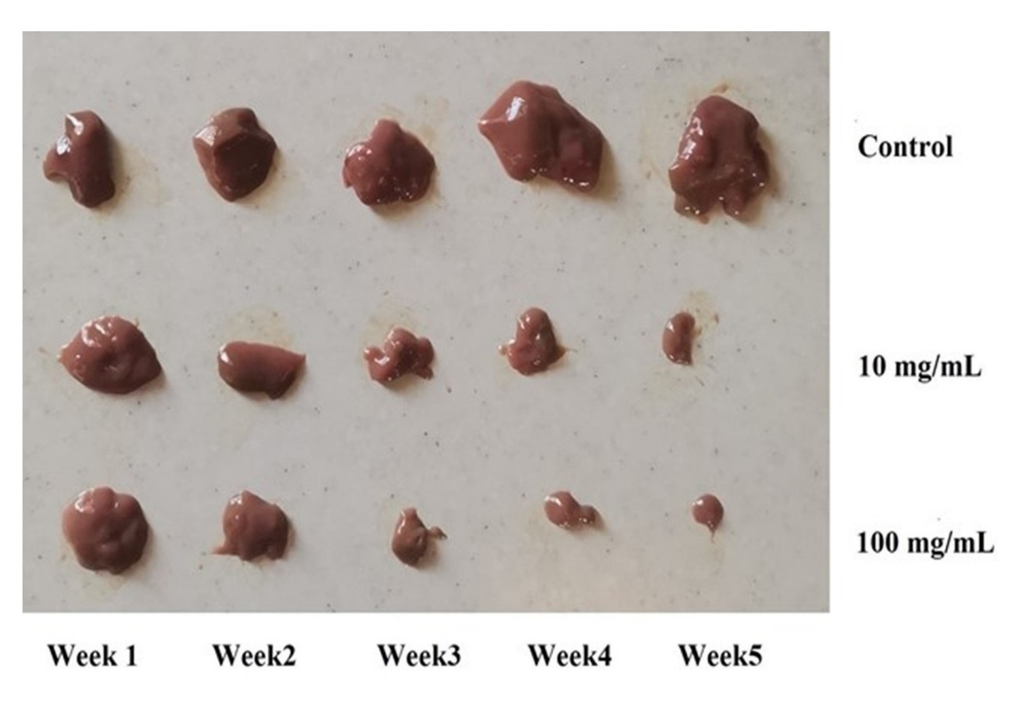
Supplementary 5. The tumor mass in PDX models vaccinated with PVNLME (10 mg/ml) and 6) PVNLME (100 mg/ml).

Supplementary 6. The mean cytokine levels and the cell quantification for CD8+, Tregs, MDSC, CD45RA(+) CCR7 (-), PD-1, and CTLA-4(+) cells in PDX models receiving, 1) empty nanoliposomes, 2) free multi-epitope peptide, 3) free irrelevant peptide, 4) PBS, 5) PVNLME (10 mg/ml), and 6) PVNLME (100 mg/ml). The sample size was n=6 mice per each group. * Indicates significant difference when compared with other groups at the same time (P<0.05, n=6).

 | Interleukin 4 (pg/ml)
 | Week 1 | Week 2 | Week 3 | Week 4 | Week 5
PBS | 10 | 11 | 10 | 11 | 10
Free irrelevant peptide | 10 | 11 | 10 | 11 | 11.5
Empty nanoliposomes | 11 | 10 | 10 | 10 | 11
Free multi-epitope peptide | 11 | 11 | 12 | 11 | 10
PVNLME (10 mg/ml) | 11 | 25* | 27* | 38* | 49*
PVNLME (100 mg/ml) | 12 | 28* | 38* | 45* | 62*
The non-humanized mice | 10 | 11 | 10 | 11 | 10
 | Interleukin 6 (pg/ml)
 | Week 1 | Week 2 | Week 3 | Week 4 | Week 5
PBS | 10 | 11 | 10 | 11 | 11
Free irrelevant peptide | 11 | 11 | 11 | 10 | 12
Empty nanoliposomes | 10 | 11 | 11 | 10 | 11
Free multi-epitope peptide | 11 | 12 | 11 | 10 | 11
PVNLME (10 mg/ml) | 21* | 32* | 82* | 155* | 302*
PVNLME (100 mg/ml) | 31* | 41* | 126* | 215* | 518*
The non-humanized mice | 11 | 11 | 11 | 10 | 11
 | Interleukin 10 (pg/ml)
 | Week 1 | Week 2 | Week 3 | Week 4 | Week 5
PBS | 11 | 11 | 11 | 10 | 11
Free irrelevant peptide | 10 | 10 | 11 | 11 | 12
Empty nanoliposomes | 10 | 11 | 10 | 10 | 11
Free multi-epitope peptide | 11 | 11 | 12 | 10 | 11
PVNLME (10 mg/ml) | 18 | 32* | 48* | 53* | 85*
PVNLME (100 mg/ml) | 15 | 31* | 65* | 77* | 185*
The non-humanized mice | 10 | 11 | 10 | 11 | 10
 | Tumor necrosis factor (pg/ml)
 | Week 1 | Week 2 | Week 3 | Week 4 | Week 5
PBS | 9 | 10 | 9 | 8 | 8
Free irrelevant peptide | 10 | 8 | 10 | 10 | 11
Empty nanoliposomes | 10 | 9 | 10 | 10 | 11
Free multi-epitope peptide | 11 | 11 | 10 | 11 | 12
PVNLME (10 mg/ml) | 12 | 20* | 35* | 49* | 65*
PVNLME (100 mg/ml) | 17 | 32* | 41* | 52* | 65*
The non-humanized mice | 9 | 8 | 10 | 9 | 9
 | Interferon-gamma (pg/ml)
 | Week 1 | Week 2 | Week 3 | Week 4 | Week 5
PBS | 10 | 11 | 11 | 10 | 11
Free irrelevant peptide | 11 | 11 | 10 | 11 | 12
Empty nanoliposomes
Free multi-epitope peptide
PVNLME (10 mg/ml) | 19 | 28* | 39* | 44* | 50*
PVNLME (100 mg/ml) | 22 | 30* | 49* | 70* | 81*
The non-humanized mice | 10 | 10 | 9 | 10 | 11
 | CD8+ T cells (Normalized to control)
 | Week 1 | Week 2 | Week 3 | Week 4 | Week 5
PBS | 1 | 1 | 1 | 1 | 1
Free irrelevant peptide | 1 | 1 | 1.1 | 1.2 | 1.2
Empty nanoliposomes | 1 | 1 | 1 | 1 | 1.2
Free multi-epitope peptide | 1 | 1 | 1 | 1 | 1.3
PVNLME (10 mg/ml) | 1.5* | 2* | 2.8* | 3.2* | 4*
PVNLME (100 mg/ml) | 1.6* | 2.1* | 3* | 3.5* | 4.2*
The non-humanized mice | 1 | 1 | 1 | 1 | 1
 | Tregs (Normalized to control)
 | Week 1 | Week 2 | Week 3 | Week 4 | Week 5
PBS | 1 | 1 | 1 | 1 | 1
Free irrelevant peptide | 1 | 1 | 1.2 | 1.4 | 1.5
Empty nanoliposomes | 1 | 1 | 1 | 1 | 1
Free multi-epitope peptide | 1 | 1 | 1 | 1 | 1.4
PVNLME (10 mg/ml) | 1.6* | 1.9* | 2.6* | 3.1* | 5*
PVNLME (100 mg/ml) | 1.6* | 2.1* | 2.7* | 3.5* | 6*
The non-humanized mice | 1 | 1 | 1 | 1 | 1
 | MDSCs (Normalized to control)
 | Week 1 | Week 2 | Week 3 | Week 4 | Week 5
PBS | 1 | 1 | 1 | 1 | 1
Free irrelevant peptide | 1 | 1.1 | 1.2 | 1.2 | 1.2
Empty nanoliposomes | 1 | 1 | 1.1 | 1 | 1
Free multi-epitope peptide | 1 | 1.2 | 1.3 | 1.4 | 1.
PVNLME (10 mg/ml) | 5* | 4.2* | 3.5* | 2.8* | 1.5*
PVNLME (100 mg/ml) | 5.1* | 4* | 3.1* | 2.1* | 1.5*
The non-humanized mice | 1 | 1 | 1 | 1 | 1
 | PD-1 (Normalized to control)
 | Week 1 | Week 2 | Week 3 | Week 4 | Week 5
PBS | 1 | 1 | 1 | 1 | 1
Free irrelevant peptide | 1 | 1 | 1 | 1 | 1
Empty nanoliposomes | 1 | 1 | 1 | 1 | 1
Free multi-epitope peptide | 1 | 1.1 | 1.2 | 1.2 | 1.3
PVNLME (10 mg/ml) | 6* | 5.2* | 4.2* | 3* | 2*
PVNLME (100 mg/ml) | 6.1* | 5* | 4* | 3* | 1.9*
The non-humanized mice | 1 | 1 | 1 | 1 | 1
 | CTLA-4 (Normalized to control)
 | Week 1 | Week 2 | Week 3 | Week 4 | Week 5
PBS | 1 | 1 | 1 | 1 | 1
Free irrelevant peptide | 1 | 1.1 | 1.1 | 1.1 | 1
Empty nanoliposomes | 1 | 1 | 1 | 1 | 1
Free multi-epitope peptide | 1 | 1 | 1.1 | 1.2 | 1.2
PVNLME (10 mg/ml) | 4* | 3.2* | 3* | 2* | 1.3*
PVNLME (100 mg/ml) | 4.1* | 3* | 2.8* | 2* | 1.1*
The non-humanized mice | 1 | 1 | 1 | 1 | 1
 | CD45RA(+) CCR7 (-) (Normalized to control)
 | Week 1 | Week 2 | Week 3 | Week 4 | Week 5
PBS | 1 | 1 | 1 | 1 | 1
Free irrelevant peptide | 1 | 1 | 1 | 1.2 | 1.2
Empty nanoliposomes | 1 | 1 | 1 | 1 | 1
Free multi-epitope peptide | 1 | 1 | 1.2 | 1.2 | 1.3
PVNLME (10 mg/ml) | 1.2* | 2* | 2.9* | 3.1* | 3.6*
PVNLME (100 mg/ml) | 1.3* | 2.1* | 2.9* | 3* | 3.8*
The non-humanized mice | 1 | 1 | 1 | 1 | 1
 | hCD34+ (Normalized to control)
 | Week 1 | Week 2 | Week 3 | Week 4 | Week 5
PBS | 1 | 1 | 1 | 1 | 1
Free irrelevant peptide | 1 | 1 | 1 | 1 | 1.2
Empty nanoliposomes | 1 | 1 | 1 | 1 | 1
Free multi-epitope peptide | 1 | 1 | 1.1 | 1.2 | 1.2
PVNLME (10 mg/ml) | 11 | 11 | 10 | 11 | 10
PVNLME (100 mg/ml) | 10 | 11 | 11 | 11 | 10
The non-humanized mice | ND | ND | ND | ND | ND

Supplementary 7. The quantification of CD8, Ki-67, cleaved caspase-3 markers inside of tumor, liver, and kidney in humanized and non-humanized mice at week 5 to assess toxicity based on histopathology data.

 | CD8 (Normalized to control)
 | Tumor | Liver | Kidney
PBS | 1 | 1 | 1
Free irrelevant peptide | 1 | 1.1 | 1.1
Empty nanoliposomes | 1 | 1 | 1
Free multi-epitope peptide | 1 | 1 | 1.1
PVNLME (10 mg/ml) | 5* | 1.5 | 1.9
PVNLME (100 mg/ml) | 6* | 1.6 | 1.8
The non-humanized mice | 1 | 1 | 1
 | Ki-67 (Normalized to control)
 | Tumor | Liver | Kidney
PBS | 1 | 1 | 1
Free irrelevant peptide | 1 | 1.1 | 1.2
Empty nanoliposomes | 1 | 1 | 1
Free multi-epitope peptide | 1 | 1.1 | 1.2
PVNLME (10 mg/ml) | 6* | 1.3 | 1.3
PVNLME (100 mg/ml) | 7* | 1.2 | 1.3
The non-humanized mice | 1 | 1 | 1
 | Cleaved Caspase-3 (Normalized to control)
 | Tumor | Liver | Kidney
PBS | 1 | 1 | 1
Free irrelevant peptide | 1 | 1 | 1
Empty nanoliposomes | 1 | 1 | 1
Free multi-epitope peptide | 1 | 1 | 1
PVNLME (10 mg/ml) | 6 | 1 | 1.2
PVNLME (100 mg/ml) | 5 | 1 | 1
The non-humanized mice | 1 | 1 | 1

