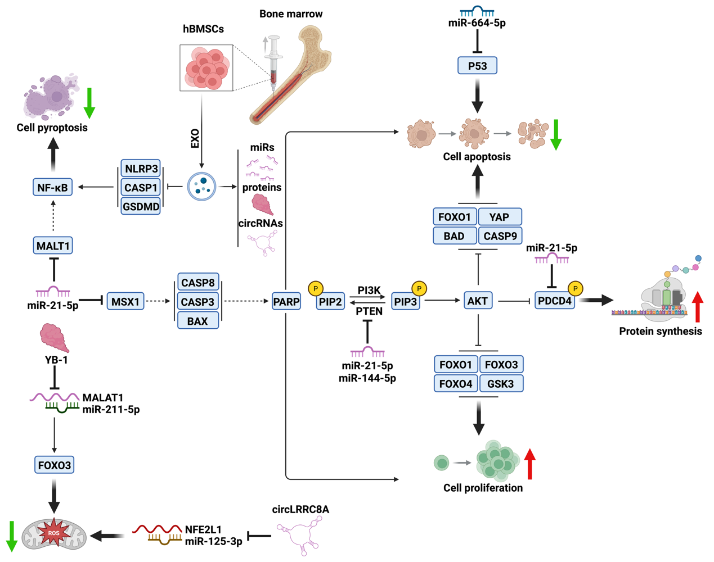
Fig. S2 Schematic diagram of the mechanism of human bone marrow mesenchymal stem cell-derived exosomes in the treatment of premature ovarian insufficiency. hBMSCs, human bone marrow mesenchymal stem cells; EXO, exosomes; miR, micro ribonucleic acid; circRNAs, circular ribonucleic acid. (Created with Biorender.com)

