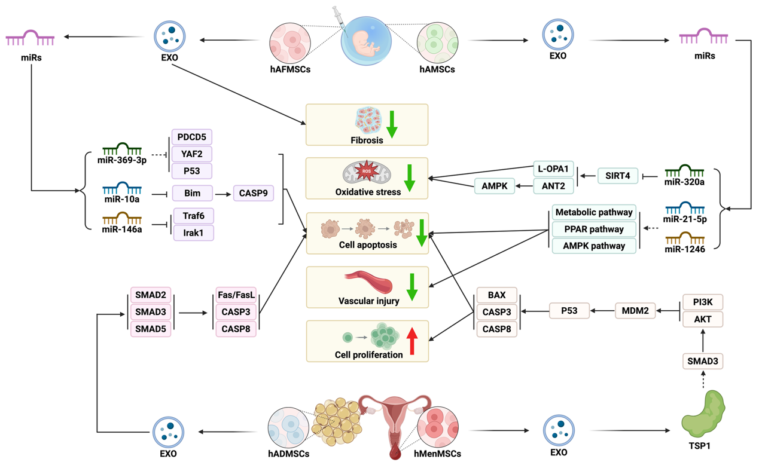
Fig. S3 Schematic diagram of the mechanism of human amniotic fluid & amniotic & adipose & menstrual blood mesenchymal stem cell-derived exosomes in the treatment of premature ovarian insufficiency. hAFMSCs, human amniotic fluid mesenchymal stem cells; hAMSCs, human amniotic mesenchymal stem cells; hADMSCs, human adipose mesenchymal stem cells; hMenMSCs, human menstrual blood mesenchymal stem cells; EXO, exosomes; miRs, micro ribonucleic acid; TSP1, thrombospondin-1. (Created with Biorender.com)

