Additional material

Distinct urinary exosomal microRNAs as biomarkers for differentiating premature ovarian insufficiency and menopause

Syeda Maham^{1 #}, Jae Hee Kang^{2#}, Ibadullah Kahttana³, Soohyun Oh², Mee-Sup Yoon^{1,4,5*}, Seung Joo Chon^{2 *}

¹Department of Health Sciences and Technology, GAIHST, Gachon University, Incheon, 21999, Korea, ²Department of Obstetrics and Gynecology, Gil Medical Center, College of Medicine, Gachon University, Incheon, 21565, Korea, ³Division of Electronics and Information Engineering, Jeonbuk National University, Jeonju, 54896, Korea, ⁴Lee Gil Ya Cancer and Diabetes Institute, Gachon University, Incheon, 21999, Korea, ⁵Department of Molecular Medicine, College of Medicine, Gachon University, Incheon, 21999, Korea.
#These authors contributed equally to this work.

* Corresponding Author: Professor Mee-Sup Yoon, Professor Seung Joo Chon
Additional Materials and Methods
Participant Selection and Menopausal Stage Classification
Inclusion criteria required participants to visit the Department of Gynecology of Gil Hospital, Gachon University and complete a hospital-administered questionnaire. Exclusion criteria included (1) use of hormone therapy or hormonal contraception within one month, (2) presence of severe medical conditions such as myocardial infarction, stroke, and cancer, (3) prior surgical removal of both ovaries before menopause, and (4) absence of medical records within a year. Menopausal stages classification was based on self-reported menstrual cycle patterns, following the STRAW+10 criteria (19-21). Participants were categorized as follows: (1) Premenopause, defined by regular to variable menstrual cycles, (2) Postmenopause: amenorrhea for 12 months or more since the last period. Notably, this classification relies solely on self-reported menstrual history and age and did not incorporate follicle-stimulating hormone (FSH) levels, in premenopausal women since serum FSH evaluation is not a routinely required index in women of these age groups.
Participant Recruitment and Sample Collection for POI
All individuals, including POI patients and control participants, were women who sought medical care at the outpatient clinic in the Department of Gynecology of Gil Hospital, Gachon University (Incheon, Korea), between January 2019 and August 2021. POI was diagnosed in women under 40 years of age who had experienced amenorrhea for at least six months, accompanied by persistent hypergonadotropic hypogonadism, confirmed by elevated gonadotropin levels measured at four-week intervals. The duration of amenorrhea was determined from the date of the last menstrual period to the first outpatient visit. The control group consisted of non-pregnant women with regular menstrual cycles and no abnormalities detected via gynecologic ultrasonography. Exclusion criteria included a history of medication use affecting glucose or lipid metabolism and any known medical conditions, such as polycystic ovarian syndrome (PCOS), Cushing’s syndrome, congenital adrenal hyperplasia, androgen-secreting tumors, or endometriosis. Urine samples were collected from 11 POI patients and 11 control participants. For individuals with active menstrual cycles, morning urine samples were obtained on non-menstrual days to ensure sample consistency.

Table S1: Sequences of the microRNA primers used in this study.
microRNA | Cat. No | Sequence
hsa-miR-4516 | YP02112882 | GGGAGAAGGGUCGGGGC
hsa-let-7f-5p | YP00204359 | UGAGGUAGUAGAUUGUAUAGUU
hsa-let-7c-5p | YP00204767 | UGAGGUAGUAGGUUGUAUGGUU
hsa-miR-151a-5p | YP00204007 | UCGAGGAGCUCACAGUCUAGU
hsa-miR-16-5p | YP00205702 | UAGCAGCACGUAAAUAUUGGCG
hsa-miR-29a-3p | YP00204698 | UAGCACCAUCUGAAAUCGGUUA
hsa-miR-30b-5p | YP00204765 | UGUAAACAUCCUACACUCAGCU

Table S2: Mouse primers used in this study.

Gene | Forward (5`-3`) | Reverse (5`-3`)
Gapdh | TCCCACTCTTCCACCTTCGA | CAGGAAATGAGCTTGACAAAGTTG
Amh | CCACACCTCTCTCCACTGGTA | GGCACAAAGGTTCAGGGGG
Fsh | GCCATAGCTETGAATTGACCA | AGATCCCTAGTGTAGCAGTAGC
Gene abbreviations: Gapdh; Glyceraldehyde-3-phosphate dehydrogenase, Amh; Anti-mullerian hormone, Fsh; Follicle stimulating hormone.

No | miRNA | miRNA sequencing
No | miRNA | Up/Down | Fold change | P-value
1 | has-miR-4516 | Up | 35.549 | 0.32
2 | hsa-miR-30b-5p | Down | 0.010 | 0.064
3 | hsa-miR-16-5p | Down | 0.007 | 0.038
4 | hsa-let-7c-5p | Down | 0.142 | 0.025
5 | hsa-let-7f-5p | Down | 0.348 | 0.026
6 | hsa-miR-151a-5p | Down | 0.105 | 0.026
7 | hsa-miR-29a-3p | Down | 0.001 | 0.136
Table S3. Differentially expressed microRNAs identified by miRNA sequencing in patients with premature ovarian syndrome (POI).

Table S4: FDR-adjusted significance of candidate miRNA in control and POI
miRNA | p_POI | q_POI | rank_POI | bh_crit_POI | signif_POI_5%
hsa-miR-30b-5p | 0.0001 | 0.00035 | 1 | 0.007143 | TRUE
hsa-miR-16-5p | 0.0001 | 0.00035 | 2 | 0.014286 | TRUE
hsa-miR-4516 | 0.001 | 0.00175 | 4 | 0.028571 | TRUE
hsa-miR-29a-3p | 0.0008 | 0.00175 | 3 | 0.021429 | TRUE
hsa-let-7f-5p | 0.0015 | 0.0021 | 5 | 0.035714 | TRUE
hsa-let-7c-5p | 0.0031 | 0.003617 | 6 | 0.042857 | TRUE
hsa-miR-151a-5p | 0.0037 | 0.0037 | 7 | 0.05 | TRUE

Abbreviations: p_POI; raw p value of POI , q_POI; Benjamini-Hochberg adjusted p-value (q-value) in POI, rank_POI; Rank order of raw p-values (1 = smallest) for POI, bh_crit_POI; Benjamini–Hochberg critical threshold at each rank, calculated as (rank / total tests) × 0.05, signif_POI_5%; Statistical significance at a 5% false discovery rate (TRUE/FALSE)

Table S5: False discovery rate-adjusted significance analysis of candidate miRNAs between pre-menopausal and post-menopausal women.
miRNA | p_PM | q_PM | rank_PM | bh_crit_PM | signif_PM _5%
hsa-miR-4516 | 0.0001 | 0.000175 | 1 | 0.007143 | TRUE
hsa-miR-30b-5p | 0.0001 | 0.000175 | 2 | 0.014286 | TRUE
hsa-miR-29a-3p | 0.0001 | 0.000175 | 3 | 0.021429 | TRUE
hsa-miR-151a-5p | 0.0037 | 0.0037 | 6 | 0.05 | TRUE
hsa-let-7f-5p | 0.0005 | 0.0007 | 4 | 0.035714 | TRUE
hsa-let-7c-5p | 0.0027 | 0.00315 | 5 | 0.042857 | TRUE
hsa-miR-16-5p | ns | ns | ns | ns | FALSE

Abbreviations: p_PM; Raw p value in Post-menopause, q_PM; Benjamini-Hochberg adjusted p-value (q-value) in post-menopause, rank_PM; Rank order of the raw p-value (1 = smallest), bh_crit_PM; Benjamini–Hochberg criterion threshold at each rank, calculated as (rank / total tests) × 0.05, signif_PM_5%; Statistical significance at a 5% false discovery rate (TRUE/FALSE)

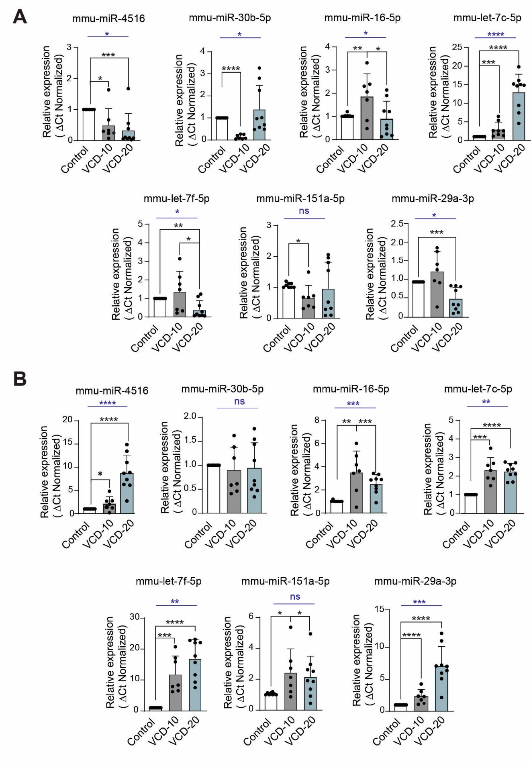
Figure S1. Tissue specific miRNA expression in VCD-induced mouse model.
(A) Relative miRNA expression (mmu-miR-4516, mmu-miR-30b-5p, mmu-miR-16-5p, mmu-let-7c-5p, mmu-let-7f-5p, mmu-miR-151a-5p, and mmu-miR-29a-3p) in uterine tissues. (B) Relative miRNA expression in kidney tissue. Expression levels were normalized to mmu-miR-103a-3p. Data are presented as mean ± standard deviation (control: n=8, VCD-10: n=7, VCD-20: n=9). Overall group differences were assessed by using one-way ANOVA with Tukey’s post hoc test. Blue asterisks above bars indicate significant differences between groups. Pairwise comparisons were further evaluated by Mann–Whitney U test. Asterisks (*) indicate significant differences (*p < 0.05, **p < 0.01, ***p < 0.001, ****p < 0.0001).

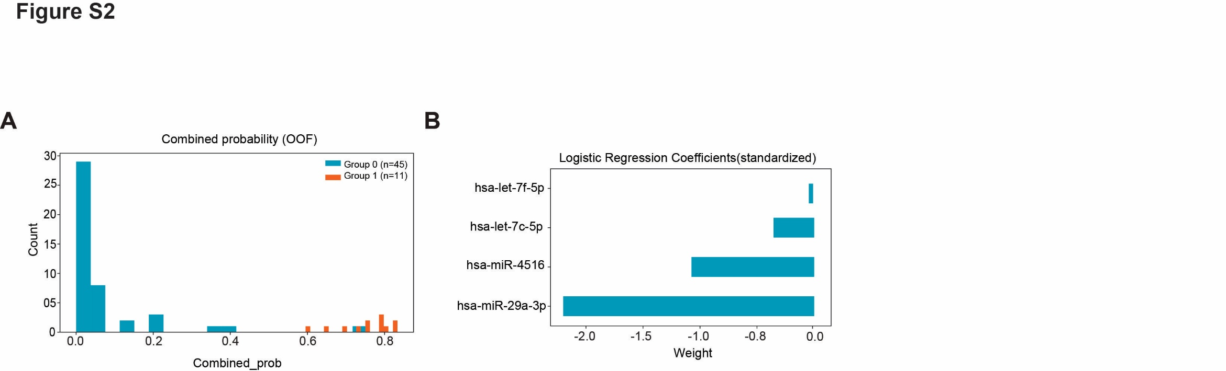

Figure S2: Logistic regression analysis of selected miRNAs from Receiver Operating Characteristic (ROC) model.
(A) Histogram displaying the out-of-fold (OOF) predicted probabilities for each subject, generated via five-fold cross-validation. Group 0 represents post-menopause subjects (n = 45, blue bars), and group 1 represents POI subjects (n = 11, orange bars). The clear separation of probability distributions highlights the strong discriminative power of the combined miRNA panel for distinguishing POI from post-menopause. (B) Bar plot showing the standardized logistic regression coefficients (weights) for each urinary exosomal miRNA within the multivariable model, indicating their direction and relative influence on classification between POI and post-menopause.
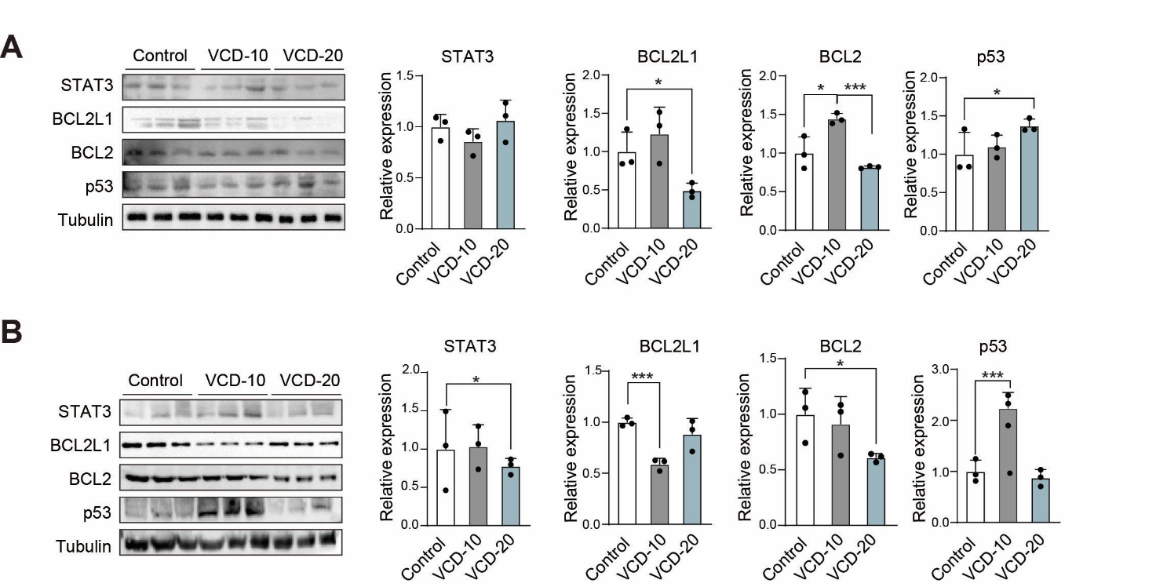

Figure S3. Protein expression analysis of STAT3, BCL2L1, BCL2 and p53 in uterine and kidney tissues of the VCD-induced mouse model.
(A) Western blot analysis and quantification of STAT3, BCL2L1, BCL2, and p53 protein levels in the uterine tissues from control, VCD-10 and VCD-20 groups (n=3 per group). (B) Western blot analysis and quantification of STAT3, BCL2L1, BCL2, and p53 protein levels in kidney tissues from control, VCD-10 and VCD-20 groups (n=3 per group). Protein levels were normalized to tubulin and band intensities were quantified using ImageJ software. Data are presented as mean ± SD (n = 3 per group). Pairwise comparisons between groups were evaluated using two-tailed unpaired Student's t-tests. Asterisks (*) indicate significant differences (*p < 0.05, ***p < 0.001) compared to control group.

