Supplementary Table 1. Search strategies
(Fibre*[tiab] OR fiber[tiab] OR fibrous[tiab] OR prebiotic*[tiab] OR inulin[tiab] OR resistant starch[tiab] OR resistant-starch[tiab] OR pectin*[tiab] OR cellulose*[tiab] OR lignin[tiab] OR gum[tiab] OR plant mucilage[tiab] OR plant-mucilage[tiab] OR roughage[tiab] OR hemicellulose*[tiab] OR psyllium[tiab] OR beta-glucan*[tiab] OR beta glucan [tiab] OR whole grain*[tiab] OR bran[tiab] OR crude-fibre[tiab] OR soluble-fibre[tiab] OR soluble fibre*[tiab] OR fermentable-fibre[tiab] OR fermentable-fibre[tiab] OR insoluble-fibre[tiab] OR dextrin*[tiab] OR oligosaccharide*[tiab] OR wheat-bran[tiab] OR polysaccharide*[tiab] OR non-starch polysaccharide*[tiab] OR arabinoxylan*[tiab] OR fructan*[tiab] OR polyuronide*[tiab] OR raffinose[tiab] OR polydextrose[tiab] OR xantham gum*[tiab] OR xantham-gum*[tiab] OR guar gum*[tiab] OR guar-gum*[tiab] OR plant gum*[tiab] OR plant-gum*[tiab] OR methylcellulose*[tiab] OR arabinogalactan*[tiab] OR galactomannan*[tiab] OR synbiotic*[tiab] OR symbiotic*[tiab] OR Microbiota*[Tiab] OR Microbiome[Tiab] OR Microbiome*[Tiab] OR Gut microflora*[Tiab] OR Gut-microflora*[Tiab] OR Gut-microbiota*[Tiab] OR Human-Microbiome*[Tiab] OR cultured milk products[MeSH Terms] OR milk product[Title/Abstract] OR yogurt*[Title/Abstract] OR kefir*[Title/Abstract] OR dairy product*[Title/Abstract] OR Fermented Foods and Beverages[MeSH Terms] OR Fermented milk[Title/Abstract] OR Nissle[Title/Abstract] OR Fermented Foods[Title/Abstract] OR buttermilk[Title/Abstract] OR lassi[Title/Abstract] OR doogh[Title/Abstract] OR dough[Title/Abstract] OR dahi[Title/Abstract] OR amasi[Title/Abstract] OR filmjolk[Title/Abstract] OR chal[Title/Abstract] OR yeast*[Title/Abstract]) OR synbiotics [MeSH Terms] OR cultured milk products [MeSH Terms] OR Dietary Fiber [MeSH terms] OR prebiotics[MeSH Terms] OR "Dietary Approaches To Stop Hypertension"[Mesh] OR DASH [tiab] OR Dietary Approaches to Stop Hypertension [tiab] OR mediterranean [tiab] OR MED diet* [tiab] OR MD diet* [tiab] OR "Diet, Mediterranean"[Mesh]) AND (Polycystic Ovary Syndrome[MeSH] OR Polycystic Ovary Syndrome*[tiab] OR Ovary Syndrome, Polycystic[Tiab] OR Syndrome, Polycystic Ovary[Tiab] OR Stein-Leventhal Syndrome[Tiab] OR Stein Leventhal Syndrome [Tiab] OR Syndrome, Stein-Leventhal[Tiab] OR Sclerocystic Ovarian Degeneration[Tiab] OR Ovarian Degeneration, Sclerocystic [Tiab] OR Sclerocystic Ovary Syndrome [Tiab] OR Polycystic Ovarian Syndrome*[Tiab] OR Ovarian Syndrome, Polycystic[Tiab] OR Sclerocystic Ovar* [Tiab] OR Ovary, Sclerocystic[Tiab] OR Sclerocystic Ovary[Tiab])

 | NO | SMD (95% CI) | I² (%) | P-heterogeneity
Weight
Type of intervention
Synbiotics | 7 | -0.71 (-1.35, -0.06) | 89.7 | <0.001
Prebiotics | 2 | -0.37 (-0.73, -0.02) | 0.0 | 0.872
Duration (week)
≤8 | 6 | -0.21 (-0.41, -0.01) | 0.0 | 0.460
>8 | 3 | -2.26 (-4.44, -0.08) | 96.2 | <0.001
BMI
≤ 30 | 1 | -0.62 (-1.24, -0.00) | - | -
˃ 30 | 8 | -0.58 (-1.11, -0.04) | 87.8 | <0.001
BMI
Type of intervention
Synbiotics | 7 | -0.42 (-0.85, 0.00) | 78.1 | <0.001
Prebiotics | 2 | -0.48 (-0.83, -0.12) | 0.0 | 0.882
Duration (week)
≤8 | 1 | -0.62 (-1.24, -0.00) | - | -
>8 | 8 | -0.58 (-1.11, -0.04) | 87.8 | <0.001
WC
Type of intervention
Synbiotics | 5 | -0.84 (-1.57, -0.12) | 88.4 | <0.001
Prebiotics | 2 | -0.73 (-1.10, -0.37) | 0.0 | 0.966
Duration (week)
≤8 | 1 | -0.84 (-1.47, -0.21) | - | -
>8 | 6 | -0.78 (-1.35, -0.21) | 85.9 | <0.001
BMI
≤ 30 | 4 | -0.58 (-0.89, -0.26) | 37.8 | 0.185
˃ 30 | 3 | -1.18 (-2.67, 0.31) | 93.7 | <0.001
HC
Duration (week)
≤8 | 1 | 0.0 (-0.60, 0.60) | - | -
>8 | 4 | -0.29 (-0.88, 0.30) | 80.9 | 0.001
BMI
≤ 30 | 2 | -0.09 (-0.42, 0.23) | 0.0 | 0.722
˃ 30 | 3 | -0.40 (-1.36, 0.56) | 87.2 | <0.001
WHR
Duration (week)
≤8 | 1 | -1.34 (-2.01, -0.67) | - | -
>8 | 4 | -0.711 (-1.46, 0.04) | 87.5 | <0.001
BMI
≤ 30 | 2 | -0.80 (-1.78, 0.19) | 84.6 | 0.011
˃ 30 | 3 | -0.92 (-2.18, 0.33) | 91.7 | <0.001

Supplementary Table 2. The effect of prebiotics and synbiotics interventions on obesity indices.

Supplementary Table 3. The effect of prebiotics and synbiotics interventions on lipid profile.
 | NO | SMD (95% CI) | I² (%) | P-heterogeneity
TC
Type of intervention
Synbiotics | 7 | -0.65 (-1.27, -0.03) | 88.0 | <0.001
Prebiotics | 1 | -0.99 (-1.51, -0.46) | - | -
Duration (week)
≤8 | 2 | -0.53 (-0.92, -0.15) | 0.0 | 0.331
>8 | 6 | -0.78 (-1.54, -0.02) | 90.8 | <0.001
BMI
≤ 30 | 5 | -0.45 (-0.82, -0.08) | 59.4 | 0.043
˃ 30 | 3 | -1.46 (-3.34, 0.42) | 95.6 | <0.001
TG
Type of intervention
Synbiotics | 7 | -0.59 (-1.11, -0.07) | 83.6 | <0.001
Prebiotics | 1 | -0.84 (-1.36, -0.32) | - | -
Duration (week)
≤8 | 2 | -0.49 (-1.06, 0.08) | 52.0 | 0.149
>8 | 6 | -0.68 (-1.29, -0.06) | 86.5 | <0.001
BMI
≤ 30 | 5 | -0.47 (-0.91, -0.02) | 71.5 | 0.007
˃ 30 | 3 | -1.01 (-2.31, 0.29) | 92.0 | <0.001
LDL-C
Type of intervention
Synbiotics | 7 | -0.62 (-1.16, -0.09) | 84.5 | <0.001
Prebiotics | 1 | -1.27 (-1.81, -0.72) | - | -
Duration (week)
≤8 | 2 | -0.65 (-1.04, -0.26) | 1.7 | 0.313
>8 | 6 | -0.74 (-1.42, -0.05) | 88.9 | <0.001
BMI
≤ 30 | 5 | -0.50 (-1.02, 0.02) | 79.1 | 0.001
˃ 30 | 3 | -1.21 (-2.56, 0.15) | 92.3 | <0.001
HDL-C
Type of intervention
Synbiotics | 7 | 0.31 (0.09, 0.54) | 18.0 | 0.292
Prebiotics | 1 | 0.85 (0.33, 1.37) | - | -
Duration (week)
≤8 | 2 | 0.57 (0.19, 0.95) | 0.0 | 0.749
>8 | 6 | 0.31 (0.01, 0.61) | 47.4 | 0.090
BMI
≤ 30 | 5 | 0.41 (0.08, 0.74) | 49.1 | 0.097
˃ 30 | 3 | 0.33 (-0.05, 0.72) | 30.5 | 0.237

Supplementary Table 4. The effect of prebiotics and synbiotics interventions on FPG, and CRP.

 | NO | SMD (95% CI) | I² (%) | P-heterogeneity
FPG
Type of intervention
Synbiotics | 7 | -0.44 (-0.85, -0.03) | 76.8 | <0.001
Prebiotics | 1 | -1.43 (-1.99-0.87) | - | -
Duration (week)
≤8 | 2 | -0.54 (-0.93, -0.15) | 3.5 | 0.309
>8 | 6 | -0.61 (-1.20, -0.03) | 86.7 | <0.001
BMI
≤ 30 | 5 | -0.63 (-1.01, -0.26) | 64.30 | 0.024
˃ 30 | 3 | -0.53 (-1.70, 0.63) | 91.0 | <0.001
HOMA-IR
Duration (week)
≤8 | 2 | -1.22 (-1.63, -0.81) | 0.0 | 0.674
>8 | 2 | -0.38 (-1.29, 0.53) | 86.9 | 0.006
BMI
≤ 30 | 3 | -1.09 (-1.41, -0.76) | 0.0 | 0.531
˃ 30 | 1 | -0.33 (-0.33, 0.46) | - | -
QUICKI
Duration (week)
≤8 | 1 | 1.30 (0.63, 1.96) | - | -
>8 | 2 | 0.44 (-0.42, 1.30) | 85.2 | 0.009
BMI
≤ 30 | 2 | 1.05 (0.63, 1.47) | 0.0 | 0.357
˃ 30 | 1 | 0.02 (-0.38, 0.41) | - | -
Insulin
Duration (week)
≤8 | 2 | -0.60 (-1.81, 0.62) | 88.7 | 0.003
>8 | 5 | -0.62 (-1.27, 0.03) | 87.2 | <0.001
BMI
≤ 30 | 4 | -0.50 (-1.05, 0.06) | 79.7 | 0.002
˃ 30 | 3 | -0.83 (-2.11, 0.45) | 92.1 | <0.001
CRP
Type of intervention
Synbiotics | 4 | 0.01 (-0.46, 0.48) | 71.3 | 0.015
Prebiotics | 3 | -0.37 (-0.74, 0.01) | 29.4 | 0.243
Duration (week)
≤8 | 1 | -0.71 (-1.33, -0.08) | - | -
>8 | 6 | -0.06 (-0.41, 0.29) | 65.3 | 0.013
BMI
≤ 30 | 6 | -0.27 (-0.55, 0.01) | 37.7 | 0.155
˃ 30 | 1 | 0.50 (0.10, 0.90) | - | -

Supplementary figure1; BW
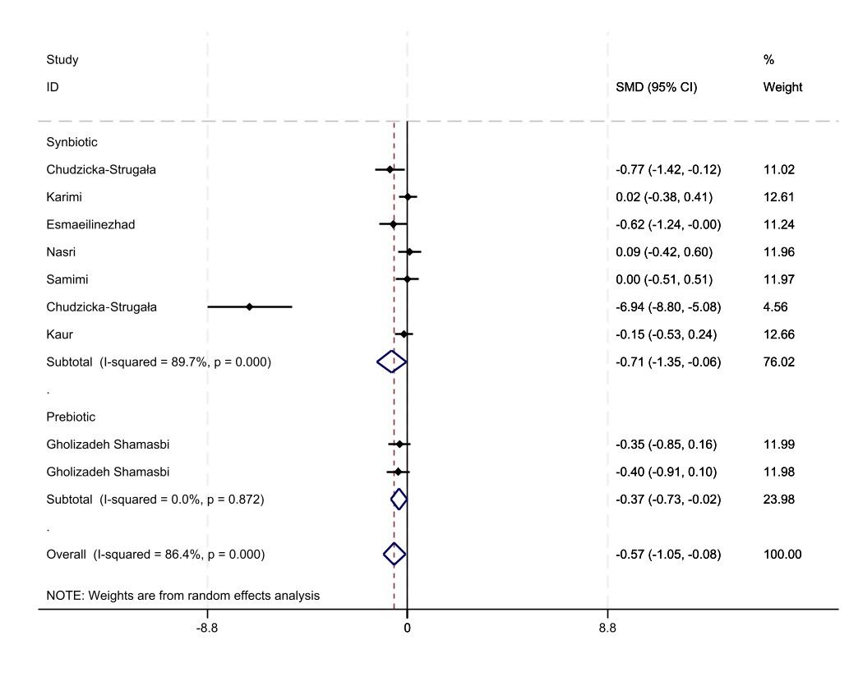

Supplementary figure2; BMI 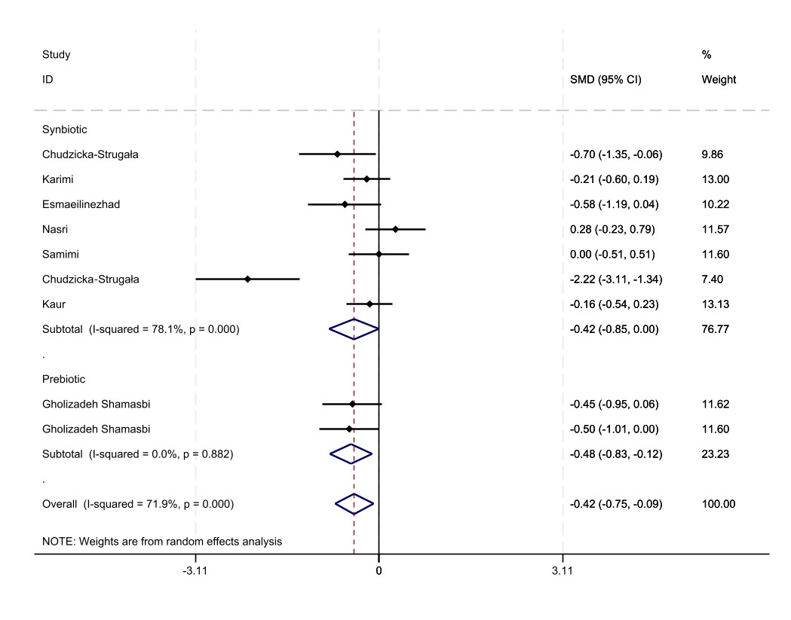

Supplementary figure3; WC
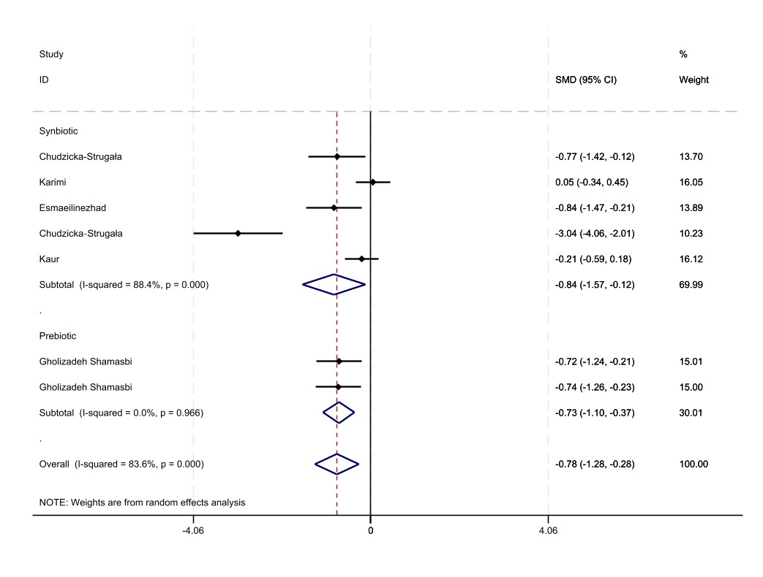
Supplementary figure4; HC
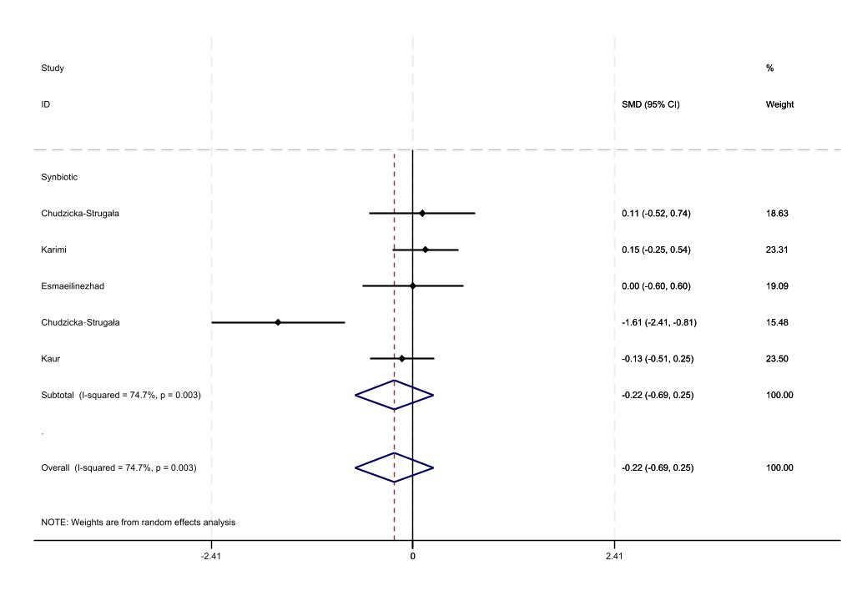

Supplementary figure5; WHR
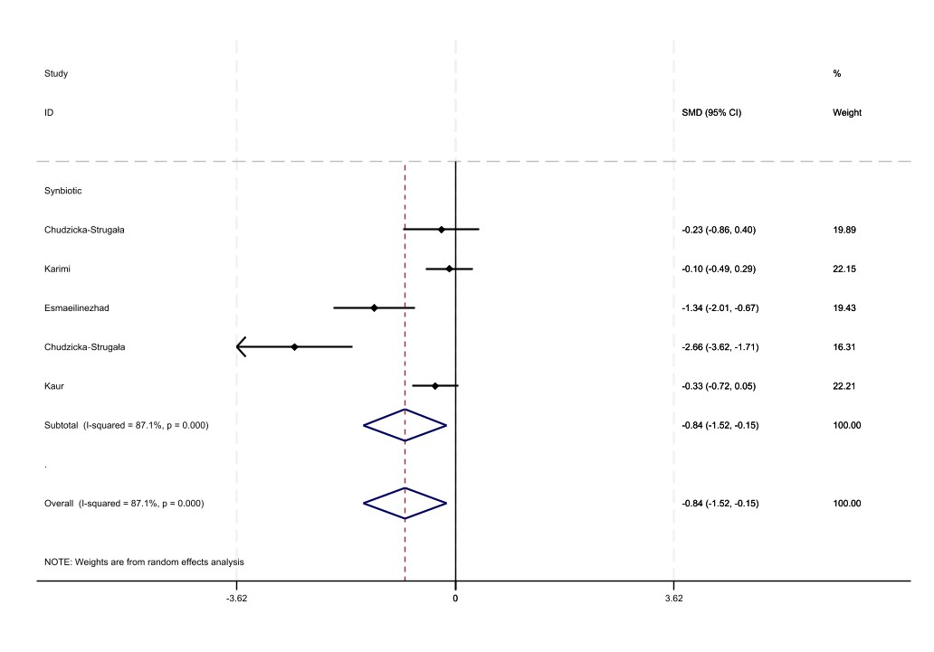

Supplementary figure 6; Hs-CRP
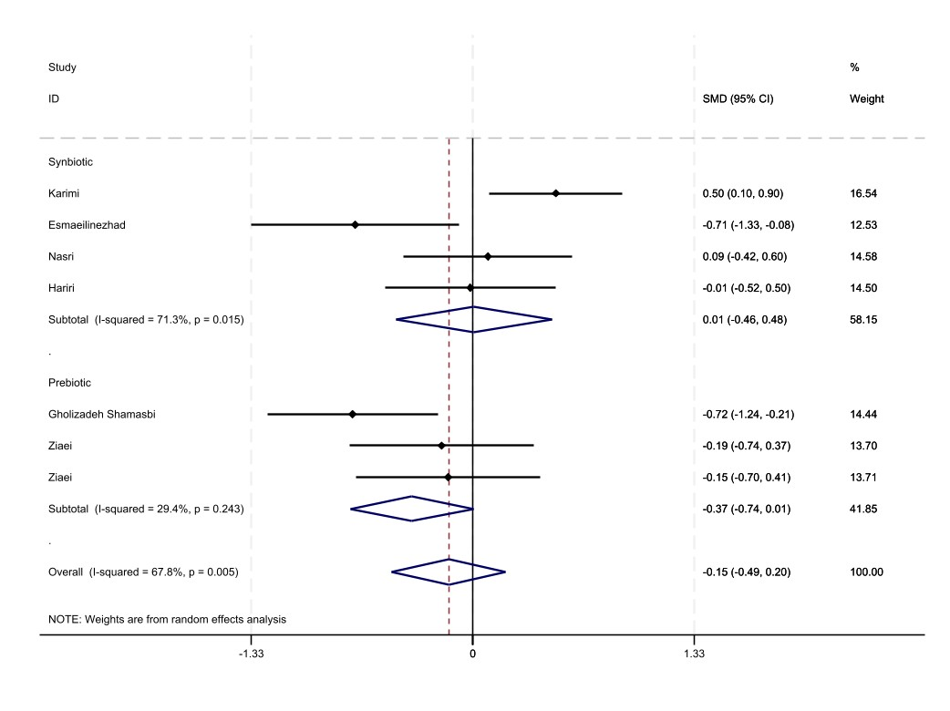

Supplementary figure 7; TAC,MDA, and GSH.
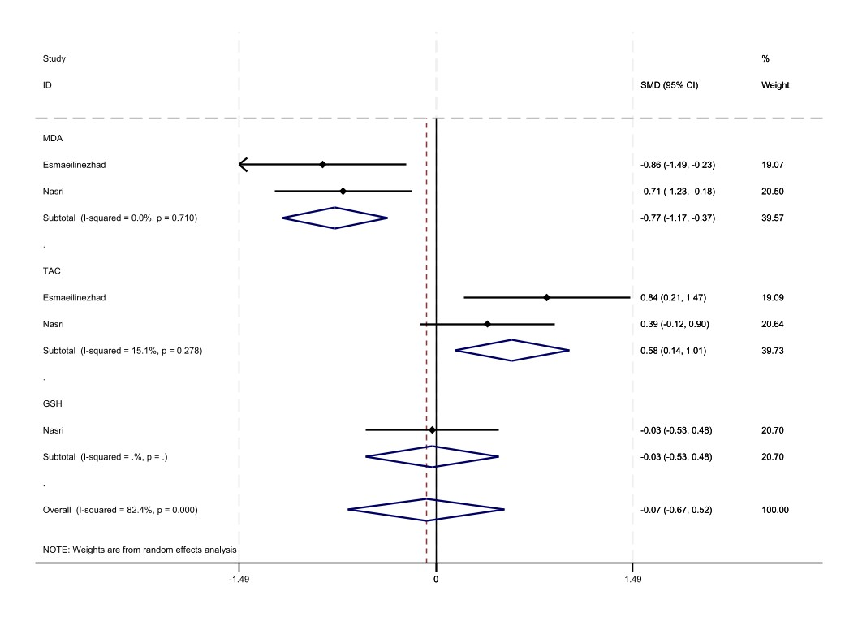

Supplementary figure 8; TG

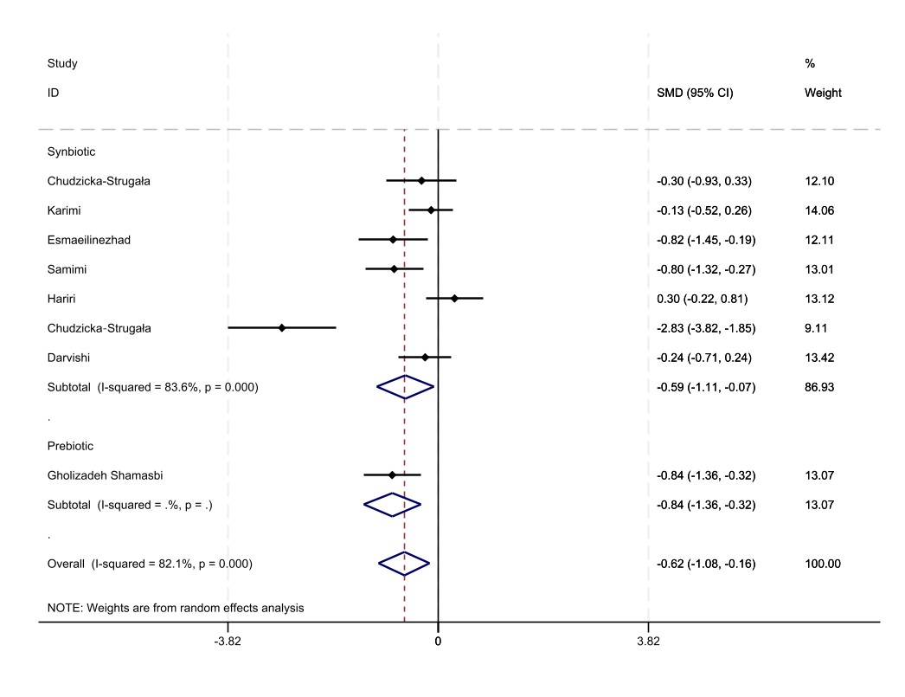
Supplementary figure 9; LDL-C
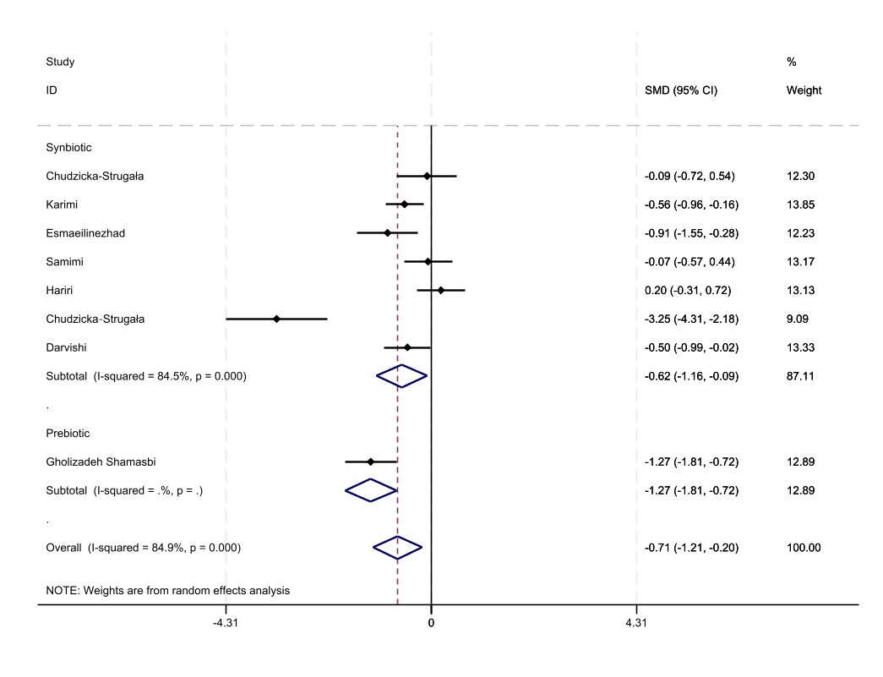

Supplementary figure 10; TC
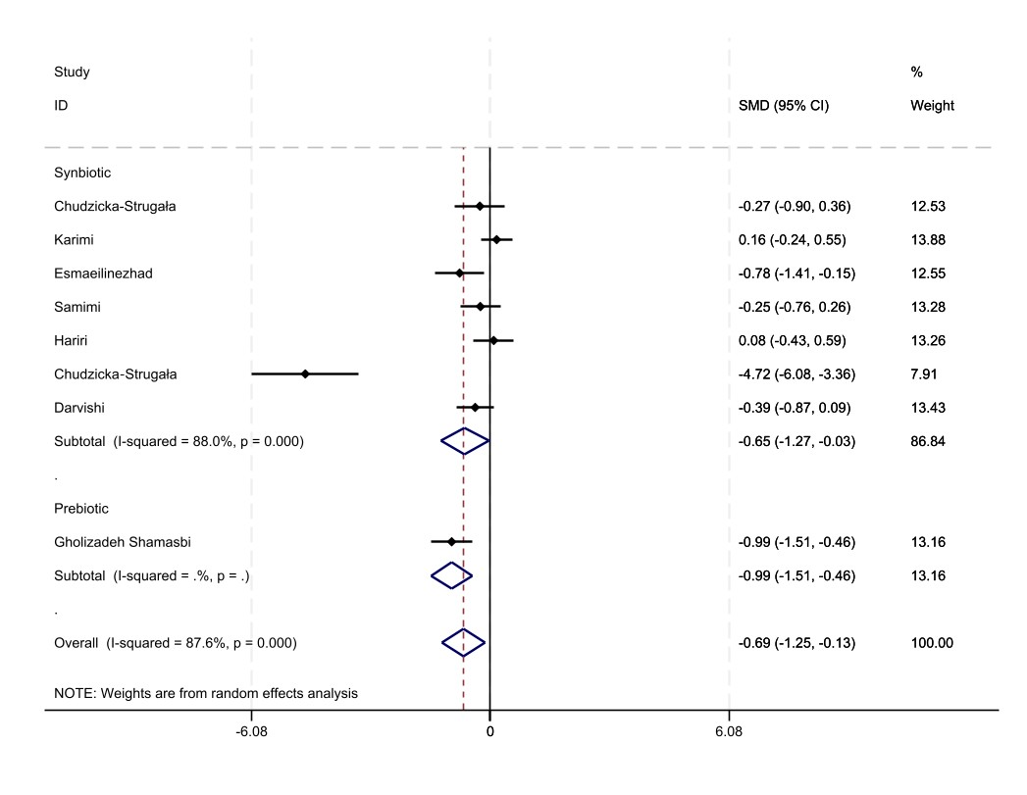

Supplementary figure 11; HDL
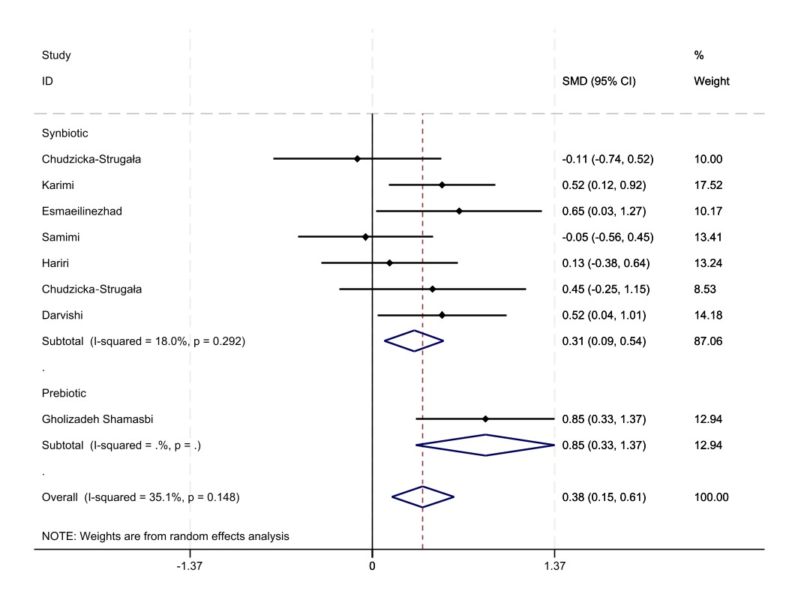
Supplementary figure12; FPG
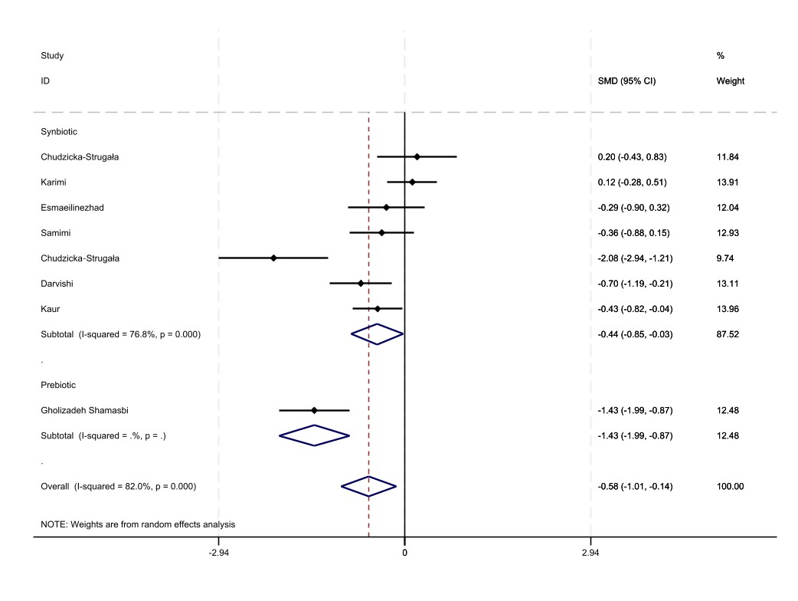
Supplementary figure13; Insulin
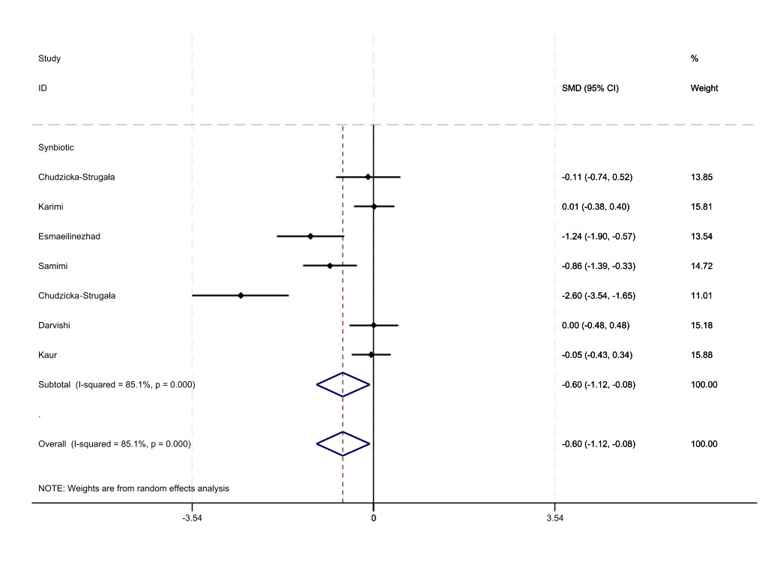

Supplementary figure14; HOMA-IR
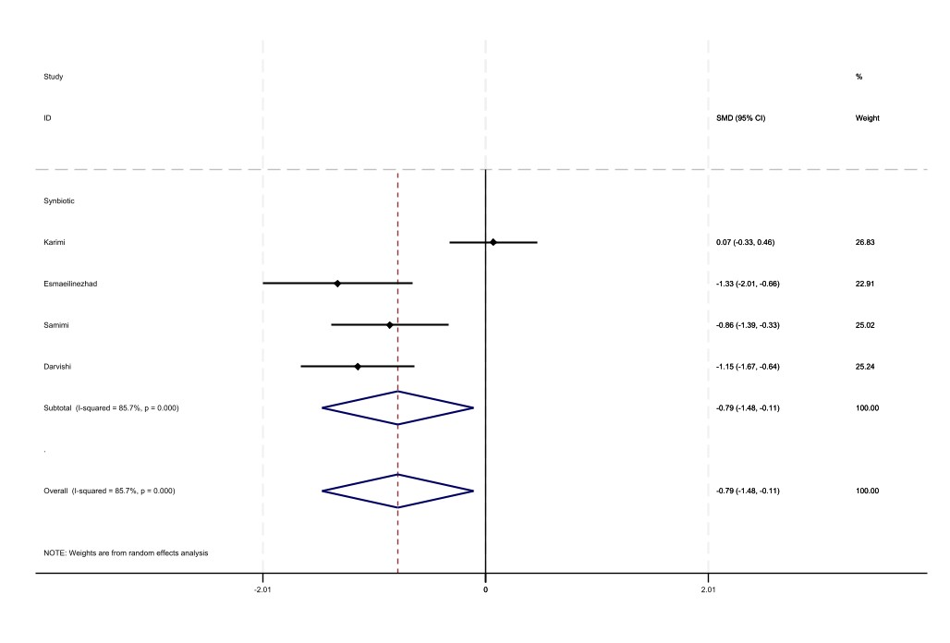

Supplementary figure15; QUICKI
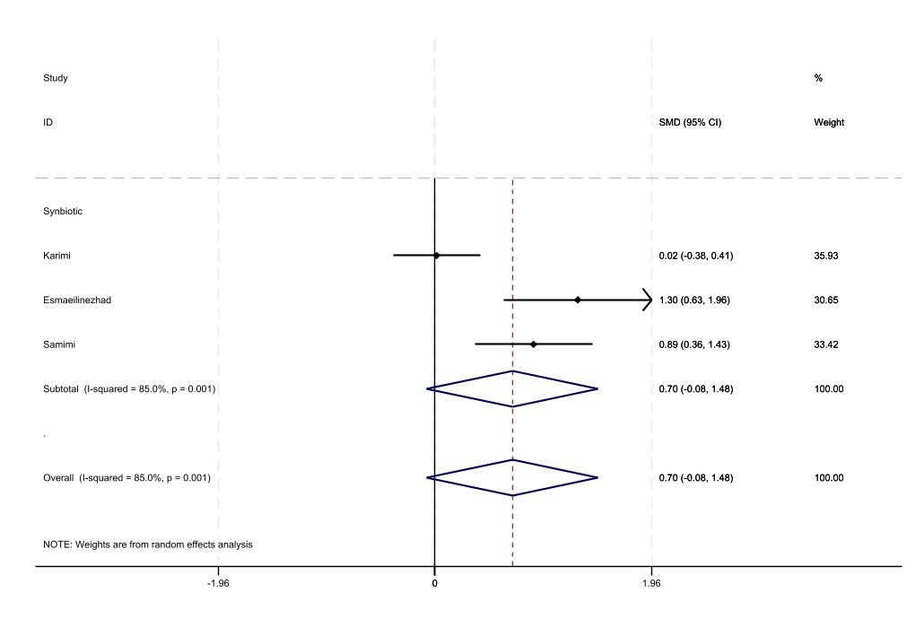

Supplementary figure16; SBP and DBP
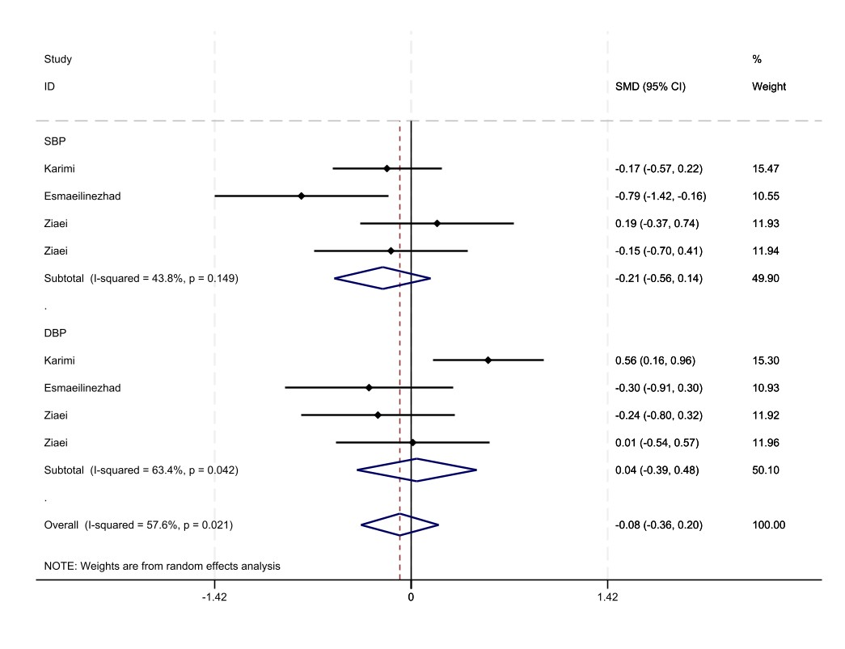

Supplementary figure17; Testosterone, DHEAS, SHBG
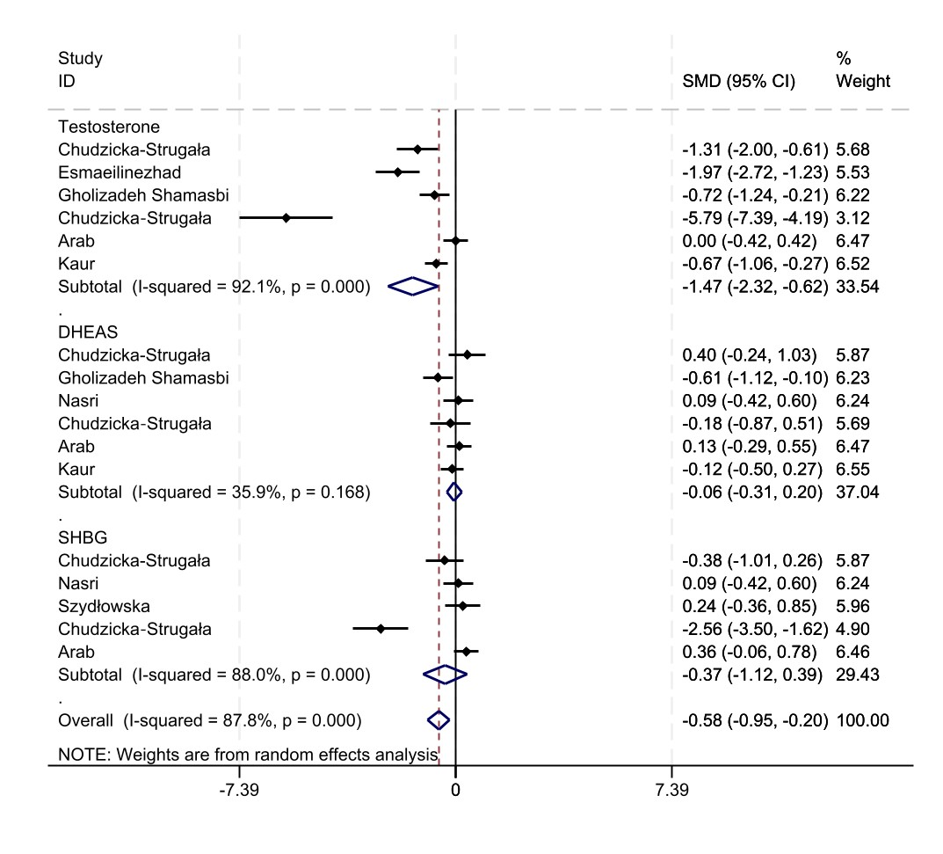
Supplementary figure18; FSH, LH, LH/FSH ratio
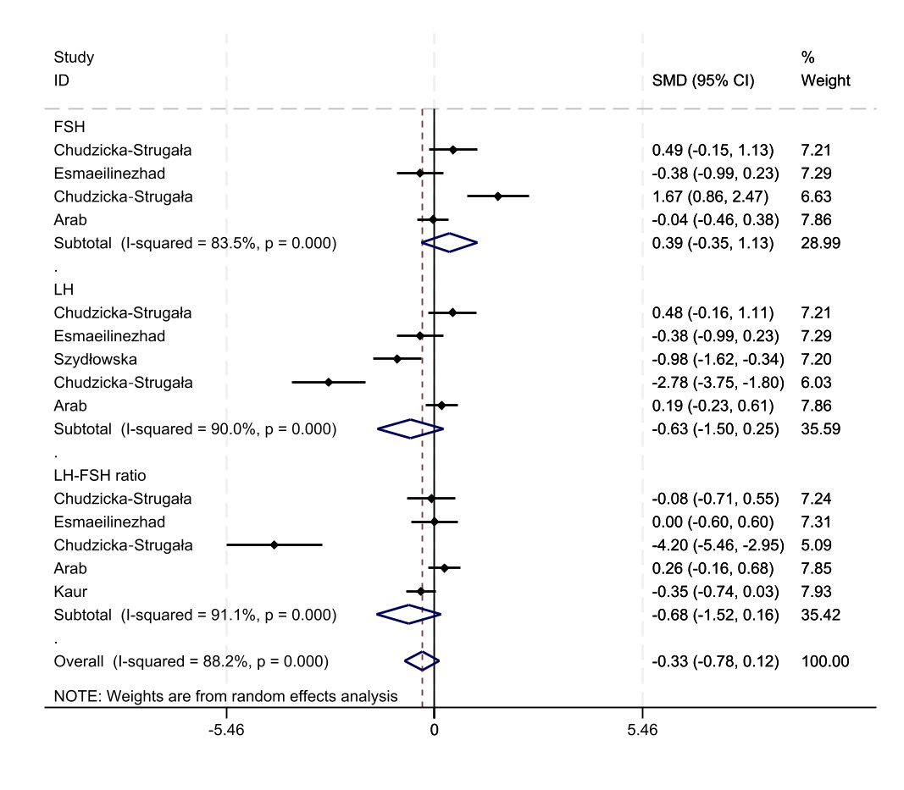

Supplementary figure 19.A; Funnel plot for weight
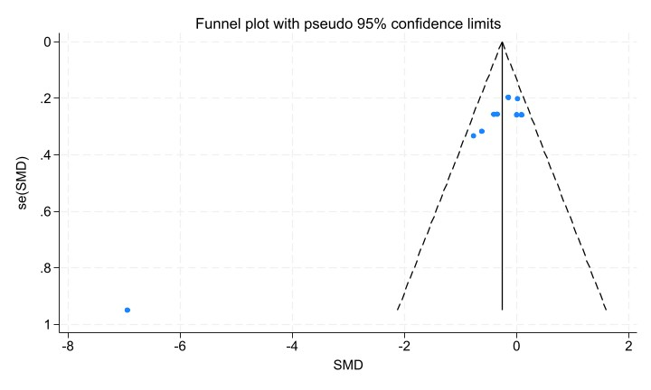

Supplementary figure 19.B; Funnel plot for BMI
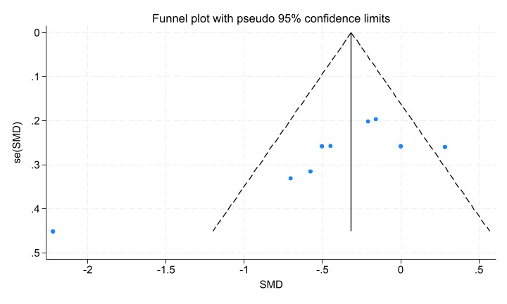

Supplementary figure19.C; Funnel plot for WC
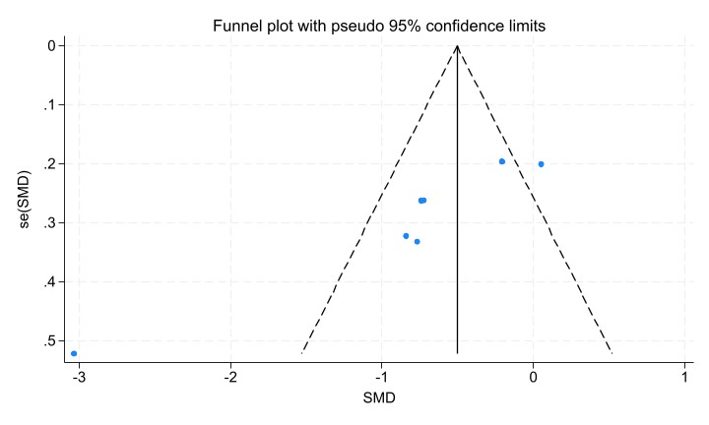

Supplementary figure19.D; Funnel plot for FPG
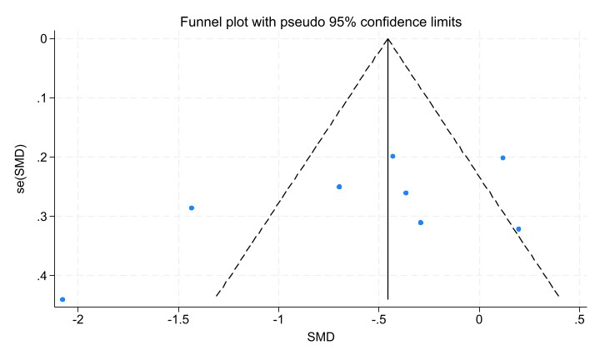

Supplementary figure19.E; Funnel plot for TG
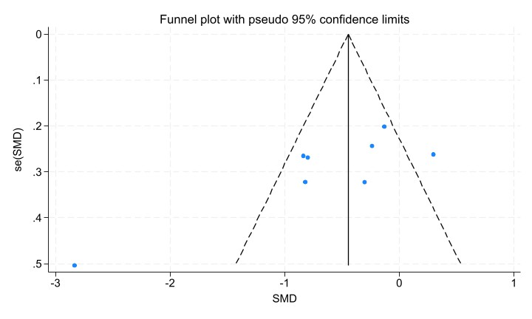

Supplementary figure19.F; Funnel plot for TC
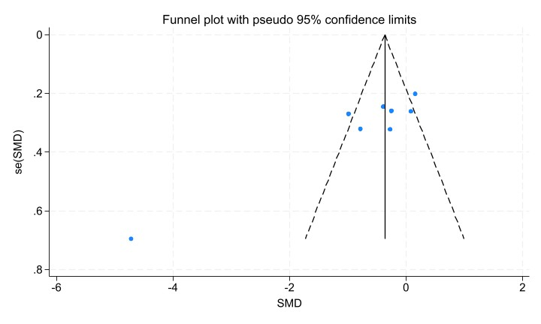

Supplementary figure19.G; Funnel plot for LDL-C
