Additional information
Figure S1. The patients' inclusion and exclusion process.
Figure S2. Correlation analysis between inflammatory markers.
Table S1. Two-stage general linear regression between PLR and AFC.
Table S2. Two-stage general linear regression between NLR and AFC.
Table S3. Two-stage general linear regression between PLR and number of retrieved oocytes.
Table S4. Association between SII and AMH levels in different subgroups.
Table S5. Association between PPN and AMH levels in different subgroups.
Table S6. Association between PRL and AMH levels in different subgroups.
Table S7. Association between NLR and AMH levels in different subgroups.
Table S8. Association between SII and AFC levels in different subgroups.
Table S9. Association between PPN and AFC levels in different subgroups.
Table S10. Association between PRL and AFC levels in different subgroups.
Table S11. Association between NLR and AFC levels in different subgroups.
Table S12. Association between SII and number of retrieved oocytes in different subgroups.
Table S13. Association between PPN and number of retrieved oocytes in different subgroups.
Table S14. Association between PRL and number of retrieved oocytes in different subgroups.
Table S15. Association between NLR and number of retrieved oocytes in different subgroups.
Table S16. Sensitivity analysis of the relationship between inflammatory markers and AMH.
Table S17. Sensitivity analysis of the relationship between inflammatory markers and AFC.
Table S18. Sensitivity analysis of the relationship between inflammatory markers and number of retrieved oocytes.

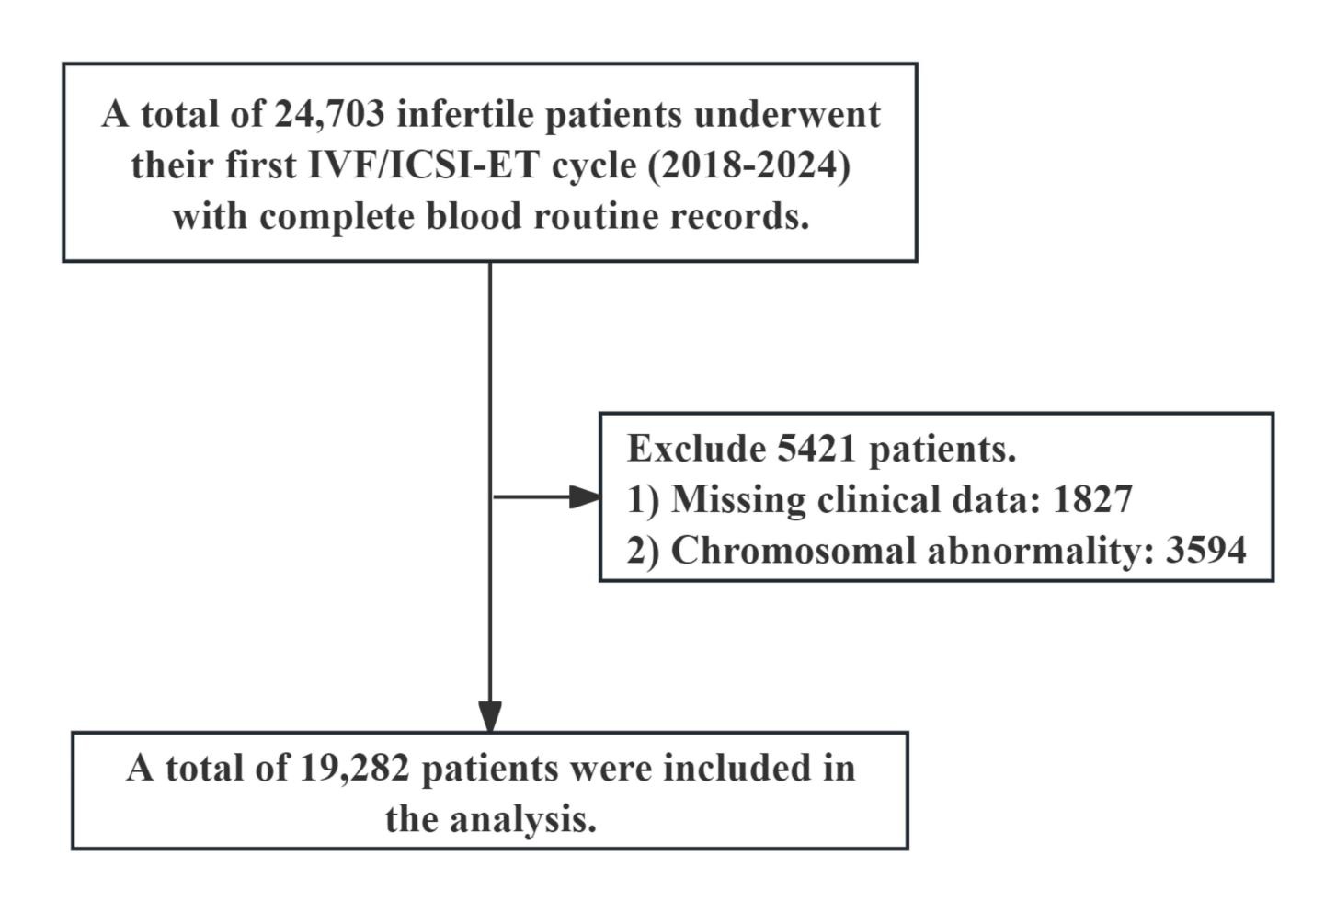
Figure S1. The patients' inclusion and exclusion process.

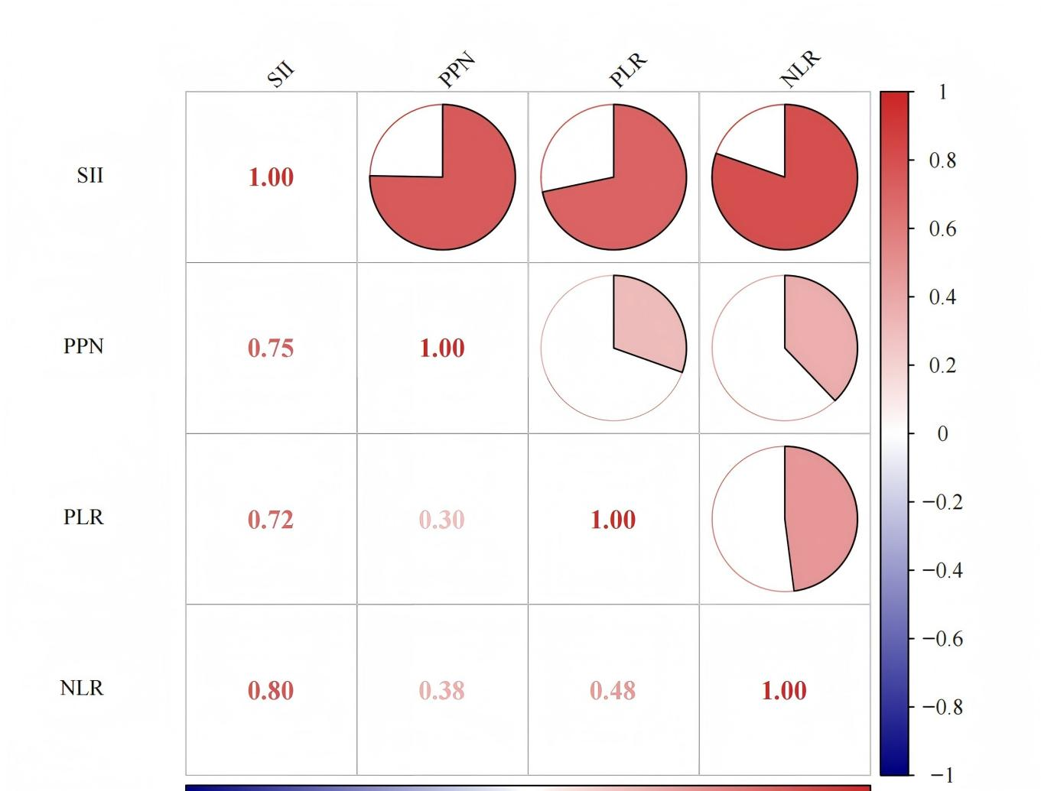
Figure S2. Correlation analysis between inflammatory markers.

Table S1. Two-stage general linear regression between PLR and AFC
 | PLR |  | β（95%cl) |  | P
AFC_sqrt | Standard linear model |  | -0.001(-0.003,0.000) |  | 0.012
 | PLR<123.53 |  | -0.001(-0.005,0.000) |  | 0.459
 | PLR>123.53 |  | -0.001(-0.037,0.000) |  | 0.001
 | Log-likelihood ratio test |  |  |  | <0.001
Model adjusted for age, BMI, duration of infertility，FSH，LH，PRL，T，E₂，P，stimulation protocol，and cause of infertility.

Table S2. Two-stage general linear regression between NLR and AFC
 | NLR |  | β（95%cl) |  | P
AFC_sqrt | Standard linear model |  | -0.033(-0.043,-0.023) |  | <0.001
 | NLR<2.22 |  | -0.048(-0.096,0.000) |  | 0.052
 | NLR>2.22 |  | -0.001(-0.037,0.000) |  | 0.002
 | Log-likelihood ratio test |  |  |  | <0.001
Model adjusted for age, BMI, duration of infertility，FSH，LH，PRL，T，E₂，P，stimulation protocol，and cause of infertility.

Table S3. Two-stage general linear regression between PLR and number of retrieved oocytes
 | PLR |  | β（95%cl) |  | P
number of retrieved oocytes _sqrt | Standard linear model |  | -0.001(-0.023,0.000) |  | 0.012
 | PLR<123.59 |  | -0.001(-0.002,0.001) |  | 0.424
 | PLR>123.59 |  | -0.001(-0.002,0.000) |  | 0.001
 | Log-likelihood ratio test |  |  |  | <0.001
Model adjusted for age, BMI, duration of infertility，FSH，LH，PRL，T，E₂，P，stimulation protocol，and cause of infertility.

Table S4. Association between SII and AMH levels in different subgroups
Subgroups | Q1 [48.38,347.63] | Q2 (347.63,470.67] | Q3 (470.67,637.57] | Q4 (637.57,3157.89] | P-int
Age |  |  |  |  | 0.184
18-29years | ref | 0.012 (-0.009,0.019) | 0.005 (-0.010,0.019) | 0.001 (-0.014,0.016)
30-35years | ref | -0.009 (-0.050,0.032) | 0.003 (-0.038,0.043) | -0.007 (-0.048,0.035)
36-55years | ref | 0.014 (-0.040,0.068) | 0.054 (0.001,0.108) | -0.028 (-0.081,0.025)
BMI |  |  |  |  | 0.597
<18.5kg/m² | ref | -0.028 (-0.110,0.054) | -0.017 (-0.102,0.068) | -0.007 (-0.093,0.080)
18.5-24kg/m² | ref | -0.004 (-0.068,0.060) | 0.040 (-0.026,0.106) | -0.008 (-0.075,0.060)
≥24kg/m² | ref | -0.012 (-0.085,0.061) | 0.009 (-0.065,0.083) | -0.029 (-0.104,0.045)
Stimulation protocol |  |  |  |  | 0.300
GnRH Antagonistc | ref | -0.037 (-0.071,-0.004) | 0.002 (-0.0304,0.035) | -0.067 (-0.099,-0.034)
GnRH agonist | ref | 0.010 (-0.033,0.052) | -0.007 (-0.050,0.036) | 0.044 (-0.001,0.087)
Other protocols | ref | -0.025 (-0.076,0.027) | -0.008 (-0.059,0.043) | -0.036 (-0.086,-0.015)
Model adjusted for age, BMI, duration of infertility，FSH，LH，PRL，T，E₂，P，stimulation protocol，and cause of infertility.

Table S5. Association between PPN and AMH levels in different subgroups
Subgroups | Q1 [90.90,579.81] | Q2 (579.81,807.29] | Q3 (807.29,1107.39] | Q4 (1107.39,2671.80] | P-int
Age |  |  |  |  | 0.339
18-29years | ref | 0.005 (-0.011,0.021) | -0.003 (-0.019,0.013) | -0.010 (-0.024,0.005)
30-35years | ref | 0.024 (-0.018,0.066) | 0.009 (-0.033,0.051) | -0.012 (-0.030,0.054)
36-55years | ref | 0.009 (-0.045,0.063) | -0.014 (-0.068,0.040) | -0.029 (-0.082,0.025)
BMI |  |  |  |  | 0.350
<18.5kg/m² | ref | -0.010 (-0.088,0.069) | -0.012 (-0.075,0.100) | -0.006 (-0.096,0.083)
18.5-24kg/m² | ref | -0.013 (-0.075,0.049) | 0.016 (-0.051,0.083) | -0.016 (-0.089,0.057)
≥24kg/m² | ref | 0.016 (-0.058,0.091) | 0.018 (-0.059,0.095) | -0.029 (-0.110,0.052)
Stimulation protocol |  |  |  |  | 0.084
GnRH Antagonistc | ref | -0.026 (-0.059,0.006) | -0.011 (-0.043,0.022) | -0.035 (-0.069,-0.002)
GnRH agonist | ref | -0.024 (-0.067,0.019) | -0.012 (-0.055,0.031) | 0.006 (-0.037,0.049)
Other protocols | ref | -0.050 (-0.101,0.001) | -0.019 (-0.070,0.031) | -0.035 (-0.085,0.016)
Model adjusted for age, BMI, duration of infertility，FSH，LH，PRL，T，E₂，P，stimulation protocol，and cause of infertility.

Table S6. Association between PRL and AMH levels in different subgroups
Subgroups | Q1 [23.86,100.00] | Q2 (100.00,123.53] | Q3 (123.53,152.57] | Q4 (152.57,663.27] | P-int
Age |  |  |  |  | 0.364
18-29years | ref | -0.002 (-0.017,0.013) | 0.009 (-0.006,0.025) | -0.002 (-0.017,0.014)
30-35years | ref | 0.002 (-0.073,0.010) | -0.018 (-0.047,0.037) | -0.034 (-0.079,0.004)
36-55years | ref | -0.006 (-0.061,0.049) | 0.017 (-0.038,0.071) | -0.047 (-0.101,0.007)
BMI |  |  |  |  | 0.827
<18.5kg/m² | ref | 0.051 (-0.037,0.140) | 0.054 (-0.033,0.140) | 0.045 (-0.042,0.131)
18.5-24kg/m² | ref | 0.023 (-0.044,0.088) | 0.017 (-0.049,0.084) | 0.042 (-0.023,0.107)
≥24kg/m² | ref | -0.007 (-0.079,0.065) | -0.011 (-0.084,0.062) | -0.001 (-0.072,0.072)
Stimulation protocol |  |  |  |  | 0.161
GnRH Antagonistc | ref | -0.011 (-0.044,0.973) | -0.025 (0.058,0.009) | -0.047 (-0.080,-0.015)
GnRH agonist | ref | 0.042 (0.000,0.084) | 0.017 (-0.024,0.059) | 0.018 (-0.023,0.060)
Other protocols | ref | 0.033 (-0.017,0.083) | 0.012 (-0.038,0.062) | -0.035 (-0.084,0.015)
Model adjusted for age, BMI, duration of infertility，FSH，LH，PRL，T，E₂，P，stimulation protocol，and cause of infertility.

Table S7. Association between NLR and AMH levels in different subgroups
Subgroups | Q1 [0.53,1.74] | Q2 (1.74,2.22] | Q3 (2.22,2.88] | Q4 (2.88,13.72] | P-int
Age |  |  |  |  | 0.712
18-29years | ref | -0.004 (-0.009,0.018) | -0.003 (-0.017,0.011) | -0.006 (-0.007,0.020)
30-35years | ref | -0.002 (-0.039,0.035) | 0.017 (-0.020,0.054) | -0.010 (-0.047,0.027)
36-55years | ref | 0.012 (-0.035,0.060) | 0.033 (-0.014,0.081) | -0.015 (-0.062,0.032)
BMI |  |  |  |  | 0.179
<18.5kg/m² | ref | -0.089 (-0.178,-0.001) | -0.100 (-0.186,-0.014) | -0.033 (-0.115,0.049)
18.5-24kg/m² | ref | -0.052 (-0.119,0.014) | 0.015 (-0.052,0.081) | -0.048 (-0.112,0.016)
≥24kg/m² | ref | -0.072 (-0.144,0.000) | -0.022 (-0.094,0.051) | -0.067 (-0.138,0.005)
Stimulation protocol |  |  |  |  | 0.095
GnRH Antagonistc | ref | -0.016 (-0.049,0.018) | -0.029 (-0.062,0.005) | -0.065 (-0.098,-0.032)
GnRH agonist | ref | 0.021 (-0.027,0.069) | 0.037 (-0.010,0.084) | 0.060 (0.013,0.109)
Other protocols | ref | 0.020 (-0.025,0.065) | 0.033 (-0.012,0.079) | 0.049 (0.004,0.094)
Model adjusted for age, BMI, duration of infertility，FSH，LH，PRL，T，E₂，P，stimulation protocol，and cause of infertility.

Table S8. Association between SII and AFC levels in different subgroups
Subgroups | Q1[48.38,347.63] | Q2(347.63,470.67] | Q3(470.67,637.57] | Q4(637.57,3157.89] | P-int
Age |  |  |  |  | 0.809
18-29years | ref | -0.004(-0.031,0.022) | -0.011(-0.037,0.016) | 0.023(-0.003,0.049)
30-35years | ref | 0.012(-0.058,0.081) | -0.051(-0.121,0.019) | -0.037(-0.107,0.033)
36-55years | ref | 0.0506(-0.039,0.140) | 0.040(-0.049,0.128) | -0.037(-0.125,0.051)
BMI |  |  |  |  | 0.901
<18.5kg/m² | ref | 0.016(-0.111,,0.143) | -0.068(-0.199,0.064) | -0.072(-0.206,0.062)
18.5-24kg/m² | ref | -0.009(-0.115,0.098) | 0.012(-0.099,0.123) | 0.021(-0.092,0.134)
≥24kg/m² | ref | 0.100(-0.021,0.221) | 0.085(-0.0381,0.208) | 0.073(-0.052,0.197)
Stimulation protocol |  |  |  |  | 0.013
GnRH Antagonistc | ref | -0.066(-0.132,0.001) | -0.089(-0.155,-0.023) | -0.140(-0.205,-0.075)
GnRH agonist | ref | 0.087(-0.003,0.176) | 0.087(-0.003,0.176) | 0.132(0.044,0.220)
Other protocols | ref | 0.057(-0.029,0.143) | 0.100(0.0145,0.185) | 0.125(0.040,0.209)
Model adjusted for age, BMI, duration of infertility，FSH，LH，PRL，T，E₂，P，stimulation protocol，and cause of infertility.

Table S9. Association between PPN and AFC levels in different subgroups
Subgroups | Q1[90.90,579.81] | Q2(579.81,807.29] | Q3(807.29,1107.39] | Q4(1107.39,2671.80] | P-int
Age |  |  |  |  | 0.165
18-29years | ref | -0.004(-0.031,0.023) | -0.005(-0.031,0.022) | -0.001(-0.027,0.025)
30-35years | ref | -0.053(-0.123,0.017) | -0.063(-0.134,0.007) | -0.044(-0.115,0.026)
36-55years | ref | -0.008(-0.095,0.080) | -0.087(-0.176,0.001) | -0.033(-0.121,0.055)
BMI |  |  |  |  | 0.034
<18.5kg/m² | ref | 0.043(-0.077,0.163) | -0.032(-0.164,0.101) | -0.028(-0.165,0.109)
18.5-24kg/m² | ref | 0.113(0.011,0.215) | -0.011(-0.121,0.098) | 0.029(-0.091,0.149)
≥24kg/m² | ref | 0.172(0.050,0.294) | 0.068(-0.058,0.194) | 0.054(-0.058,0.188)
Stimulation protocol |  |  |  |  | <0.001
GnRH Antagonistc | ref | -0.010(-0.076,0.055) | -0.051(-0.117,0.014) | -0.094(-0.160,-0.028)
GnRH agonist | ref | 0.073(-0.015,0.161) | 0.102(0.014,0.191) | 0.141(0.053,0.229)
Other protocols | ref | 0.056(-0.029,0.141) | 0.050(-0.034,0.135) | 0.140(0.055,0.225)
Model adjusted for age, BMI, duration of infertility，FSH，LH，PRL，T，E₂，P，stimulation protocol，and cause of infertility.

Table S10. Association between PRL and AFC levels in different subgroups
Subgroups | Q1[23.86,100.00] | Q2(100.00,123.53] | Q3(123.53,152.57] | Q4(152.57,663.27] | P-int
Age |  |  |  |  | 0.721
18-29years | ref | -0.011(-0.036,0.015) | 0.007(-0.019,0.033) | 0.016(-0.011,0.042)
30-35years | ref | -0.043(-0.113,-0.027) | 0.016(-0.053,0.086) | -0.004(-0.074,0.067)
36-55years | ref | -0.075(-0.165,0.015) | -0.008(-0.097,0.080) | -0.013(-0.101,0.074)
BMI |  |  |  |  | 0.406
<18.5kg/m² | ref | -0.037(-0.175,0.101) | -0.084(-0.220,0.024) | -0.108(-0.243,0.026)
18.5-24kg/m² | ref | 0.004(-0.108,0.116) | -0.054(-0.167,0.058) | 0.003(-0.108,0.113)
≥24kg/m² | ref | -0.027(-0.149,0.095) | -0.093(-0.216,0.030) | -0.024(-0.146,0.097)
Stimulation protocol |  |  |  |  | 0.621
GnRH Antagonistc | ref | -0.002(-0.069,0.065) | -0.048(-0.115,0.019) | -0.073(-0.138,-0.001)
GnRH agonist | ref | 0.029(-0.061,0.119) | 0.061(-0.029,0.151) | 0.051(-0.038,0.139)
Other protocols | ref | -0.057(-0.143,0.029) | -0.030(-0.116,0.056) | 0.028(-0.057,0.113)
Model adjusted for age, BMI, duration of infertility，FSH，LH，PRL，T，E₂，P，stimulation protocol，and cause of infertility.

Table S11. Association between NLR and AFC levels in different subgroups
Subgroups | Q1[0.53,1.74] | Q2(1.74,2.22] | Q3(2.22,2.88] | Q4(2.88,13.72] | P-int
Age |  |  |  |  | 0.398
18-29years | ref | 0.007(-0.019,0.033) | 0.009(-0.018,0.035) | 0.019(-0.007,0.045)
30-35years | ref | -0.018(-0.087,0.052) | -0.025(-0.095,0.045) | -0.033(-0.103,0.037)
36-55years | ref | 0.025(-0.065,0.115) | 0.016(-0.074,0.105) | -0.036(-0.125,0.052)
BMI |  |  |  |  | 0.156
<18.5kg/m² | ref | 0.020(-0.119,0.159) | -0.112(-0.25,0.024) | -0.055(-0.182,0.073)
18.5-24kg/m² | ref | -0.020(-0.133,0.092) | 0.009(-0.104,0.122) | -0.024(-0.074,0.143)
≥24kg/m² | ref | 0.043(-0.081,0.166) | 0.032(-0.091,0.155) | -0.007(-0.080,0.162)
Stimulation protocol |  |  |  |  | 0.168
GnRH Antagonistc | ref | -0.088(-0.155,-0.021) | -0.094(-0.160,-0.027) | -0.163(-0.229,-0.097)
GnRH agonist | ref | 0.117(0.027,0.208) | 0.107(0.017,0.197) | 0.132(0.043,0.222)
Other protocols | ref | 0.110(0.024,0.196) | 0.088(0.003,0.174) | 0.131(0.046,0.217)
Model adjusted for age, BMI, duration of infertility，FSH，LH，PRL，T，E₂，P，stimulation protocol，and cause of infertility.

Table S12. Association between SII and number of retrieved oocytes in different subgroups
Subgroups | Q1[48.38,347.63] | Q2(347.63,470.67] | Q3(470.67,637.57] | Q4(637.57,3157.89] | P-int
Age |  |  |  |  | 0.691
18-29years | ref | 0.005(-0.018,0.029) | -0.018(-0.042,0.006) | 0.002(-0.021,0.025)
30-35years | ref | -0.014(-0.074,0.046) | 0.056(-0.004,0.117) | 0.022(-0.038,0.083)
36-55years | ref | 0.029(-0.048,0.107) | 0.097(0.021,0.174) | 0.007(-0.069,0.083)
BMI |  |  |  |  | 0.447
<18.5kg/m² | ref | 0.116(0.005,0.228) | 0.027(-0.089,0.142) | -0.009(-0.127,0.108)
18.5-24kg/m² | ref | -0.037(-0.128,0.055) | -0.011(-0.106,0.084) | 0.040(-0.057,0.137)
≥24kg/m² | ref | 0.103(-0.001,0.208) | 0.057(-0.049,0.163) | 0.122(0.014,0.229)
Stimulation protocol |  |  |  |  | 0.197
GnRH Antagonistc | ref | 0.017(-0.041,0.068) | 0.011(-0.042,0.065) | -0.036(-0.089,0.016)
GnRH agonist | ref | -0.025(-0.102,0.052) | -0.019(-0.095,0.058) | -0.013(-0.079,0.073)
Other protocols | ref | -0.018(-0.092,0.056) | -0.033(-0.106,0.040) | 0.025(-0.047,0.098)
Model adjusted for age, BMI, duration of infertility，FSH，LH，PRL，T，E₂，P，stimulation protocol，and cause of infertility.

Table S13. Association between PPN and number of retrieved oocytes in different subgroups
Subgroups | Q1[90.90,579.81] | Q2(579.81,807.29] | Q3(807.29,1107.39] | Q4(1107.39,2671.80] | P-int
Age |  |  |  |  | 0.377
18-29years | ref | -0.003(-0.025,0.008) | 0.014(-0.010,0.038) | -0.016(-0.040,0.007)
30-35years | ref | 0.060(-0.001,0.121) | 0.037(-0.023,0.098) | 0.051(-0.009,0.112)
36-55years | ref | 0.020(-0.056,0.095) | 0.014(-0.063,0.090) | 0.013(-0.063,0.089)
BMI |  |  |  |  | 0.091
<18.5kg/m² | ref | 0.080(-0.025,0.185) | 0.058(-0.058,0.174) | -0.001(-0.053,0.006)
18.5-24kg/m² | ref | 0.031(-0.056,0.119) | 0.016(-0.078,0.110) | 0.083(-0.021,0.186)
≥24kg/m² | ref | 0.156(0.050,0.261) | 0.109(0.001,0.217) | 0.129(0.017,0.246)
Stimulation protocol |  |  |  |  | 0.079
GnRH Antagonistc | ref | -0.006(-0.059,0.047) | 0.015(-0.038,0.068) | -0.050(-0.104,0.004)
GnRH agonist | ref | 0.014(-0.061,0.090) | -0.036(-0.113,0.040) | 0.0059(-0.071,0.081)
Other protocols | ref | 0.036(-0.037,0.109) | -0.010(-0.082,0.063) | 0.032(-0.041,0.105)
Model adjusted for age, BMI, duration of infertility，FSH，LH，PRL，T，E₂，P，stimulation protocol，and cause of infertility.

Table S14. Association between PRL and number of retrieved oocytes in different subgroups
Subgroups | Q1[23.86,100.00] | Q2(100.00,123.53] | Q3(123.53,152.57] | Q4(152.57,663.27] | P-int
Age |  |  |  |  | 0.631
18-29years | ref | -0.006(-0.029,0.018) | -0.008(-0.031,0.015) | 0.005(-0.018,0.029)
30-35years | ref | 0.044(-0.016,0.104) | 0.034(-0.027,0.094) | 0.003(-0.058,0.064)
36-55years | ref | 0.030(-0.048,0.108) | 0.022(-0.055,0.098) | -0.009(-0.085,0.067)
BMI |  |  |  |  | 0.932
<18.5kg/m² | ref | 0.006(-0.115,0.127) | -0.090(-0.210,0.029) | -0.100(-0.218,0.018)
18.5-24kg/m² | ref | 0.036(-0.061,0.132) | -0.030(-0.127,0.067) | -0.024(-0.120,0.071)
≥24kg/m² | ref | 0.043(-0.062,0.148) | 0.066(-0.040,0.172) | -0.007(-0.112,0.097)
Stimulation protocol |  |  |  |  | 0.466
GnRH Antagonistc | ref | 0.002(-0.052,0.057) | -0.037(-0.09,0.017) | -0.072(-0.125,-0.020)
GnRH agonist | ref | -0.013(-0.090,0.064) | 0.031(-0.046,0.108) | 0.012(-0.063,0.088)
Other protocols | ref | -0.072(-0.146,0.002) | -0.051(-0.125,0.023) | -0.018(-0.054,0.093)

Table S15. Association between NLR and number of retrieved oocytes in different subgroups
Subgroups | Q1[0.53,1.74] | Q2(1.74,2.22] | Q3(2.22,2.88] | Q4(2.88,13.72] | P-int
Age |  |  |  |  | 0.427
18-29years | ref | -0.001(-0.030,0.007) | -0.027(-0.051,-0.004) | -0.001(-0.018,0.002)
30-35years | ref | 0.002(-0.058,0.062) | 0.017(-0.044,0.077) | 0.044(-0.017,0.104)
36-55years | ref | -0.007(-0.084,0.071) | -0.007(-0.084,0.071) | 0.018(-0.058,0.095)
BMI |  |  |  |  | 0.563
<18.5kg/m² | ref | 0.039(-0.083,0.161) | 0.005(-0.114,0.124) | -0.002(-0.114,0.110)
18.5-24kg/m² | ref | -0.027(-0.124,0.071) | -0.030(-0.127,0.068) | 0.028(-0.066,0.121)
≥24kg/m² | ref | -0.011(-0.117,0.095) | 0.002(-0.105,0.108) | 0.065(-0.039,0.168)
Stimulation protocol |  |  |  |  | 0.467
GnRH Antagonistc | ref | 0.010(-0.045,0.065) | 0.007(-0.047,0.062) | -0.021(-0.075,0.033)
GnRH agonist | ref | -0.001(-0.038,0.020) | 0.020(-0.057,0.098) | 0.025(-0.051,0.102)
Other protocols | ref | 0.007(-0.067,0.081) | 0.019(-0.055,0.093) | 0.040(-0.034,0.114)

Table S16. Sensitivity analysis of the relationship between inflammatory markers and AMH.
Inflammatory markers | Model 1 (unadjusted) |  |  | Model 2 (adjusted)
 | β (95% CI) | P | P for trend | β (95% CI) | P | P for trend
SII |  |  | <0.001 |  |  | <0.001
Q1[48.38,345.94] | ref |  |  | ref
Q2(345.94,467.65] | 0.007(-0.016,0.031) | 0.535 |  | 0.000(-0.020,0.021) | 0.959
Q3(467.65,632.22] | -0.004(-0.028,0.020) | 0.742 |  | -0.009(-0.029,0.012) | 0.396
Q4(632.22,3157.89] | -0.047(-0.070,-0.023) | <0.001 |  | -0.037(-0.058,-0.017) | <0.001
PPN |  |  | 0.038 |  |  | <0.001
Q1[92.40,575.40] | ref |  |  | ref
Q2(575.4,794.20] | -0.014(-0.038,0.010) | 0.242 |  | -0.023(-0.043,0.002) | 0.029
Q3(794.20,1092.00] | -0.005(-0.028,0.019) | 0.707 |  | -0.014(-0.035,0.006) | 0.170
Q4(1092.00,2671.8] | -0.030(-0.053,-0.006) | 0.014 |  | -0.040(-0.061,-0.020) | <0.001
PLR |  |  | 0.253 |  |  | 0.970
Q1[27.72,99.34] | ref |  |  | ref
Q2(99.34,123.39] | -0.004(-0.027,0.020) | 0.761 |  | 0.000(-0.020,0.020) | 0.986
Q3(123.39,152,10] | -0.003(-0.027,0.021) | 0.795 |  | 0.002(-0.018,0.023) | 0.837
Q4(152.10,663.26] | -0.015(-0.038,0.009) | 0.223 |  | -0.001(-0.022,0.019) | 0.918
NLR |  |  | 0.253 |  |  | 0.597
Q1[0.53,1.74] | ref |  |  | ref
Q2(1.74,2.22] | -0.004(-0.028,0.020) | 0.746 |  | -0.002(-0.022,0.019) | 0.857
Q3(2.22,2.88] | -0.022(-0.046,0.001) | 0.063 |  | -0.016(-0.036,0.004) | 0.125
Q4(2.88,13.72] | -0.063(-0.086,-0.039) | <0.001 |  | -0.041(-0.062,-0.021) | <0.001

Table S17. Sensitivity analysis of the relationship between inflammatory markers and AFC.
Inflammatory markers | Model 1 (unadjusted) |  |  | Model 2 (adjusted)
 | β (95% CI) | P | P for trend | β (95% CI) | P | P for trend
SII |  |  | <0.001 |  |  | 0.998
Q1[48.38,345.94] | ref |  |  | ref
Q2(345.94,467.65] | -0.008(-0.051,0.034) | 0.698 |  | -0.024(-0.061,0.013) | 0.211
Q3(467.65,632.22] | -0.021(-0.064,0.021) | 0.320 |  | -0.003(-0.070,0.004) | 0.081
Q4(632.22,3157.89] | -0.076(-0.118,-0.034) | <0.001 |  | -0.064(-0.102,-0.027) | <0.001
PPN |  |  | 0.816 |  |  | 0.104
Q1[92.40,575.40] | ref |  |  | ref
Q2(575.4,794.20] | 0.009(-0.034,0.051) | 0.685 |  | -0.008(-0.045,0.030) | 0.690
Q3(794.20,1092.00] | 0.017(-0.025,0.059) | 0.428 |  | -0.006(-0.043,0.032) | 0.765
Q4(1092.00,2671.8] | -0.008(-0.050,0.034) | 0.709 |  | -0.034(-0.071,-0.004) | 0.080
PLR |  |  | 0.178 |  |  | 0.808
Q1[27.72,99.34] | ref |  |  | ref
Q2(99.34,123.39] | 0.024(-0.018,0.066) | 0.269 |  | 0.024(-0.010,0.058) | 0.168
Q3(123.39,152,10] | 0.015(-0.027,0.057) | 0.493 |  | 0.015(-0.019,0.049) | 0.390
Q4(152.10,663.26] | -0.028(-0.070,0.015) | 0.200 |  | -0.001(-0.036,0.033) | 0.934
NLR |  |  | <0.001 |  |  | <0.001
Q1[0.53,1.74] | ref |  |  | ref
Q2(1.74,2.22] | -0.011(-0.053,0.031) | 0.615 |  | -0.010(-0.047,0.027) | 0.597
Q3(2.22,2.88] | -0.060(-0.102,-0.017) | 0.006 |  | -0.053(-0.090,-0.016) | 0.005
Q4(2.88,13.72] | -0.124(-0.166,-0.082) | <0.001 |  | -0.089(-0.127,-0.052) | <0.001

Table S18. Sensitivity analysis of the relationship between inflammatory markers and number of retrieved oocytes.
Inflammatory markers | Model 1 (unadjusted) |  |  | Model 2 (adjusted)
 | β (95% CI) | P | P for trend | β (95% CI) | P | P for trend
SII |  |  | <0.001 |  |  | <0.001
Q1[48.38,345.94] | ref |  |  | ref
Q2(345.94,467.65] | -0.005(-0.047,0.037) | 0.815 |  | -0.022(-0.060,0.015) | 0.247
Q3(467.65,632.22] | -0.029(-0.070,0.013) | 0.180 |  | -0.040(-0.077,-0.002) | 0.038
Q4(632.22,3157.89] | -0.080(-0.121,-0.038) | <0.001 |  | -0.079(-0.116,-0.041) | <0.001
PPN |  |  | 0.007 |  |  | <0.001
Q1[92.40,575.40] | ref |  |  | ref
Q2(575.4,794.20] | -0.009(-0.051,0.032) | 0.662 |  | 0.027(-0.065,0.010) | 0.154
Q3(794.20,1092.00] | 0.009(-0.032,0.051) | 0.660 |  | -0.013(-0.051,0.024) | 0.484
Q4(1092.00,2671.8] | -0.067(-0.109,-0.025) | 0.002 |  | -0.101(-0.139,-0.063) | <0.001
PLR |  |  | 0.006 |  |  | <0.001
Q1[27.72,99.34] | ref |  |  | ref
Q2(99.34,123.39] | 0.008(-0.033,0.050) | 0.693 |  | 0.019(-0.019,0.056) | 0.331
Q3(123.39,152,10] | -0.021(-0.063,0.020) | 0.314 |  | -0.006(-0.044,0.031) | 0.742
Q4(152.10,663.26] | -0.052(-0.093,-0.010) | 0.016 |  | -0.025(-0.063,-0.012) | 0.189
NLR |  |  | <0.001 |  |  | 0.006
Q1[0.53,1.74] | ref |  |  | ref
Q2(1.74,2.22] | -0.014(-0.056,0.027) | 0.498 |  | -0.016(-0.053,0.022) | 0.413
Q3(2.22,2.88] | -0.043(-0.084,-0.001) | 0.046 |  | -0.004(-0.078,0.002) | 0.037
Q4(2.88,13.72] | -0.087(-0.129,-0.045) | <0.001 |  | -0.063(-0.101,-0.025) | 0.001

