The method for sample size calculation：
The sample size was arrived at through a formal sample size calculation for case-control studies. The following formula was employed：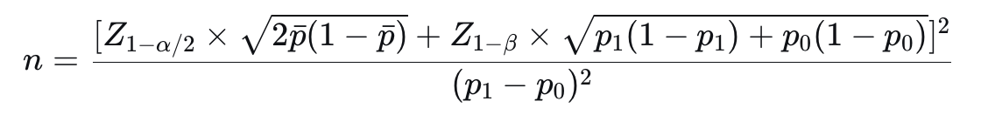
Z1−α/2​ andZ1−β​ are the quantiles of the standard normal distribution.
α=0.05 (two-sided)，Z1−α/2=1.96Z1−α/2​=1.96
β=0.10 (90% power)，Z1−β=1.282Z1−β​=1.282
p1 = (OR × p0) / (1 – p0 + OR × p0)
pˉ=(p1​+p0​)/2 (Average of the two exposure rates)
Previous studies have reported odds ratios (ORs) for various endocrine-disrupting chemicals in relation to PCOS risk: for instance, 1.53 for BPA (Hossein Rashidi B et al. 2017), 2.39 for pesticide exposure (Yang Q et al. 2015), with certain pollutants reaching ORs as high as 4 (Yang Q et al. 2015). Based on these findings, an OR of 2 was selected for sample size calculation. According to the literature, the prevalence of PCOS in women of reproductive age ranges from approximately 5% to 18%. This study, therefore, set the control group prevalence (P₀) at 10% and 15% for calculation. The calculation yielded approximately 394 participants (for P₀ = 10%) and 282 participants (for P₀ = 15%) per group. To ensure adequate power and account for potential dropouts, we targeted a recruitment of 300 - 350 participants for both cases and controls.

