7A IOSE80,A2780,A2780-DDP cell’s SLCO3A1
The antibody website shows that SLCO3A1 has multiple bands, with the main band around 76kd.
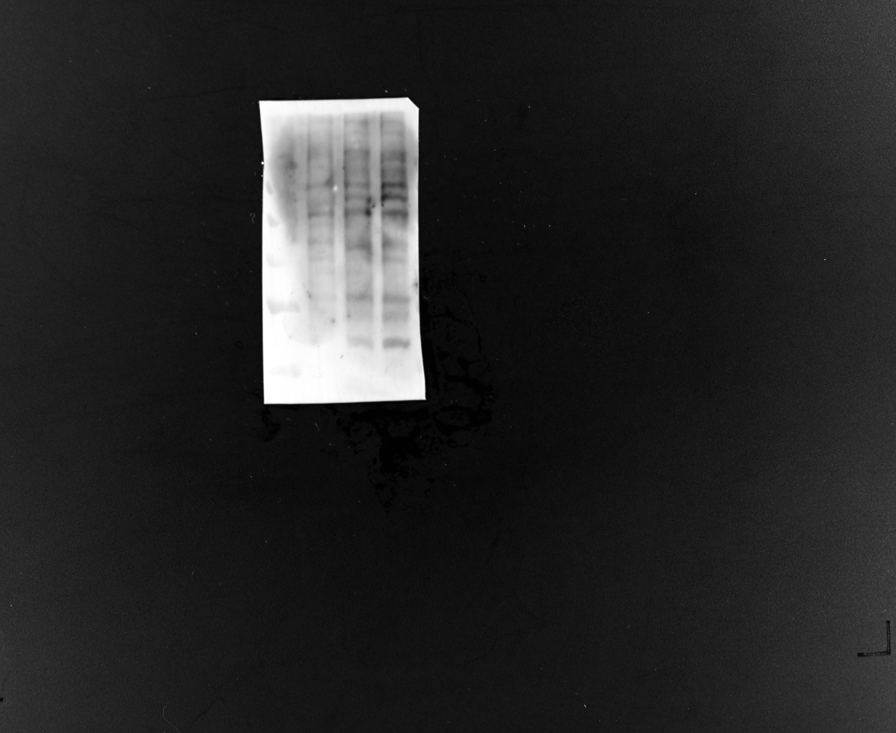
7A IOSE80,A2780,A2780-DDP cells’GAPDH
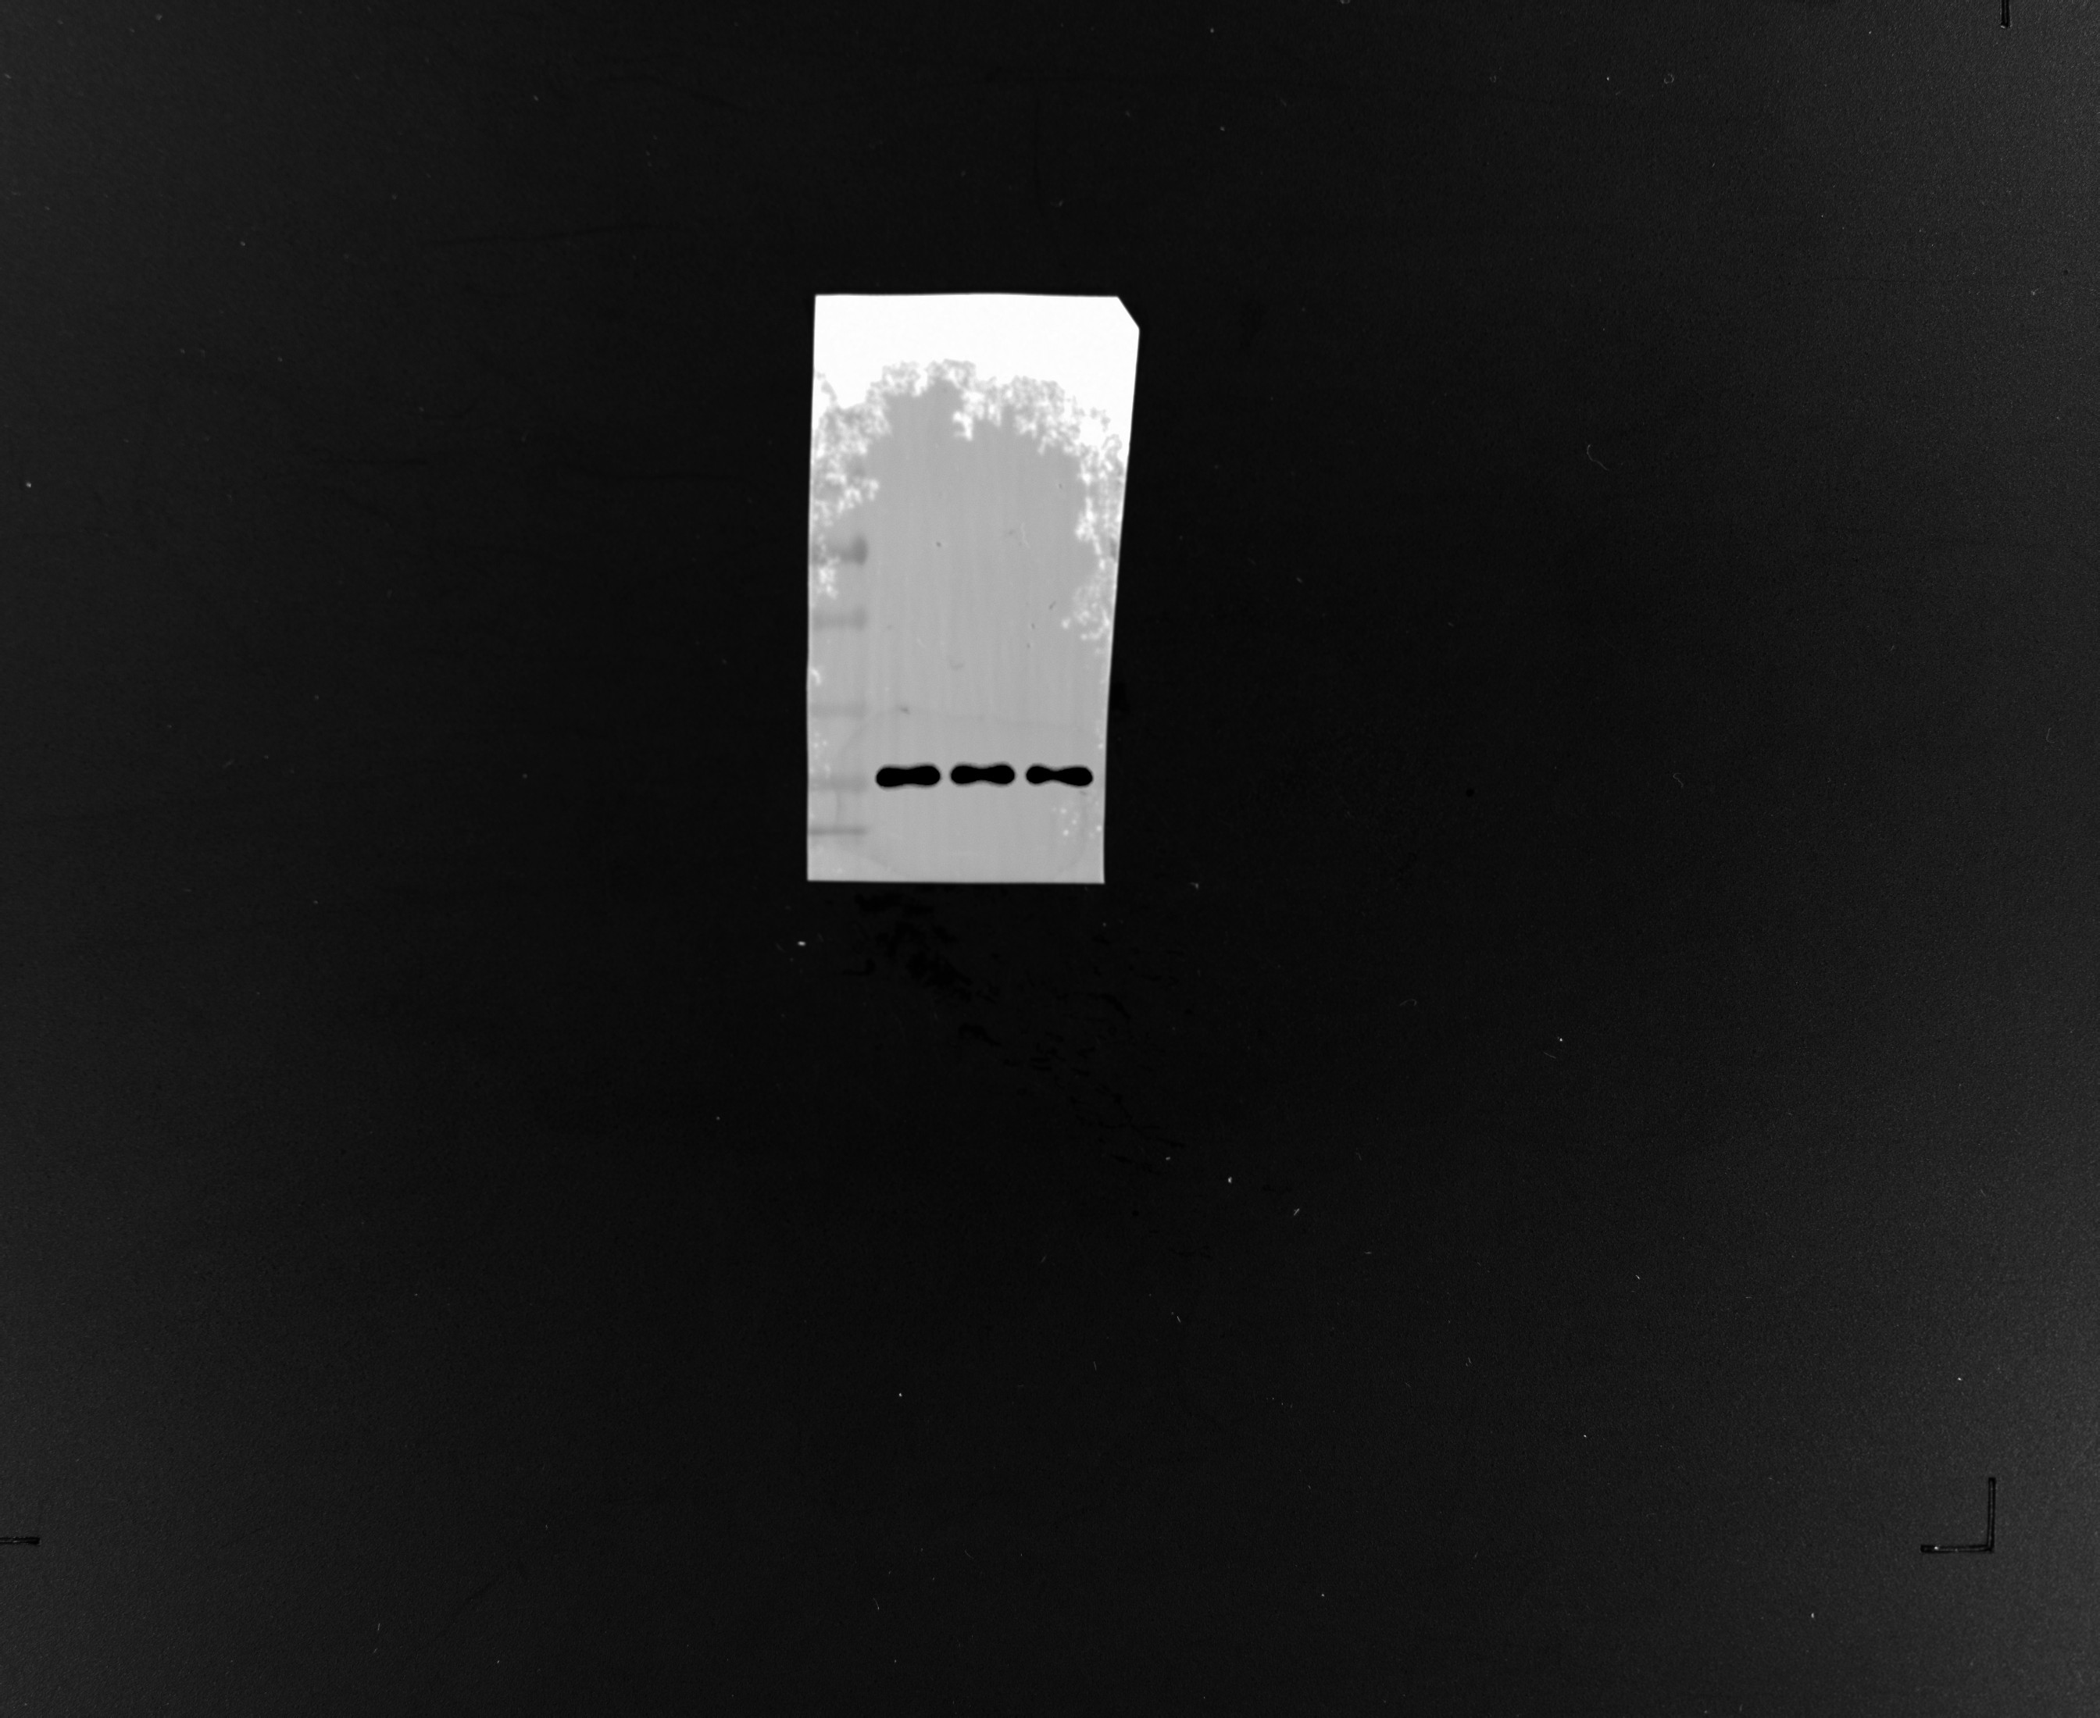

7A siNC siSLCO3A1 in A2780-DDP cell SLCO3A1
7A siNC siSLCO3A1 in A2780-DDP cell GAPDH
7A oeNC oeSLCO3A1 in A2780 cell
7G shNC shSLCO3A1 in A2780-DDP cell SLCO3A1 (manuscript)
7G shNC shSLCO3A1 in A2780-DDP cell SLCO3A1 (replicate)
7G shNC shSLCO3A1 in A2780-DDP cell SLCO3A1 (replicate2)
7G shNC shSLCO3A1 in A2780-DDP cell β-catenin (manuscript)
7G shNC shSLCO3A1 in A2780-DDP cell β-catenin (replicate)
7G shNC shSLCO3A1 in A2780-DDP cell β-catenin (replicate2)

7G shNC shSLCO3A1 in A2780-DDP cell c-Myc (manuscript）
7G shNC shSLCO3A1 in A2780-DDP cell GAPDH (manuscript）
7G shNC shSLCO3A1 in A2780-DDP cell GAPDH (replicate）

7G shNC shSLCO3A1 in A2780-DDP cell GAPDH (replicate2）
1S A SLCO3A1
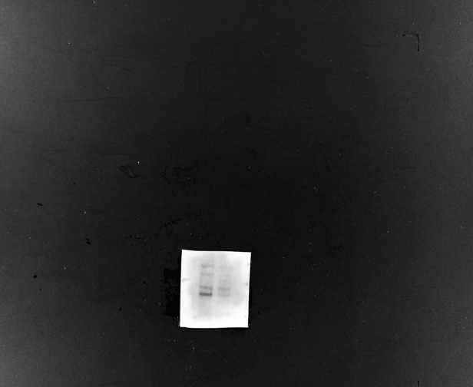
1S A β-catenin
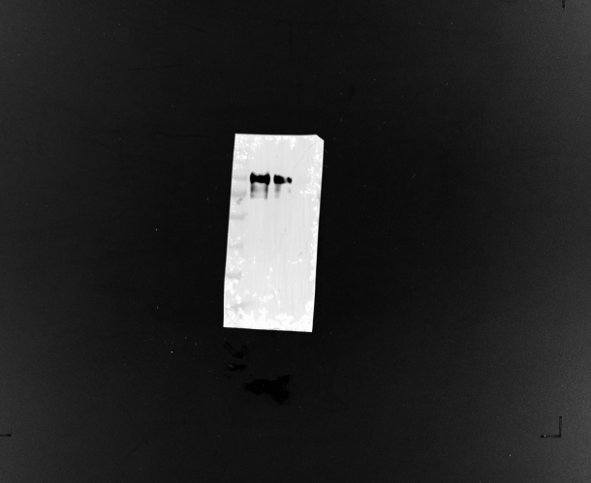

1S c-Myc
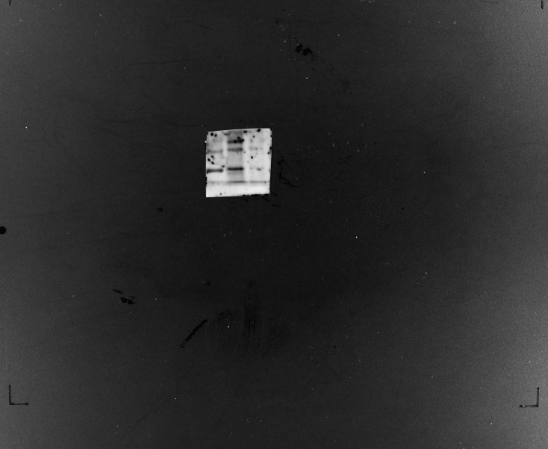
1S GAPDH
