Supplemental Material 4.
Subgroup Analysis Results (tail vein vs. ovarian injection)
2.1Primordial Follicle Count
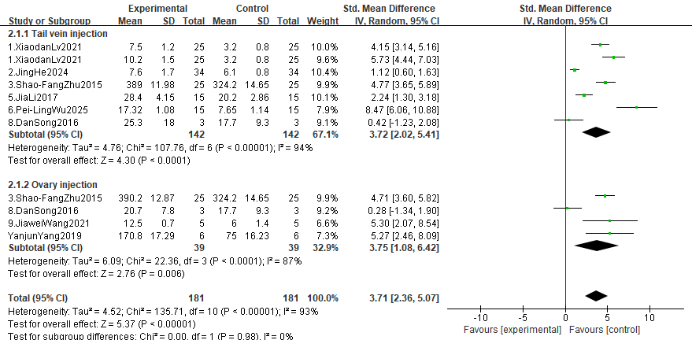

2.2Primary Follicle Count
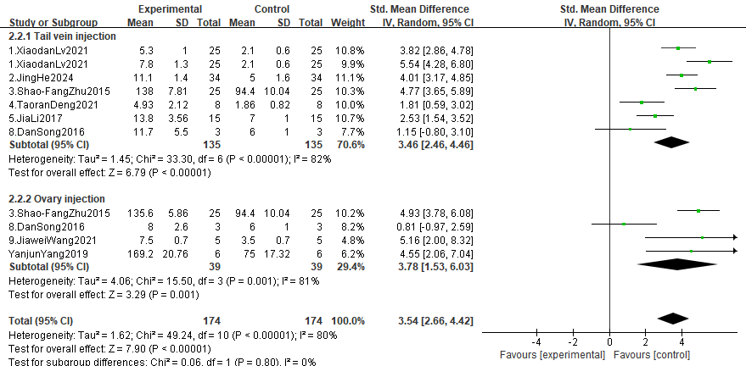

2.3Secondary Follicle Count
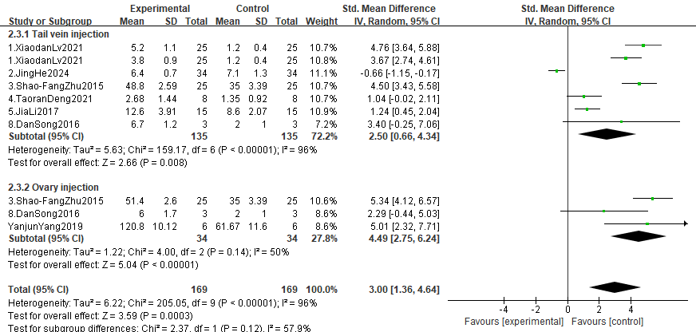

2.4Antral Follicle Count
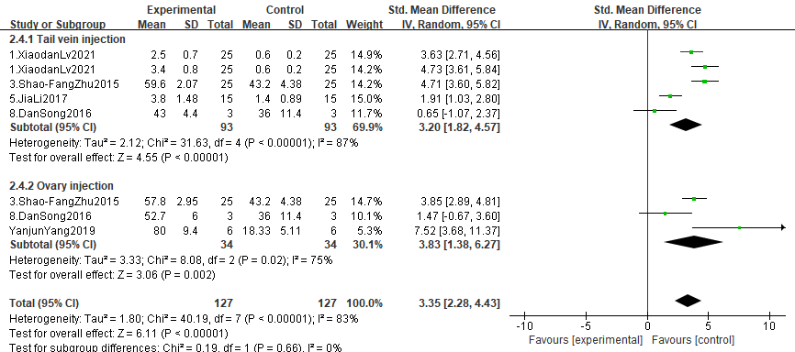

2.5 E2 Level
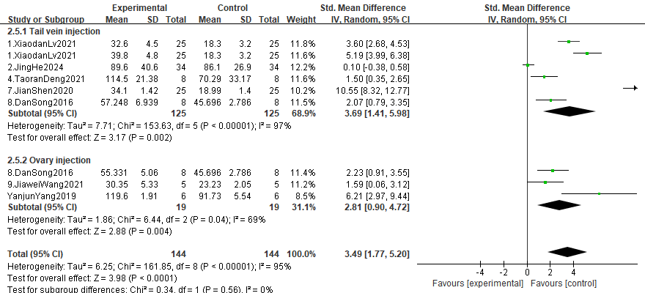

2.6 FSH Level
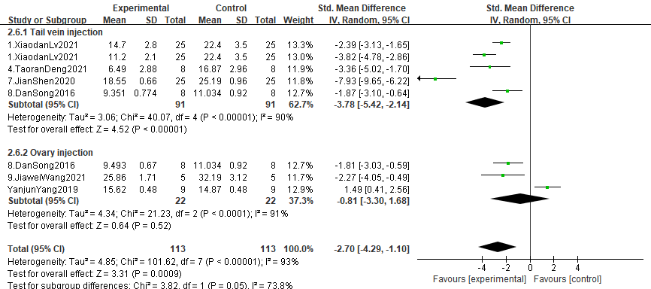

2.7 AMH Level
