Supplementary Table 1. Stability validation of the RLR-selected gene via bootstrap resampling.
Feature Set | Gene Number | AUROC | Frequency(%)
KIF20A,CHGB | 2 | 1 | 38.0%
KIF20A,PYCR1,NBEA,PGR | 4 | 1 | 6.0%
ECT2,TTK,ABCA8 | 3 | 1 | 4.0%
DTL,PYCR1,CHGB,EPB41L3 | 4 | 1 | 4.0%
PBK,TTK,OGN | 3 | 1 | 4.0%
ECT2,PBK,ABCA8 | 3 | 1 | 4.0%
DTL,MAL,TNC,ABCA8,EPB41L3 | 5 | 1 | 2.0%
BUB1B,CHGB | 2 | 1 | 2.0%
DTL,PODNL1,CHGB,PGR | 4 | 1 | 2.0%
NCAPD2,CHGB | 2 | 1 | 2.0%
DTL,NCAPD2,TSPAN8 | 3 | 1 | 2.0%
APLP1,DTL,PYCR1,CHGB,CNN1 | 5 | 1 | 2.0%
FOXM1,TNC,ADH1B | 3 | 1 | 2.0%
MRPL19,CHGB | 2 | 1 | 2.0%
DTL,PAK1IP1,TNC,ABCA8,EPB41L3 | 5 | 1 | 2.0%
CHGB | 1 | 1 | 2.0%
ECT2,ABCA8 | 2 | 1 | 2.0%
SMC4,NBEA | 2 | 1 | 2.0%
DTL,CHGB | 2 | 1 | 2.0%
DTL,PODNL1,PYCR1,CCDC69,CHGB,PGR | 6 | 1 | 2.0%
DTL,PODNL1,ABCA8 | 3 | 1 | 2.0%
DTL,PYCR1,TNC,CHGB,CNN1,DPT,PGR | 7 | 1 | 2.0%
GLDC,TTK,ABCA8 | 3 | 1 | 2.0%
ASPM,C1orf106,TTK,ABCA8,OGN | 5 | 1 | 2.0%
TTK,ABCB1 | 2 | 1 | 2.0%
CHGB,PGR | 2 | 1 | 2.0%

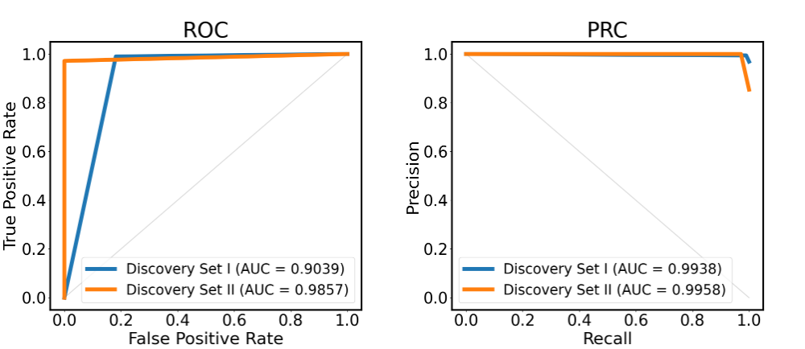

Supplementary Figure 1. Performance evaluation of KCP. AUROC and AUPRC of KCP in the Discovery Set I and II, respectively.

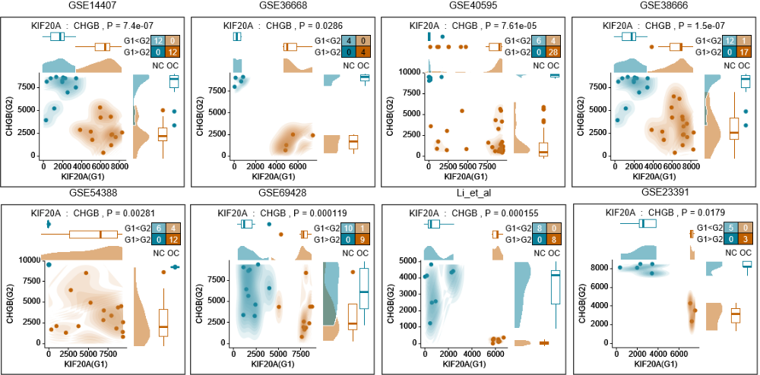
Supplementary Figure 2. PAGE plot of KIF20A and CHGB in the external validation sets. X axis and Y axis represent the ranking of KIF20A and CHGB, respectively, between the HGSOC (orange) and normal (blue) samples.
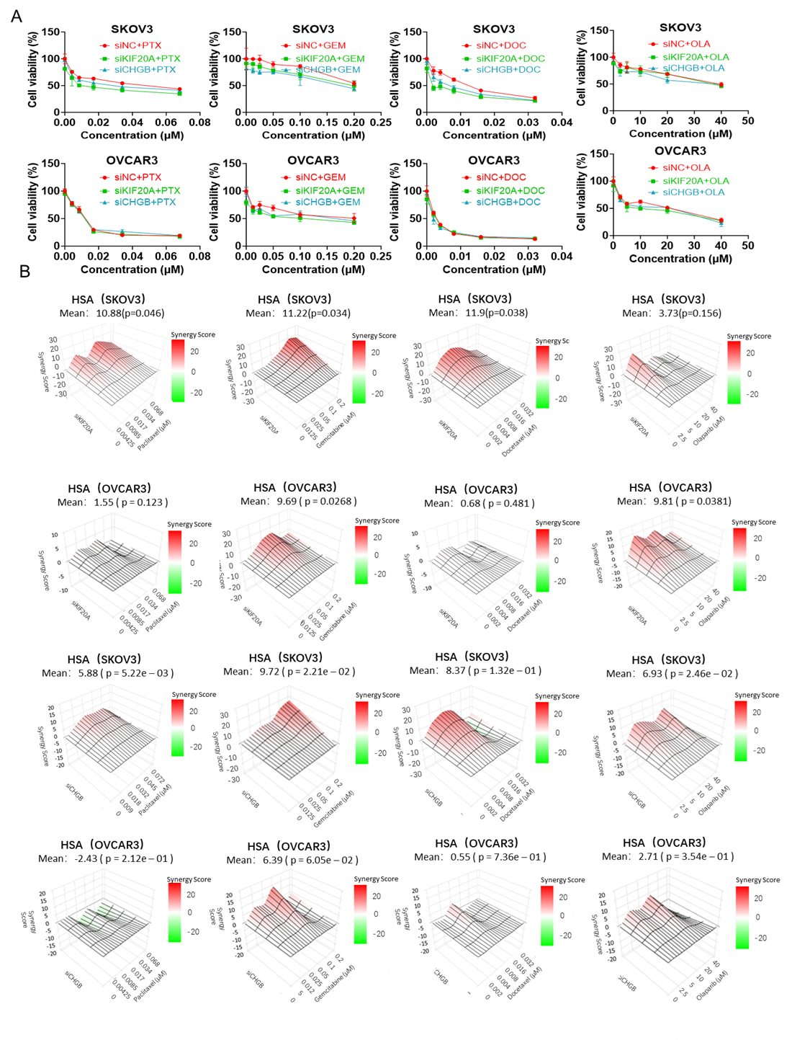
Supplementary Figure 3. The effect of KIF20A and CHGB knockdown combined with drugs on chemotherapy sensitivity of ovarian cancer cells. (A) Effect of different concentrations of Paclitaxel, Gemcitabine, Docetaxel, and Olaparib on cell viability in two ovarian cancer cell lines before and after siKIF20A and siCHGB treatment. (B) Synergy score plot for siKIF20A and siCHGB combined with Paclitaxel, Gemcitabine, Docetaxel, and Olaparib in the two ovarian cancer cell lines.

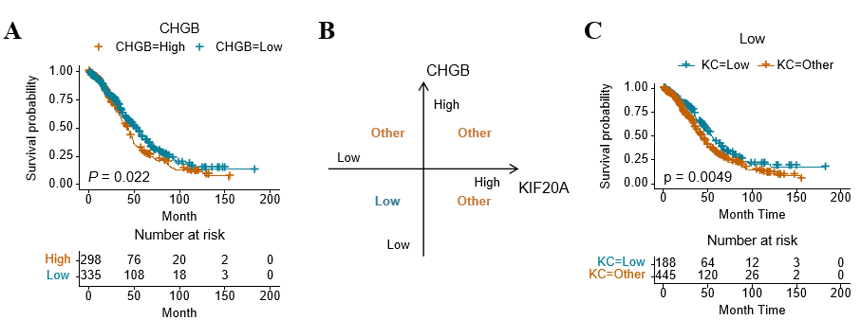
Supplementary Figure 4. Kaplan-Meier survival analysis of CHGB and the combined KCP signature (KIF20A::CHGB).
(A) Kaplan-Meier plot comparing five-year overall survival between high-risk and low-risk groups in the combined TCGA and GSE18520 cohort, stratified by the optimal expression threshold of CHGB.
(B-C) Expression levels of KIF20A and CHGB were each dichotomized into high-risk and low-risk groups using optimal cutoffs. Samples with low expression of both genes were defined as the low-risk group, while all other combinations were assigned to the Other group. The Kaplan-Meier curves show the comparison of five-year overall survival between the low-risk and Other groups. This combined stratification yielded significantly more pronounced prognostic separation than using either KIF20A or CHGB alone.

