Supplementary Results
Table S1. Treatment Exposure: Chemotherapy, Bevacizumab, and PARP Inhibitor (N=70).
Variable | Value
Chemotherapy and bevacizumab
Platinum–taxane cycles, total — median (range) | 7 (6–10)
Bevacizumab cycles (among 42 recipients) — median (range) | 15 (3–24)
PARP inhibitor (among 52 recipients)
Agent — olaparib | 36 (69.2%)
Agent — niraparib | 16 (30.8%)
Combined with bevacizumab | 15 (28.8%)
Starting dose — full | 37 (71.2%)
Starting dose — reduced by one level | 12 (23.1%)
Starting dose — reduced by two levels | 3 (5.8%)
Dose modification during therapy | 32 (61.5%)
Duration, months — median (IQR; range) | 19.1 (10.2–24.5; 2.0–50.0)
Discontinued by data cut-off | 43 (82.7%)
Data are n (%) unless otherwise indicated. PARPi starting-dose levels (full dose, reduced by one level, reduced by two levels) are defined in the Methods. Rucaparib and other PARP inhibitors were not available under Taiwan National Health Insurance and were not used. IQR, interquartile range; PARP, poly(ADP-ribose) polymerase.
Table S2. Reasons for discontinuation of PARPi maintenance therapy (n = 43)
Reason for discontinuation | Olaparib  (n = 30) | Niraparib  (n = 13) | Total, n (%)
Disease progression | 16 | 9 | 25 (58.1)
Completion of planned maintenance course | 14 | 2 | 16 (37.2)
Grade ≥3 hematologic toxicity | 0 | 2 | 2 (4.7)
Total | 30 | 13 | 43 (100)
Completion of planned maintenance comprised olaparib administered for 2 years (n = 14) and niraparib in 2 patients — one BRCA2 carrier who discontinued at 2 years in accordance with National Health Insurance coverage, and one BRCA–wild-type patient who self-funded 3 years of therapy. Both toxicity-related discontinuations occurred with niraparib (at 3.5 and 7 months). PARPi, poly(ADP-ribose) polymerase inhibitor.

Table S3. Baseline Characteristics: BRCAm vs BRCAwt within HRD Cohort (N=70)
Clinical Variable | BRCAm (n=37) | BRCAwt/HRD (n=33) | p value
Mean age (years) | 59.5 ± 10.7 | 59.2 ± 9.8 | 0.930
FIGO stage |  |  | 0.578
III | 29 (78.4) | 23 (69.7)
IV | 8 (21.6) | 10 (30.3)
NACT |  |  | 0.104
Yes | 25 (67.6) | 15 (45.5)
No | 12 (32.4) | 18 (54.5)
Optimal debulking |  |  | 0.101
Yes | 30 (81.1) | 21 (63.6)
No | 7 (18.9) | 12 (36.4)
Bevacizumab maintenance |  |  | 0.406
Yes | 20 (54.1) | 22 (66.7)
No | 17 (45.9) | 11 (33.3)
CA125 ≥10.9 U/mL |  |  | 1.000
Yes | 23 (62.2) | 21 (63.6)
No | 14 (37.8) | 12 (36.4)
PARPi maintenance |  |  | <0.001
Yes | 36 (97.3) | 16 (48.5)
No | 1 (2.7) | 17 (51.5)
Recurrence | 16 (43.2) | 21 (63.6)
Death | 6 (16.2) | 7 (21.2)
Median PFS (months)  Median OS (months) | 58.6  NR | 15.5  NR | 0.020  0.317

Table S4. HRD-positive/BRCAwt Subgroup: PARPi vs No PARPi (N=33)
Variable | PARPi (n=16) | No PARPi (n=17) | p value
Mean age (years) | 56.6 ± 11.7 | 61.7 ± 7.2 | 0.141
NACT |  |  | 1.000
Yes | 7 (43.8) | 8 (47.1)
No | 9 (56.2) | 9 (52.9)
Optimal debulking |  |  | 0.818
Yes | 11 (68.8) | 10 (58.8)
No | 5 (31.2) | 7 (41.2)
Bevacizumab maintenance |  |  | 1.000
Yes | 11 (68.8) | 11 (64.7)
No | 5 (31.2) | 6 (35.3)
CA125 ≥10.9 U/mL |  |  | 0.223
Yes | 8 (50.0) | 13 (76.5)
No | 8 (50.0) | 4 (23.5)
Median PFS (months) | 23.1 | 13.0 | 0.226
3-year PFS rate | 44.1% | 25.0%
This analysis is restricted to the 33 HRD-positive/BRCAwt patients (16 who received and 17 who did not receive PARPi maintenance); the single BRCAm patient who did not receive PARPi maintenance is included in the overall cohort but not in this BRCAwt subgroup. CA125, cancer antigen 125; NACT, neoadjuvant chemotherapy; PARPi, poly(ADP-ribose) polymerase inhibitors; PFS, progression-free survival

Table S5. Univariate and Multivariate Cox Regression for Progression-Free Survival within the HRD-positive/BRCAwt Subgroup (N=33).
Variable | Univariate HR | 95% CI | p value | Multivariate HR | 95% CI | p value
Age (≥60 vs <60) | 2.057 | 0.820–5.165 | 0.124 | — | — | —
NACT (yes vs no) | 3.235 | 1.285–8.139 | 0.013 | 4.559 | 1.625–12.793 | 0.004
Optimal debulking (yes vs no) | 0.568 | 0.235–1.377 | 0.211 | 0.875 | 0.326–2.348 | 0.792
Bevacizumab (yes vs no) | 0.458 | 0.189–1.108 | 0.083 | — | — | —
CA125 ≥10.9 U/mL (yes vs no) | 3.896 | 1.291–11.757 | 0.016 | 4.453 | 1.248–15.898 | 0.021
PARPi use (yes vs no) | 0.532 | 0.217–1.306 | 0.169 | 0.411 | 0.153–1.104 | 0.078
PFS event defined as progression, recurrence, or death from any cause. The multivariate model included NACT, optimal debulking, CA125, and PARPi use; age and bevacizumab (—) were not entered. CA125, cancer antigen 125; CI, confidence interval; HR, hazard ratio; NACT, neoadjuvant chemotherapy; PARPi, poly(ADP-ribose) polymerase inhibitors.

Table S6. Three-Year PFS Rates by BRCA Status and PARPi Access.
Subgroup | N | Events | Median PFS (months) | 3-year PFS rate
BRCAm + PARPi | 36 | 16 | 58.6 | 57.4%
HRD-positive/BRCAwt + PARPi | 16 | 9 | 23.1 | 44.1%
All HRD-positive, no PARPi | 18 | 12 | 13.0 | 23.6%
PFS event defined as progression, recurrence, or death from any cause; three-year PFS estimated by the Kaplan–Meier method. Of the 18 HRD-positive patients who did not receive PARPi maintenance, 17 were BRCAwt (predominantly reflecting NHI reimbursement and self-funding constraints) and 1 was BRCAm who discontinued within two weeks owing to dysgeusia and therefore did not meet the maintenance exposure threshold defined in the Methods. PARPi, poly(ADP-ribose) polymerase inhibitors; PFS, progression-free survival.

Figure S1. Receiver operating characteristic (ROC) curve for post-chemotherapy serum CA125 in predicting disease progression in the HRD-positive cohort (N=70), with the optimal cutoff identified by Youden's index indicated by the red dot.
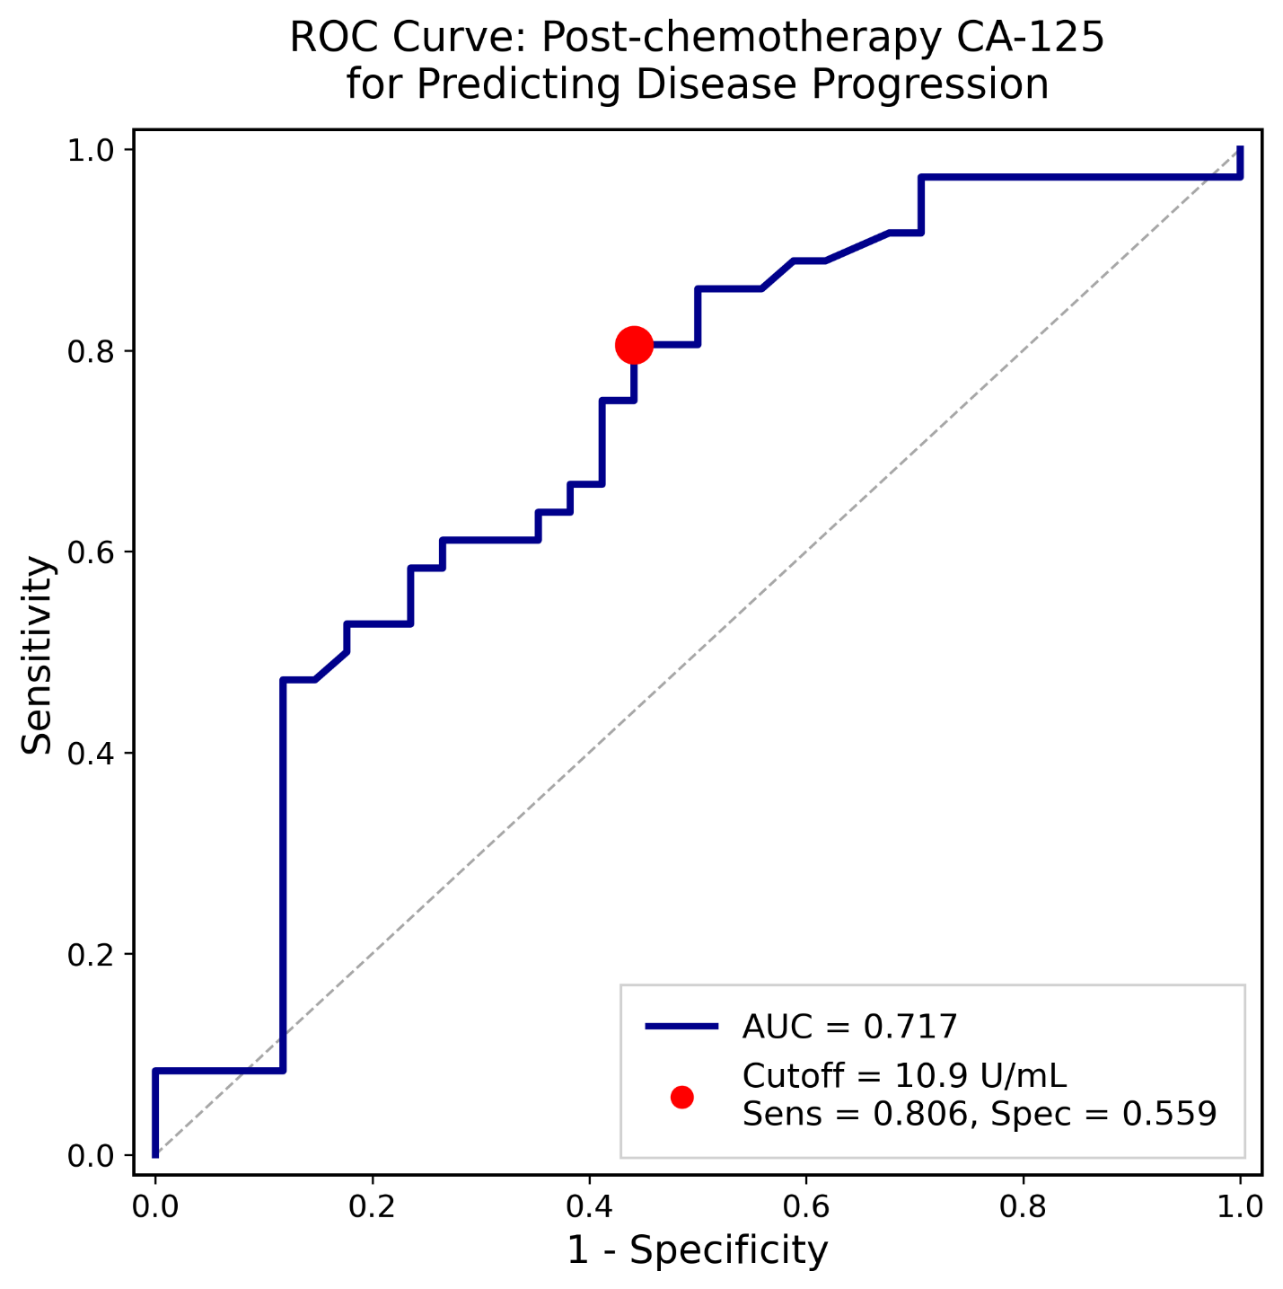

Figure S2. Kaplan-Meier survival curves for progression-free survival stratified by HRD status and PARPi maintenance access among 70 HRD-positive patients, comprising BRCAm with PARPi (n=36), HRD-positive/BRCAwt with PARPi (n=16), and HRD-positive without PARPi (n=18)

