SUPPLEMENTAL MATERIAL

Andreea M. Newtson ^{1,3,a}, Danielle P. Uhl ^{1,a}, Emily S. Kolpin ¹, Paige K. Malmrose ¹, Samantha Parks ¹, Craig M. Rush ⁴, Sofia Gabrilovich ^{1,5}, Jianling Bi ^{1,6} , Eric J. Devor ^{1,2}, Kaitriana E. Colling ¹, Haley Losh ¹, Jessica Andrew-Udoh ¹, Jason Gertz ⁴, Pilar de la Puente ⁷, Kimberly K. Leslie ^{1,8,} and Kristina W. Thiel ^{1, 2,}

1 Department of Obstetrics and Gynecology, University of Iowa, Iowa City, Iowa, USA
2 Holden Comprehensive Cancer Center, University of Iowa, Iowa City, Iowa, USA
3 Endeavor Health, Evanston, Illinois, USA
4 Department of Oncological Sciences, Huntsman Cancer Institute, University of Utah, Salt Lake City, Utah, USA
5 Medical College of Wisconsin, Milwaukee, Wisconsin, USA
6 Women and Children’s Hospital of Chongqing Medical University and the Chongqing Health Center for Women and Children, Chongqing, China
7 Sanford Research, Sioux Falls, South Dakota, USA
8 University of New Mexico Health Sciences, Albuquerque, New Mexico, USA
a indicates equal contributions

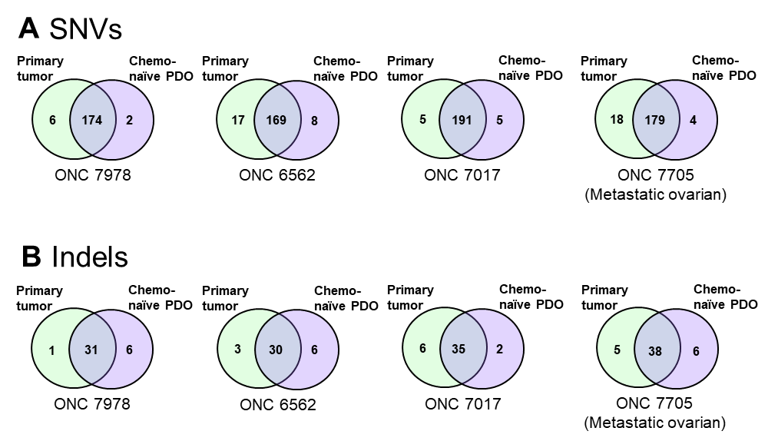

Figure S1: Mutational profile comparison between primary tumor and chemotherapy-naïve organoids. Genomic DNA was isolated from primary tumor specimens and paired chemotherapy-naïve PDOs and sent to Novagene for next generation sequencing. A: Comparison of shared and unique SNVs after common polymorphisms have been filtered out. B: Comparison of shared and unique Indels after common polymorphisms have been filtered out.

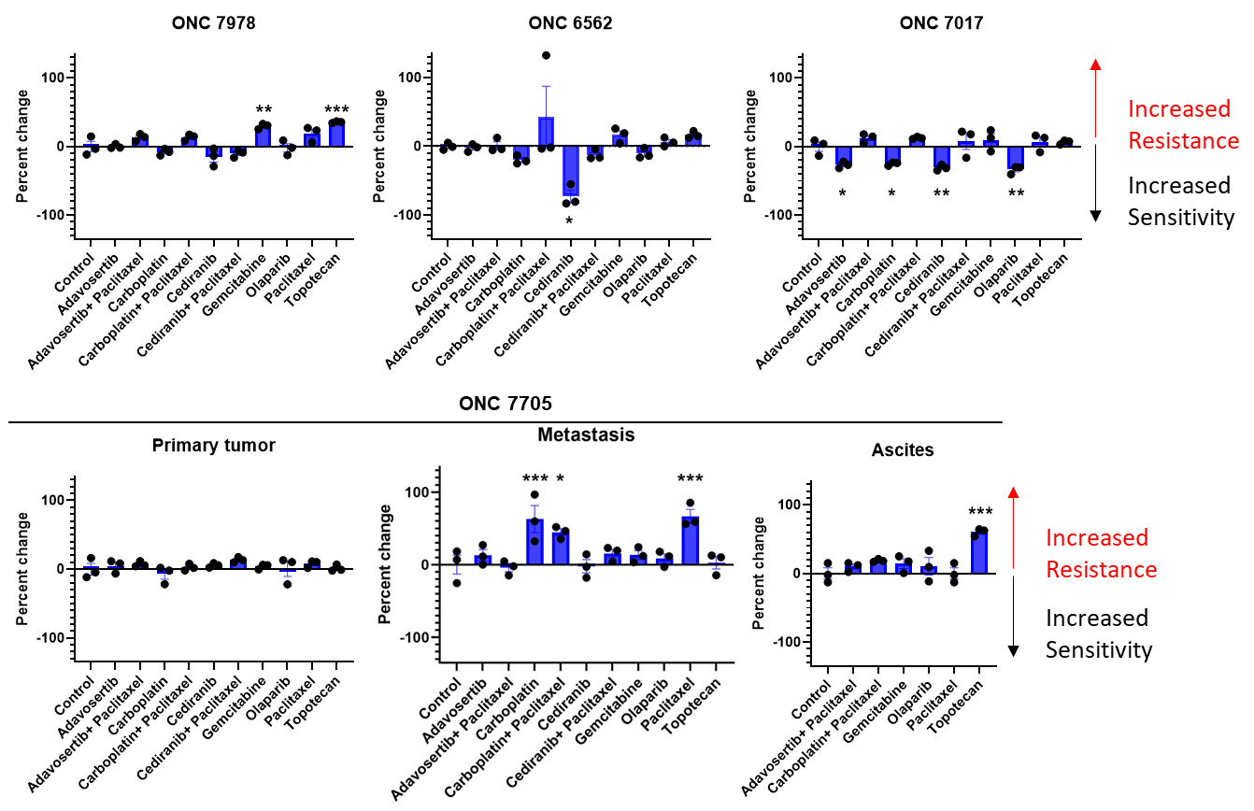

Figure S2: Organoid drug response prior to chemotherapy treatment and after chemotherapy exposure. Drug sensitivity after chemotherapy exposure was compared to drug sensitivity of chemotherapy naïve PDOs to determine the percent change in drug sensitivity after exposure to chemotherapy as depicted in the formula in Figure 4C. Any value above the x-axis indicates increased resistance, whereas any value below the x-axis indicates increased sensitivity after chemo-exposure. *p < 0.05, **p < 0.001, ***p < 0.001 by one-way ANOVA with Dunnett’s multiple comparisons test.

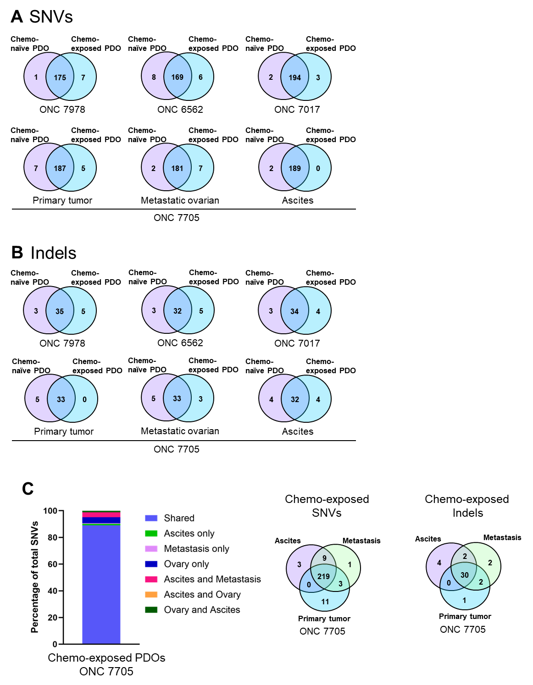
Figure S3: Mutational profile comparison between chemotherapy-naïve and chemotherapy exposed organoids. Genomic DNA was isolated from chemotherapy-naïve PDOs and paired chemotherapy exposed PDOs subjected to next generation sequencing using a 484-gene panel. A: Comparison of shared and unique SNVs after common polymorphisms have been filtered out. B: Comparison of shared and unique indels after common polymorphisms have been filtered out. C: Comparison of shared and unique indels and SNVs in PDOs created from three different sites in ONC 7705.

