Additional file 4
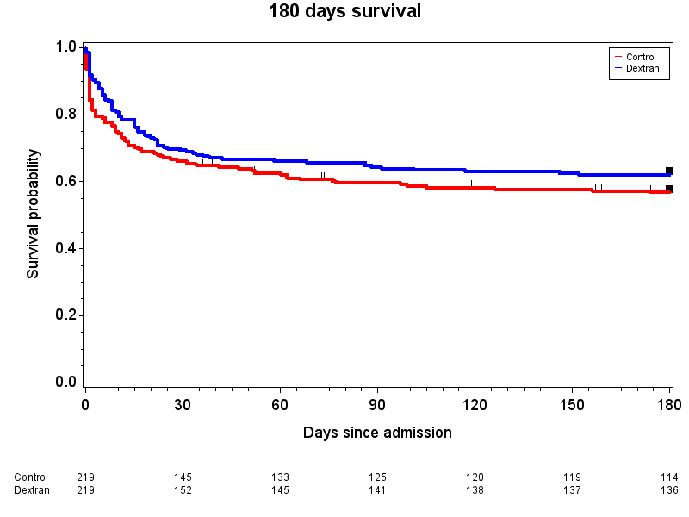
Additional Fig. 2 Kaplan–Meier estimates of the probability of 180-day survival including only patients who received > 900 ml dextran 70 the first 5 days in the ICU in dextran group. P=0.19 for the comparison between the control group (red line) and the dextran group (blue line). Difference between groups was tested using the stratified log-rank test

