Additional file
Rotated Component Matrix

Rotated Component Matrix
 | Component
 | 1 | 2 | 3 | 4
by the book, I feel well prepared for the course. | ,244 | ,176 | ,661 | ,184
I have high expectations for the course. | ,622 | ,237 | ,333 | -,045
I expect an increased safety in the assessment of the kinematics. | ,886 | -,036 | ,059 | ,060
I expect more safety in the classification of critical / non-critical patients. | ,888 | -,033 | ,073 | ,073
I expect to treat life-threatening situations faster. | ,868 | -,004 | ,072 | ,025
I expect to expand my knowledge in trauma care. | ,828 | ,124 | ,138 | -,052
I feel safe in thoracic needle decompression. | -,168 | ,129 | ,467 | ,558
I feel safe in airway management. | ,086 | ,533 | ,459 | ,113
I feel safe in the proper handling of the spineboard. | ,147 | ,545 | ,026 | ,551
I feel safe in the proper handling of the pelvic sling. | ,061 | ,195 | -,010 | ,867
I feel safe in proper handling with neck collars. | ,166 | ,684 | ,218 | ,155
I feel safe in treatment of traumatological emergencies. | -,050 | ,752 | ,308 | ,121
I feel safe in removing a helmet. | ,042 | ,809 | ,110 | ,100
I feel safe in the rescue off the vehicle (extrication). | ,086 | ,754 | ,114 | ,159
# t0 Ich bin bestrebt, mich regelmäßig durch medizinische Fachzeitschriften fortzubilden. | ,205 | ,182 | ,786 | -,073
Extraction Method: Principal Component Analysis. Rotation Method: Varimax with Kaiser Normalization.

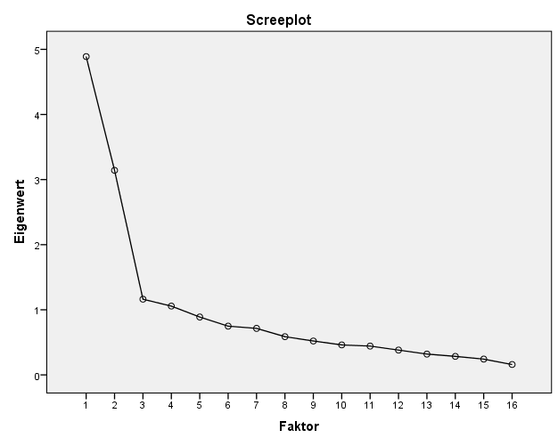
Figure: scree plot of eigenvalues of the factor analysis

Table: Additional questions after one year.
 | TIME POINT
QUESTION | after t2  MW±SD  median
- I have studied the manual after the course once again. | 3.4 ± 1.9  4.0
- I attend the kinematics more than before the course | 5.4 ± 1.5  6.0
- I use the ABCDE structure in the care of trauma patients. | 6.0 ± 1.2  6.0
- My prehospital care of trauma patients has change after the course | 5.6 ± 1.4  6.0
- After PHTLS training of the emergency medical service it is noticed a subjective change in the care of trauma patients by colleagues. | 5.9 ± 1.1  6.0
- My prehospital care of trauma patients has improved after the course. | 5.6 ± 1.4  6.0
- After PHTLS training of the emergency medical service it is noticed a subjective improvement in the care of trauma patients by colleagues. | 6.0 ± 0.9  6.0

