Appendix

TRIAGE III trial

All documents included are from the TRIAGE III trial.

Table of contents

List of Steering Committee members 2
List of investigators 3
Inclusion and exclusion criteria for patients 4
Additional description of statistics 5
Appendix Figures 6
Appendix Tables 9

List of Steering Committee members

Kasper Iversen, M.D., D.M.Sc.¹
Jesper Eugen-Olsen, Ph.D.²
Lars Simon Rasmussen, M.D., D.M.Sc.³
Lars Køber, M.D., D.M.Sc.⁴
Erik Kjøller, M.D., D.M.Sc.¹
Birgitte Nybo Jensen, M.D., Ph.D.⁵
Lisbet Ravn, M.D.⁶

Chief Statistician:
Theis Lange, Ph.D.^{7,8}

Data Manager:
Thomas Kallemose, MSc.²

Affiliations:
1Department of Cardiology, Herlev and Gentofte Hospital, University of Copenhagen, Herlev Ringvej 75, 2730 Herlev, Denmark. 2Clinical Research Centre, Hvidovre and Amager Hospital, University of Copenhagen, Kettegård Alle 30, 2650 Hvidovre, Denmark. 3Department of Anaesthesia, Rigshospitalet, University of Copenhagen, Blegdamsvej 9, 2100 Copenhagen, Denmark. 4Department of Cardiology, Rigshospitalet, University of Copenhagen, Blegdamsvej 9, 2100 Copenhagen, Denmark. 5Department of Emergency Medicine, Bispebjerg Hospital, University of Copenhagen, Bispebjerg Bakke 23, 2400 Copenhagen, Denmark. 6Department of Emergency Medicine, Herlev Hospital, University of Copenhagen, Herlev Ringvej 75, 2730 Herlev, Denmark. ⁷Department of Public Health, University of Copenhagen, Section of biostatistics, Øster Farimagsgade 5, 1014, Copenhagen, Denmark, and Center for Statistical Science, Peking University, No. 5 Yiheyuan Road Haidian District, Beijing, 100871, China.
.

List of investigators

Herlev and Gentofte Hospital, University of Copenhagen

Martin Schultz Department of Cardiology and Internal Medicine
Malene H. Andersen Department of Cardiology
Sarah Holle Department of Cardiology
Morten Alstrup Department of Cardiology
Andreas Sandø Department of Cardiology
Thomas Høi-Hansen Department of Cardiology
Kasper Iversen Department of Cardiology
Morten Lind Department of Emergency medicine
Lisbet Ravn Department of Emergency medicine

Bispebjerg Hospital, University of Copenhagen

Birgitte Nybo Jensen Department of Emergency medicine

Hvidovre and Amager Hospital, University of Copenhagen

Jeppe Meyer Clinical Research Center
Peter B S Andersen Clinical Research Center
Line Jee Hartmann Rasmussen Clinical Research Center
Thomas Kallemose Clinical Research Center
Jesper Eugen-Olsen Clinical Research Center

Rigshospitalet, University of Copenhagen
Jakob S. Stefansson Department of Anaesthesia
Alexander C. Falkentoft Department of Cardiology
Lars Køber Department of Cardiology
Lars Simon Rasmussen Department of Anaesthesia

Inclusion and exclusion criteria for patients

Inclusion criteria

- ≥16 years at admittance.
- Acute arrival at the emergency department within the inclusion period.
- Have routine blood tests analyzed, including hemoglobin, C-reactive protein, and creatinine, within 6 hours of admission to the emergency department.
- As the results of the blood tests can take up to two hours to provide, the doctors cannot change outcome based on biomarker levels until those data are provided. Hence, inclusion time will be calculated as time for blood sampling + 2 hours.

Exclusion criteria

- Arrival at the gynecological-, obstetric-, and pediatric department.

Additional description of statistics
Definitions of specific secondary outcomes
In-hospital admission is defined as admissions at the ED longer than 24 hours. Some patients remained in the ED for treatment and subsequent discharge, the majority of patients was transferred to stationary wards at the participating hospitals.
Admissions to the medical wards is defined as all ED visits allocated to the medical area of the ED and all transfer from this or other ED area to a stationary medical ward. Admissions to all internal medicine wards (excluding cardiology) and at medical areas of the ED were combined, which is in accordance with the data from the Danish National Patient Registry.

Appendix Figures

Appendix Figure 1. Survival of the TRIAGE III population stratified by suPAR quartiles.
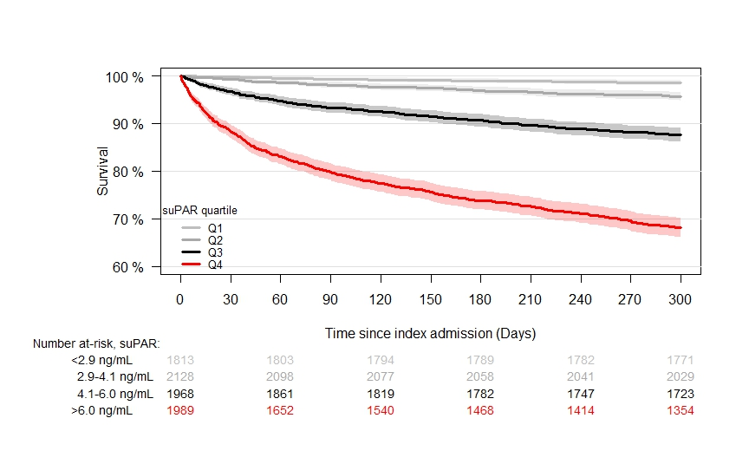

Appendix Figure 1. Kaplan-Meier plot displaying survival of patients acutely admitted at two emergency departments stratified by quartiles of soluble urokinase plasminogen activator receptor (suPAR). Log-rank test: P<0.001.

Appendix Figure 2. Result of survey among doctors participating in the TRIAGE III trial. 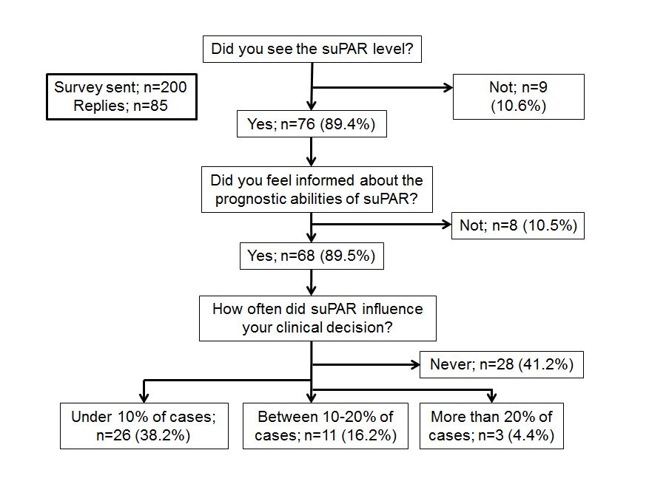

Appendix Figure 2. Flow chart showing the replies from the web-based anonymous survey of 200 randomly selected emergency department doctors in the TRIAGE III trial, in which patients who were acutely admitted to the emergency department were allocated to measurement of soluble urokinase plasminogen activator receptor (suPAR) as a prognostic marker or to control (no suPAR measurement).

Appendix Tables
Appendix Table 1. Characteristics of acutely admitted patients at the index admission, stratified by cluster.
Hospital | Herlev hospital |  | Bispebjerg hospital
Patient Characteristic  No. of patients | Intervention  (N = 5,449) | Control  (N=4,332) | Intervention  (N=3,451) | Control  (N=3,569)
Female sex, no. (%) | 2,913 (53.5) | 2,256 (52.1) | 1,776 (51.5) | 1,919 (53.8)
Age (years), mean (SD) | 60.98 (20.30) | 61.06 (20.52) | 59.45 (21.44) | 60.62 (20.90)
Charlson score, mean (SD) | 0.75 (1.56) | 0.71 (1.53) | 0.60 (1.28) | 0.69 (1.42)
Biomarkers, median (IQR)
Albumin (g/L) | 42 (38–44) | 41 (38–44) | 35 (31–39) | 35 (31–39)
Creatinine (µmol/L) | 72 (60–90) | 72 (60–89) | 80 (67–97) | 78 (65–97)
CRP (mg/L) | 3.0 (3.0–41.0) | 3.0 (3.0–41.0) | 7.7 (2.0–37.0) | 8.0 (2.0–42.0)
Hemoglobin (mmol/L) | 8.3 (7.5-9.0) | 8.3 (7.5-9.0) | 8.4 (7.6–9.1) | 8.3 (7.5–9.0)
suPAR (ng/ml) | 4.1 (3.0–5.9) | n.a. | 4.1 (2.9–6.1) | n.a
Admissions
Length of hospital stay (days), mean (SD) | 3.95 (6.64) | 4.11 (8.28) | 5.08 (10.29) | 5.03 (9.16)
Transfer to medical ward, n (%) | 1,985 (36.5) | 1,609 (37.3) | 1,752 (50.8) | 1,887 (52.9)
Transfer to the ICU, n (%) | 39 (0.7) | 38 (0.9) | 80 (2.3) | 65 (1.8)
Subgroups, diagnoses at discharged
Cancers, n (%) | 461 (8.5) | 350 (8.1) | 98 (2.8) | 121 (3.4)
Cardiovascular disease, no. (%) | 1014 (18.6) | 769 (17.8) | 904 (26.2) | 957 (26.8)
Infections, no. (%) | 969 (17.8) | 817 (18.9) | 707 (20.5) | 767 (21.5)
Neurological disease, no. (%) | 489 (9.0) | 400 (9.2) | 447 (13.0) | 464 (13.0)
Surgery during admission, no. (%) | 474 (8.7) | 411 (9.5) | 376 (10.5) | 402 (11.6)
Outcomes
Mortality during follow-up, no. (%) | 814 (14.9) | 611 (14.1) | 427 (12.4) | 515 (14.4)
New cancers during follow up, no. (%) | 538 (9.9) | 449 (10.4) | 239 (6.9) | 251 (7.0)
Patients discharged within 24 h, no (%) | 2,961 (54.3) | 2,356 (54.4) | 1,468 (42.3) | 1,498 (42.0)
Readmission within follow up, no. (%) | 1,608 (29.5) | 1,262 (29.1) | 1,036 (30.0) | 1,061 (29.7)
CRP: C-reactive protein, ICU: Intensive care unit, IQR: interquartile range, SD: standard deviation.

Appendix Table 2. Different Cox models on all-cause mortality at end of follow-up. TRIAGE III trial.
Model | HR (95% CI) | P-value
Intention to treat (ITT)
Weighted Cox, unadjusted | 0.97 (0.89–1.07) | 0.57
Weighted Cox, adjusted for age, sex, hospital | 0.99 (0.91–1.09) | 0.88
Weighted Cox, adjusted for age, sex, hospital, Charlson score and CRP | 1.04 (0.95–1.14) | 0.41
Censoring at readmission, adjusted for age, sex, hospital, Charlson score and CRP | 1.06 (0.95–1.19) | 0.27
Subgroups, ITT – weighted Cox – fully adjusted model
Bispebjerg hospital | 1.02 (0.88–1.19) | 0.76
Herlev hospital | 1.05 (0.92–1.19) | 0.48
Age < 65 years | 1.12 (0.86–1.46) | 0.41
Age >= 65 years | 1.03 (0.93–1.14) | 0.54
Cancer | 1.03 (0.87–1.22) | 0.75
Cardiovascular disease | 1.06 (0.90–1.24) | 0.50
Infectious disease | 0.92 (0.83–1.03) | 0.13
Neurological disease | 1.08 (0.87–1.34) | 0.50
Surgery during admission | 0.97 (0.75–1.27) | 0.85
Per protocol
Weighted Cox, unadjusted | 0.98 (0.89–1.08) | 0.40
Weighted Cox, adjusted for age, sex, hospital, Charlson score and CRP | 1.04 (0.94–1.15) | 0.45
CI: confidence interval, CRP: C-reactive protein, fully adjusted model: adjusted for age, sex, hospital, Charlson Score and CRP, HR: hazard ratio, ITT: Intention to treat. Per protocol: Cohort with exclusion of patients without a suPAR measurement in the intervention periods and patients with an erroneous suPAR measurement in the control periods.

Appendix Table 3. Subgroup analyses of secondary outcomes in the intention to treat cohort.
Subgroup | Intervention | Control | P-value
Bispebjerg hospital, no. of patients | 3,467 | 3,584
Length of hospital stay (days), mean (SD) | 5.13 (10.36) | 5.04 (9.19) | 0.702
Patients discharged from hospital within 24 hours, no. (%) | 1,470 (42.4) | 1,502 (41.9) | 0.701
Readmissions within 30 days, no. (%) | 289 (8.3) | 300 (8.4) | 0.048*
Herlev hospital, no. of patients | 5,462 | 4,350
Length of hospital stay (days), mean (SD) | 3.94 (6.63) | 4.11 (8.27) | 0.270
Patients discharged from hospital within 24 hours, no. (%) | 2,969 (54.4) | 2,366 (54.6) | 0.924
Readmissions within 30 days, no. (%) | 524 (9.6) | 323 (7.4) | <0.001*
Age < 65, no. of patients | 4,566 | 3,990
Length of hospital stay (days), mean (SD) | 3.08 (8.10) | 3.20 (8.80) | 0.527
Patients discharged from hospital within 24 hours, no. (%) | 2,952 (64.7) | 2,537 (63.7) | 0.327
Readmissions within 30 days, no. (%) | 330 (7.2) | 258 (6.5) | 0.400
Age >= 65, no. of patients | 4,334 | 3,912
Length of hospital stay (days), mean (SD) | 5.76 (8.23) | 5.88 (8.39) | 0.507
Patients discharged from hospital within 24 hours, no. (%) | 1,477 (34.1) | 1,317 (33.8) | 0.743
Readmissions within 30 days, no. (%) | 502 (11.6) | 375 (9.6) | 0.028*
Cancer, no. of patients | 613 | 524
Length of hospital stay (days), mean (SD) | 8.32 (12.76) | 8.96 (13.56) | 0.416
Patients discharged from hospital within 24 hours, no. (%) | 135 (22.1) | 113 (21.9) | 0.969
Readmissions within 30 days, no. (%) | 69 (11.3) | 41 (7.8) | 0.097
Cardiovascular disease, no. of patients | 2,069 | 1,886
Length of hospital stay (days), mean (SD) | 7.01 (11.77) | 6.83 (10.98) | 0.621
Patients discharged from hospital within 24 hours, no. (%) | 591 (28.6) | 559 (29.7) | 0.482
Readmissions within 30 days, no. (%) | 111 (5.4) | 110 (5.8) | 0.209
Infections, no. of patients | 1,676 | 1,584
Length of hospital stay (days), mean (SD) | 7.3 (10.32) | 7.3 (12.17) | 0.986
Patients discharged from hospital within 24 hours, no. (%) | 454 (27.1) | 454 (28.7) | 0.097
Readmissions within 30 days, no. (%) | 226 (13.5) | 158 (10.0) | 0.001*
Neurological disease, no. of patients | 1,008 | 923
Length of hospital stay (days), mean (SD) | 8.74 (17.11) | 8.66 (14.86) | 0.912
Patients discharged from hospital within 24 hours, no. (%) | 238 (23.8) | 234 (25.5) | 0.414
Readmissions within 30 days, no. (%) | 45 (4.4) | 36 (3.9) | 0.710
Surgery during admission, no. of patients | 978 | 871
Length of hospital stay (days), mean (SD) | 7.10 (13.99) | 6.81 (11.58) | 0.633
Patients discharged from hospital within 24 hours, no. (%) | 253 (25.9) | 255 (29.3) | 0.109
Readmissions within 30 days, no. (%) | 101 (10.3) | 73 (8.4) | 0.367
SD: standard deviation.

