Additional file 2. Call-handlers working station and screens
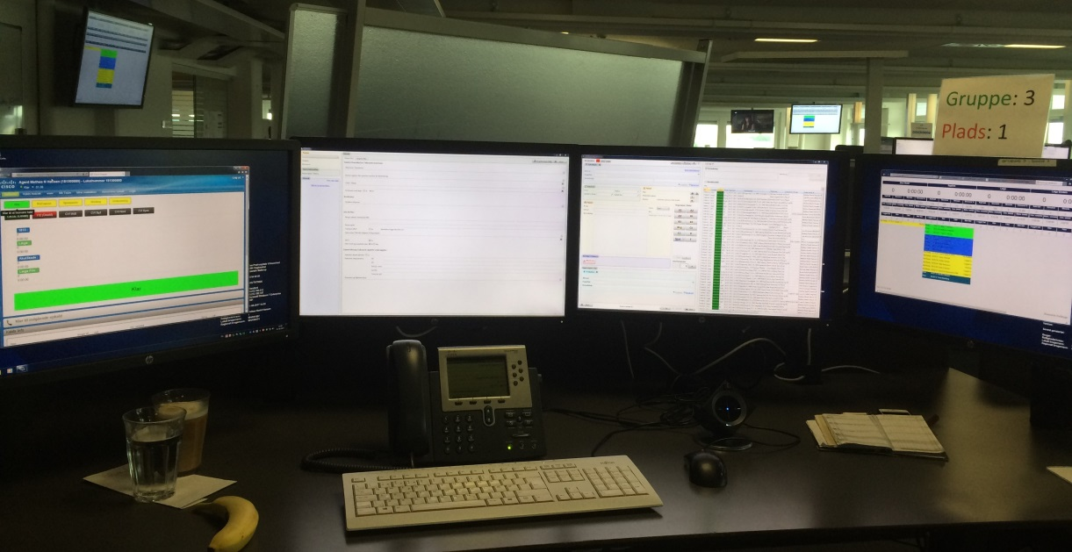
Screen 4
Screen 3
Screen 1
Screen 2
The call-handlers work-place consists of a table with a computer and four screens. The typical set-up of the screens from left to right is:
1) the desktop applications and telephone information on calls in queue, waiting time, and staff at work, access to websites on pharmacology treatment guidelines etc.
2-3) Two central screens, one displaying the patients’ basic information (e.g. address, personal identification number and dates of previous contacts to the medical helpline) and one having a template for current complaints and medical history.
4) the call-handler status (ready, working, recess) and the call-handler’s average talk-time and number of calls handled.

