Additional material 2.
Prehospital Patient Journal (PPJ). Electronic Casualty Clearing Station and patient wristband.

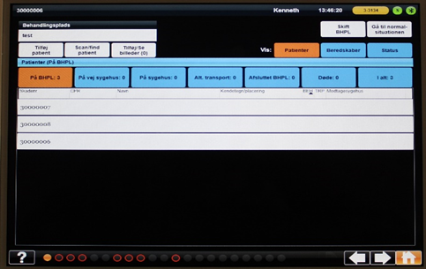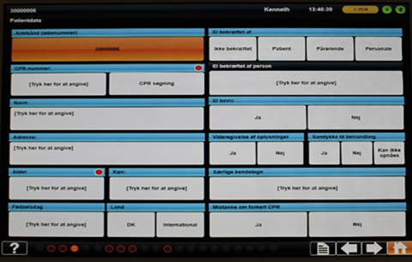

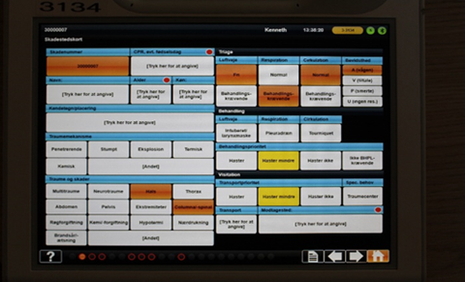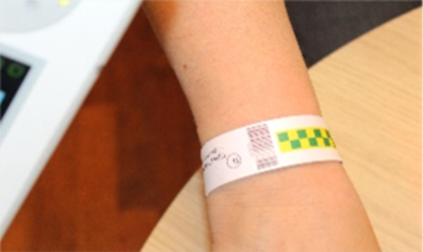

PPJ: Prehospital Patient Journal.

