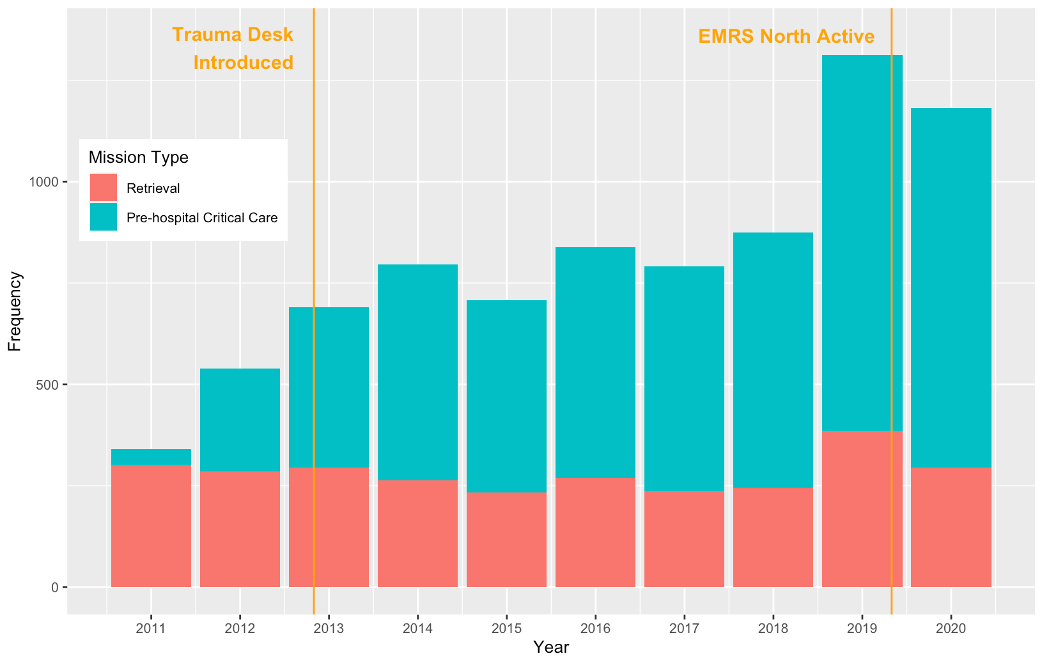
Supplementary Figure 1. Bar chart of number of Emergency Medical Retrieval Service taskings by mission type 2011-2020. Key events in the development of the service are highlighted.

 | Systolic blood pressure measurements |  |  |  | Glasgow Coma Scale observations |  |  |  | Respiratory rate observations
 | Total  n | <90mmHg  n (%) | OR (95% CI) | p value | Total  n | ≤14  n (%) | OR (95% CI) | p value | Total  n | <6 or >30  n (%) | OR (95% CI) | p value
Retrieval Missions
At EMRS Arrival | 2445 | 272 (11.1) | Reference |  | 2459 | 1562 (63.4) | Reference |  | 2410 | 155 (6.4) | Reference
At EMRS Departure | 2390 | 105 (4.4) | 0.37 (0.29-0.46) | <0.01 | 2404 | 1575 (65.5) | 1.09 (0.97-1.23) | 0.15 | 2420 | 89 (3.7) | 0.56 (0.43-0.73) | <0.01
On Arrival to Receiving Centre | 2294 | 100 (4.4) | 0.36 (0.29-0.46) | <0.01 | 2296 | 1475 (64.2) | 1.03 (0.92-1.16) | 0.61 | 2295 | 85 (3.7) | 0.56 (0.43-0.73) | <0.01
Pre-Hospital Critical Care Missions
At EMRS Arrival | 2175 | 178 (8.2) | Reference |  | 2864 | 1177 (41.1) | Reference |  | 2707 | 352 (13) | Reference
At EMRS Departure | 1701 | 138 (8.1) | 0.99 (0.79-1.25) | 0.94 | 2109 | 985 (46.7) | 1.26 (1.12-1.41) | <0.01 | 2031 | 118 (5.8) | 0.41 (0.33-0.51) | <0.01
On Arrival to Receiving Centre | 1552 | 108 (7.0) | 0.84 (0.65-1.08) | 0.17 | 1732 | 865 (49.9) | 1.43 (1.27-1.61) | <0.01 | 1690 | 72 (4.3) | 0.30 (0.23-0.39) | <0.01
Supplementary Table 1. Physiological parameters of patients attended by the Emergency Medical Retrieval Service, stratified by phase of care and mission type with univariate logistic regression of change through phases of care.

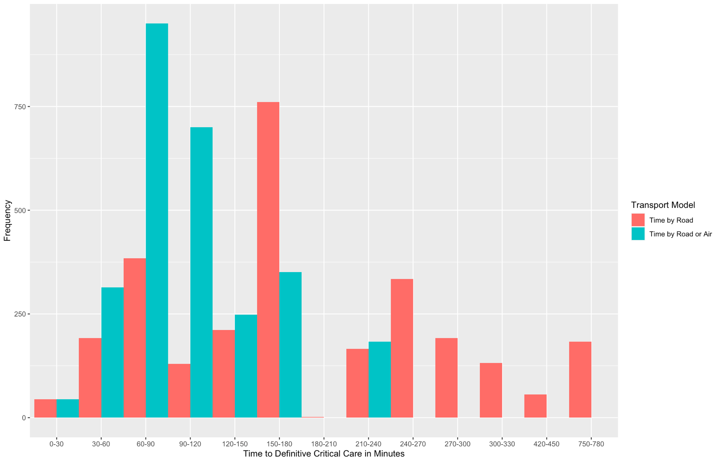
Supplementary Figure 2. Bar plot of Emergency Medical Retrieval Service retrieval missions by time to critical care unit, modelled by road alone, and modelled by the faster of either road or aeromedical transport.

Modelled Time to Critical Care Unit (minutes) | Number of patients (%)
 | Road Model | Road and Aeromedical Model
0-30 | 44 (1.6%) | 44 (1.6%)
31-60 | 192 (6.9%) | 314 (11.3%)
61-90 | 384 (13.8%) | 947 (34.0%)
91-120 | 130 (4.7%) | 700 (25.1%)
121-150 | 211 (7.6%) | 248 (8.9%)
151-180 | 761 (17.3%) | 351 (12.6%)
181-210 | 2 (<0.1%) | 0
211-240 | 166 (6.0%) | 183 (6.6%)
≥241 | 897 (32.2%) | 0
Missing Location | 21 | 21

Supplementary Figure 3. Bar plot of Emergency Medical Retrieval Service transport modalities by mission type.

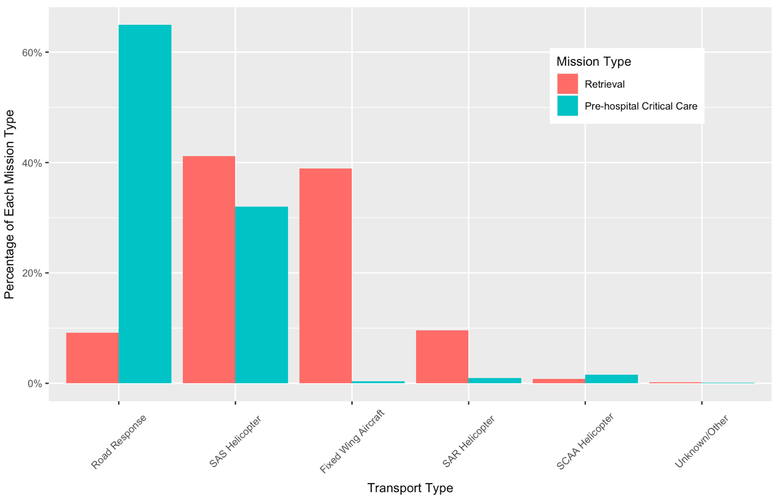

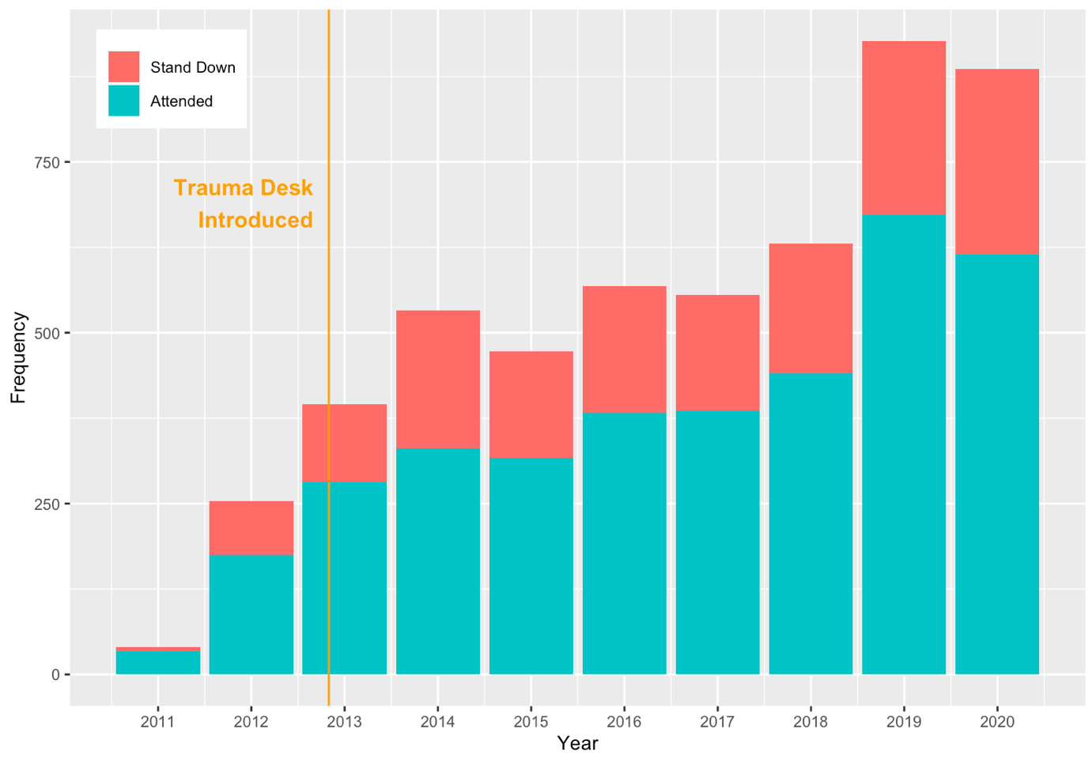
Supplementary Figure 4. Attendance and stand down rate for Emergency Medical Retrieval Service pre-hospital critical care missions by year

Supplementary Figure 5. Map of geographic distribution of Emergency Medical Retrieval Service pre-hospital critical care missions 2011-2020

