Figure S1.
- Standardized Mortality Ratio in 2018

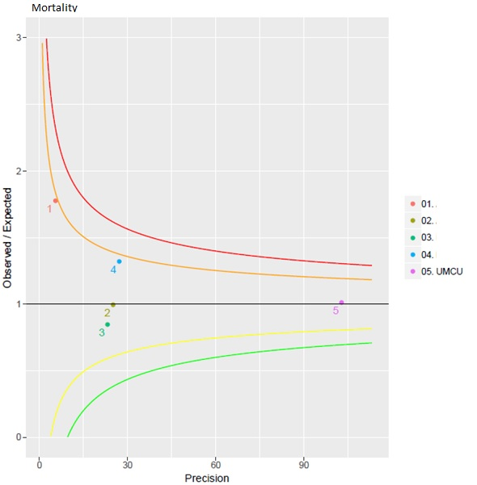

- Standardized Mortality Ratio in 2019
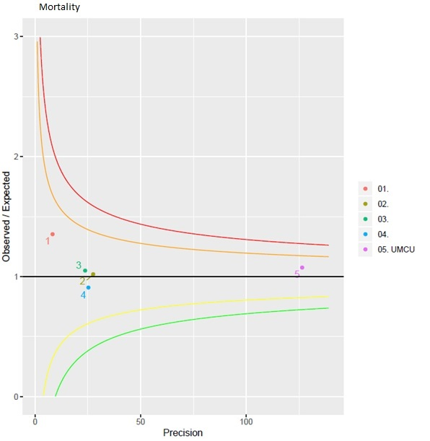
- Standardized Mortality Ratio in 2020

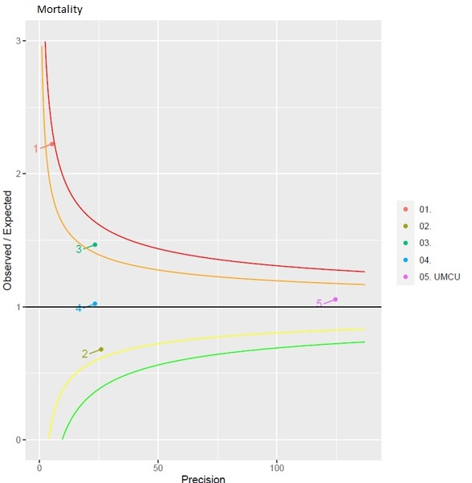

Numbers 01 through 04 are level 2/3 trauma centers within the region. Level 1 trauma center UMCU is depicted as number 05.
Red and green lines are 99.8% confidence intervals (CI), orange and yellow lines are 95% CI.
The funnel plots are provided by the Dutch National Trauma Registry.

