Assessment every 20. min:
Shivering
Subjective assessment: 0 = no shivering, 1 = a little shivering, 2 = a lot of shivering.

Objective assessment: BSAS:
Score | Definition
0 | No shivering
1 | Mild shivering neck/thorax
2 | Moderate shivering, limited to upper body/extremities
3 | Powerful shivering, torso and upper/lower extremities

Sedation (RASS)
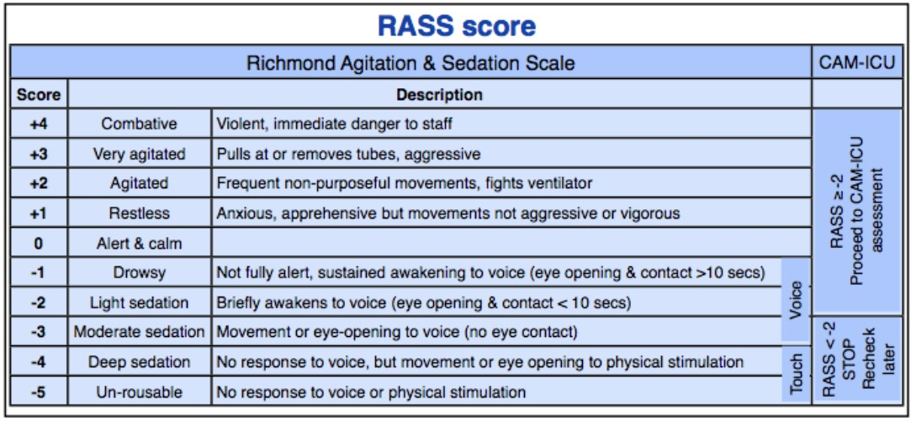
Cold discomfort
0 1 2 3 4 5 6 7 8 9 10

Extr. cold –very cold – cold – cool – slightly cool –neutral – slightly warm – warm – hot – very hot – extr. hot

Pain
0 1 2 3 4 5 6 7 8 9 10

No pain Excrutiating pain

Nausea
Yes/ No, if yes: mild, moderate or severe

