Appendix 1:
GBD Search Terms
1. Non-Fatal Injuries

GBD Estimate: Injuries by Nature
Measure: Incidence
Metric: Rate, Number
Injury: See table below (incl. Spinal Cord Injuries)
Cause: Motor Vehicle road injuries
Location: All Countries or Territories (204 total)
Age: All Ages
Sex: Both
Year: 2012-2019

2. Death Statistics

GBD Estimate: Cause of death or injury
Measure: Death
Metric: Rate, Number
Cause: Motor Vehicle road injuries
Location: All Countries or Territories (204 total)
Age: All Ages
Sex: Both
Year: 2012-2019

AIS Categories
Injury Description | AIS Region
Amputation of upper limbs, bilateral | Upper Extremity
Internal hemorrhage in abdomen and pelvis | Abdomen and Pelvic Contents
Amputation of lower limb, unilateral | Lower Extremity
Severe chest Injury | Thorax
Fracture of sternum and/or fracture of one or more ribs | Thorax
Amputation of upper limb, unilateral | Upper Extremity
Fracture of pelvis | Lower Extremity
Multiple fractures, dislocations, crashes, wounds, pains, and strains | Multiple Regions
Spinal Injuries | Spine
Injury to eyes | Face
Fracture of femur, other than femoral neck | Lower Extremity
Fracture of skull | Head
Fracture of vertebral column | Spine (Other)
Dislocation of knee | Lower Extremity
Dislocation of shoulder | Upper Extremity
Amputation of lower limbs, bilateral | Lower Extremity
Dislocation of hip | Lower Extremity
Fracture of clavicle, scapula, or humerus | Upper Extremity
Asphyxiation | External
Drowning and nonfatal submersion | External
Crush injury | External / Multiple
Fracture of hip | Lower Extremity
Moderate/Severe TBI | Head
Fracture of face bones | Face
Fracture of patella, tibia or fibula, or ankle | Lower Extremity
Burns | External
Nerve injury | Upper or Lower Extremity

Appendix 2: Guidelines for Accurate and Transparent Estimates Reporting: GATHER Statement

Item No. | Checklist Item | Complete?
1 | Define the indicators(s), populations (including age, sex, and geographic entities), and time period(s) for which estimates were made | Methods
2 | List the funding sources for the work | See Funding Statement
3 | Describe how the data were identified and accessed | Methods, Appendix 1
4 | Specify the inclusion and exclusion criteria. Identify all ad-hoc exclusions | Methods
5 | Provide information about all included data sources and their main characteristics. For each data source use, report reference information or contact name/institution, population represented, data collection method, year(s) of data collection, sex and age range, diagnostic criteria measurement method, and sample size, as relevant | Methods, See GBD reference for full information
6 | Identify and describe any categories of input data that have potentially important biases (e.g. based on characteristics listed in item 5) | Discussion
7 | Describe and give sources for any other data inputs | Methods
8 | Provide all data inputs in a file format from which data can be effectively extracted (e.g. a spreadsheet rather than a PDF), including all meta-data listed in item 5. For any data inputs that cannot be shared because of ethical or legal reasons, such as third-party ownership, provide a contact name or name of the institution that retains a right to the data | Link provided to GBD Database
9 | Provide a conceptual overview of the data analysis method. A diagram may be helpful. | Methods
10 | Provide a detailed description of all steps of the analysis, including mathematical formulae. The description should cover, as relevant, data cleaning, data pre-processing, data adjustments, and weighting of data sources, and mathematical or statistical method(s) | Methods
11 | Describe how candidate models were evaluated and the final model(s) selected | N/A
12 | Provide the results of an evaluation of model performance, if done, as well as the results of any relevant sensitivity analyses | N/A
13 | Describe methods of calculating uncertainty of estimates. State which sources of uncertainty were, and were not, accounted for in the uncertainty analyses | 95% CIs reported for regression analysis
14 | State how analytical or statistical source code used to generate estimates can be accessed | Access on request
15 | Provide published estimates in a file format from which data can be efficiently extracted | Results
16 | Report a quantitative measure of the uncertainty of the estimates (e.g. uncertainty intervals) | 95% CIs reported
17 | Interpret results in light of existing evidence. If updating a previous set of estimates, describe the reasons for changes in estimates | See Discussion
18 | Discuss limitations of the estimates. Include a discussion of any modelling assumptions or data limitations that affect interpretations of the estimates. | See Discussion

Supplementary Figure 1: World Map of Countries by World Bank Income Group 2012-2019
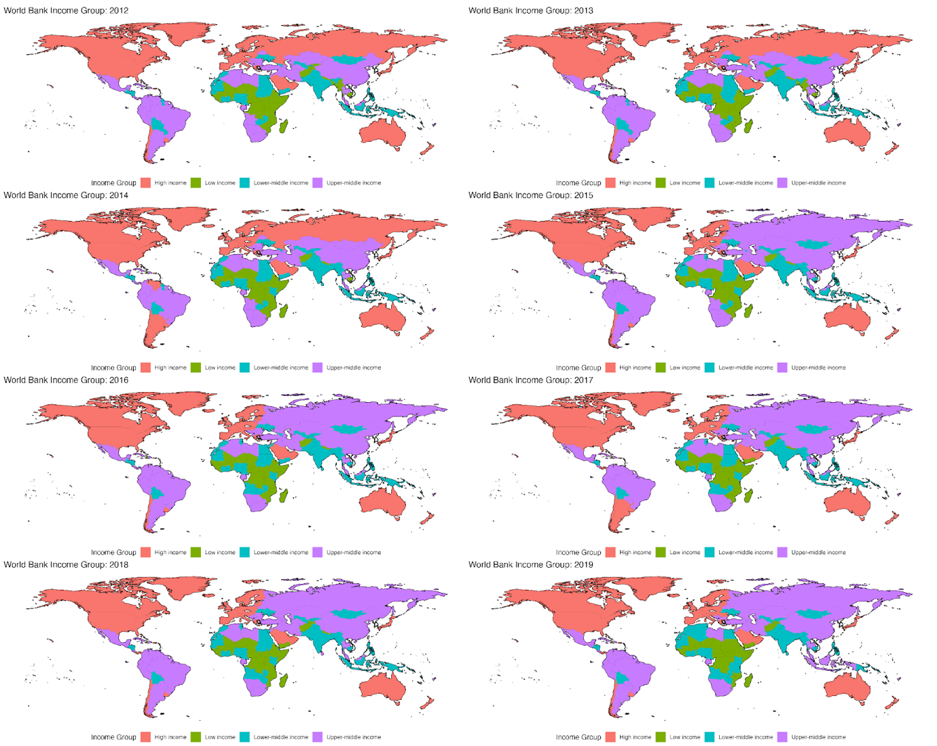

Supplementary Figure 2: Mortality from MVC per 100,000 population by World Bank Group income classification.
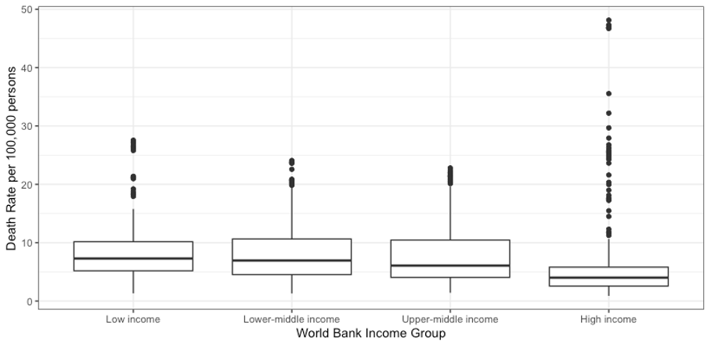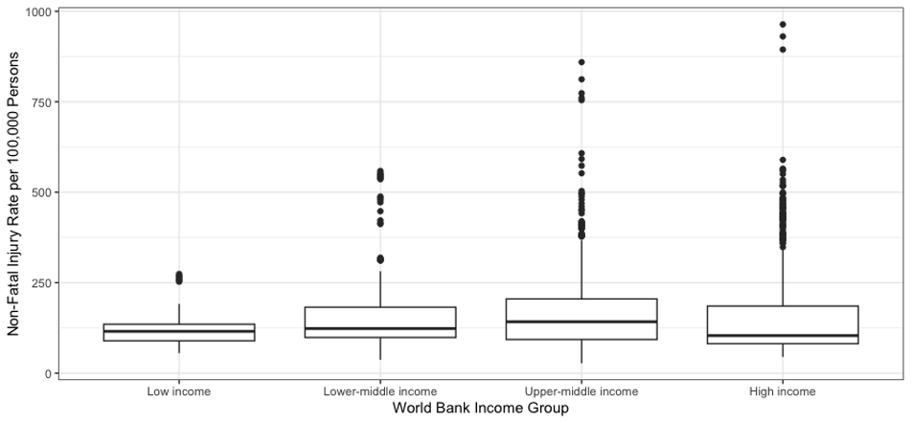
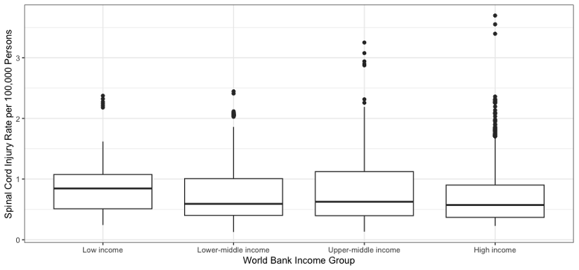

Supplementary Table 1: Incidence Rate Ratios (IRRs) with 95% Confidence Intervals and p-values (statistical significance: p < 0.05) for high income, upper-middle income, and lower-middle income countries compared with low income countries for mortality, major non-fatal injuries, and spinal cord injuries. Quasi-poisson regression models were generated for each.

Income Group | Mortality |  | Non-Fatal Injury |  | Spinal Cord Injury
Income Group | IRR (95% CI) | p-value | IRR (95% CI) | p-value | IRR (95% CI) | p-value
High Income | 0.79 (0.69-0.91) | 0.001 | 1.64 (0.56-4.82) | 0.367 | 1.03 (0.25-4.19) | 0.969
Upper-Middle Income | 0.72 (0.63-0.82) | <0.001 | 0.79 (0.27-2.31) | 0.662 | 0.45 (0.11-1.89) | 0.275
Lower-Middle Income | 0.67 (0.59-0.76) | <0.001 | 0.57 (0.19-1.72) | 0.315 | 0.35 (0.08-1.53) | 0.165

Supplementary Table 2: Proportions (%) of major non-fatal injuries grouped by AIS classification and summed by income group. Spine describes spinal cord injuries. Spine (Other) describes vertebral column fractures.

AIS Region | High income | Low income | Lower-middle income | Upper-middle income
Lower Extremity | 35.8 | 31.9 | 36.1 | 33.6
Head | 20.1 | 20.6 | 18.8 | 19.4
Upper Extremity | 9.13 | 8.43 | 7.80 | 9.02
Thorax | 7.17 | 9.26 | 6.96 | 8.96
Abdomen and Pelvic Contents | 6.90 | 8.25 | 7.79 | 7.78
Face | 6.23 | 6.34 | 6.54 | 6.36
Multiple Regions | 5.32 | 5.06 | 6.64 | 5.04
Spine (Other) | 4.89 | 5.76 | 5.62 | 5.63
External | 2.32 | 2.16 | 2.04 | 2.17
Upper or Lower Extremity | 1.03 | 1.09 | 0.90 | 1.03
Spine | 0.57 | 0.61 | 0.44 | 0.58
External / Multiple | 0.52 | 0.49 | 0.44 | 0.50

