Additional Files

Additional file 1. CONFIDE checklist. Quality assessment framework of non-traditional study type.
Robustness: study information and context
Score Time period of study/data collection Definition
A Clearly defined: Exact time frame of data collection given
B Some definition: Approximate time frame given
C No definition: No time frame given

Score Sample population Definition
A Clearly defined: 3 out of 4 parameters from age, gender,
number and study population taken from
B Some definition: 1 or 2 parameters defined from above list
C No definition: No parameters defined
N N/A: Not applicable - none population study

Score Disease description/patient condition Definition
A Clearly defined
B Some definition
C No definition
N N/A

Score Author bias Definition
A Clearly defined Clear who the author is writing on behalf of
with some reflection of potential bias
B Some definition Clear who the author is writing on behalf of
with minimal reflection of potential bias
C None Either not clear who the author is writing behalf of or
clear but with no acknowledgement of potential bias

Score Type of language Definition
A Minimal Factual; less than 10% emotive language
B Low bias Less than 30% of language includes below
C Moderate bias 30 - 50% of language includes below
D High bias Greater than 50% emotive language used: use of
"I"; personal beliefs, reflections or experiences;
inner experiences
Generalizability

Score Author perspective Definition
A The study was written and reported in country by a
native of the country.
B The study was written and reported in country by an
expatriate working as part of the response.
C The study was written and reported externally (to
the country) by an expatriate working as part of or
observing the response.

Score Applicability Definition
A Very applicable Results/findings are applicable, relevant and likely
to be similar in other settings
B Moderately applicable Results/findings are applicable, relevant and likely
to be similar in other settings but some aspects are specific to the study setting only
C Low applicability Results/findings are only applicable and relevant to
the study setting and not likely to be similar in other settings.
N N/A Opinion piece

Added value
Score Lessons learned Definition
A High System/organisational level lessons learned, described and discussed
B Moderate Individual lessons learned
C Low None or limited lessons learned

Score Triangulation to the literature Definition
A High Findings linked to previous studies, guidance or literature as part of discussion
B Moderate Some linkage to previous studies, guidance or literature
C Low No linkage to previous studies, guidance or literature

Score Implications Definition
A Good Contributes something new and/or different in terms of understanding/insight or
perspective
suggests ideas for further research; suggests implications for policy and/or practice
B Fair 1 or 2 of the above
C None None of the above

Ethics
Score Ethics Definition
A Good Where relevant ethical consideration has been
discussed and approval gained (e.g. in use of photos, patient identifiable data, informed consent)
B Fair Some mention of ethical considerations but no clear ethical approval sought
C None No mention of ethical consideration; unclear if permission sought or gained
N N/A Not relevant/none population study

Additional file 2. Danish National Crisis and Major Incident Management System
(from Hansen et al.: The Great Belt train accident: the emergency medical services response).

Government Security Committee

STRATEGIC LEVEL - GOLD
Senior Officials Security Committee
International Operational Staff
National Operational Staff

OPERATIONAL LEVEL - SILVER
Local Operational Staff

TACTICAL LEVEL - BRONZE
Local Incident Command

Police
Fire & Rescue
EMS

Ambulance Incident Commander
Casualty Clearing Station Officer
Emergency Medical Commuication Center
Ambulance
Ambulance
HEMS
SAR/JRCC

Legend: EMS: Emergency medical services; HEMS: Helicopter emergency medical services; SAR: Search & Rescue; JRCC: Joint rescue coordination center

Additional file 3. Aerial picture from the incident site (private photo).
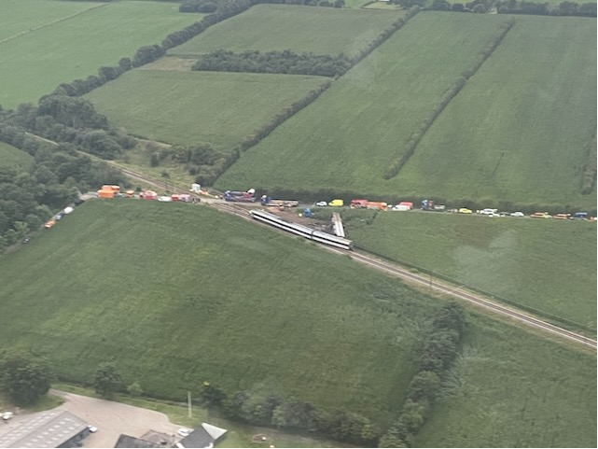
Direction of travel

Additional file 4. Overview of units and time expenditure from arrival at scene to release from the major incident.
 |  | 17:00 |  | 17:30 |  | 18:00 |  | 18:30 |  | 19:00 |  | 19:30 |  | 20:00 |  | 20:30 |  | 21:00 |  | 21:30 |  | 22:00 |  | 22:30
AMB 1 | 1
AMB 2 | 2
AMB 3 | 3
AMB 4 | 4
AMB 5 | 5
AMB 6 | 6
AMB 7 | 7
AMB 8 | 8
AMB 9 | 9
AMB 10 | 10
AMB 11 | 11
PM 1 | 12
MECU 1 | 13
MECU 2 | 14
MECU 3 | 15
HEMS 1 | 16
HEMS 2 | 17
HEMS 3 | 18
SAR | 19

