Appendix
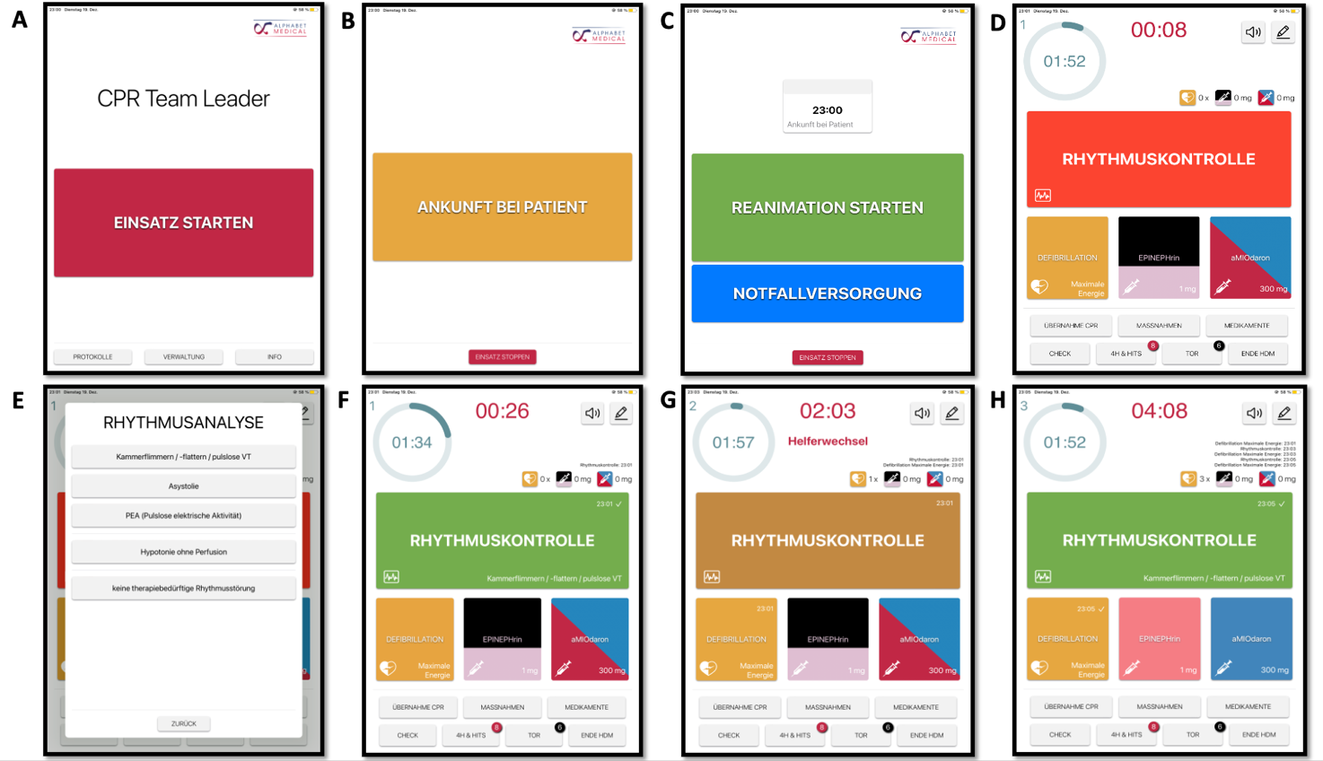
Figure 2. Screenshots illustrating the stepwise workflow of the 'CPR Team Leader' application during the ventricular fibrillation (VF) algorithm pathway.
(A) Application start screen. (B) Screen prompting confirmation of arrival at the patient. (C) Screen displaying arrival time and options to initiate resuscitation or emergency care. (D) Main resuscitation screen showing elapsed time, a countdown timer for the next rhythm check, and quick-access fields for defibrillation, epinephrine, and amiodarone administration. (E) Rhythm analysis pop-up window allowing selection of the identified cardiac rhythm (e.g., ventricular fibrillation/pulseless ventricular tachycardia, asystole, pulseless electrical activity). (F) Screen following selection of ventricular fibrillation/pulseless VT, initiating the corresponding algorithm branch. (G) Screen during ongoing resuscitation, including a prompt for team member rotation ("Helferwechsel") and updated defibrillation counter. (H) Screen at a later time point showing cumulative defibrillation, epinephrine, and amiodarone administration counts.
Parameter | Intervention  N = 40 | Kontrolle  N = 40 | Difference [95% CI] | p-value | Overall  N = 80
Mental Demand |  |  | -6.4 [-18, 5.5] | 0.3
Mean (SD) | 54.6 (25.9) | 61.0 (23.2) |  |  | 57.8 (24.6)
Median (Q1 - Q3) | 55 (30 - 80) | 63 (45 - 80) |  |  | 60 (35 - 80)
Min - Max | 15 - 100 | 10 - 100 |  |  | 10 - 100
Physical Demand |  |  | -7.6 [-20, 4.6] | 0.2
Mean (SD) | 47.3 (28.0) | 54.9 (25.7) |  |  | 51.1 (27.0)
Median (Q1 - Q3) | 40 (25 - 75) | 63 (33 - 75) |  |  | 50 (25 - 75)
Min - Max | 5 - 100 | 5 - 95 |  |  | 5 - 100
Temporal Demand |  |  | -7.5 [-19, 3.9] | 0.2
Mean (SD) | 42.4 (22.8) | 49.9 (24.3) |  |  | 46.1 (23.7)
Median (Q1 - Q3) | 38 (25 - 50) | 50 (30 - 68) |  |  | 45 (28 - 65)
Min - Max | 10 - 100 | 10 - 100 |  |  | 10 - 100
Effort |  |  | 11 [1.9, 21] | 0.020
Mean (SD) | 62.4 (21.1) | 51.0 (19.5) |  |  | 56.7 (21.0)
Median (Q1 - Q3) | 70 (50 - 75) | 50 (30 - 68) |  |  | 60 (38 - 70)
Min - Max | 20 - 100 | 20 - 90 |  |  | 20 - 100
Performance |  |  | -5.0 [-16, 6.0] | 0.4
Mean (SD) | 55.9 (22.6) | 60.9 (19.0) |  |  | 58.4 (20.9)
Median (Q1 - Q3) | 58 (40 - 73) | 65 (50 - 75) |  |  | 60 (45 - 75)
Min - Max | 15 - 95 | 20 - 100 |  |  | 15 - 100
Frustration |  |  | -14 [-25, -3.0] | 0.013
Mean (SD) | 32.6 (25.9) | 46.8 (24.0) |  |  | 39.7 (25.8)
Median (Q1 - Q3) | 23 (13 - 55) | 50 (25 - 60) |  |  | 38 (20 - 60)
Min - Max | 0 - 100 | 5 - 95 |  |  | 0 - 100
NASA TLX Raw Score |  |  | -4.9 [-12, 2.6] | 0.2
Mean (SD) | 49.2 (13.6) | 54.1 (14.6) |  |  | 51.6 (14.2)
Median (Q1 - Q3) | 50 (43 - 57) | 54 (46 - 61) |  |  | 52 (43 - 59)
Min - Max | 24 - 85 | 16 - 78 |  |  | 16 - 85
Abbreviation: CI = Confidence Interval
Supplementary Table S1. Results of NASA Task Load Index

