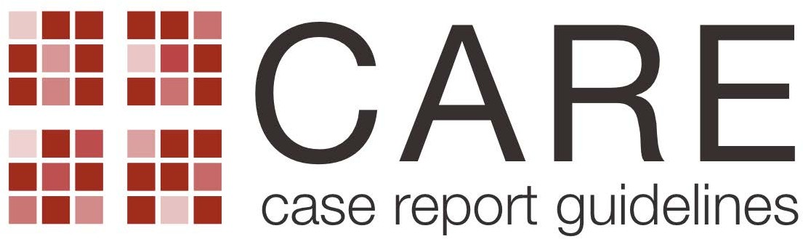
CARE Checklist of information to include when writing a case report
Topic Item Checklist item description Reported on Line
Title 1 1 A pediatric case of severe Acute Respiratory Distress Syndrome (ARDS) resembling SARS-COV-2. It was psittacosis!
Case report

Key Words 2 Psittacosis, children, ARDS, SARS-COV-2, dyspnea, targeted antibiotic therapy, medical history, case report

Abstract
(no references)
3a This case report is the first described in literature, among children in Italy. It is unique because in children psittacosis is
rare, and always misdiagnosed, instead in this child caused ARDS.
3b Severe dyspnea and systemic symptoms who required oro-tracheal intubation for acute respiratory failure
3c At the beginning, severe dyspnea required oro-tracheal intubation. After having isolated the DNA of the germ
“Chlamydia psittaci” in both serological and through bronchoalveolar lavage (BAL), he was treated with tetracyclines
(doxycillin) with rapid improvement of the general clinical conditions.
3d Take home messages: Even if it is a rare respiratory disease among children, a good doctor must think about psittacosis
as cause of respiratory symptoms (and not only flu or SARS-COV2), above all through a correct medical history, in order
to provide a targeted antibiotic therapy

Introduction 4 On psittacosis, in Italy since 2009, no epidemiological data has been received. Up to date, this would be the first
case of children psittacosis in Italy. An Italian Study indicates a surprising percentage, over 8%, of antibodies anti-
Chlamydia Psittaci in infants and children. This percentage varies little in relation to place of residence, rural or urban, or
the presence of animals, but confirms the high risk in parrot-owning households where anti-Chlamydia antibodies are
found in 37.5% of children.
Musso A, Riva C, Balbo L, Valpreda A, Garbaccio P, Migliore G, Zannino Anti-Chlamydia psittaci antibodies in a
healthy pediatric population. L.Minerva Pediatr. 1991 Apr;43(4):305-9.PMID: 1870537 Italian.

Patient Information 5a three-and-a-half-year-old male child, with persistent cough and severe dyspnea for 12 hours. The child had slept in a
room at home, with some recently bought parrots affected by psittacosis
5b persistent cough and severe dyspnea for 12 hours, not responsive to any therapy
5c Healthy child that slept at night in a room at home, with some recently bought parrots affected by psittacosis

5d Relevant past interventions with outcomes: none

Clinical Findings
Timeline
Diagnostic Assessment

Therapeutic Intervention

Follow-up and Outcomes
- When the child arrived at the hospital, the main symptoms were: intercostal, subcostal and jugular re-entries (refractory to drug therapy), severe desaturation (88%), perioral cyanosis and no fever. On auscultation of the chest, whistles and hisses were appreciated on the right lung (bronchospasm-like) and hypophonesis on the left one. He performed a molecular swab for SARS-COV-2 which gave negative results.
- Historical and current information from this episode of care organized as a timeline
8a molecular swab for SARS-COV-2 which gave negative results. chest X-ray (2p) taken in supine position. Blood
chemistry tests at entry: arterial blood gas analysis. Resuscitation couseling.
8b Diagnostic challenges (such as access to testing, financial, or cultural): none
8c Diagnosis of psittacosis, after excluding covid disease.
8d none
9a He was given oxygen at 10 liters per minute (FiO2 50%) by face mask, and 15 mg of iv methyl prednisone. Its weight
Was 15 kilos. Epinephrine was administered by aerosol and also salbutamol with beclomethasone-dipropionate, with no
benefit. Oro-tracheal Intubation (IOT) and Mechanical Assisted Ventilation (VAM), after sedation and curarization.
Empirical antibiotic therapy (iv ceftriaxone). They were all finally treated with targeted antibiotic
therapy:tetracycline (doxycillin).
9b Oro-tracheal Intubation (IOT) and Mechanical Assisted Ventilation (VAM) for 5 dys, doxycillin
9c At the beginning he was treated with Empirical antibiotic therapy (iv ceftriaxone). After having isolated the DNA of the
Germ “Chlamydia psittaci” in both serological and through bronchoalveolar lavage (BAL), he was treated with
Tetracyclines (doxycillin)
10a Clinician and patient-assessed outcomes : The child went through respiratory acidosis (pH 7,13, paO2 85 mmHg, paCO2 78
mmHg, HCO3 25,9, BE-3,3) to a normal respiratory condition on the sixth day (pH 7,44, paO2 78 mmHg, paCO2 50,
HCO3 32,3, BE 9,8).
10b None
10c None
10d Adverse and unanticipated events: none

Discussion 11a the strengths: to have rapidly isolated Chlamydia Psittaci and to have began targeted antibiotic therapy (doxycillin). AND
limitations: it was necessary to ask immediately for the environmental anamnesis given the severe dyspnea not responsive to any therapy
11b There is little literature on psittacosis and it is dated as well
11c The exceptionality of this case is given precisely by the very rare etiology in the pediatric field and by having changed a
poor prognosis into a favorable outcome, thanks to the in-depth medical history, early diagnosis and a targeted
antimicrobial therapy.
This represents the first Italian case of psittacosis described in children.

11d In conclusion, it’s very important, during the SARS-COV-2 pandemic, not to dwell on the suspected Coronavirus
pneumonia, but to thoroughly investigate also the environmental anamnesis to prevent other serious respiratory diseases
with even worse prognoses than SARS-COV-2 (20).
Although acute psittacosis with severe acute respiratory failure is unusual, especially in children, knowing the clinical, anamnestic and radiological picture of this disease, among the possible diagnoses of atypical pneumonia, can save the lives of our little patients.
Maffei C, Marracino A, Di Stanislao F, Pauri P, Clementi M, Varaldo PE. Psittacosis in a highly endemic area in Italy. Epidemiol Infect. 1987 Oct;99(2):413-9. doi: 10.1017/s095026880006790x. PMID: 3315709; PMCID: PMC2249287
Patient Perspective 12 yes
Informed Consent 13 Did the patient give informed consent? Please provide if requested . . . . . . . . . . . . . . . . . . . . . . . . . . . . . . . . . . . . . . Yes x No

