Supplementary Figure 1a: −ln(−ln) survival plot
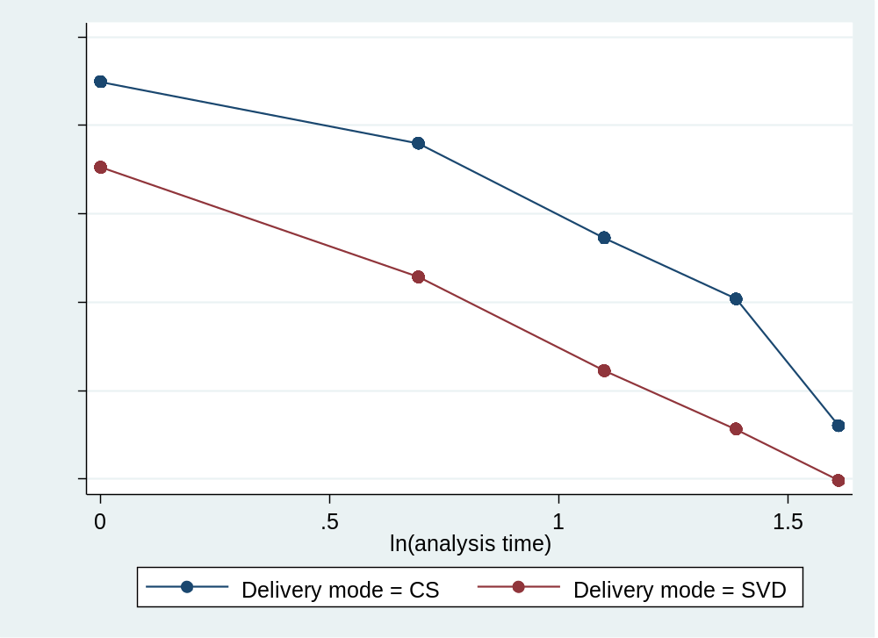
Supplementary Figure 1b: −ln(−ln) survival plot
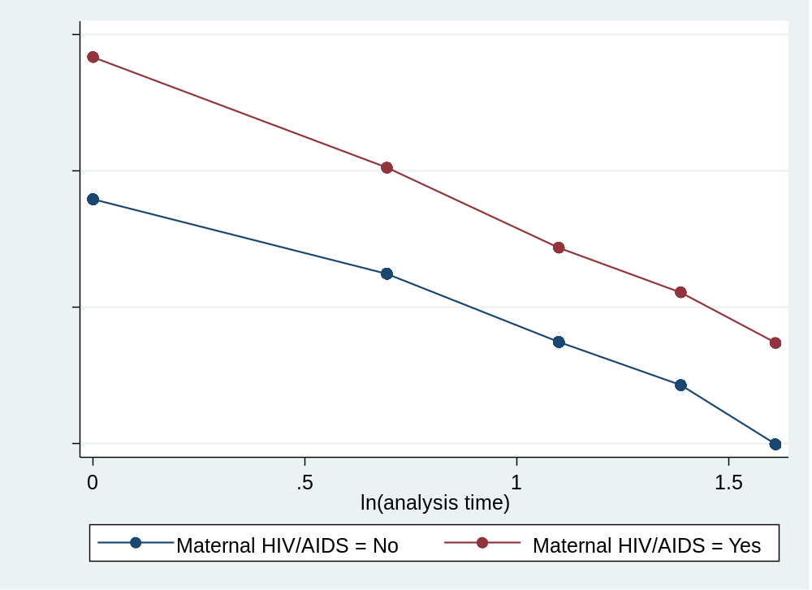
Supplementary Figure 1c: −ln(−ln) survival plot
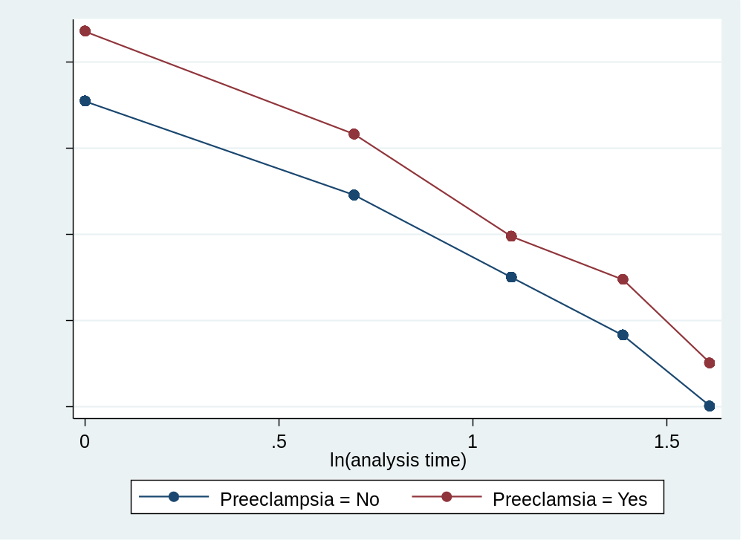
Supplementary Figure 1d: −ln(−ln) survival plot
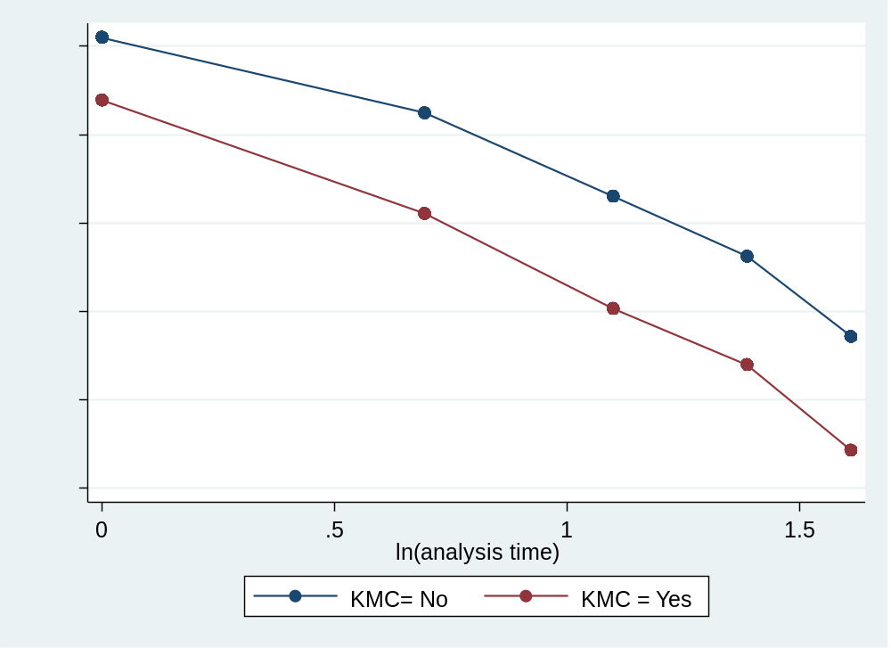
Supplementary Figure 1e: −ln(−ln) survival plot
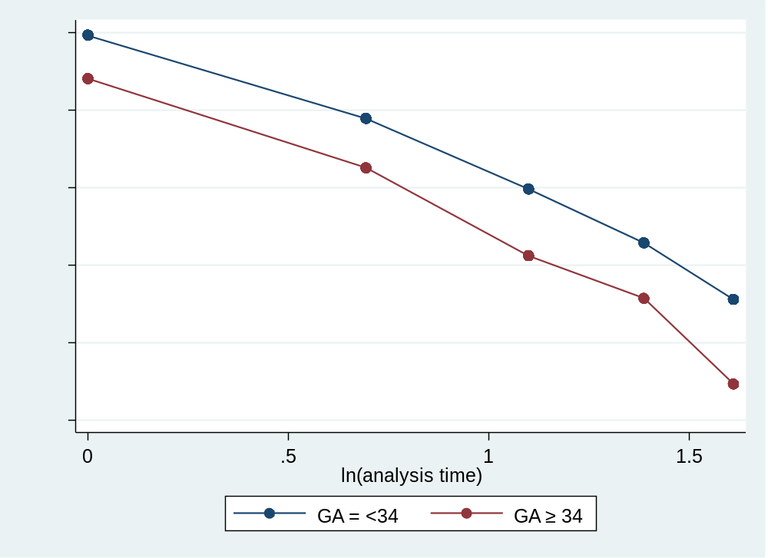

Supplementary Figure 2a: Kaplan Meier and predicted survival plot
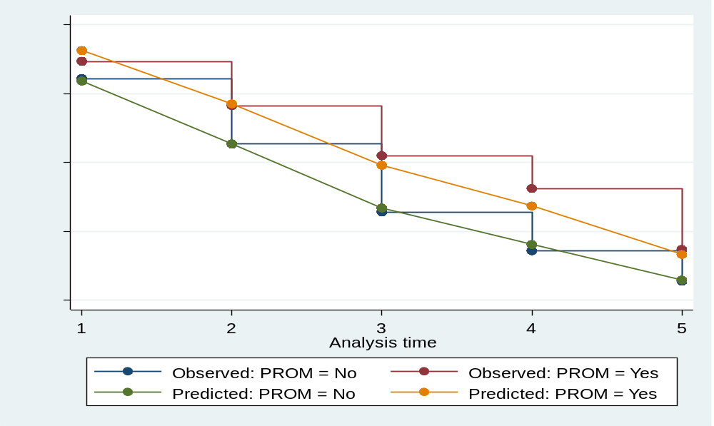
Supplementary Figure 2b: Kaplan Meier and predicted survival plot
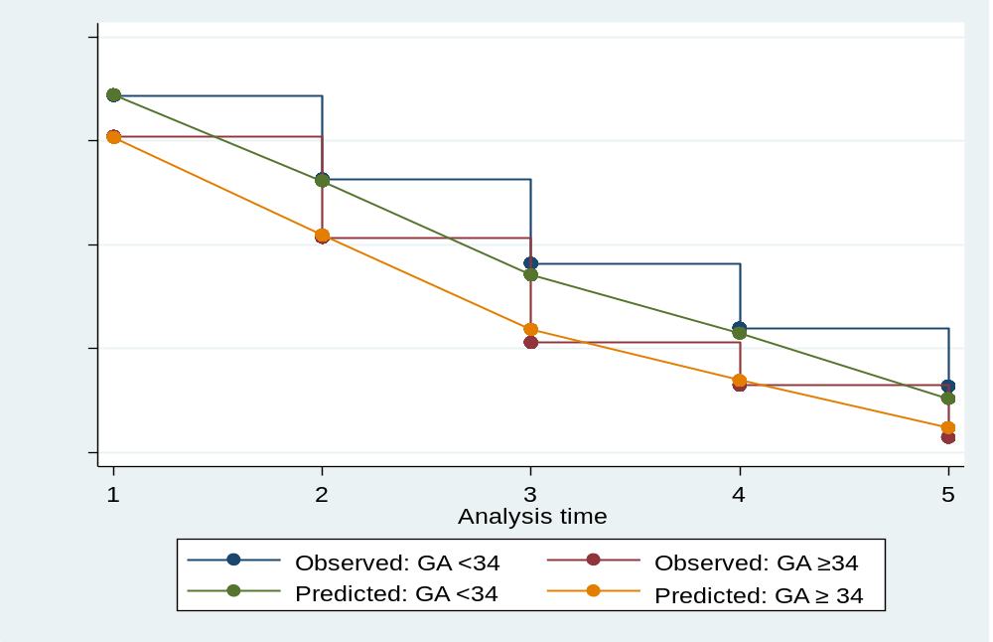
Supplementary Figure 2c: Kaplan Meier and predicted survival plot
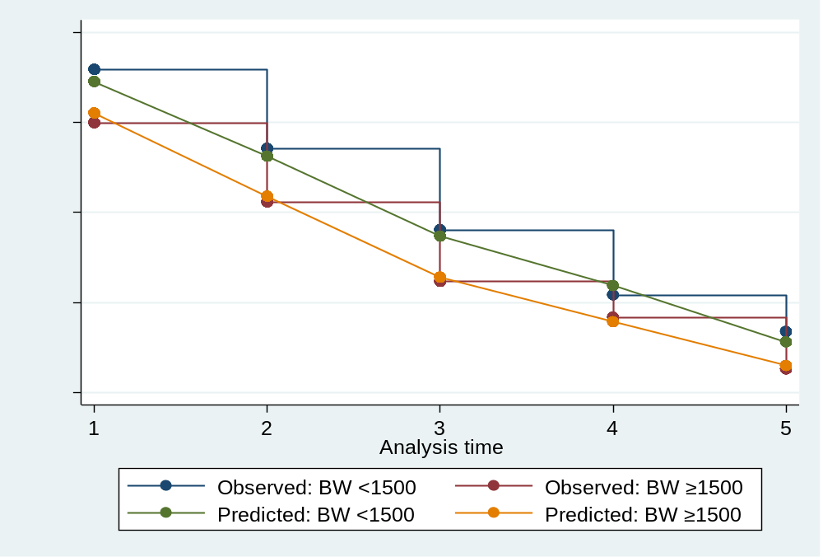
Supplementary Figure 2d: Kaplan Meier and predicted survival plot
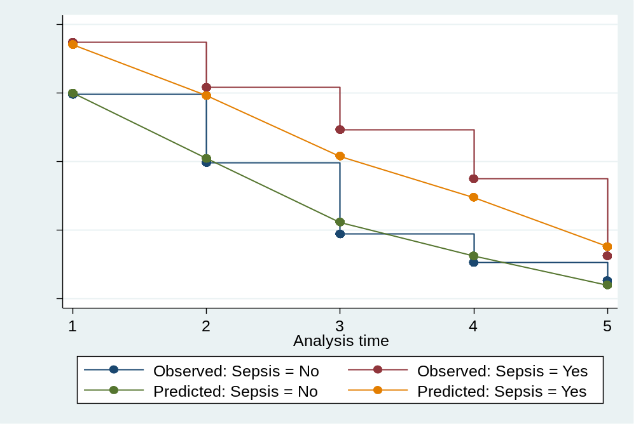
Supplementary Figure 2e: Kaplan Meier and predicted survival plot

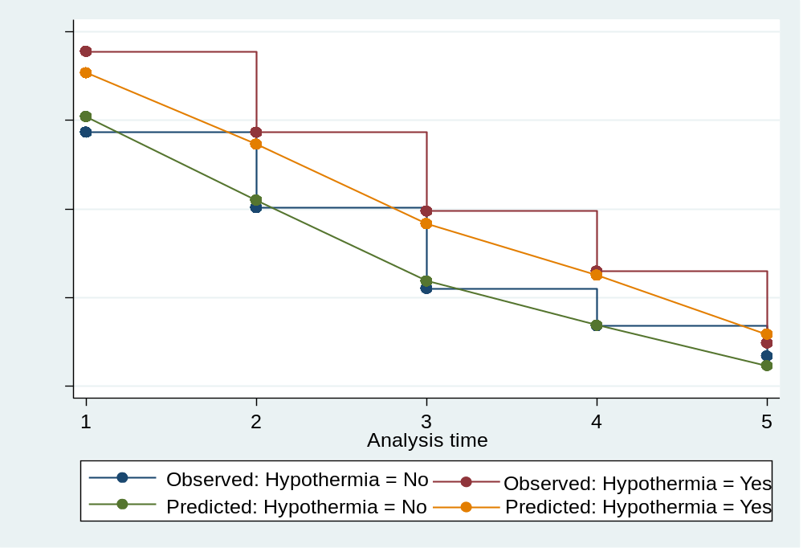
Supplementary Figure 2f: Kaplan Meier and predicted survival plot
