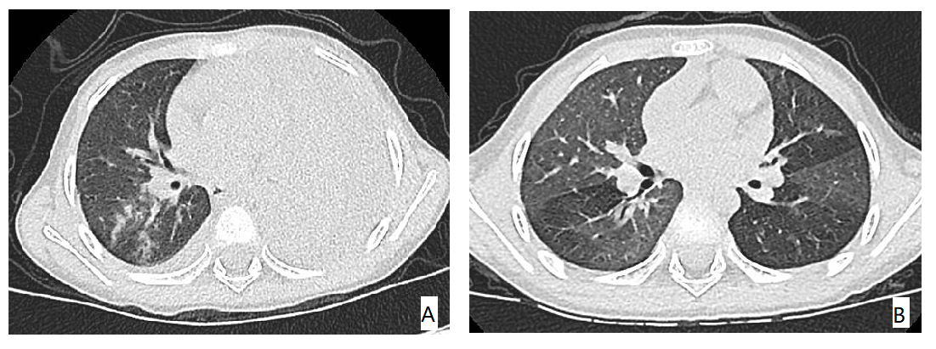
Figure 1 Representative HRCT findings of a PIBO patient with large lobar consolidation. (A) Left high-density consolidation and right pleural effusion. (B) Mosaic perfusion patterns, bronchial wall thickening.
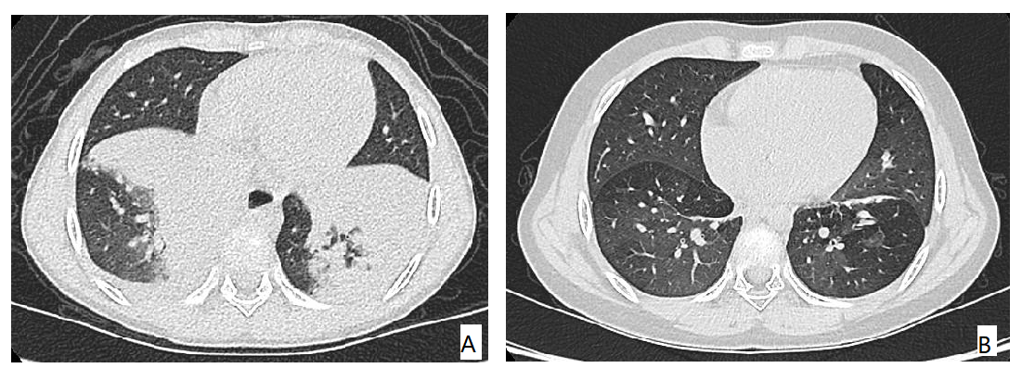
Figure 2 Representative HRCT findings of a PIBO patient with large lobar consolidation. (A) Bilateral consolidation and right pleural effusion. (B) HRCT showing mosaic perfusion patterns, bronchial wall thickening and bronchiectasis.
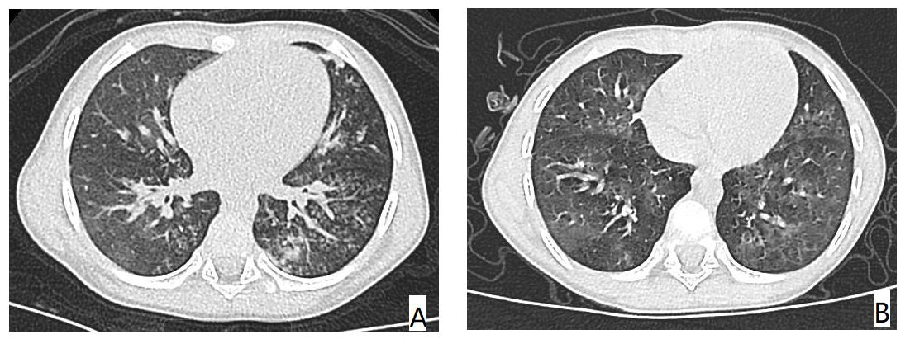
Figure 3 Representative HRCT findings of a PIBO patient with diffuse bronchiolitis. (A) Bilateral centrilobular nodules, patchy areas of ground-glass attenuation, and tree-in-bud patterns. (B) HRCT showing mosaic perfusion patterns and bronchial wall thickening.
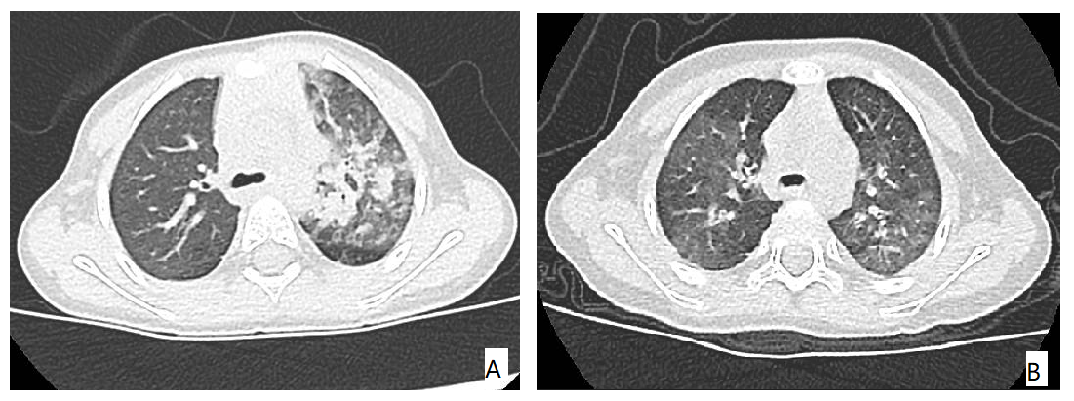
Figure 4 Representative HRCT findings of a PIBO patient with diffuse bronchiolitis. (A) Unilateral lobular areas of consolidation and areas of ground-glass attenuation. (B) Mosaic perfusion patterns and bronchial wall thickening.

