Differences in age and body weight between the groups were analyzed using the LSD-T method
LSD-T |  | 统计值 | P
AGE | EFI:EFT | t=0.77794 | 0.430
AGE | MFI:MFT | t=-0.98258 | 0.329
AGE | EFI:MFI | t=-4.14133 | <0.001*
AGE | EFT:MFT | t=-6.04542 | <0.001*
WWeight | EFI:EFT | t=1.08739 | 0.280
WWeight | MFI:MFT | t=-0.98258 | 0.986
WWeight | EFI:MFI | t=-4.08572 | <0.001*
WWeight | EFT:MFT | t=-6.15922 | <0.001*

Sample Quality Control Data
Forty fecal samples were collected from the eighty groups of preterm infants and our testing was successful, as we obtained a total of 138,800 raw sequences. After filtering, there were 134,992 high-quality sequences remaining and the data-quality Q20 ratio was greater than 90%. A number of sequencing reads was randomly selected from samples in each group and the number of operational taxonomic units (OTUs) was constructed based on the corresponding number of reads, allowing construction of a dilution curve. Our results revealed that the dilution was relatively flat prior to reaching 66,500 sequences, showing that there was sufficient sequencing depth in this study and that augmented data size would introduce relatively few additional new species (OTUs). Our data size was thus suitable and satisfied the requirements for further analysis (Fig. 1).
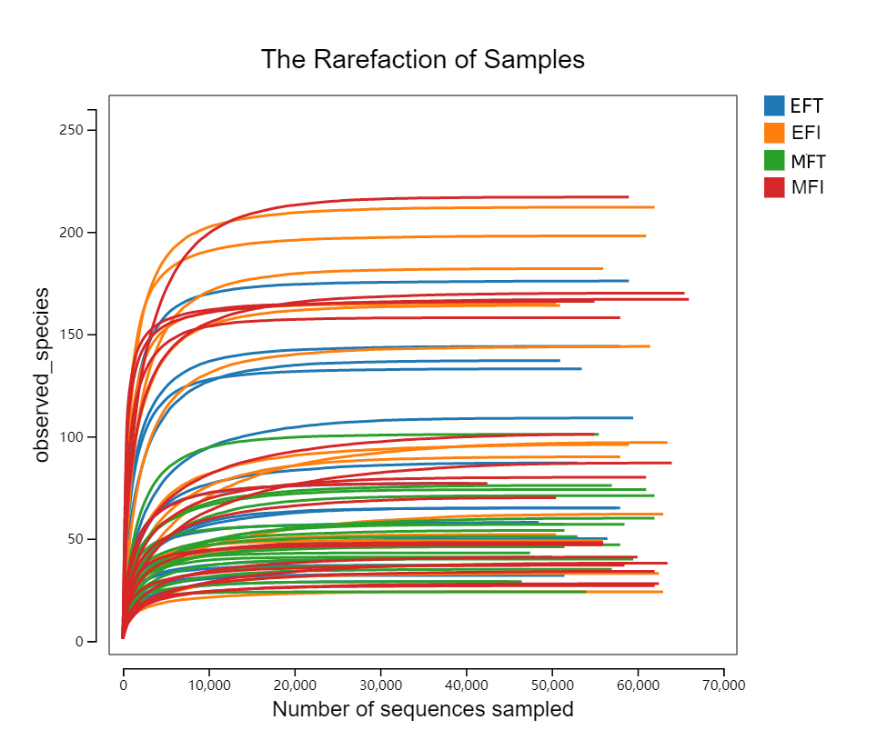
Figure 1 Dilution curves of the intestinal microbiota in each group
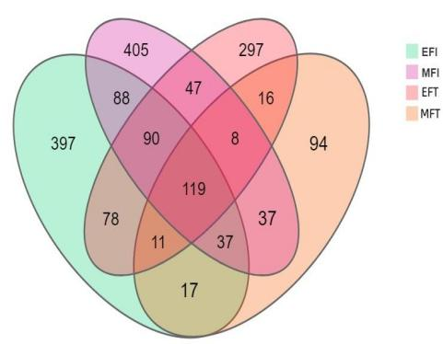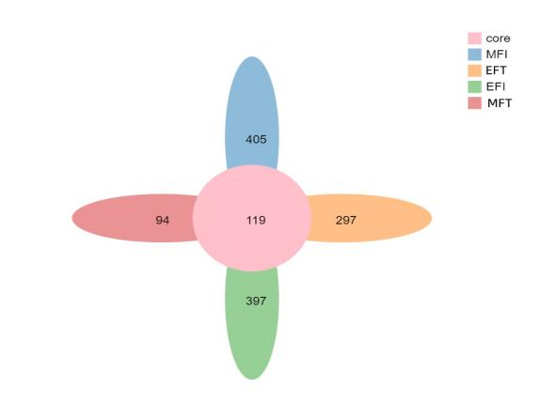
A Venn diagram B Petal diagram
Figure 2 OTU-Venn diagram and petal diagram of the gut microbiota in each group
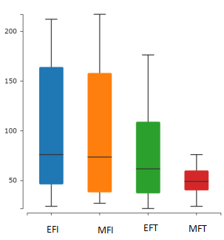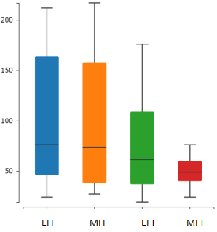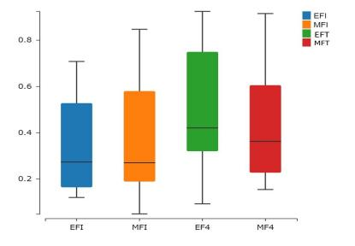
ACE Chao1 Simpson
Figure3 Box plots of Alpha diversity index of gut microbiota in each group

Statistical analysis of the Alpha diversity index of the gut microbiota in each group
Group | ACE | Chao1 | Simpson
EFI (N=20） | 76（46,164） | 76（46,164） | 0.27（0.16,0.52）
EFT (N=20） | 61.6（37,109） | 61.5（37,109） | 0.42（0.32,0.75）
MFI (N=20） | 73.5（38,158） | 73.5（38,158） | 0.27(0.19，0.58)
MFT (N=20） | 60（49,76） | 60（49,76） | 0.36(0.26，0.60)
H | 4.254 | 4.145 | 4.039
P | 0.235 | 0.246 | 0.257
Differences between groups were tested by Kruskal-Wallis rank sum test and p-values were adjusted by the Benjamini-Hochberg method. P <0.05 was considered to be statistically significant.

Differences in community structure among the groups were analyzed by Adonis analysis
Adonis | EFI:EFT | R2=0.041401；0.958599 | P=0.091
Adonis | MFI:MFT | R2=0.055985；0.944014 | P=0.021*
Adonis | EFI:MFI | R2=0.031603；0.968397 | P=0.283
Adonis | EFT:MFT | R2=0.107851；0.892148 | P=0.000**
*P < 0.05; **P < 0.01.

