Title.
Efficacy and Safety of a Single Dose of Nirsevimab against Respiratory Syncytial Virus Infection in Infants: A Meta-Analysis and Time-to-Event Analysis.
Running title.
Nirsevimab in infants to prevent RSV infections.

The content.
Supplementary Tables.
Supplementary Table 1: The detailed search strategy in each database.
Supplementary Table 2: Newcastle Ottawa scale (NOS) for quality assessment of the included observational cohort studies.
Supplementary Table 3: GRADE assessment table for the analyzed outcomes (separate file).
Supplementary Table 4: The reconstructed values of individualized patient data analysis.

Supplementary Figures.
Supplementary Fig. 1: A sensitivity leave-one-out analysis for A) RSV-related Lower respiratory tract infections, B) Hospitalization due to RSV infection (Random effects model).
Supplementary Fig. 2: A meta-analysis forest plot for subgroup analysis of RSV-related Lower respiratory tract infections (Random effects model).
Supplementary Fig. 3: A meta-analysis forest plot for subgroup analysis of Hospitalization due to RSV infection (Random effects model).
Supplementary Fig. 4: A) A meta-analysis forest plot for All-Cause Lower Respiratory Tract Infections, B) A sensitivity leave-one-out analysis for All-Cause Lower Respiratory Tract Infections (Random effects model).
Supplementary Fig. 5: A) A meta-analysis forest plot for All-Cause Hospitalizations, B) A sensitivity leave-one-out analysis for All-Cause Hospitalizations (Random effects model).
Supplementary Fig.6: A) A meta-analysis forest plot for ICU admission, B) A sensitivity leave-one-out analysis for ICU admission (Random effects model).
Supplementary Fig. 7: A) A meta-analysis forest plot for Bronchiolitis, B) A sensitivity leave-one-out analysis for Bronchiolitis (Random effects model).
Supplementary Fig. 8: A) A meta-analysis forest plot for Emergency Unit Visits, B) A sensitivity leave-one-out analysis for Emergency Unit Visits (Random effects model).
Supplementary Fig. 9: A) A meta-analysis forest plot for Need for Mechanical Ventilation, B) A sensitivity leave-one-out analysis for Need for Mechanical Ventilation (Random effects model).
Supplementary Fig. 10: A) A meta-analysis forest plot for All-Cause Mortality, B) A sensitivity leave-one-out analysis for All-Cause Mortality (Random effects model).
Supplementary Fig. 11: A) A meta-analysis forest plot for the risk of adverse events of special interest, B) A meta-analysis forest plot for the risk of Adverse events > grade 3, C) A meta-analysis forest plot for the risk of GIT adverse events (Random effects model).
Supplementary Fig. 12: A) A meta-analysis forest plot for the risk of serious adverse events, B) A sensitivity leave-one-out analysis for the risk of serious adverse events (Random effects model).
Supplementary Fig. 13: A) A meta-analysis forest plot for the risk of infections or infestations, B) A sensitivity leave-one-out analysis for the risk of infections or infestations (Random effects model).
Supplementary Fig. 14: Funnel plot to explore the publication bias in RSV-related Lower respiratory tract infections.
Supplementary Fig. 15: Funnel plot to explore the publication bias in Hospitalization due to RSV infection.

Databases | Search strategy | Results
PubMed | ("Respiratory Syncytial Virus Infection" OR "Respiratory Syncytial Virus Infections" OR "RSV Infection" OR "RSV Infections" OR "Respiratory Syncytial Virus" OR "RSV Respiratory Syncytial Virus" OR "rsv respiratory syncytial virus"[Title/Abstract] OR "rsv"[Title/Abstract] OR "respiratory syncytial virus"[Title/Abstract] OR "rsv"[All Fields]) AND ("nirsevimab"[Title/Abstract] OR "nirsevimab"[All Fields] OR "beyfortus"[Title/Abstract] OR "Nirsevimab" OR "Beyfortus") | 200
Embase | (“Nirsevimab” OR “Beyfortus”) AND (“Respiratory Syncytial Virus Infection” OR “Respiratory Syncytial Virus Infections” OR “RSV Infection” OR “RSV Infections” OR “Respiratory Syncytial Virus” OR “RSV Respiratory Syncytial Virus”) | 380
Scopus | (“Nirsevimab” OR “Beyfortus”) AND (“Respiratory Syncytial Virus Infection” OR “Respiratory Syncytial Virus Infections” OR “RSV Infection” OR “RSV Infections” OR “Respiratory Syncytial Virus” OR “RSV Respiratory Syncytial Virus”) | 346
WOS | (“Nirsevimab” OR “Beyfortus”) AND (“Respiratory Syncytial Virus Infection” OR “Respiratory Syncytial Virus Infections” OR “RSV Infection” OR “RSV Infections” OR “Respiratory Syncytial Virus” OR “RSV Respiratory Syncytial Virus”) | 244
Cochrane Central | (“Nirsevimab” OR “Beyfortus”) AND (“Respiratory Syncytial Virus Infection” OR “Respiratory Syncytial Virus Infections” OR “RSV Infection” OR “RSV Infections” OR “Respiratory Syncytial Virus” OR “RSV Respiratory Syncytial Virus”) in All Text | 29

Supplementary Table 1: The detailed search strategy in each database.

Study | Selection |  |  |  | Comparability | Outcome |  |  | Overall Quality
Study | Representativeness of the exposed cohort | Selection of the non-exposed cohort | Ascertainment of exposure | The outcome of interest was not present at the start of the study | Comparability | Assessment of outcome | Was the follow-up long enough for outcomes to occur | Adequacy of follow-up of cohorts | Overall Quality
Perramon-Malavez 2024 | ⭐ | ⭐ | -- | ⭐ | ⭐ | ⭐ | ⭐ | -- | Moderate quality
Jabagi 2025 | ⭐ | ⭐ | ⭐ | ⭐ | ⭐ | - | ⭐ | ⭐ | Good quality
Ares-Gómez 2024 | ⭐️ | ⭐️ | ⭐️ | ⭐️ | ⭐ | ⭐ | ⭐ | ⭐ | Good quality
Coma 2024 | ⭐️ | ⭐️ | -- | -- | ⭐ | ⭐ | ⭐ | -- | Moderate quality
Consolati 2024 | ⭐️ | ⭐️ | -- | ⭐️ | ⭐️ | ⭐️ | ⭐️ | -- | Moderate quality
Buey 2024 | ⭐️ | ⭐️ | ⭐️ | ⭐️ | ⭐️ | ⭐️ | ⭐️ | ⭐️ | Good quality
Alejandre 2024 | ⭐️ | ⭐️ | ⭐️ | ⭐️ | ⭐️ | ⭐️ | ⭐️ | ⭐️ | Good quality
Ma 2024 | ⭐️ | ⭐️ | ⭐️ | ⭐️ | ⭐️ | ⭐️ | ⭐️ | -- | Good quality
Gutiérrez 2024 | ⭐️ | -- | ⭐️ | -- | ⭐️ | ⭐️ | ⭐️ | -- | Moderate quality
Estrella-Porter 2024 | ⭐️ | -- | ⭐️ | -- | ⭐️ | ⭐️ | ⭐️ | -- | Moderate quality
Ernest 2024 | ⭐️ | ⭐️ | - | ⭐️ | ⭐️ | ⭐️ | ⭐️ | -- | Moderate quality
Ruiz 2024 | ⭐️ | ⭐️ | -- | ⭐️ | -- | ⭐️ | -- | -- | Low quality
Ezpeleta 2024 | ⭐️ | ⭐️ | -- | ⭐️ | ⭐️ | ⭐️ | ⭐️ | -- | Moderate quality
Levy 2024 | ⭐️ | ⭐️ | ⭐️ | ⭐️ | ⭐️ | ⭐️ | ⭐️ | ⭐️ | Good quality
Mallah 2024 | ⭐️ | ⭐️ | -- | ⭐️ | ⭐️ | ⭐️ | ⭐️ | -- | Moderate quality
Vazquez-Lope 2025 | ⭐️ | ⭐️ | ⭐️ | ⭐️ | ⭐️ | ⭐️ | ⭐️ | ⭐️ | Good quality
Perramon-Malavez 2025 | ⭐️ | ⭐️ | -- | ⭐️ | ⭐️ | ⭐️ | ⭐️ | -- | Moderate quality
Ocana de Sentuary 2024 | ⭐️ | ⭐️ | ⭐️ | ⭐️ | ⭐️ | ⭐️ | ⭐️ | ⭐️ | Good quality
Alexis Marouk 2025 | ⭐️ | ⭐️ | -- | ⭐️ | ⭐️ | ⭐️ | ⭐️ | -- | Moderate quality
Moreno-Pérez 2025 | ⭐️ | ⭐️ | -- | ⭐️ | ⭐️ | ⭐️ | ⭐️ | -- | Moderate quality

Supplementary Table 2: Newcastle Ottawa scale (NOS) for quality assessment of the included observational cohort studies.

Outcome | Arms | Number of studies | Number of patients | HR with 95% CI | RMST | RMST difference
Hospitalization | Nirsevimab | 2 | 5006 | HR: 0.14; 95% CI: [0.08, 0.25] | RMST: 4.98; 95%CI [4.98; 4.99] | RMST diff: -0.06; 95%CI [-0.08; -0.04]; p-value<0.001
Hospitalization | Placebo | 2 | 4505 | ref | RMST: 4.92; 95%CI [4.90; 4.94] | ref
LRTIs | Nirsevimab | 2 | 1963 | HR: 0.25; 95% CI: [0.16, 0.37] | RMST: 4.95; 95%CI [4.94; 4.97] | RMST diff: -0.15; 95%CI [-0.20; -0.09]; p-value<0.001
LRTIs | Placebo | 2 | 980 | ref | RMST: 4.80; 95%CI [4.75; 4.85] | ref

HR: Hazard ratio; 95% CI: Confidence interval; RMST: restricted mean survival time
Supplementary Table 4: The reconstructed values of individualized patient data analysis.

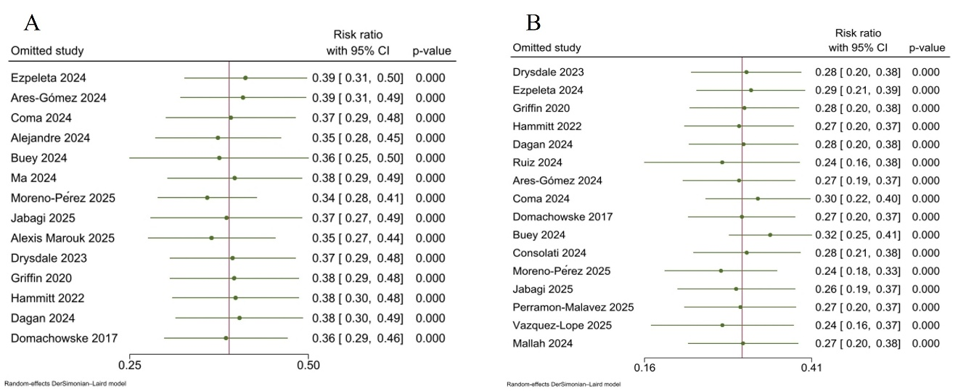
Supplementary Fig.1: A sensitivity leave-one-out analysis for A) RSV-related Lower respiratory tract infections, B) Hospitalization due to RSV infection (Random effects model).

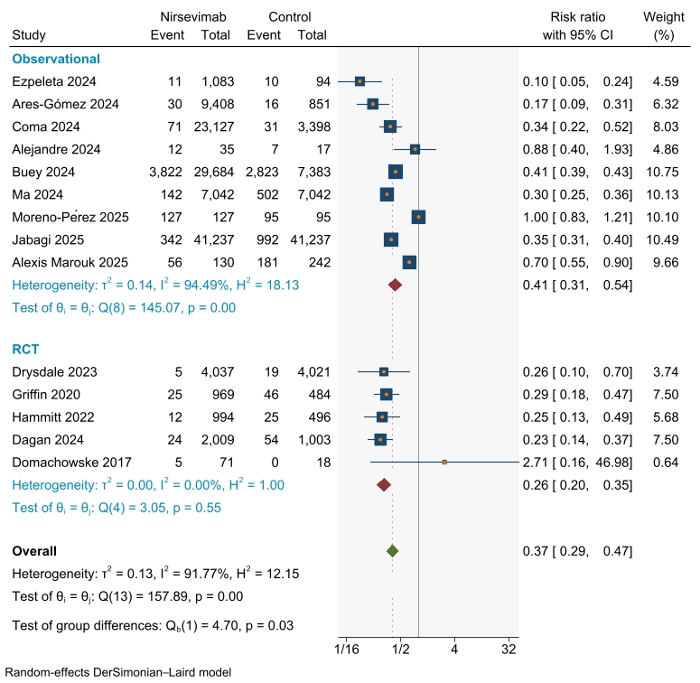
Supplementary Fig. 2: A meta-analysis forest plot for subgroup analysis of RSV-related Lower respiratory tract infections (Random effects model).

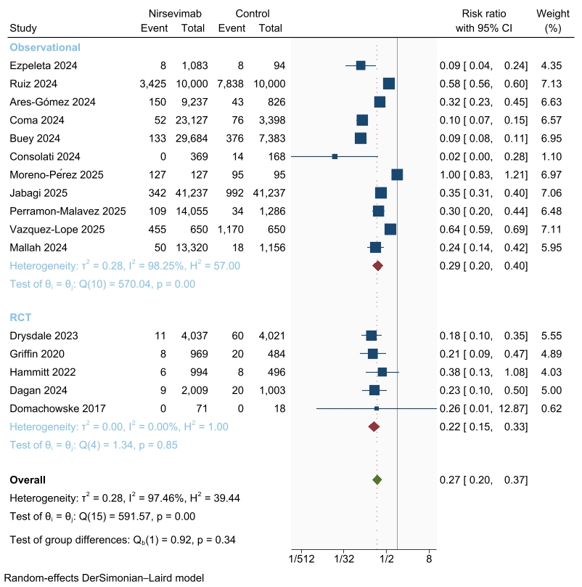
Supplementary Fig. 3: A meta-analysis forest plot for subgroup analysis of Hospitalization due to RSV infection (Random effects model).

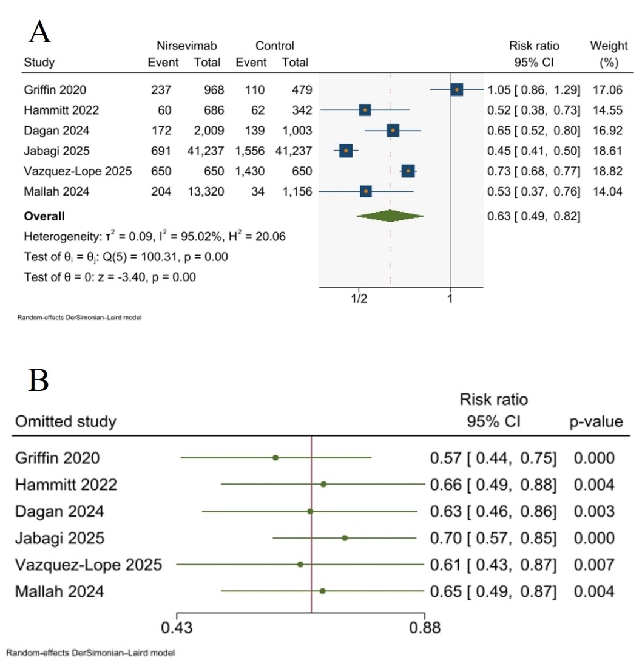
Supplementary Fig. 4: A) A meta-analysis forest plot for All-Cause Lower Respiratory Tract Infections, B) A sensitivity leave-one-out analysis for All-Cause Lower Respiratory Tract Infections (Random effects model).

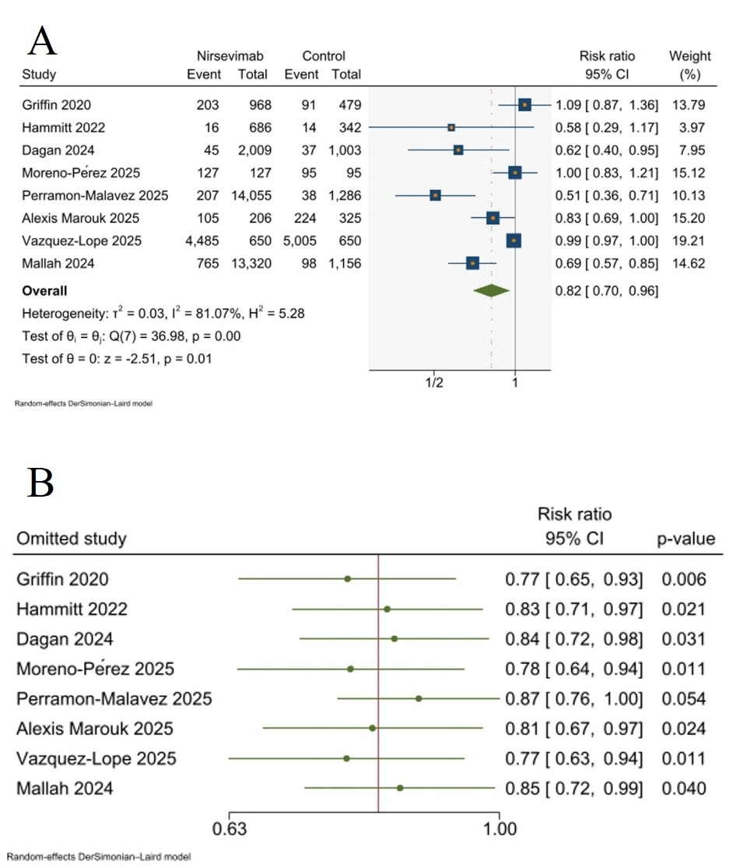
Supplementary Fig. 5: A) A meta-analysis forest plot for All-Cause Hospitalizations, B) A sensitivity leave-one-out analysis for All-Cause Hospitalizations (Random effects model).

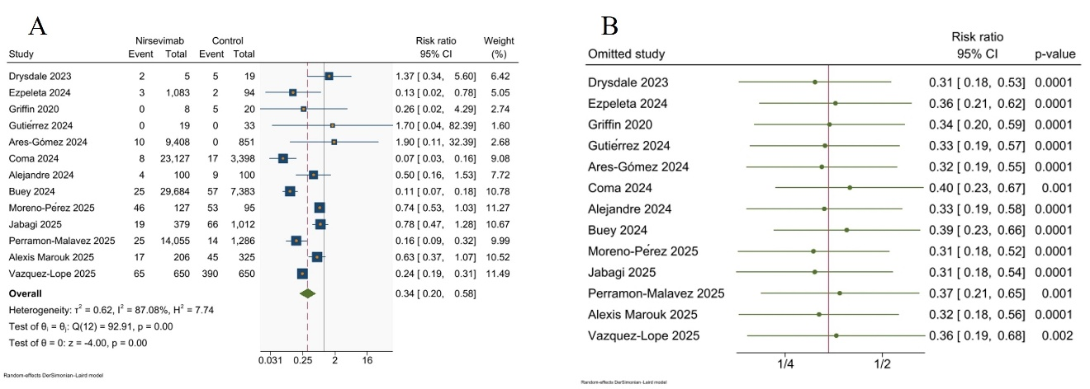
Supplementary Fig. 6: A) A meta-analysis forest plot for ICU admission, B) A sensitivity leave-one-out analysis for ICU admission (Random effects model).

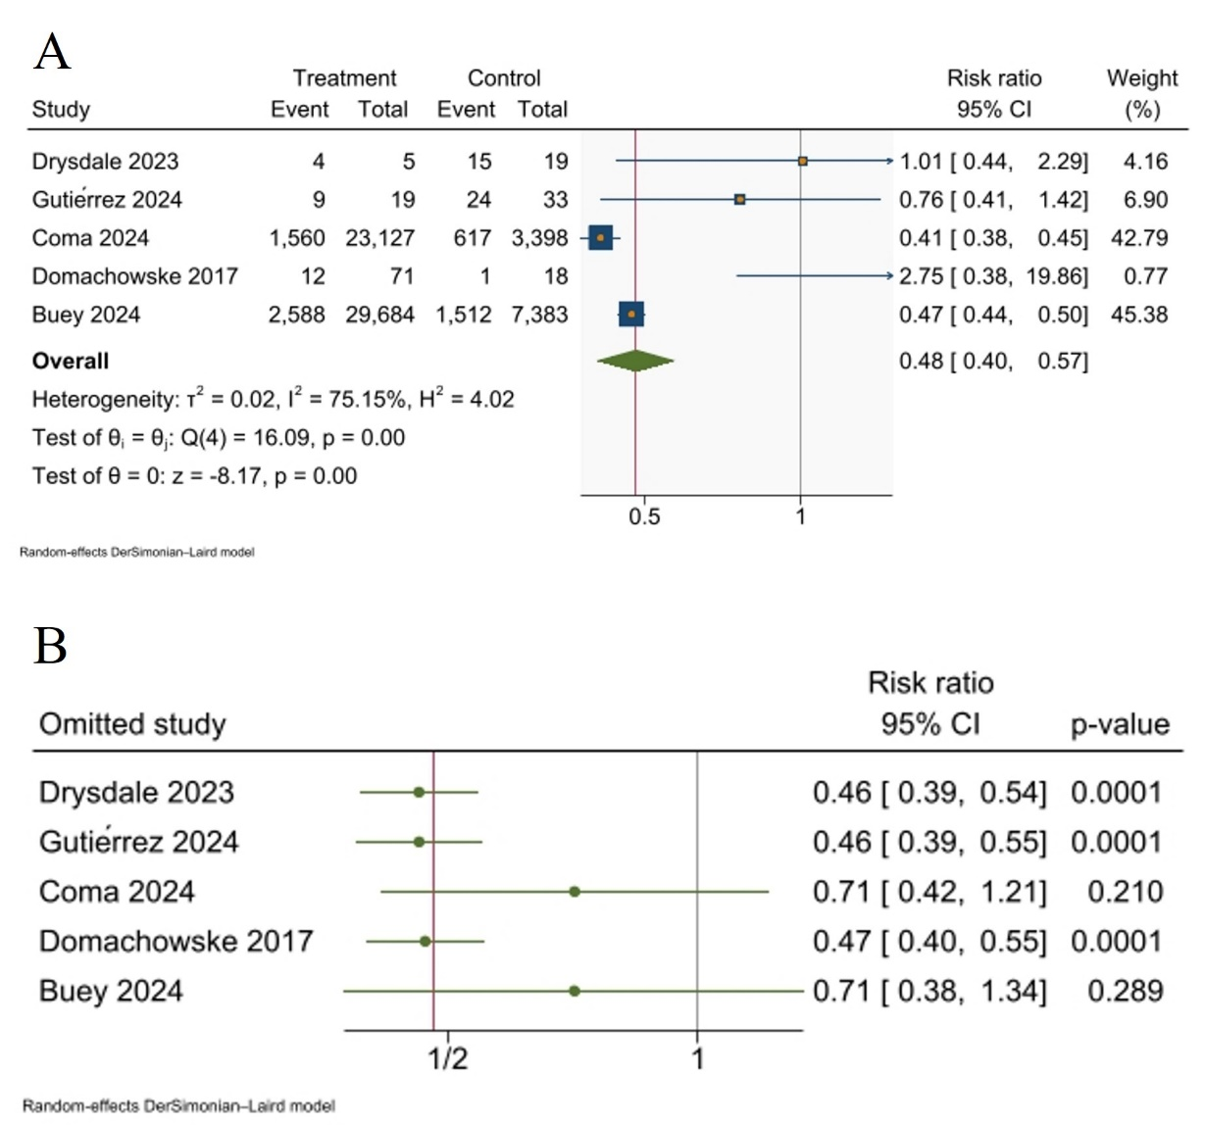
Supplementary Fig. 7: A) A meta-analysis forest plot for Bronchiolitis, B) A sensitivity leave-one-out analysis for Bronchiolitis (Random effects model).

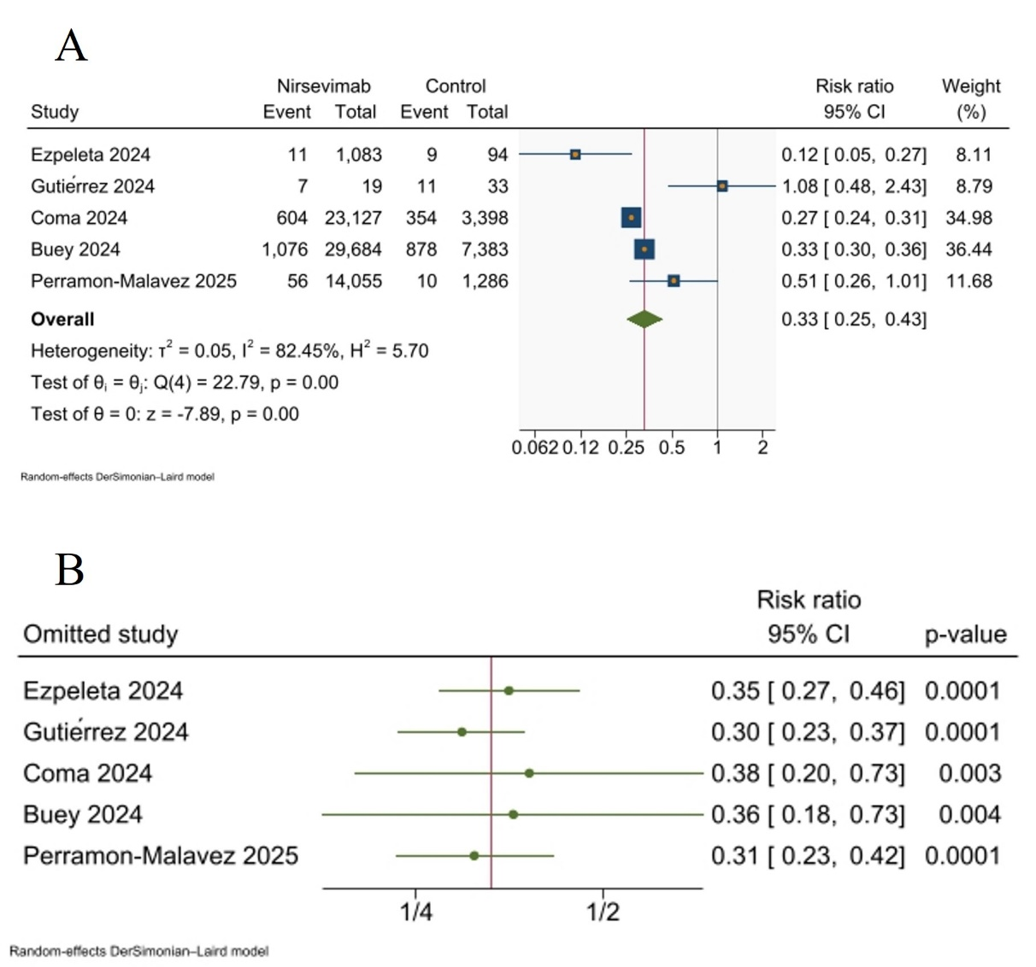

Supplementary Fig. 8: A) A meta-analysis forest plot for Emergency Unit Visits, B) A sensitivity leave-one-out analysis for Emergency Unit Visits (Random effects model).

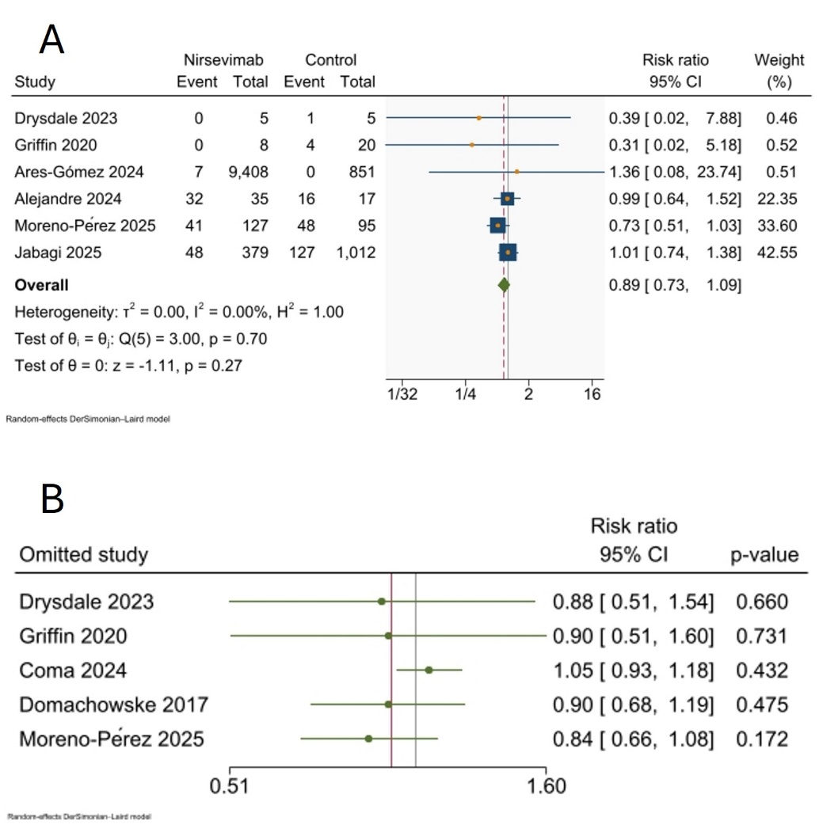
Supplementary Fig. 9: A) A meta-analysis forest plot for Need for Mechanical Ventilation, B) A sensitivity leave-one-out analysis for Need for Mechanical Ventilation (Random effects model).

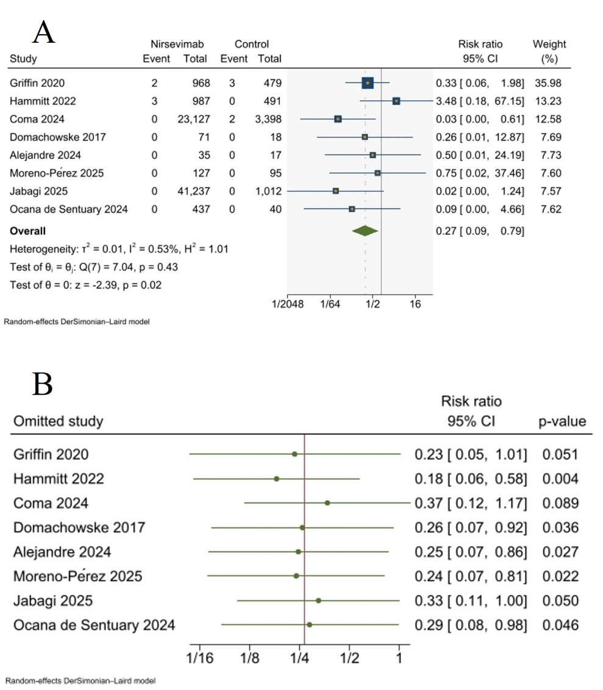
Supplementary Fig. 10: A) A meta-analysis forest plot for All-Cause Mortality, B) A sensitivity leave-one-out analysis for All-Cause Mortality (Random effects model).

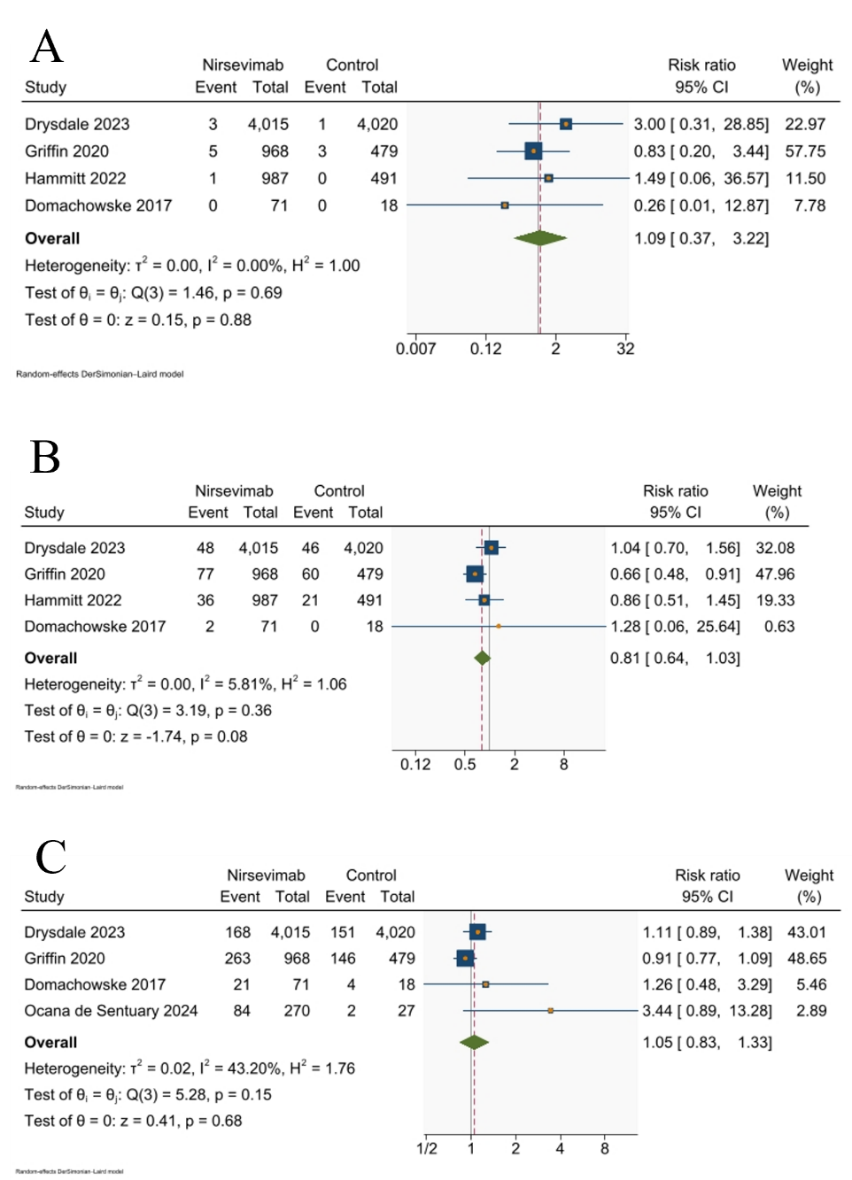
Supplementary Fig. 11: A) A meta-analysis forest plot for the risk of adverse events of special interest, B) A meta-analysis forest plot for the risk of Adverse events > grade 3, C) A meta-analysis forest plot for the risk of GIT adverse events (Random effects model).

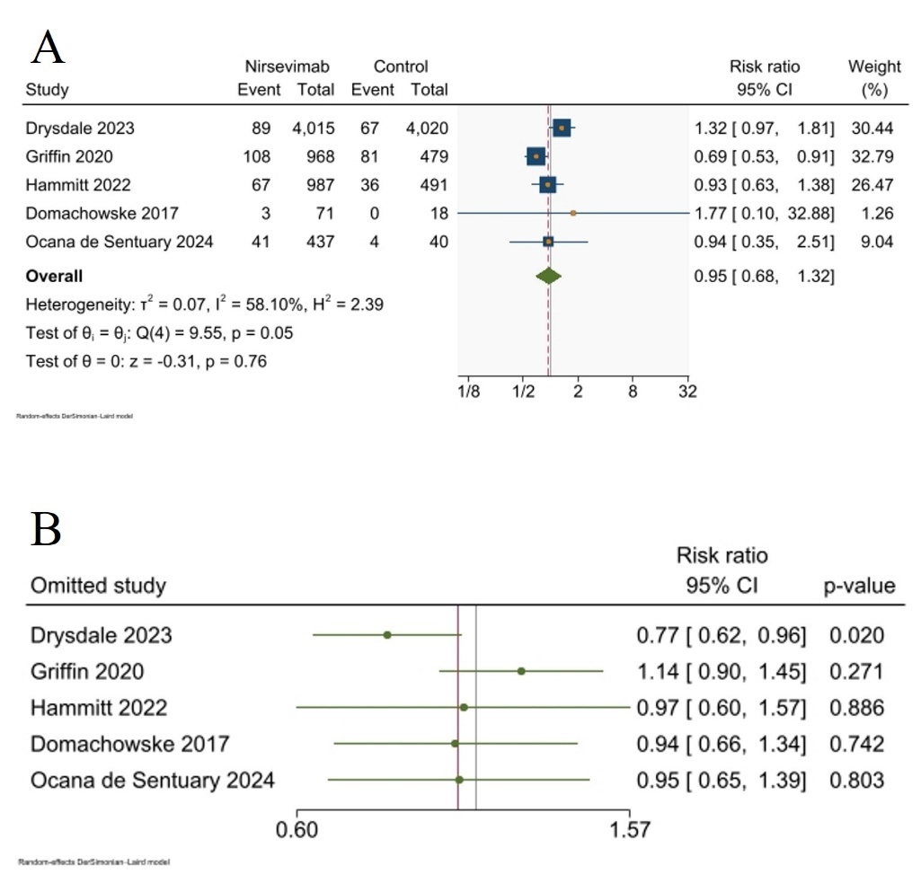
Supplementary Fig. 12: A) A meta-analysis forest plot for the risk of serious adverse events, B) A sensitivity leave-one-out analysis for the risk of serious adverse events (Random effects model).

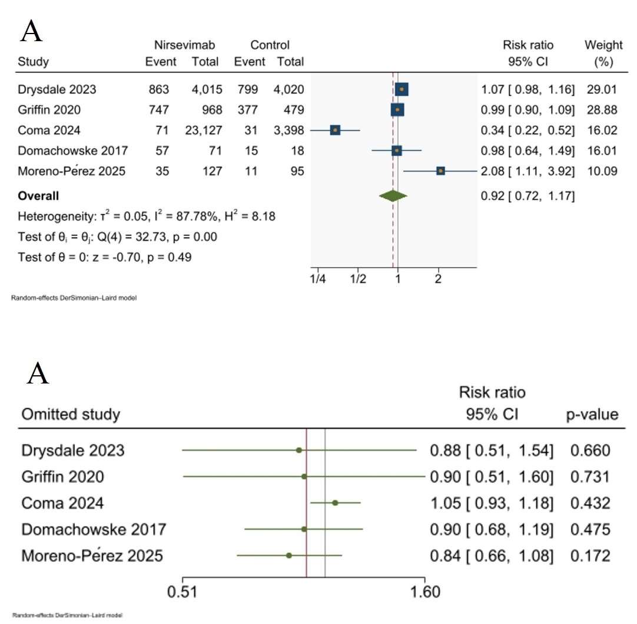
Supplementary Fig. 13: A) A meta-analysis forest plot for the risk of infections or infestations, B) A sensitivity leave-one-out analysis for the risk of infections or infestations (Random effects model).

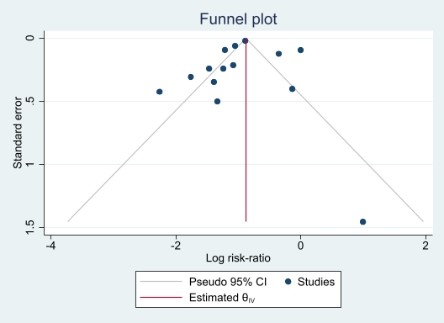
Supplementary Fig. 14: Funnel plot to explore the publication bias in RSV-related Lower respiratory tract infections.

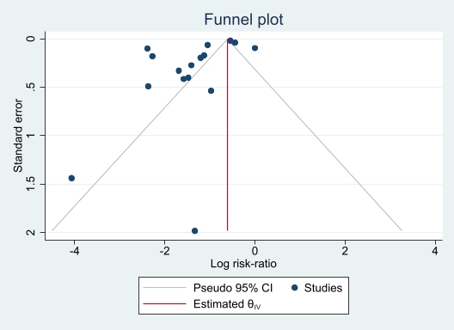
Supplementary Fig. 15: Funnel plot to explore the publication bias in Hospitalization due to RSV infection.

