Sanger sequencing traces confirming paternal transmission of the familial NF1 NM_000267:c.6947T>G variant in available family members.

Grandmother (I-1, asymptomatic carrier)
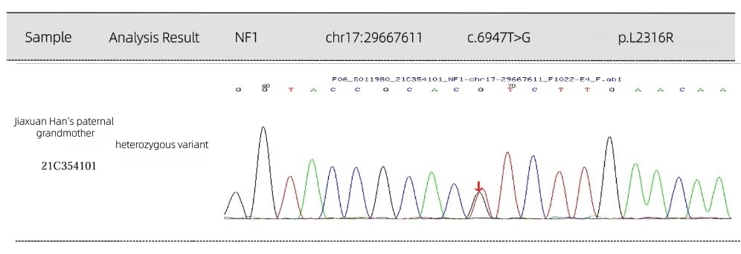

Father (II-1, asymptomatic carrier)
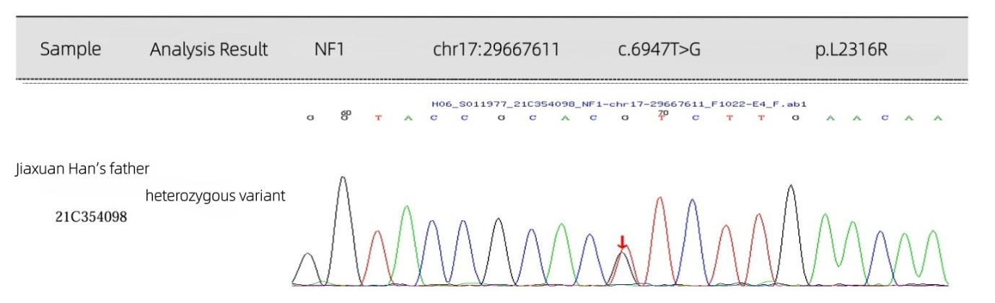

Mother (II-2, wild-type)
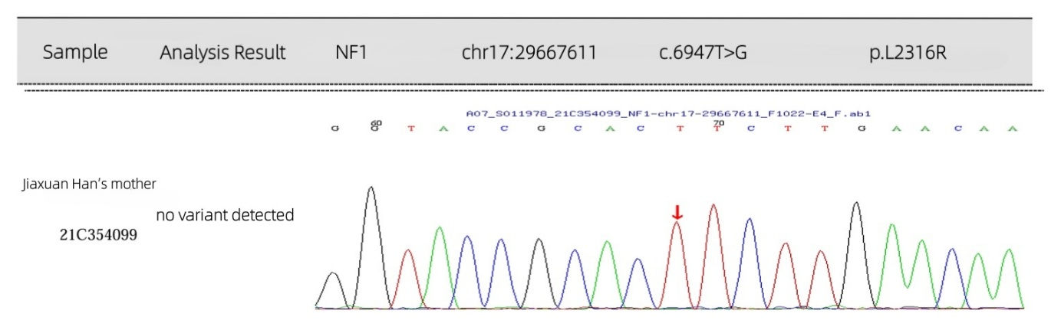

Sister (III-2, asymptomatic carrier)
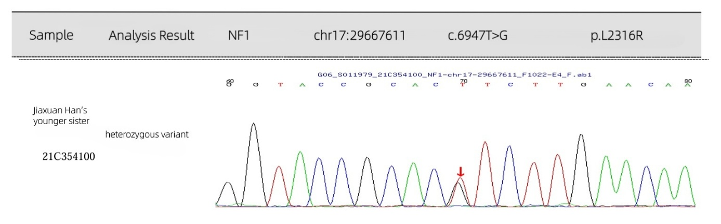

Proband (III-1, affected carrier)
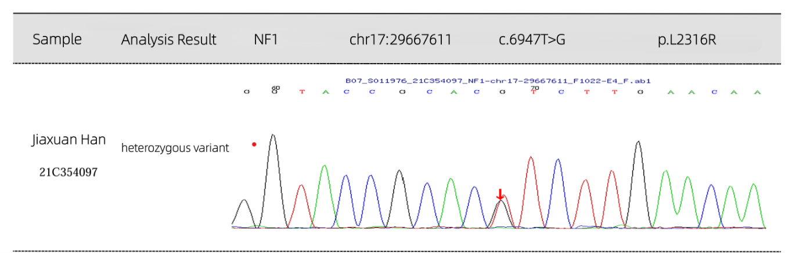Note: The mother (II-1) shows the wild-type (T/T) genotype. The father (II-2), sister (III-2), and proband (III-1) all show the heterozygous (T/G) variant, indicated by the arrow.

