Title
Living with Developmental and/or Epileptic Encephalopathies: Exploring Health-Related Quality of Life in Children, Youth, and Their Families

Authors
Luca Bergonzini^{1,2,3,§}, Federica Sperandeo², Silvia Lelli², Jacopo Lenzi⁴, Lucia Gamberini², Antonella Boni¹, Valentina Gentile¹, Valentina Marchiani¹, Tullio Messana¹, Angelo Russo¹, Luca Soliani¹, Duccio Maria Cordelli^{1,2}

Affiliations
- IRCCS Istituto delle Scienze Neurologiche di Bologna, U.O.C. Neuropsichiatria dell’età pediatrica, Member of the ERN EpiCare, Bologna, Italy;
- Department of Medical and Surgical Sciences (DIMEC), Alma Mater Studiorum - University of Bologna, Bologna, Italy;
- International PhD College, Collegio Superiore, Alma Mater Studiorum - University of Bologna, Bologna, Italy;
- Department of Biomedical and Neuromotor Sciences (DIBINEM), Alma Mater Studiorum – University of Bologna, Bologna, Italy;

§ Correspondence
Luca Bergonzini, IRCCS Istituto delle Scienze Neurologiche di Bologna, UOC Neuropsichiatria dell’età pediatrica, Policlinico di Sant’Orsola, Via Massarenti, 9, 40138, Bologna (Italy). Department of Medical and Surgical Sciences, Alma Mater Studiorum – University of Bologna. Email: l.bergonzini@unibo.it

Supplementary Material

PedsQL Epilepsy | DEEs/EEs  (n=52) | DEs  (n=34) | p
Epilepsy Impact | 51.4 [37.2 – 63.9] | 66.7 [50.0 – 77.8] | 0.011*
Cognitive functioning | 8.3 [0.0 – 25.0] | 22.9 [8.3 – 44.2] | 0.012*
Sleep/Rest | 41.7 [25.0 – 58.3] | 50.0 [35.4 – 64.6] | 0.039*
Executive Functioning | 16.7 [0.0 – 35.4] | 31.3 [20.8 – 53.1] | 0.014*
Mood/Behavior | 60.0 [50.0 – 75.0] | 55.0 [40.0 – 75.0] | 0.416
Supplementary table 1. PedsQL Epilepsy Module scores in children with developmental and epileptic encephalopathies/epileptic encephalopathies (DEEs/EEs) and developmental encephalopathies (DEs). Values are presented as median [interquartile range]. P values refer to Mann–Whitney U tests. *p < 0.05.

PedsQL Epilepsy | Daily seizures  (n=27) | Weekly/monthly seizures (n=59) | p
Epilepsy Impact | 41.7 [25.0 – 56.9] | 61.1 [45.8 – 77.8] | < 0.001*
Cognitive functioning | 6.3 [0.0 – 24.0] | 18.7 [5.8 – 41.7] | 0.096
Sleep/Rest | 33.3 [20.8 – 58.3] | 41.7 [33.3 – 58.3] | 0.041*
Executive Functioning | 12.5 [0.0 – 33.3] | 29.2 [13.5 – 45.8] | 0.730
Mood/Behavior | 57.5 [46.3 – 70.0] | 60.0 [45.0 – 75.0] | 0.076
Supplementary table 2. PedsQL Epilepsy Module scores in children with daily seizures and children with weekly/monthly seizures. Values are presented as median [interquartile range]. P values refer to Mann–Whitney U tests. *p < 0.05.

PedsQL Epilepsy | Gross motor impairment  (n=62) | No gross motor impairment  (n=24) | p
Epilepsy Impact | 52.8 [37.5 – 68.7] | 63.9 [47.9 – 78.1] | 0.027*
Cognitive functioning | 8.33 [0.0 – 26.0] | 27.1 [15.7 – 45.8] | 0.002*
Sleep/Rest | 41.7 [25.0 – 50.0] | 58.3 [39.6 – 66.7] | 0.027*
Executive Functioning | 20.8 [4.2 – 33.3] | 35.4 [20.8 – 54.2] | 0.033*
Mood/Behavior | 55.0 [45.0 – 75.0] | 62.5 [45.0 – 75.0] | 0.960
Supplementary table 3. PedsQL Epilepsy Module scores in children with and without gross motor impairment. Values are presented as median [interquartile range]. P values refer to Mann–Whitney U tests. *p < 0.05.

PedsQL Epilepsy | Behavioral issues  (n=68) | No behavioral issues (n=18) | p
Epilepsy Impact | 54.2 [39.7 – 70.1] | 54.2 [37.8 – 88.2] | 0.438
Cognitive functioning | 16.7 [1.0 – 36.5] | 25.0 [0.0 – 43.7] | 0.749
Sleep/Rest | 41.7 [25.0 – 58.3] | 41.7 [33.3 – 58.3] | 0.782
Executive Functioning | 25.0 [8.3 – 37.5] | 27.1 [17.7 – 61.5] | 0.206
Mood/Behavior | 55.0 [45.0 – 75.0] | 70.0 [51.2 – 75.0] | 0.142
Supplementary table 4. PedsQL Epilepsy Module scores in families of children with and without behavioral issues. Values are presented as median [interquartile range]. P values refer to Mann–Whitney U tests.

PedsQL Epilepsy | Sleep problems  (n=28) | No sleep problems  (n=58) | p
Epilepsy Impact | 48.6 [27.1 – 56.9] | 58.3 [41.7 – 75.0] | 0.010*
Cognitive functioning | 2.1 [0.0 – 16.7] | 22.9 [8.3 – 41.7] | < 0.001*
Sleep/Rest | 33.3 [16.7 – 43.8] | 50.0 [33.3 – 66.7] | 0.004*
Executive Functioning | 16.7 [0.0 – 25.0] | 30.0 [12.5 – 45.8] | 0.010*
Mood/Behavior | 57.5 [45.0 – 77.5] | 60.0 [47.5 – 75.0] | 0.938
Supplementary table 5. PedsQL Epilepsy Module scores in children with and without sleep problems. Values are presented as median [interquartile range]. P values refer to Mann–Whitney U tests. *p < 0.05.

PedsQL Epilepsy | Gastrointestinal comorbidities  (n=56) | No gastrointestinal comorbidities  (n=30) | p
Epilepsy Impact | 47.2 [32.3 – 61.1] | 58.3 [41.7 – 75.0] | 0.019*
Cognitive functioning | 0.0 [0.0 – 16.7] | 22.9 [8.3 – 41.7] | < 0.001*
Sleep/Rest | 33.3 [18.8 – 47.9] | 50.0 [33.3 – 58.3] | 0.013*
Executive Functioning | 12.5 [0.0 – 31.2] | 29.2 [16.7 – 45.8] | 0.009*
Mood/Behavior | 55.0 [50.0 – 80.0] | 60.0 [41.3 – 75.0] | 0.375
Supplementary table 6. PedsQL Epilepsy Module scores in children with and without gastrointestinal comorbidities. Values are presented as median [interquartile range]. P values refer to Mann–Whitney U tests. *p < 0.05.

PedsQL Epilepsy | Cardiovascular problems  (n=11) | No cardiovascular problems  (n=75) | p
Epilepsy Impact | 72.2 [44.4 – 81.3] | 52.8 [38.9 – 69.4] | 0.187
Cognitive functioning | 20.8 [4.2 – 41.7] | 16.7 [0.0 – 37.5] | 0.591
Sleep/Rest | 41.7 [33.3 – 75.0] | 41.7 [25.0 – 58.3] | 0.688
Executive Functioning | 20.8 [12.5 – 54.2] | 25.0 [8.3 – 40.6] | 0.498
Mood/Behavior | 77.5 [51.3 – 90.0] | 55.0 [45.0 – 75.0] | 0.061
Supplementary table 7. PedsQL Epilepsy Module scores in children with and without cardiovascular problems. Values are presented as median [interquartile range]. P values refer to Mann–Whitney U tests.

PedsQL Epilepsy | Respiratory problems  (n=14) | No respiratory problems  (n=72) | p
Epilepsy Impact | 50.0 [36.8 – 57.6] | 55.6 [39.7 – 75.0] | 0.164
Cognitive functioning | 8.3 [0.0 – 16.7] | 16.7 [1.0 – 41.7] | 0.099
Sleep/Rest | 41.7 [16.7 – 41.7] | 41.7 [33.3 – 62.5] | 0.042*
Executive Functioning | 14.6 [0.0 – 27.1] | 25.0 [12.5 – 45.8] | 0.074
Mood/Behavior | 50.0 [46.3 – 73.8] | 60.0 [45.0 – 75.0] | 0.483
Supplementary table 8. PedsQL Epilepsy Module scores in children with and without respiratory problems. Values are presented as median [interquartile range]. P values refer to Mann–Whitney U tests. *p < 0.05.

PedsQL Epilepsy | Vision or hearing impairment  (n=34) | No vision or hearing impairment  (n=52) | p
Epilepsy Impact | 56.9 [41.7 – 74.3] | 52.8 [37.2 – 70.1] | 0.569
Cognitive functioning | 16.7 [0.0 – 40.6] | 16.7 [4.2 – 32.3] | 0.843
Sleep/Rest | 41.7 [25.0 – 56.2] | 50.0 [33.3 – 58.3] | 0.168
Executive Functioning | 22.9 [8.3 – 40.6] | 25.0 [10.4 – 45.8] | 0.996
Mood/Behavior | 65.0 [50.0 – 75.0] | 55.0 [45.0 – 75.0] | 0.200
Supplementary table 9. PedsQL Epilepsy Module scores in children with and without vision or hearing impairment. Values are presented as median [interquartile range]. P values refer to Mann–Whitney U tests.

PedsQL Epilepsy | Drug-resistant epilepsy  (n=55) | No drug-resistant epilepsy  (n=30) | p
Epilepsy Impact | 47.2 [36.1 – 58.3] | 75.0 [56.9 – 88.2] | < .001*
Cognitive functioning | 8.3 [0.0 – 25.0] | 31.3 [16.7 – 45.8] | < .001*
Sleep/Rest | 37.5 [25.0 – 50.0] | 58.3 [43.8 – 66.7] | < .001*
Executive Functioning | 16.7 [1.0 – 33.3] | 37.5 [25.0 – 61.9] | < .001*
Mood/Behavior | 50.0 [45.0 – 71.3] | 70.0 [55.0 – 75.0] | 0.063
Supplementary table 10. PedsQL Epilepsy Module scores in children with and without drug-resistant epilepsy. Values are presented as median [interquartile range]. P values refer to Mann–Whitney U tests. *p < 0.05.
PedsQL Epilepsy | DRE with VNS  (n=13) | DRE with no VNS  (n=48) | p
Epilepsy Impact | 52.8 [41.7 – 58.3] | 55.6 [38.9 – 75.0] | 0.641
Cognitive functioning | 0.0 [0.0 – 16.7] | 16.7 [4.2 – 41.7] | 0.139
Sleep/Rest | 41.7 [25.0 – 75.0] | 41.7 [31.2 – 58.3] | 0.274
Executive Functioning | 0.0 [0.0 – 25.0] | 25.0 [12.5 – 45.8] | 0.118
Mood/Behavior | 65.0 [60.0 – 90.0] | 55.0 [45.0 – 75.0] | 0.010
Supplementary table 11. PedsQL Epilepsy Module scores in children with drug-resistant epilepsy (DRE), stratified by vagus nerve stimulation (VNS) treatment. Values are presented as median [interquartile range]. P values refer to Mann–Whitney U tests. *p < 0.05.

PedsQL Epilepsy | KD  (n=12) | No KD  (n=74) | p
Epilepsy Impact | 38.8 [30.7 – 52.8] | 56.9 [41.7 – 75.0] | 0.014*
Cognitive functioning | 0.0 [0.0 – 12.5] | 16.7 [4.2 – 41.7] | 0.016*
Sleep/Rest | 29.2 [16.7 – 41.7] | 41.7 [33.3 – 66.7] | 0.017*
Executive Functioning | 12.5 [0.0 – 21.8] | 29.2 [12.5 – 45.8] | 0.18
Mood/Behavior | 62.5 [50.0 – 72.5] | 55.0 [45.0 – 75.0] | 0.762
Supplementary table 12. PedsQL Epilepsy Module scores in children with and without ketogenic diet (KD) treatment. Values are presented as median [interquartile range]. P values refer to Mann–Whitney U tests. *p < 0.05.

PedsQL Epilepsy | PICU Admission (n=15) | No PICU Admission  (n=70) | p
Epilepsy Impact | 50.0 [40.3 – 59.7] | 55.6 [38.9 – 74.3] | 0.526
Cognitive functioning | 16.7 [4.2 – 33.3] | 16.7 [0.0 – 38.5] | 0.952
Sleep/Rest | 41.7 [20.8 – 54.2] | 41.7 [25.0 – 58.3] | 0.569
Executive Functioning | 25.0 [2.1 – 37.5] | 25.0 [12.5 – 45.8] | 0.677
Mood/Behavior | 50.0 [47.5 – 77.5] | 60.0 [45.0 – 75.0] | 0.871
Supplementary table 13. PedsQL Epilepsy Module scores in children with and without PICU admission. Values are presented as median [interquartile range]. P values refer to Mann–Whitney U tests.

PedsQL Epilepsy | Focal Seizures  (n=67) | No Focal Seizures  (n=19) | p
Epilepsy Impact | 52.8 [38.9 – 72.2] | 61.1 [40.3 – 73.6] | 0.696
Cognitive functioning | 16.7 [0.0 – 41.7] | 16.7 [6.7- 35.4] | 0.630
Sleep/Rest | 41.7 [27.1 – 58.3] | 33.3 [25.0 – 58.3] | 0.517
Executive Functioning | 25.0 [8.3 – 44.8] | 20.8 [12.5 – 33.3] | 0.886
Mood/Behavior | 57.5 [45.0 – 75.0] | 60.0 [45.0 – 90.0] | 0.640
Supplementary table 14. PedsQL Epilepsy Module scores in children with and without focal seizures. Values are presented as median [interquartile range]. P values refer to Mann–Whitney U tests.

PedsQL Epilepsy | Generalized Seizures  (n=64) | No Generalized Seizures  (n=22) | p
Epilepsy Impact | 52.8 [38.5 – 72.9] | 56.9 [47.9 – 72.2] | 0.437
Cognitive functioning | 14.6 [0.0 – 36.5] | 20.8 [0.0 – 40.6] | 0.617
Sleep/Rest | 41.7 [25.0 – 58.3] | 45.8 [41.7 – 58.3] | 0.225
Executive Functioning | 25.0 [8.33 – 37.5] | 27.5 [16.7 – 44.8] | 0.516
Mood/Behavior | 60.0 [45.0 – 75.0] | 55.0 [46.3 – 75.0] | 0.992
Supplementary table 15. PedsQL Epilepsy Module scores in children with and without generalized seizures. Values are presented as median [interquartile range]. P values refer to Mann–Whitney U tests.

 | Drug-resistant epilepsy | Gastrointestinal comorbidities | Daily seizures | mRSC | Age at epilepsy onset
Epilepsy Impact | b = -20.3,  p<0.001 | b = -10.6,  p=0.019 | b = -12.0,  p = 0.017 | - | -
Cognitive Functioning | b = -17.0,  p = 0.001 | - | - | b = -7.6,  p = 0.002 | -
Sleep/Rest | b = -16.3,  p = 0.003 | - | - | - | b = 1.9,  p = 0.016
Executive Functioning | b = -18.9,  p < 0.001 | - | - | - | b = 2.0,  p = 0.011
Supplementary table 16. Summary of multivariable regression models identifying predictors of PedsQL™ Epilepsy Module subscale scores. The table presents the significant predictors for each subscale, along with their regression coefficients (b) and p-values. For the Epilepsy Impact score (adjusted R² = 0.345), predictors included drug-resistant epilepsy, gastrointestinal comorbidities, and daily seizures. The Cognitive Functioning score (adjusted R² = 0.266) was predicted by drug-resistant epilepsy and total mRSC score. Sleep/Rest scores (adjusted R² = 0.210) were associated with drug-resistant epilepsy and age at epilepsy onset, while Executive Functioning scores (adjusted R² = 0.249) were predicted by drug-resistant epilepsy and age at epilepsy onset.
PedsQL Family Impact | DEEs/EEs  (n= 60) | DEs  (n=40) | p
Overall score | 52.1 [40.1 – 67.7] | 58.0 [47.5 – 71.7] | 0.103
Physical functioning | 50.0 [37.5 – 70.8] | 60.4 [44.8 – 76.0] | 0.050
Emotional functioning | 45.0 [33.8 – 70.0] | 55.0 [40.0 – 86.3] | 0.246
Social functioning | 62.5 [43.8 – 75.0] | 62.5 [50.0 – 87.5] | 0.401
Cognitive functioning | 65.0 [50.0 – 80.0] | 75.0 [59.1 – 95.0] | 0.089
Communication | 58.3 [41.7 – 83.3] | 66.7 [50.0 – 83.3] | 0.422
Worry | 30.0 [20.0 – 50.0] | 40.0 [25.0 – 65.0] | 0.087
Daily activities | 33.3 [10.4 – 62.5] | 50.0 [25.0 – 60.4] | 0.057
Family relationship | 75.0 [35.0 – 90-0] | 65.0 [47.5 – 100.0] | 0.521
Supplementary table 17. PedsQL Family Impact Module scores in families of children with developmental and epileptic encephalopathies/epileptic encephalopathies (DEEs/EEs) and developmental encephalopathies (DEs). Values are presented as median [interquartile range]. P values refer to Mann–Whitney U tests.

PedsQL Family Impact | Daily seizures  (n=30) | Weekly/monthly seizures (n=70) | p
Overall score | 48.3 [36.2 – 65.1] | 55.9 [46.5 – 70.7] | 0.085
Physical functioning | 45.8 [37.5 – 65.6] | 58.3 [41.7 – 75.0] | 0.089
Emotional functioning | 45.0 [25.0 – 75.0] | 50.0 [40.0 – 73.8] | 0.330
Social functioning | 56.3 [39.1 – 75.0] | 62.5 [45.3 – 87.5] | 0.413
Cognitive functioning | 72.5 [51.3 – 80.0] | 70.0 [55.0 – 85.0] | 0.561
Communication | 54.2 [41.7 – 83.3] | 66.7 [50.0 – 83.3] | 0.312
Worry | 30.0 [20.0 – 40.0] | 40.0 [20.0 – 60.0] | 0.067
Daily activities | 25.0 [8.3 – 56.3] | 41.7 [25.0 – 66.7] | 0.088
Family relationship | 60.0 [30.0 – 90.0] | 75.0 [50.0 – 95.0] | 0.241
Supplementary table 18. PedsQL Family Impact Module scores in families of children with daily seizures and children with weekly/monthly seizures. Values are presented as median [interquartile range]. P values refer to Mann–Whitney U tests.

PedsQL Family Impact | Gross motor impairment  (n=73) | No gross motor impairment  (n=27) | p
Overall score | 53.5 [41.0 – 69.4] | 55.6 [47.9 – 71.2] | 0.534
Physical functioning | 50.0 [37.5 – 70.8] | 62.5 [47.9 – 70.8] | 0.150
Emotional functioning | 50.0 [40.0 – 75.0] | 45.0 [25.0 – 70.0] | 0.297
Social functioning | 56.3 [43.8 – 81.3] | 62.5 [50.0 - 87.5] | 0.572
Cognitive functioning | 65.0 [55.0 – 85.0] | 70.0 [60.0 – 80.0] | 0.864
Communication | 58.3 [41.7 – 83.3] | 75.0 [54.2 – 83.3] | 0.384
Worry | 30.0 [20.0 – 55.3] | 40.0 [30.0 – 57.5] | 0.386
Daily activities | 29.2 [16.7 – 58.3] | 50.0 [41.7 – 75.0] | 0.016*
Family relationship | 77.5 [40.0 – 95.0] | 60.0 [35.0 – 87.5] | 0.319
Supplementary table 19. PedsQL Family Impact Module scores in families of children with and without gross motor impairment. Values are presented as median [interquartile range]. P values refer to Mann–Whitney U tests. *p < 0.05.

PedsQL Family Impact | Behavioral issues  (n=75) | No behavioral issues  (n=25) | p
Overall score | 54.9 [40.6 – 66.8] | 58.3 [48.6 – 77.1] | 0.095
Physical functioning | 54.2 [37.5 – 70.8] | 62.5 [45.8 – 75.0] | 0.158
Emotional functioning | 50.0 [30.0 – 75.0] | 65.0 [43.8 – 90.0] | 0.161
Social functioning | 62.5 [43.8 – 81.3] | 62.5 [43.8 – 93.8] | 0.272
Cognitive functioning | 65.0 [50.0 – 80.0] | 75.0 [68.8 – 85.0] | 0.031*
Communication | 58.3 [41.7 – 83.3] | 75.0 [50.0 – 83.3] | 0.149
Worry | 32.5 [20.0 – 50.0] | 40.0 [25.0 – 70.0] | 0.167
Daily activities | 33.3 [16.7 – 58.3] | 41.7 [33.3 – 75.0] | 0.101
Family relationship | 65.0 [41.3 – 90.0] | 80.0 [35.0 – 100.0] | 0.573
Supplementary table 20. PedsQL Family Impact Module scores in families of children with and without behavioral issues. Values are presented as median [interquartile range]. P values refer to Mann–Whitney U tests. *p < 0.05.

PedsQL Family Impact | Sleep disorders  (n=34) | No sleep disorders  (n=66) | p
Overall score | 53.8 [37.7 – 68.9] | 55.7 [43.9 – 70.0] | 0.342
Physical functioning | 50.0 [37.7 – 70.8] | 56.3 [41.7 – 70.8] | 0.600
Emotional functioning | 50.0 [36.3 – 75.0] | 50.0 [40.0 – 75.0] | 0.870
Social functioning | 56.3 [37.5 – 79.7] | 62.5 [45.3 – 87.5] | 0.312
Cognitive functioning | 65.0 [51.3 – 80.0] | 70.0 [55.0 – 85.0] | 0.293
Communication | 50.0 [41.7 – 75.0] | 66.7 [50.0 – 83.3] | 0.051
Worry | 40.0 [20.0 – 59.1] | 30.0 [20.0 – 50.0] | 0.304
Daily activities | 25.0 [8.3 – 50.0] | 50.0 [25.0 – 66.7] | 0.021*
Family relationship | 67.5 [30.0 – 100.0] | 65.0 [50.0 – 90.0] | 0.778
Supplementary table 21. PedsQL Family Impact Module scores in families of children with and without sleep disorders. Values are presented as median [interquartile range]. P values refer to Mann–Whitney U tests. *p < 0.05.

PedsQL Family Impact | Gastrointestinal comorbidities  (n=36) | No gastrointestinal comorbidities  (n=64) | p
Overall score | 49.7 [37.1 – 71.7] | 57.6 [46.2 – 69.4] | 0.195
Physical functioning | 45.8 [40.6 – 75.0] | 60.4 [41.7 – 70.8] | 0.342
Emotional functioning | 45.0 [40.0 – 78.8] | 52.5 [33.8 – 75.0] | 0.994
Social functioning | 56.3 [37.5 – 82.8] | 62.5 [50.0 – 87.5] | 0.332
Cognitive functioning | 69.4 [55.0 – 85.0] | 70.0 [55.0 – 85.0] | 0.988
Communication | 58.3 [41.7 – 77.1] | 66.7 [50.0 – 83.3] | 0.376
Worry | 30.0 [20.0 – 55.3] | 40.0 [20.0 – 57.5] | 0.500
Daily activities | 29.2 [16.7 – 50.0] | 41.7 [16.7 – 66.7] | 0.117
Family relationship | 67.5 [33.8 – 91.3] | 65.0 [50.0 – 92.5] | 0.412
Supplementary table 22. PedsQL Family Impact Module scores in families of children with and without gastrointestinal comorbidities. Values are presented as median [interquartile range]. P values refer to Mann–Whitney U tests.

PedsQL Family Impact | Cardiovascular problems  (n=18) | No cardiovascular problems  (n=82) | p
Overall score | 52.1 [40.6 – 73.9] | 55.6 [43.2 – 69.4] | 0.907
Physical functioning | 45.8 [38.5 – 69.8] | 58.3 [41.7 – 70.8] | 0.421
Emotional functioning | 52.5 [26.3 – 86.3] | 50.0 [40.0 – 75.0] | 1.000
Social functioning | 56.3 [40.6 – 85.9] | 62.5 [43.8 – 85.9] | 0.583
Cognitive functioning | 70.0 [57.2 – 92.5] | 70.0 [55.0 – 83.8] | 0.662
Communication | 66.7 [43.8 – 83.3] | 62.5 [50.0 – 83.3] | 0.828
Worry | 45.0 [30.0 – 60.0] | 32.5 [20.0 – 50.0] | 0.124
Daily activities | 33.3 [16.7 – 58.3] | 41.7 [16.7 – 64.6] | 0.959
Family relationship | 60.0 [40.0 – 95.0] | 67.5 [41.3 – 90.0] | 0.848
Supplementary table 23. PedsQL Family Impact Module scores in families of children with and without cardiovascular problems. Values are presented as median [interquartile range]. P values refer to Mann–Whitney U tests.

PedsQL Family Impact | Respiratory problems  (n=19) | No respiratory problems  (n=81) | p
Overall score | 48.6 [31.6 – 59.7] | 56.9 [44.1 – 70.1] | 0.074
Physical functioning | 45.8 [39.6 – 52.1] | 58.3 [41.7 – 70.8] | 0.108
Emotional functioning | 45.0 [25.0 – 65.0] | 50.0 [40.0 – 75.0] | 0.209
Social functioning | 56.3 [34.4 – 75.0] | 62.5 [43.8 – 87.5] | 0.373
Cognitive functioning | 60.0 [45.0 – 80.0] | 70.0 [55.0 – 85.0] | 0.440
Communication | 50.0 [33.3 – 75.0] | 66.7 [50.0 – 83.3] | 0.085
Worry | 30.0 [20.0 – 47.5] | 37.5 [20.0 – 57.2] | 0.685
Daily activities | 25.0 [8.3 – 41.7] | 41.7 [16.7 – 66.7] | 0.096
Family relationship | 55.0 [30.0 – 95.0] | 70.0 [45.0 – 90.0] | 0.362
Supplementary table 24. PedsQL Family Impact Module scores in families of children with and without respiratory problems. Values are presented as median [interquartile range]. P values refer to Mann–Whitney U tests.

PedsQL Family Impact | Impairments in vision and hearing  (n=40) | No impairments in vision and hearing  (n=60) | p
Overall score | 52.1 [39.6 – 77.8] | 55.6 [44.9 – 66.1] | 0.736
Physical functioning | 52.1 [37.5 – 75.0] | 56.3 [41.7 – 70.8] | 0.961
Emotional functioning | 60.0 [37.5 – 90.0] | 45.0 [38.8 – 66.3] | 0.087
Social functioning | 59.4 [42.2 – 87.5] | 62.5 [43.8 – 81.3] | 0.852
Cognitive functioning | 75.0 [55.0 – 91.3] | 67.5 [55.0 – 80.0] | 0.391
Communication | 66.7 [41.7 – 83.3] | 58.3 [50.0 – 83.3] | 0.932
Worry | 30.0 [20.0 – 58.1] | 40.0 [20.0 – 51.3] | 0.799
Daily activities | 33.3 [20.8 – 79.2] | 41.7 [15.7 – 58.3] | 0.181
Family relationship | 80.0 [32.5 – 100.0] | 65.0 [50.0 – 90.0] | 0.705
Supplementary table 25. PedsQL Family Impact Module scores in families of children with and without impairments in vision and hearing. Values are presented as median [interquartile range]. P values refer to Mann–Whitney U tests.

PedsQL Family Impact | Drug resistant epilepsy  (n=61) | No drug resistant epilepsy  (n=38) | p
Overall score | 52.1 [38.2 – 66.0] | 59.4 [50.9 – 76.0] | 0.006*
Physical functioning | 45.8 [33.3 – 66.7] | 66.7 [54.2 – 82.3] | 0.001*
Emotional functioning | 50.0 [40.0 – 70.0] | 57.5 [32.5 – 82.5] | 0.477
Social functioning | 56.3 [43.8 – 75.0] | 68.8 [56.3 – 92.2] | 0.030*
Cognitive functioning | 65.0 [55.0 – 80.0] | 75.0 [60.0 – 88.8] | 0.101
Communication | 58.3 [41.7 – 83.3] | 70.8 [52.1 – 83.3] | 0.169
Worry | 30.0 [20.0 – 50.0] | 45.0 [20.0 – 50.0] | 0.096
Daily activities | 25.0 [16.7 – 50.0] | 50.0 [41.7 – 75.0] | < 0.001*
Family relationship | 65.0 [35.0 – 90.0] | 80.0 [55.0 – 95.0] | 0.150
Supplementary table 26. PedsQL Family Impact Module scores in families of children with and without drug resistant epilepsy. Values are presented as median [interquartile range]. P values refer to Mann–Whitney U tests. *p < 0.05.

PedsQL Family Impact | DRE with VNS  (n=13) | DRE with no VNS  (n=48) | p
Overall score | 54.2 [37.5 – 64.6] | 55.6 [42.7 – 69.8] | 0.765
Physical functioning | 50.0 [41.7 – 70.8] | 58.3 [41.7 – 70.8] | 0.572
Emotional functioning | 55.0 [45.0 – 90.0] | 50.0 [32.5 – 75.0] | 0.182
Social functioning | 50.0 [43.8 – 68.8] | 62.5 [43.8 – 87.5] | 0.770
Cognitive functioning | 75.0 [65.0 – 85.0] | 68.8 [55.0 – 85.0] | 0.206
Communication | 50.0 [41.7 – 83.3] | 66.7 [50.0 – 83.3] | 0.818
Worry | 35.0 [25.0 – 60.0] | 37.5 [20.0 – 55.0] | 0.582
Daily activities | 33.3 [16.7 – 50.0] | 41.7 [16.7 – 64.6] | 0.495
Family relationship | 50.0 [25.0 – 80.0] | 75.0 [45.0 – 95.0] | 0.181
Supplementary table 27. PedsQL Family Impact Module scores in families of children with drug-resistant epilepsy (DRE), stratified by vagus nerve stimulation (VNS) treatment. Values are presented as median [interquartile range]. P values refer to Mann–Whitney U tests.

PedsQL Family Impact | KD  (n=12) | No KD  (n=88) | p
Overall score | 43.7 [35.1 – 59.7] | 55.9 [43.6 – 69.6] | 0.185
Physical functioning | 45.8 [39.6 – 62.5] | 56.3 [41.7 – 70.8] | 0.175
Emotional functioning | 47.5 [23.8 – 55.0] | 50.0 [40.0 – 75.0] | 0.309
Social functioning | 62.5 [43.8 – 75.0] | 62.5 [43.8 – 87.5] | 0.992
Cognitive functioning | 70.0 [47.5 – 82.5] | 70.0 [55.0 – 85.0] | 0.554
Communication | 58.3 [33.3 – 83.3] | 66.7 [50.0 – 83.3] | 0.646
Worry | 25.0 [18.8 – 40.0] | 40.0 [20.0 – 58.1] | 0.275
Daily activities | 20.8 [12.5 – 47.9] | 41.7 [16.7 – 62.5] | 0.214
Family relationship | 62.5 [33.8 – 80.0] | 75.0 [40.0 – 95.0] | 0.470
Supplementary table 28. PedsQL Family Impact Module scores in families of children with and without ketogenic diet (KD) treatment. Values are presented as median and interquartile range [interquartile range]. P values refer to Mann–Whitney U tests.

PedsQL Family Impact | PICU Admission (n=19) | No PICU Admission (n=80) | p
Overall score | 43.1 [38.2 – 54.2] | 58.0 [46.1 – 71.5] | 0.016*
Physical functioning | 45.8 [37.5 – 47.9] | 60.4 [41.7 – 71.9] | 0.036*
Emotional functioning | 40.0 [25.0 – 52.5] | 55.0 [42.8 – 76.3] | 0.008*
Social functioning | 56.3 [37.5 – 62.5] | 62.5 [43.8 – 87.5] | 0.078
Cognitive functioning | 60.0 [45.0 – 77.5] | 72.5 [55.0 – 85.0] | 0.143
Communication | 58.3 [37.5 – 70.8] | 66.7 [50.0 – 83.3] | 0.062
Worry | 40.0 [20.0 – 45.0] | 35.0 [20.0 – 60.0] | 0.604
Daily activities | 25.0 [12.5 – 45.8] | 41.7 [20.8 – 66.7] | 0.077
Family relationship | 50.0 [37.5 – 77.5] | 75.0 [42.5 – 95.0] | 0.074
Supplementary table 29. PedsQL Family Impact Module scores in families of children with and without PICU admission. Values are presented as median and interquartile range [interquartile range]. P values refer to Mann–Whitney U tests. *p < 0.05.

PedsQL Family Impact | Focal Seizures  (n=78) | No Focal Seizures  (n=22) | p
Overall score | 54.2 [42.5 – 69.4] | 56.9 [41.0 – 71.5] | 0.680
Physical functioning | 54.2 [38.5 – 70.8] | 60.4 [42.7 – 70.8] | 0.333
Emotional functioning | 50.0 [40.0 – 75.0] | 45.0 [26.3 – 78.8] | 0.751
Social functioning | 59.4 [43.8 – 79.7] | 68.8 [45.3 – 87.5] | 0.325
Cognitive functioning | 65.0 [55.0 – 80.0] | 75.0 [58.8 – 98.8] | 0.088
Communication | 62.5 [43.8 – 83.3] | 66.7 [50.0 – 89.6] | 0.694
Worry | 40.0 [20.0 – 60.0] | 30.0 [20.0 – 40.0] | 0.450
Daily activities | 41.7 [16.7 – 58.3] | 45.8 [16.7 – 66.7] | 0.685
Family relationship | 65.0 [40.0 – 90.0] | 70.0 [32.5 – 95.0] | 0.882
Supplementary table 30. PedsQL Family Impact Module scores in families of children with and without focal seizures. Values are presented as median and interquartile range [interquartile range]. P values refer to Mann–Whitney U tests.

PedsQL Family Impact | Generalized Seizures (n=74) | No Generalized Seizures (n=26) | p
Overall score | 55.2 [41.3 – 71.4] | 56.3 [44.0 – 67.0] | 0.759
Physical functioning | 54.2 [41.7 – 70.8] | 56.3 [41.7 – 69.8] | 0.881
Emotional functioning | 50.0 [40.0 – 75.0] | 45.0 [36.3 – 70.0] | 0.804
Social functioning | 62.5 [43.8 – 85.9] | 56.3 [39.1 – 85.9] | 0.673
Cognitive functioning | 70.0 [55.0 – 85.0] | 66.9 [55.0 – 83.8] | 0.900
Communication | 62.5 [50.0 – 83.3] | 66.7 [43.8 – 83.3] | 0.937
Worry | 35.0 [20.0 – 53.8] | 40.0 [20.0 – 60.0] | 0.872
Daily activities | 41.7 [16.7 – 58.3] | 41.7 [16.7 – 66.7] | 0.994
Family relationship | 65.0 [40.0 – 95.0] | 80.0 [60.0 – 90.0] | 0.321
Supplementary table 31. PedsQL Family Impact Module scores in families of children with and without generalized seizures. Values are presented as median and interquartile range [interquartile range]. P values refer to Mann–Whitney U tests.

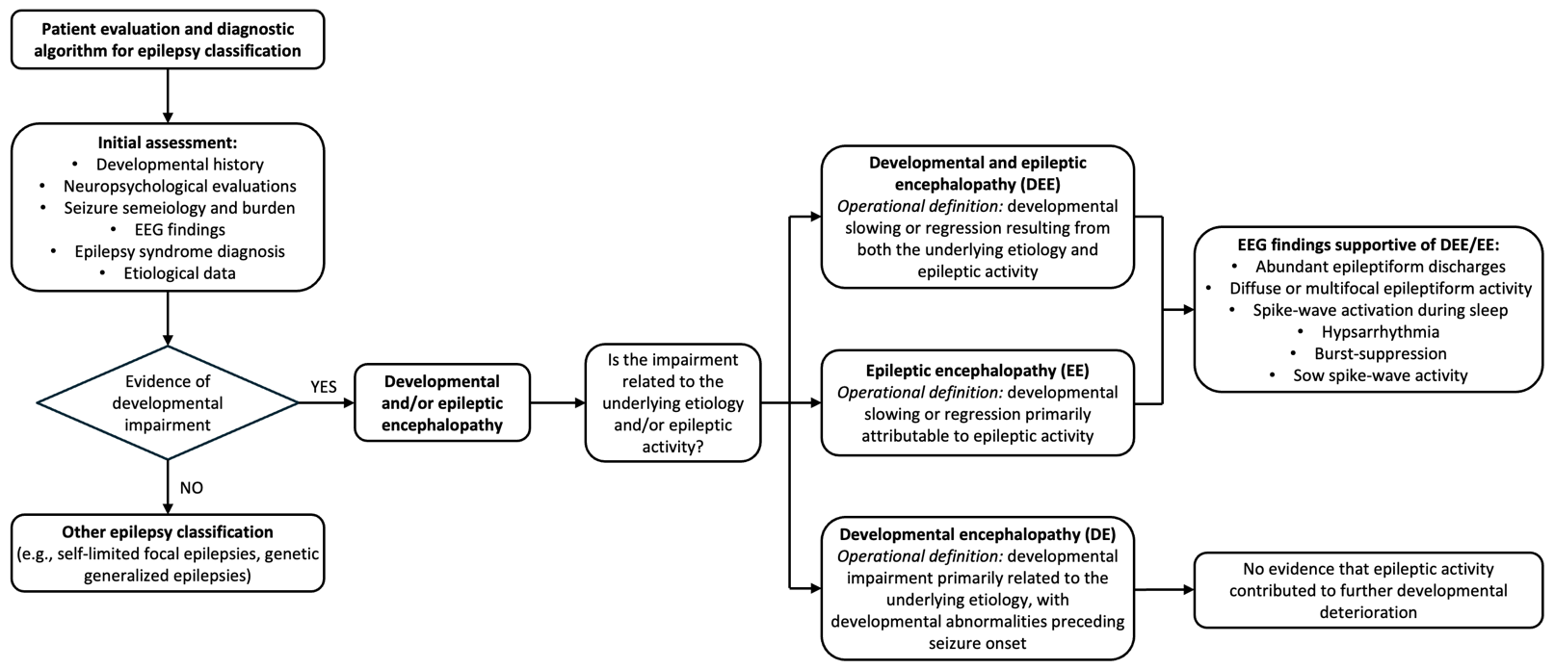
Supplementary figure 1. Diagnostic algorithm used for classification of patients as developmental encephalopathy (DE), epileptic encephalopathy (EE), or developmental and epileptic encephalopathy (DEE).
Classification was based on ILAE operational concepts of DE, EE, and DEE, considering the presence of developmental impairment, its temporal relationship with epilepsy onset, and the presumed contribution of epileptic activity to developmental slowing or regression. EEG features supportive of EE/DEE included abundant epileptiform discharges, diffuse or multifocal epileptiform activity, and spike-wave activation during sleep (including hypsarrhythmia, burst-suppression, and slow spike-wave patterns when applicable). DE was assigned when developmental impairment was primarily attributable to the underlying etiology without evidence that epileptic activity contributed to further developmental deterioration.
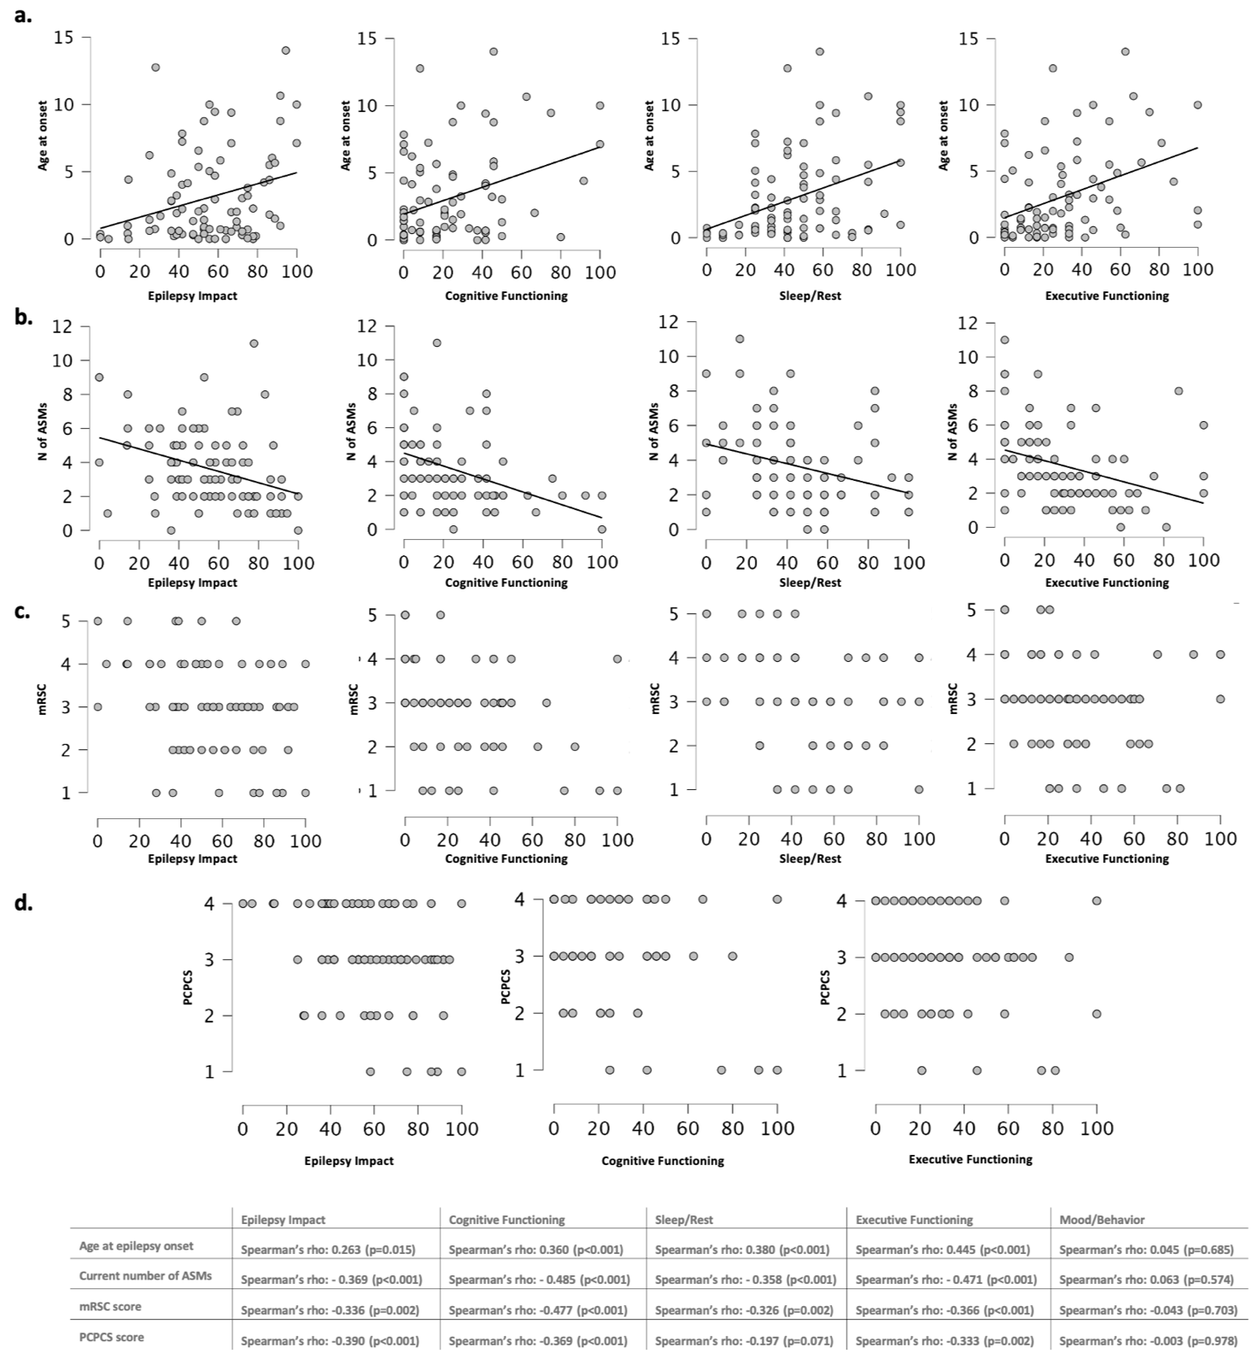
Supplementary figure 2. Scatter plots of patient HRQoL by subscales and age at epilepsy onset (a), current number of anti-seizure medications (b), mRSC score (c), and PCPCS score (d). Plots show pairwise relationships between variables; (a) and (b) include a linear regression line with the corresponding Spearman’s rank correlation coefficient, indicating the strength and direction of each association. No regression line is shown in (c) and (d) due to the ordinal nature of the clinical scores. A summary table presents the results of the correlation analyses between these variables, including correlation coefficients and statistical significance.

