Additional file 1
Legend
Table S1. Search strategy
Table S1. Search strategy (cont.)
Table S2. Modified Newcastle-Ottawa quality assessment scale for cohort studies
Table S3. Risk of bias assessment for cohort study
Figure S1. Contour-enhanced funnel plot of pre-hospital adrenaline effect on prehospital ROSC.
Figure S2. Contour-enhanced funnel plot of pre-hospital adrenaline effect on overall return of spontaneous circulation
Figure S3. Contour-enhanced funnel plot of pre-hospital adrenaline effect on hospital admission
Figure S4. Contour-enhanced funnel plot of pre-hospital adrenaline effect on survival to discharge.

Table S1. Search strategy
Medline (Pubmed) database
Search | Query | Items
#25 | Search ((#11) OR #15) OR #24 | 882
#24 | Search (((((((#16) OR #17) OR #18) OR #19) OR #20) OR #21) OR #23) OR #24 | 1692876
#23 | Search "return of spontaneous circulation" | 1335
#22 | Search ROSC | 1076
#21 | Search "Patient Admission"[Mesh] | 18109
#20 | Search "Patient Discharge"[Mesh] | 18334
#19 | Search Death | 581038
#18 | Search "Death"[Mesh] | 112854
#17 | Search "Survival"[Mesh] | 3857
#16 | Search survival | 1294547
#15 | Search ((#12) OR #13) OR #14 | 130546
#14 | Search "Epinephrine"[Mesh] | 111637
#13 | Search epinephrine | 124562
#12 | Search adrenaline | 130546
#11 | Search (((((((((#1 OR #2) OR #3) OR #4) OR #5 OR #6 OR #7) OR #8) OR #9 OR #10 | 79728
#10 | Search "Heart Arrest"[Mesh] | 33041
#9 | Search "Out-of-Hospital Cardiac Arrest"[Mesh] | 817
#8 | Search "out-of-hospital cardiac arrest" | 2660
#7 | Search "out of hospital cardiac arrest" | 2660
#6 | Search "Ventricular Fibrillation"[Mesh] | 14609
#5 | Search "pulseless electrical activity" | 478
#4 | Search "PEA" | 11010
#3 | Search asystole | 47639
#2 | Search "ventricular fibrillation" | 21832
#1 | Search "cardiac arrest" | 20803

Table S1. Search strategy (continue)
Scopus database
((TITLE-ABS-KEY("out of hospital cardiac arrest")) OR (TITLE-ABS-KEY("cardiac arrest")) OR (TITLE-ABS-KEY("ventricular fibrillation")) OR (TITLE-ABS-KEY("asystole")) OR (TITLE-ABS-KEY("heart arrest")) OR (TITLE-ABS-KEY("pulseless electrical activity")) OR (TITLE-ABS-KEY("PEA"))) AND ((TITLE-ABS-KEY("epinephrine")) OR (TITLE-ABS-KEY("adrenaline"))) AND ((TITLE-ABS-KEY("return of spontaneous circulation")) OR (TITLE-ABS-KEY(rosc)) OR (TITLE-ABS-KEY(death)) OR (TITLE-ABS-KEY(survival)) OR (TITLE-ABS-KEY(discharge)) OR (TITLE-ABS-KEY(admission)))

Table S2. Modified Newcastle-Ottawa quality assessment scale for cohort studies
Items |  | Risk of bias
Representativeness of the OHCA cohort
 | True representativeness of OHCA | Low
 | Partial Representativeness of OHCA | High
 | No description | Unclear
Ascertainment of exposure
 | Secure record or structured interview | Low
 | Written self report | High
 | No description | Unclear
Assessment of outcome
 | Independent blind assessment or record linkage | Low
 | Self report | High
 | No description | Unclear
Adjusted analysis for confounders
 | Yes | Low
 | No | High
Missing data
 | Less than 5% | Low
 | More than 5% | High
 | No statement | Unclear
OHCA; out of hospital cardiac arrest
Table S3. Risk of bias assessment for cohort study
Author, Year (reference) | Representativeness of OHCA | Ascertainment of AD | Ascertainment of outcomes | Adjusted analysis | Missing data
Herlitz, 1994 [20] | Low | Unclear | Unclear | High | Low
Herlitz, 1995 [5] | High | Unclear | Unclear | High | High
Herlitz, 1995 [19] | Low | Unclear | Unclear | Low | Low
Guyette, 2004 [17] | Low | Low | Low | Low | Low
Ong, 2007 [16] | Low | Low | Low | Low | Low
Vayrynen, 2008 [21] | Low | Low | Low | Low | Low
Yanagawa, 2010 [15] | Low | Low | Low | Low | Low
Hagihara, 2012 [12] | Low | Low | Low | Low | Low
Hayashi, 2012 [13] | Low | Low | Low | Low | Low
Machida, 2012 [18] | High | Low | Low | High | Unclear
Nordseth, 2012 [14] | Low | Low | Low | High | High
Neset, 2013 [35] | Low | Low | Low | Low | Low
Goto, 2013 [36] | Low | Low | Low | Low | Low

AD; adrenaline, OHCA; out of hospital cardiac arrest

Figure S1. Contour-enhanced funnel plot of pre-hospital adrenaline effect on prehospital ROSC.
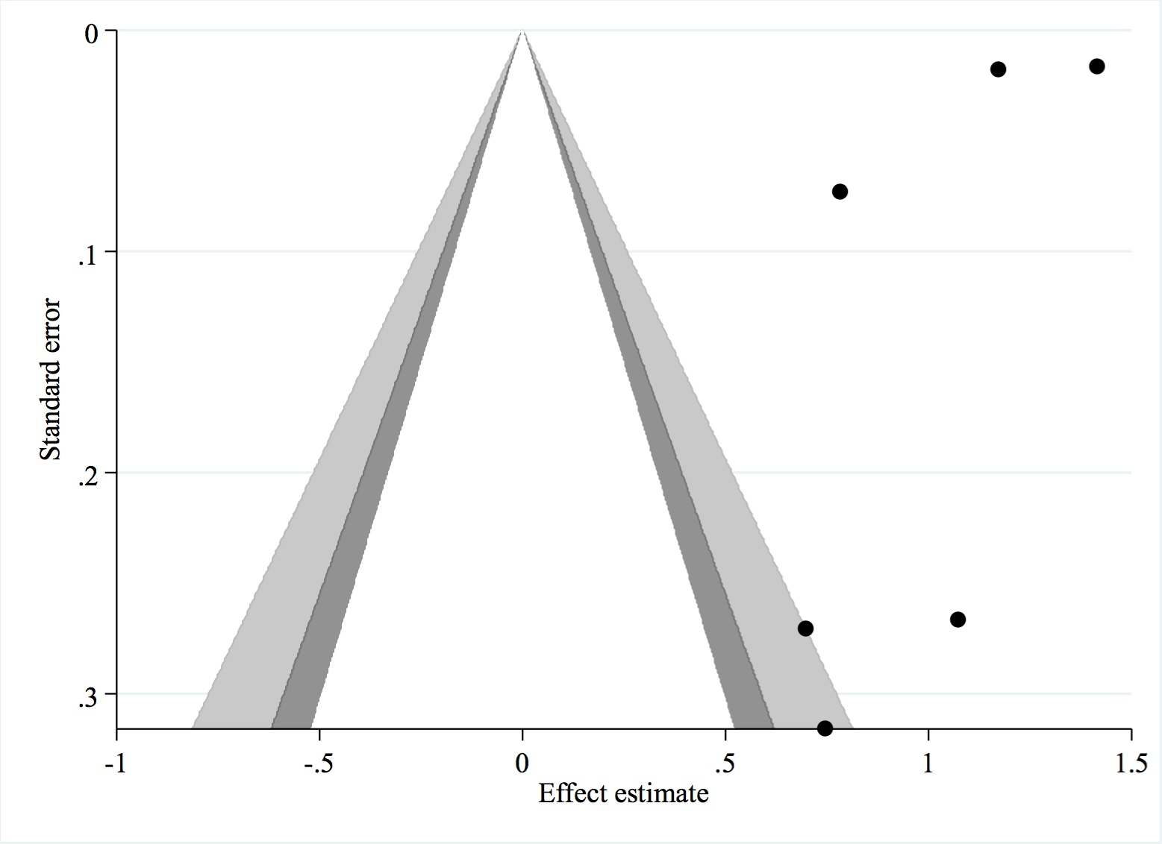

Figure S2. Contour-enhanced funnel plot of pre-hospital adrenaline effect on overall return of spontaneous circulation
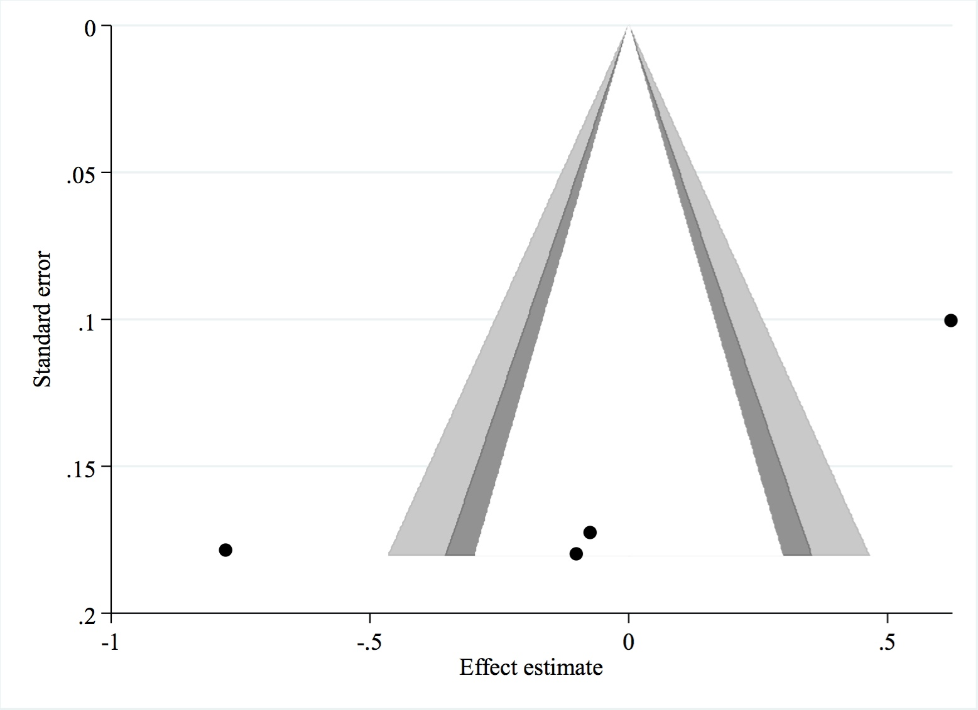

Figure S3. Contour-enhanced funnel plot of pre-hospital adrenaline effect on hospital admission
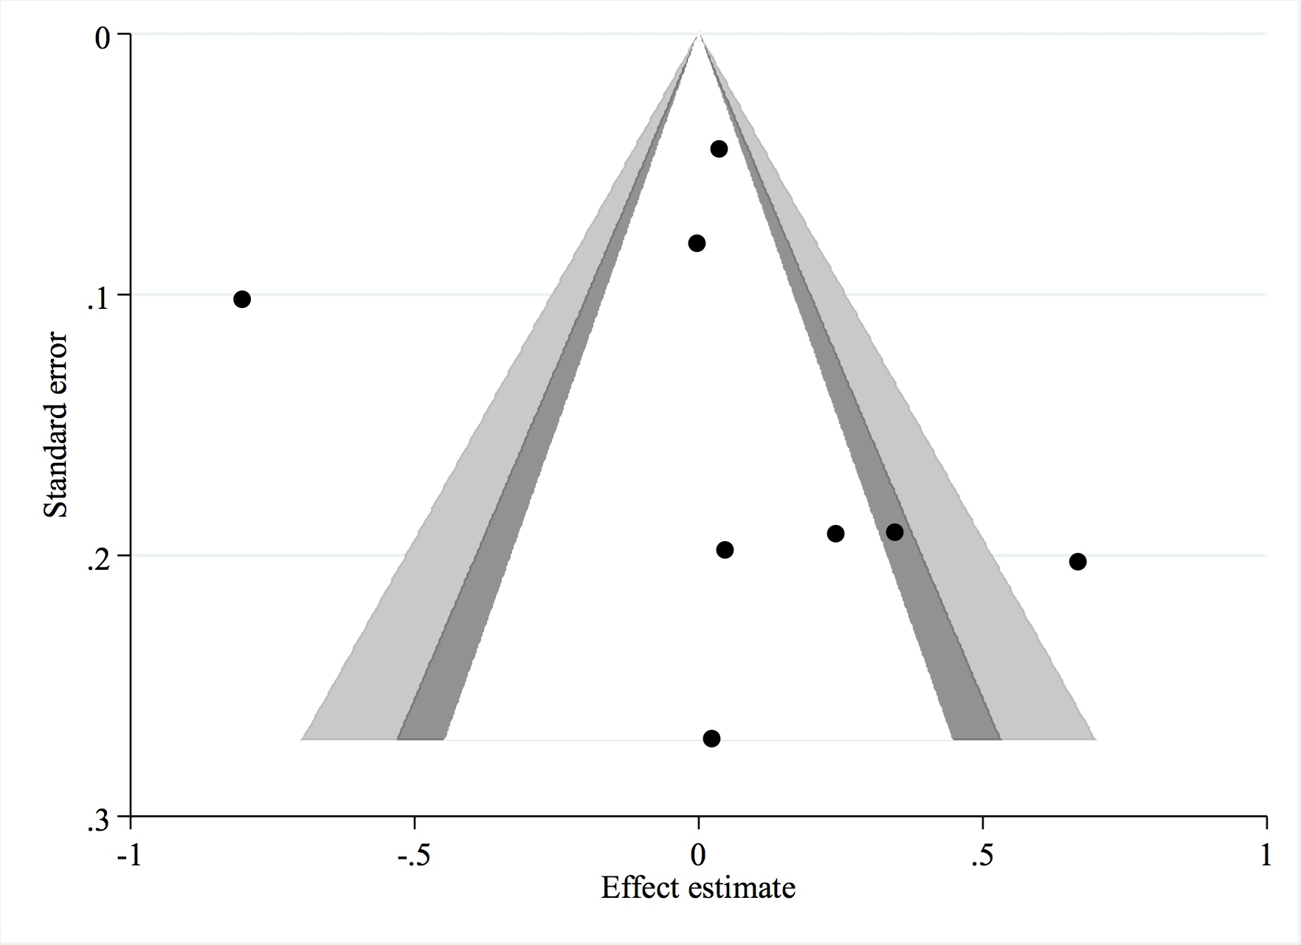

Figure S4. Contour-enhanced funnel plot of pre-hospital adrenaline effect on survival to discharge.

